Pertemuan 3
Rafif Muhammad Faiz
J0403251024
TPL B/ P2

- Tugas 1
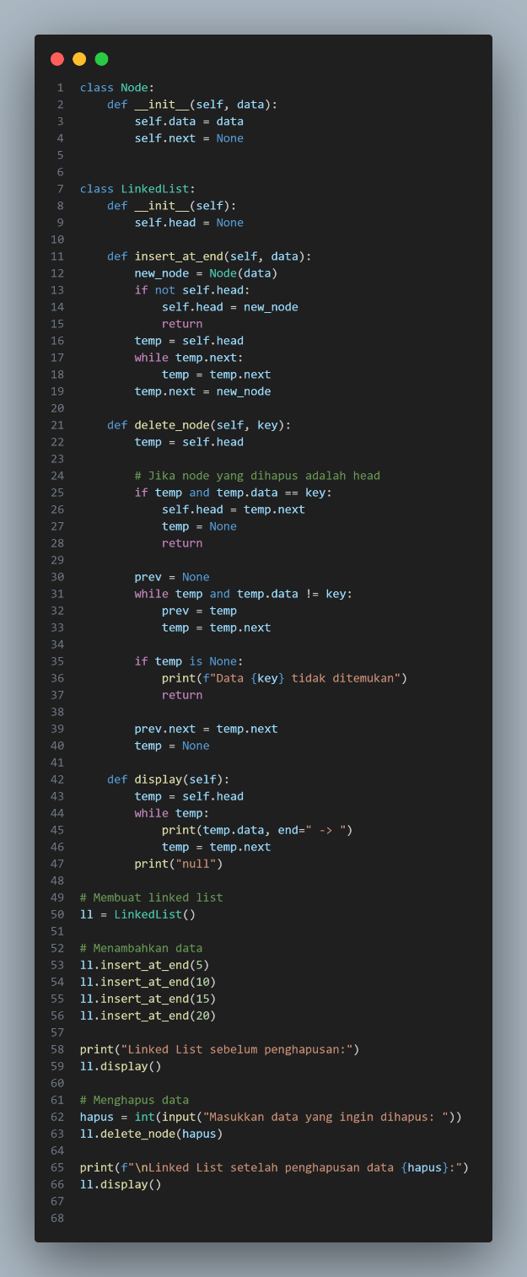

- Tugas 2
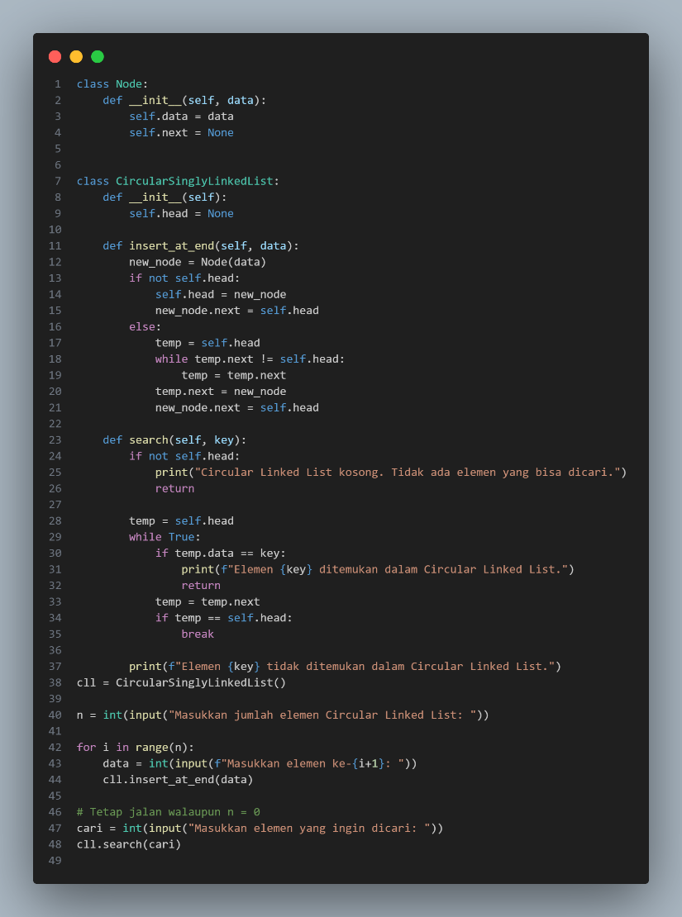

- Tugas 4
