Homework 6: Hadoop Installation

Step 1: Preparation and Download

I started by reading instructions on http://courses.dce.harvard.edu/~cscie55/hadoop/GettingStarted.html and think about how they fit my system. I am using Ubuntu 14.04 LTS as my main operating system which seems to be a good fit for Hadoop. Here, I knew that I can skip the ssh installation step because I already have ssh installed on my computer.

I started off by generating keys for ssh and put the public key into ~/.ssh/authorized_keys. Then, I downloaded Hadoop 2.7.1 binary from Apache website. I selected the recommended mirror and downloaded.

After the download completed, I extracted the tar.gz file to /home/pipat/Applications/hadoop-2.7.1 folder. I put the files there because it is the folder that I keep programs that I use solely under my username (pipat). By doing this, I don't need to set ownership of the folder because it is already owned by my username.

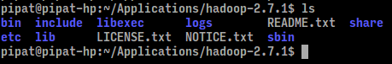
I copied Hadoop config folder hadoop-2.7.1/etc/hadoop to hadoop-2.7.1/etc/hadoop-deployed in order to preserve the original version. Config files in hadoop-deployed were used in this homework.

Step 2: Modify .bashrc

I needed to add Hadoop executables to .bashrc in order to use them. From terminal, I used nano to modify .bashrc. I did not need root access to change this. I typed “nano ~/.bashrc” and added the following:

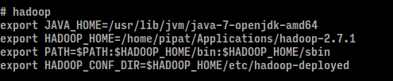
First, I set JAVA_HOME to my Java installation path. I chose Java 7 OpenJDK in this case. The HADOOP_HOME referred to Hadoop installation path and HADOOP_CONF referred to hadoop-deployed path as mentioned in Step 1. I also added bin and sbin to PATH for easy execution.

After that, I typed “source ~/.bashrc” in order to activate the changes.

Step 3: Configure core-site.xml and hdfs-site.xml

Next, I configured core-site.xml and hdfs-site.xml to reflect running Hadoop on localhost. I added the following to the files. I also created hadoop/hadoop-name and hadoop/hadoop-data under /home/pipat.

core-site.xml:
<configuration>
<property>
<name>fs.defaultFS</name>
<value>hdfs://localhost/</value>
</property>
</configuration>
hdfs-site.xml
<configuration>
<property>
<name>dfs.replication</name>
<value>1</value>
</property>
<!-- Arrange the Hadoop backing store for name and data -->
<!-- Use your home directory where you see /Users/charliesawyer -->
<property>
<name>dfs.name.dir</name>
<value>/home/pipat/hadoop/hadoop-name</value>
</property>
<property>
<name>dfs.data.dir</name>
<value>/home/pipat/hadoop/hadoop-data</value>
</property>
</configuration>
Step 4: Format namenode and start Hadoop

I logged in through ssh by typing “ssh localhost”. Then I typed “hdfs namenode -format”. At first, it failed with a message that it cannot find JAVA_HOME. I looked up online and found that I should try adding “export JAVA_HOME="/usr/lib/jvm/java-7-openjdk-amd64" in hadoop-env.sh. Now it worked.

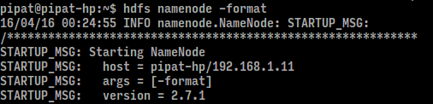
Then, I started Hadoop cluster by typing “start-dfs.sh” and checking it with jps. The result is as follows:
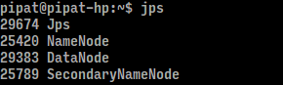
Step 5: Running wordcount locally

I started by downloading all files needed into a folder “hw6”. The I stored input text files in …
hw6/input/fleas
hw6/input/jabberwocky

Then, I set HADOOP_CLASSPATH to include hadoop-mapreduce-client-core, hadoop-common, and commons-cli by using the following:

“export HADOOP_CLASSPATH=.:$HADOOP_HOME/share/hadoop/mapreduce/hadoop-mapreduce-client-core-2.7.1.jar:$HADOOP_HOME/share/hadoop/common/hadoop-common-2.7.1.jar:$HADOOP_HOME/share/hadoop/tools/lib/commons-cli-1.2.jar”

Then, I executed wordcount by executing:
“hadoop WordCount -fs file:/// -jt local input/fleas output/fleas”
“hadoop WordCount -fs file:/// -jt local input/jabberwocky output/jabberwocky”
The part-r-0000 output files were created (see attached). Also, terminal results were recorded.

For fleas, I found that the word “fleas” are most frequent with 3 occurances. For jabberwocky, “the” are most frequent with 15 occurances.

Step 6: Running wordcount on cluster

I started by making directory for input and copying files to HDFS. Then, I -ls to check if files were successfully copied to HDFS. I also loaded wordcount.jar.

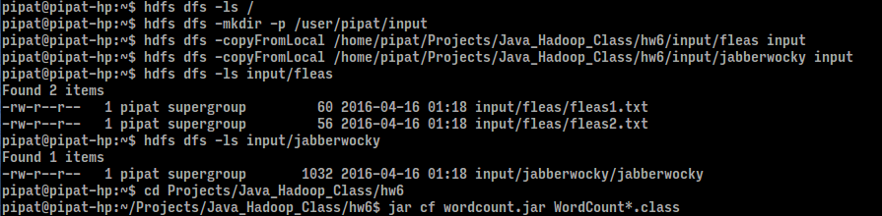
Then, I ran the following commands to run wordcount for fleas and jabberwocky on a cluster.
“hadoop jar wordcount.jar WordCount input/fleas output/fleas”
“hadoop jar wordcount.jar WordCount input/jabberwocky output/jabberwocky”

The terminal outputs are attached. The tails of the outputs were exported to text files as below:

