

Programme
Master of Software Engineering

Course
MSE907

Design and Implementation of a Real-Time Traffic Anomaly Detection and AI Benchmarking Pipeline

Project Proposal

Jiuyu Li (270746245)

Supervisor’s Name: Dr. Prakash Kumar Karn
Date: 15 April 2026

1. Background to the Problem or Study
Smart cities rely on IoT sensors to monitor traffic. While Machine Learning (ML) is highly effective at predicting traffic anomalies, these models are usually trained on clean, static datasets in a controlled lab environment.
In the real world, live streaming data is chaotic. Physical sensors frequently transmit "dirty data," such as negative vehicle speeds or broken JSON formats. If a system feeds this unvalidated streaming data directly into an AI model, it leads to two major problems: system crashes and wasted cloud API costs. In the field of MLOps, failing to validate data before inference is a classic example of "Hidden Technical Debt."
Therefore, modern traffic anomaly detection is not just an AI problem; it is a software engineering challenge. There is a strong need for a robust middleware architecture. This Capstone project addresses this gap by building a real-time pipeline that uses a Dead Letter Queue (DLQ) to filter out dirty data before it touches the AI. Furthermore, it provides a benchmarking framework to compare local ML models against cloud LLM APIs under real-time stress.

2. Problem Statement
Current traffic anomaly detection systems are predominantly designed as monolithic, offline models. These traditional systems operate under the unrealistic assumption that input data is already perfectly clean. However, when deployed in real-world streaming environments, they are constantly exposed to malformed "dirty data" from faulty physical sensors or network errors.
The primary problem is that existing architectures lack a dedicated, "Zero-AI" data isolation layer. When invalid data is fed directly into inference engines without prior validation, it causes two critical failures:
System Vulnerability: Local predictive models (e.g., XGBoost) often crash or produce highly skewed predictions when processing corrupted inputs.
Financial and Latency Waste: Sending unvalidated, malformed data to external cloud LLM APIs wastes expensive computational tokens and creates severe latency bottlenecks.
Currently, there is a critical lack of a fault-tolerant streaming middleware capable of physically intercepting and isolating corrupted data before it reaches the AI layer, while simultaneously benchmarking the performance of multiple predictive models.

3. Objectives of Research
The primary aim of this research is to design and evaluate a robust streaming middleware for traffic anomaly detection. To achieve this, the project is broken down into the following specific, measurable objectives:
Objective 1: To design and implement a "Zero-AI" data validation gateway. The objective is to utilize strict schema validation (e.g., Pydantic) to intercept and physically isolate corrupted streaming data into a Dead Letter Queue (DLQ), ensuring that invalid payloads are filtered out before consuming expensive AI computational resources.
Objective 2: To develop an asynchronous Dual-Track AI routing engine. The objective is to engineer a high-concurrency message dispatcher capable of routing clean data simultaneously to a local predictive model (Track A) and an external cloud-based LLM API (Track B), managing network latency and timeouts effectively.
Objective 3: To construct a real-time benchmarking dashboard and evaluate system performance. The objective is to visualize system throughput and conduct A/B stress testing to quantitatively compare the inference latency, accuracy, and operational costs between the local AI model and the cloud API under high-load conditions.

4. Scope and Limitation of Study
Scope of the Study: This Capstone project is strictly focused on the backend software engineering architecture required for real-time stream processing and MLOps. The scope encompasses the development of the Pydantic-based validation gateway, the Dead Letter Queue (DLQ) integration, and the asynchronous dual-track AI dispatcher. The system will be evaluated using high-frequency, simulated traffic sensor payloads (JSON format) to test concurrency and fault tolerance.
Limitation of the Study: A primary limitation of this research is the reliance on software-simulated data streams. While these simulations can effectively stress-test the backend middleware, they cannot perfectly replicate the unpredictable network fluctuations, hardware degradation, or packet loss inherent in physical 5G/IoT sensor networks on real streets. Furthermore, the objective is to benchmark the architectural robustness and latency of the pipeline, not to invent a novel anomaly detection algorithm from scratch. Therefore, the system will utilize established models (e.g., XGBoost) and existing commercial LLM APIs to conduct the benchmarking experiments.

5. Literature Review
This Capstone project is situated at the intersection of Anomaly Detection, Real-Time Stream Processing, and Machine Learning Operations (MLOps). A review of foundational literature reveals that while algorithmic theories are mature, deploying them securely in high-concurrency production environments remains a critical engineering challenge.
The theoretical groundwork for identifying data outliers is comprehensively established by Chandola et al. (2009) in their seminal survey on anomaly detection. They detail various algorithmic approaches to identify deviations in complex datasets. However, a limitation of traditional anomaly detection research is its inherent focus on static data analysis. Transitioning these algorithms to monitor live urban traffic requires a robust, high-throughput architectural paradigm.
To address the challenges of continuous data ingestion, Kreps et al. (2011) introduced the paradigm of distributed messaging systems for log processing, famously materialized as Apache Kafka. Their research demonstrates that real-time, high-concurrency environments require highly decoupled architectures, asynchronous message routing, and reliable queuing mechanisms. The asynchronous dispatcher and routing principles utilized in this Capstone project are heavily inspired by Kreps’s findings, ensuring the system can handle massive simulated traffic payloads without bottlenecking.
Even with advanced anomaly algorithms and robust streaming architectures, the integration of Machine Learning models introduces severe operational vulnerabilities. Sculley et al. (2015) from Google articulate this in their research on "Hidden Technical Debt in Machine Learning Systems." They warn that in production ML systems, the core prediction algorithm is merely a fraction of the necessary infrastructure. Without strict data verification, configuration management, and isolation mechanisms, live systems are highly susceptible to silent failures caused by corrupted input data.
Synthesis: The existing literature highlights a clear gap: combining theoretical anomaly detection (Chandola) with robust streaming architectures (Kreps) requires mitigating severe ML technical debt (Sculley). This project directly bridges this gap by proposing a domain-agnostic streaming middleware. By implementing a strict Pydantic-based validation layer and a Dead Letter Queue (DLQ), the system physically isolates corrupted data before it reaches the inference engines, thereby enabling a safe, high-concurrency benchmarking pipeline for both local ML models and cloud-based LLM APIs.

6. Methodology
This research adopts a Quantitative and Experimental Systems Design methodology. Given the project's focus on backend architecture, stream processing, and model benchmarking, a quantitative approach is essential to objectively measure system throughput, latency, and fault tolerance under high-concurrency conditions. The methodology is structured into the following four phases:
1. Methodological Approach (Quantitative Design) The study is inherently quantitative and experimental. Rather than conducting qualitative user studies, this research constructs a controlled software environment to test causal relationships between data validation strategies (independent variable) and system robustness/latency (dependent variables).
2. Data Collection Methods (Simulation) Since physical deployment of IoT hardware at urban intersections is beyond the project scope, data collection will rely on simulating high-frequency sensor streams. The system will utilize existing, open-source traffic datasets (e.g., vehicle coordinates, speeds) and stream them through a custom traffic generator script to bombard the API Gateway, intentionally injecting corrupted data (e.g., negative integers, missing JSON keys) to test fault tolerance.
3. Implementation and Analysis Strategy The system architecture and subsequent data analysis follow a distinct pipeline:
Validation & Isolation: Utilizing Pydantic, incoming streams are evaluated against strict schemas. The quantitative metric here is the "Interception Success Rate" (ensuring 100% of dirty data is routed to the DLQ).
Asynchronous Routing: Clean data is dispatched via an async router.
A/B Benchmarking Analysis: The core analysis compares Track A (Local predictive model, e.g., XGBoost) and Track B (Cloud LLM API). Performance is quantitatively analyzed using three primary metrics: Inference Latency (milliseconds), Cost-efficiency (API token usage), and Predictive Accuracy.
4. Justification and Acknowledgment of Limitations The choice of a DLQ-based asynchronous architecture is justified by its proven ability to mitigate "Hidden Technical Debt" in MLOps, completely decoupling data cleansing from AI inference. Limitations: It is acknowledged that laboratory-based software simulations cannot perfectly replicate the unpredictable network fluctuations of physical 5G/IoT traffic sensors in real life. However, this controlled quantitative approach remains the most rigorous method to stress-test the backend middleware's core logic and concurrency limits.
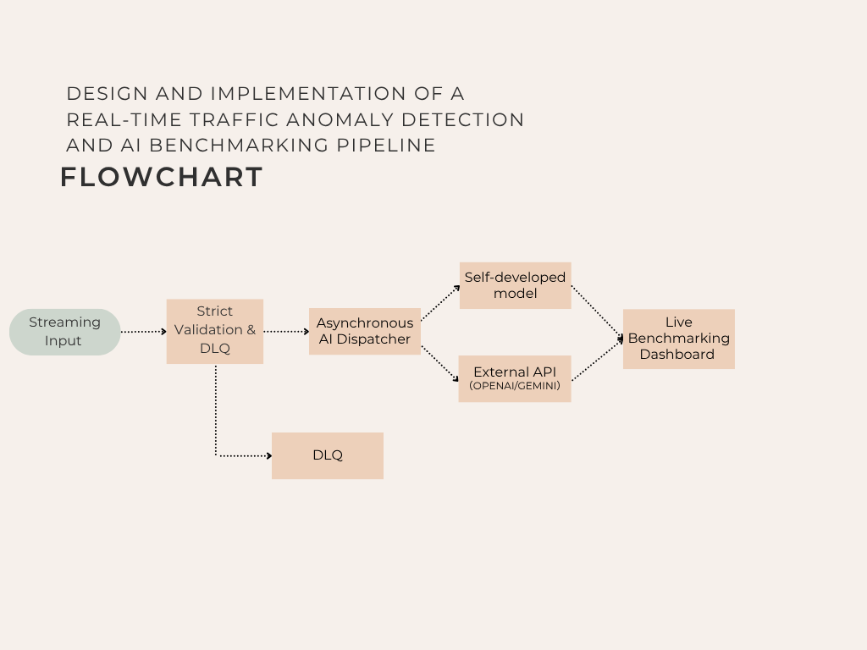
Flowchart

7. Proposed Schedule
Phase 1: Research, Definition & Environment Setup (Weeks 1-2)
Tasks: Complete the literature review and finalize the exact Pydantic validation schemas. Initialize the local development environment and containerize the application (Python FastAPI, Docker).
Milestone: Finalize and submit the Capstone Proposal; prepare the raw traffic datasets required for simulating high-frequency streaming.
Phase 2: Core Security Gateway & DLQ Development (Weeks 3-5)
Tasks: Program the Pydantic validation models and implement the fail-fast interception logic. Develop the Dead Letter Queue (DLQ) database module to ensure the physical isolation of corrupted data payloads.
Milestone: Complete the prototype of the "Zero-AI" data cleansing layer and successfully pass preliminary fault-tolerance unit tests.
Phase 3: Asynchronous Dual-Track AI Routing Integration (Weeks 6-8)
Tasks: Develop the asynchronous message dispatcher. Implement concurrent API calls to the local predictive model (Track A) and the external cloud LLM (Track B). Load and configure pre-trained weights for the local model.
Milestone: Fully integrate the core predictive pipeline, capable of simultaneously routing clean data and retrieving inference results from both AI tracks.
Phase 4: Stress Testing, Dashboarding & Project Closure (Weeks 9-12)
Tasks: Construct the real-time benchmarking dashboard to visualize metrics. Conduct high-concurrency stress testing to collect data on inference latency, cloud API costs, and system throughput. Draft and finalize the Capstone Report.
Milestone: Conclude all experimental data analysis and submit the final project source code alongside the completed dissertation.

8. Significance of Study
The significance of this Capstone project lies in its direct contribution to the field of Machine Learning Operations (MLOps) and Intelligent Transportation Systems (ITS). While existing research heavily focuses on maximizing algorithmic accuracy in controlled laboratory environments, this project addresses the critical, often-overlooked engineering bottlenecks of deploying AI in chaotic, real-world streaming environments.
Specifically, the significance is demonstrated across three dimensions:
Architectural Robustness: By introducing a strict "Zero-AI" Pydantic validation layer and a Dead Letter Queue (DLQ), this study provides a highly fault-tolerant blueprint. It demonstrates how to physically isolate data corruption, significantly mitigating the "Hidden Technical Debt" that frequently causes production system crashes.
Economic and Operational Efficiency: In the era of commercial Large Language Models (LLMs), routing raw, unvalidated streaming data to cloud APIs is financially unsustainable. This middleware acts as a financial safeguard, ensuring that only clean, validated data consumes expensive API tokens, thereby optimizing operational costs.
Benchmarking Methodology: The asynchronous dual-track engine provides developers and urban planners with a reproducible framework to quantitatively evaluate the trade-offs between deploying local, low-latency models (e.g., XGBoost) versus high-capability external cloud APIs under high-concurrency stress.
Ultimately, this project bridges the critical gap between theoretical data science and robust software engineering, delivering a scalable, cost-effective middleware solution ready for industrial production.

9. References
Sculley, D., et al. (2015). Hidden Technical Debt in Machine Learning Systems. Advances in Neural Information Processing Systems (NeurIPS), 28.
https://papers.neurips.cc/paper/5656-hidden-technical-debt-in-machine-learning-systems.pdf
Kreps, J., Narkhede, N., & Rao, J. (2011). Kafka: A Distributed Messaging System for Log Processing. Proceedings of the NetDB, 11, 1-7.
https://dl.acm.org/doi/10.1145/1541880.1541882
Chandola, V., Banerjee, A., & Kumar, V. (2009). Anomaly detection: A survey. ACM Computing Surveys (CSUR), 41(3), 1-58.
http://pages.cs.wisc.edu/~akella/CS744/F17/838-CloudPapers/Kafka.pdf

