Modeling and Simulation을 이용한 Special population에서의 약물 인허가 현황과 관련규정

Sungpil Han

2017-11-16

# 서론

모델링과 시뮬레이션을 사용하면 특수 집단에서의 약물 사용에 큰 도움을 줄 수 있다. 장점을 기술. (R Core Team 2017)

* 안전성을 확보
* 적절한 용량의 사용 가능
* 부작용 발생 시 빠른 대처 가능
* 비용 절감

용량을 결정하는 것은 특수 집단에서의 약물 사용에 있어 가장 주된 결정 사항이다. 최근 세계 각국의 규제 기관에서는 특수 집단에서 모델 기반 약물 개발에 대해 적극 장려하고 있다. 계량약리학 혹은 정량적 임상약리학 분야의 모델의 개발에 대해 약동학, 약력학에 영향을 미치는 인자를 발견하게 할 수 있다. 특히 소아와 성인의 약동학 비교를 통하여 용량/노출-반응 관계를 살펴볼 수 있다. (그림 @ref(fig:ms-ped))

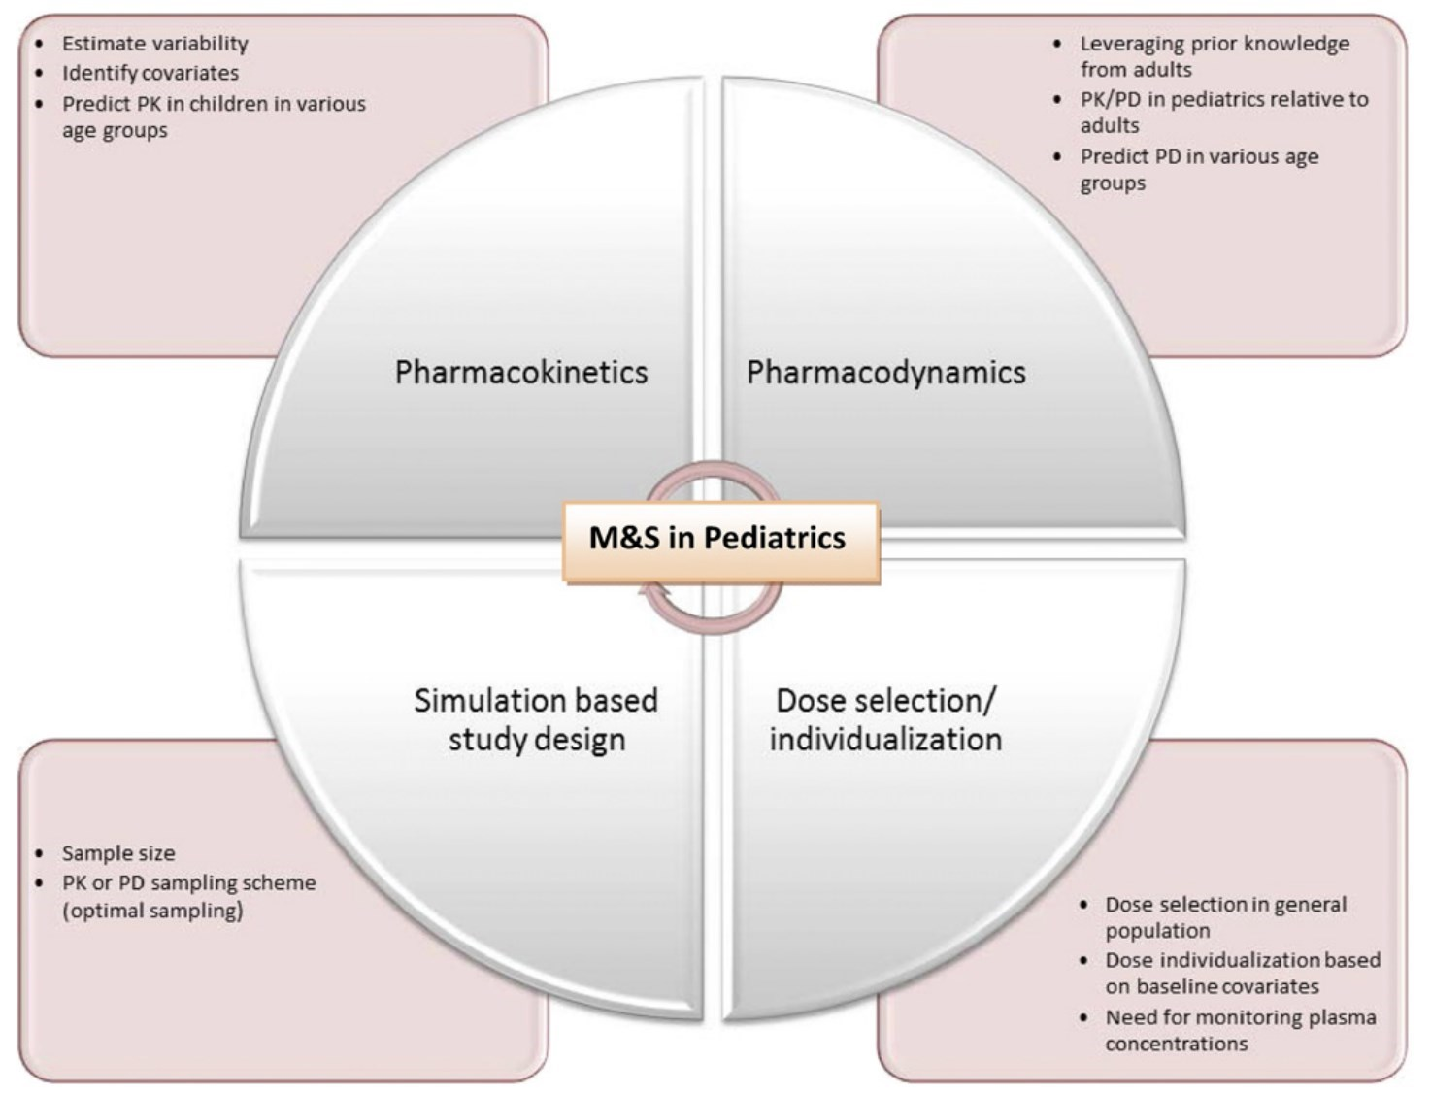

PK/PD model in pediatrics

Dose selection is one of the key decisions made during drug development in pediatrics. There are regulatory initiatives that promote the use of model-based drug development in pediatrics. Pharmacometrics or quantitative clinical pharmacology enables development of models that can describe factors affecting pharma- cokinetics and/or pharmacodynamics in pediatric patients. This manuscript describes some examples in which pharmacometric analysis was used to support approval and labeling in pediatrics. In particular, the role of pharmacokinetic (PK) comparison of pediatric PK to adults and utilization of dose/exposure-response analysis for dose selection are highlighted. Dose selection for esomeprazole in pediatrics was based on PK matching to adults, whereas for adalimumab, exposure-response, PK, efficacy, and safety data together were useful to recommend doses for pediatric Crohn’s disease. For vigabatrin, demonstration of similar dose-response between pediatrics and adults allowed for selection of a pediatric dose. Based on model-based pharmacokinetic simulations and safety data from darunavir pediatric clinical studies with a twice- daily regimen, different once-daily dosing regimens for treatment- naïvehumanimmunodeficiencyvirus1–infectedpediatricsubjects 3 to<12yearsofagewereevaluated.Theroleofphysiologicallybased pharmacokinetic modeling (PBPK) in predicting pediatric PK is rapidly evolving. However, regulatory review experiences and an understanding of the state of science indicate that there is a lack of established predictive performance of PBPK in pediatric PK prediction. Moving forward, pharmacometrics will continue to play a key role in pediatric drug development contributing to- ward decisions pertaining to dose selection, trial designs, and assessing disease similarity to adults to support extrapolation of efficacy.

# 모델링/시뮬레이션을 이용한 특수 집단에서 약물 인허가 현황

## FDA

|  |  |
| --- | --- |
| 구분 | 약물 |
| 소아 | Esomeprazole |
| 소아 | Vigabatrin |
| 소아 | Adalimumab |

1. Esomeprazole in Pediatrics for the Treatment of Gastroesophageal Reflux Disease with Erosive Esophagitis: Intravenous Dose Selection (Mehrotra et al. 2016)
2. Approval of Vigabatrin for Refractory Complex Partial Seizures in Pediatrics (Mehrotra, 2016, Drug Metabolism and Disposition)
3. Adalimumab: Crohn’s Disease in Children: Dose Selection (Mehrotra, 2016, Drug Metabolism and Disposition)
4. Darunavir : Exposure-Response and PK Matching to Bridge Dosing for Different Patient Populations in Pediatrics for the Treatment of Human Immunodeficiency Virus (Mehrotra, 2016, Drug Metabolism and Disposition)
5. Topiramate: Topiramate Dosing Regimen was Derived by Matching Steady State Trough Concentrations (CMIN) for Different Age Groups
6. Pralidoxime: Derived and recommended Pediatric Dosing Recommendations without any empirical data
7. Peramivir: Derived and recommended Pediatric Dosing Recommendations without any empirical data

Mehrotra의 서론 부분을 요약.

에소메프라졸을 소아에서 GERD 치료시 사용. (Mehrotra et al. 2016)

## EMEA

* 2015년 EMEA MSWG (Modeling and Simulation Working Group)에 의뢰된 관련 업무의 사례 수 (Figure 1)

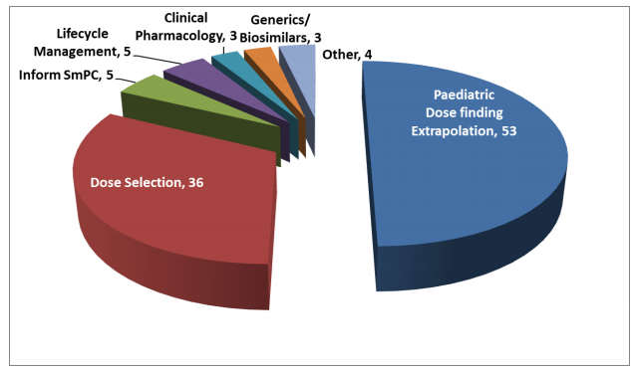



2015년 EMEA MSWG (Modeling and Simulation Working Group)에 의뢰된 관련 업무의 사례 수. Reference: <http://www.ema.europa.eu/docs/en_GB/document_library/Report/2017/03/WC500222778.pdf>

## PMDA

* 2014년에서 2016년까지 PBPK를 사용한 17 개의 NDA 제출 (2017, Sato, CPT Pharmacometrics Syst. Pharmacol)

# 모델링/시뮬레이션 관련 규정

## FDA

### 일반론

* Guidance for Industry End-of-Phase 2A Meetings <https://www.fda.gov/downloads/Drugs/.../Guidances/ucm079690.pdf>

### 소아

* 1994, Pediatric Labeling Rule(Extrapolation Introduced)
* 1997, FDA Modernization Act (FDAMA) (Pediatric Exclusivity – incentive)
* 2002, Best Pharmaceuticals for Children Act(BPCA) (incentive)
* 2003, Pediatric Research Equity Act(PREA) (requirement)
* 2007, FDA Amendments Act(FDAAA) (reauthorized BPCA & PREA)
* 2012, FDA Safety & Innovation Act(FDASIA) (Permanently reauthorizes BPCA & PREA)
* 2014: General Clinical Pharmacology Considerations for Pediatric Studies for Drugs and Biological Products <https://www.fda.gov/downloads/drugs/guidancecomplianceregulatoryinformation/guidances/ucm425885.pdf>

## EMEA

EMEA

* 2016, Reflection paper on extrapolation of efficacy and safety in paediatric medicine development <http://www.ema.europa.eu/docs/en_GB/document_library/Regulatory_and_procedural_guideline/2016/04/WC500204187.pdf>
* 2016, Guideline on the qualification and reporting of physiologically based pharmacokinetic (PBPK) modelling and simulation <http://www.ema.europa.eu/docs/en_GB/document_library/Scientific_guideline/2016/10/WC500213940.pdf>
* Guideline on the qualification and reporting of physiologically based pharmacokinetic (PBPK) modelling and simulation <http://www.ema.europa.eu/docs/en_GB/document_library/Scientific_guideline/2016/07/WC500211315.pdf>

## PMDA

* 영어 자료가 제한되어 의미있는 자료를 아직 찾지 못하였습니다.

# 참고문헌

## Warning in citation(pkg, auto = if (pkg == "base") NULL else TRUE): no date  
## field in DESCRIPTION file of package 'dplyr'

## Warning in citation(pkg, auto = if (pkg == "base") NULL else TRUE): could  
## not determine year for 'dplyr' from package DESCRIPTION file

## Warning in citation(pkg, auto = if (pkg == "base") NULL else TRUE): no date  
## field in DESCRIPTION file of package 'tidyverse'

## Warning in citation(pkg, auto = if (pkg == "base") NULL else TRUE): could  
## not determine year for 'tidyverse' from package DESCRIPTION file

Mehrotra, N., A. Bhattaram, J. C. Earp, J. Florian, K. Krudys, J. E. Lee, J. Y. Lee, et al. 2016. “Role of Quantitative Clinical Pharmacology in Pediatric Approval and Labeling.” *Drug Metabolism and Disposition* 44 (7). American Society for Pharmacology & Experimental Therapeutics (ASPET): 924–33. doi:[10.1124/dmd.116.069559](https://doi.org/10.1124/dmd.116.069559).

R Core Team. 2017. *R: A Language and Environment for Statistical Computing*. Vienna, Austria: R Foundation for Statistical Computing. <https://www.R-project.org/>.