Nimotuzumab

Mirjam Trame

2020-07-08

nlmixr

nlmixr

This is an example of a complex model that can be estimated.

In the example below, a target-mediated drug disposition PK model for nimotuzumab is illustrated (Rodríguez-Vera et al. 2015).

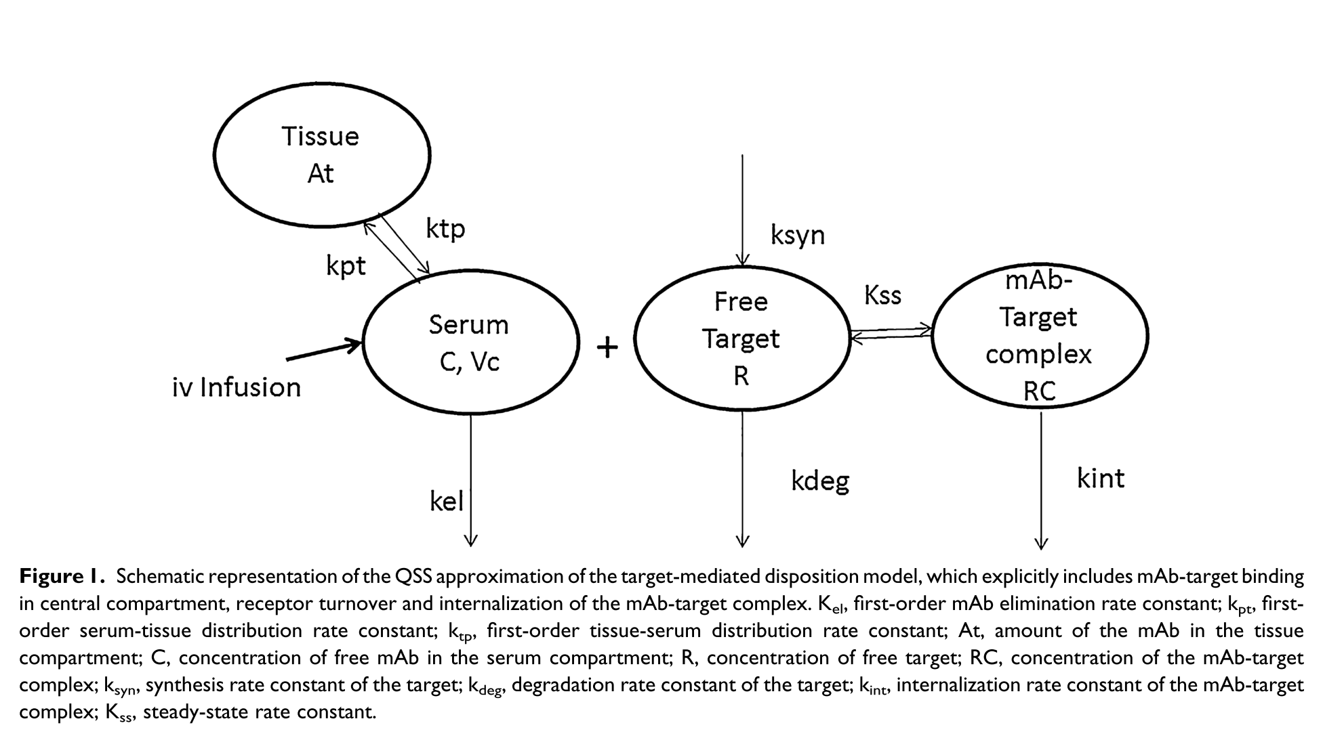

Model Schematic

# nlmixr model

library(nlmixr)  
library(xpose)  
library(xpose.nlmixr)  
library(ggplot2)  
  
nimo <- function() {  
 ini({  
 ## Note that the UI can take expressions  
 ## Also note that these initial estimates should be provided on the log-scale  
 tcl <- log(0.001)  
 tv1 <- log(1.45)  
 tQ <- log(0.004)  
 tv2 <- log(44)  
 tkss <- log(12)  
 tkint <- log(0.3)  
 tksyn <- log(1)  
 tkdeg <- log(7)  
 ## Initial estimates should be high for SAEM ETAs  
 eta.cl ~ 2  
 eta.v1 ~ 2  
 eta.kss ~ 2  
 ## Also true for additive error (also ignored in SAEM)  
 add.err <- 10  
 })  
 model({  
 cl <- exp(tcl + eta.cl)  
 v1 <- exp(tv1 + eta.v1)  
 Q <- exp(tQ)  
 v2 <- exp(tv2)  
 kss <- exp(tkss + eta.kss)  
 kint <- exp(tkint)  
 ksyn <- exp(tksyn)  
 kdeg <- exp(tkdeg)  
  
 k <- cl/v1  
 k12 <- Q/v1  
 k21 <- Q/v2  
  
 eff(0) <- ksyn/kdeg ##initializing compartment  
  
 ## Concentration is calculated  
 conc = 0.5*(central/v1-eff-kss)+0.5*sqrt((central/v1-eff-kss)**2+4*kss*central/v1)  
  
 d/dt(central) = -(k+k12)*conc*v1+k21*peripheral-kint*eff*conc*v1/(kss+conc)  
 d/dt(peripheral) = k12*conc*v1-k21*peripheral ##Free Drug second compartment amount  
 d/dt(eff) = ksyn - kdeg*eff - (kint-kdeg)*conc*eff/(kss+conc)  
  
 IPRED=log(conc)  
  
 IPRED ~ add(add.err)  
 })  
}

# Fit

load("nimoData.rda")  
#fit <- nlmixr(nimo, nimoData, est="saem", control=list(print=0),  
# table=list(cwres=TRUE, npde=TRUE))  
#save(fit, file = "nimofit.rda")  
load("nimofit.rda")

# Goodness of fit Plots

## Add cwres/npde after fit  
fit <- fit %>% addCwres() %>% addNpde();  
## Since it is already there it doesn't actually change anything.  
  
  
##Goodness-of-fit plots  
  
plot(fit); ## Standard nlmixr plots

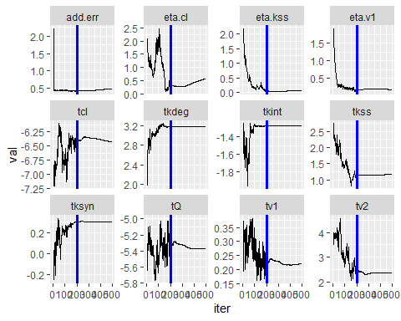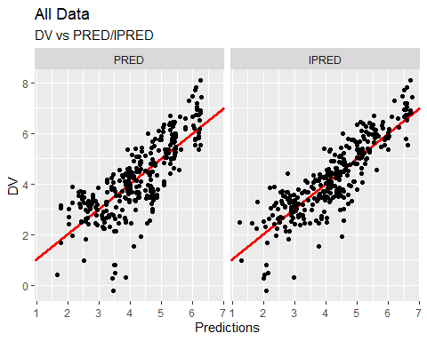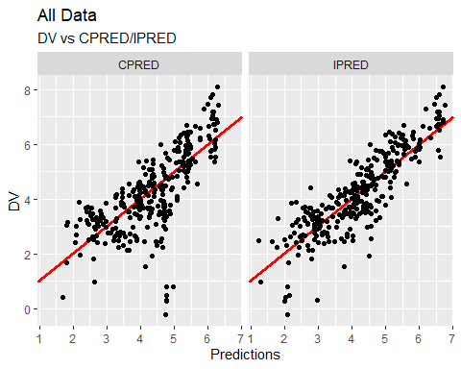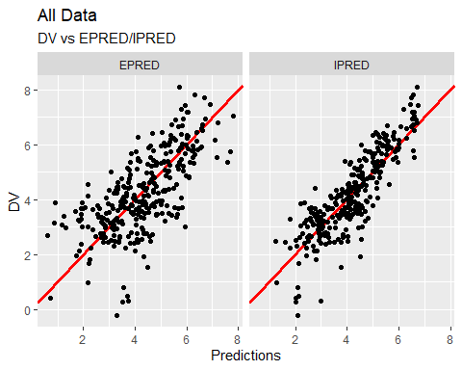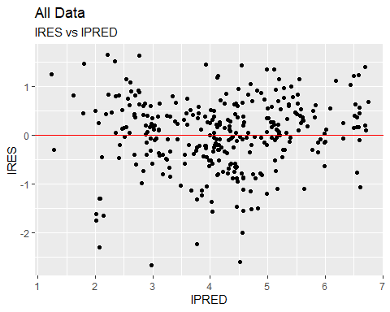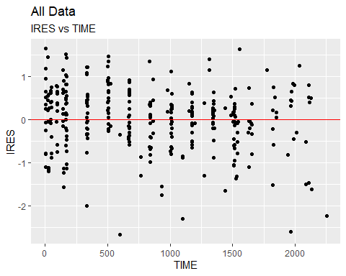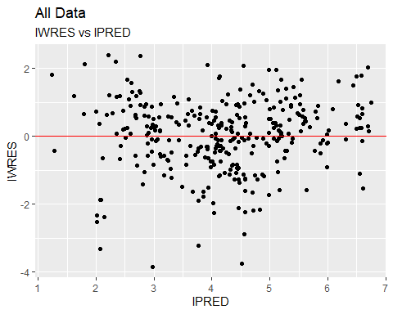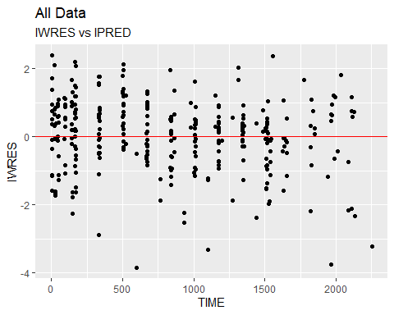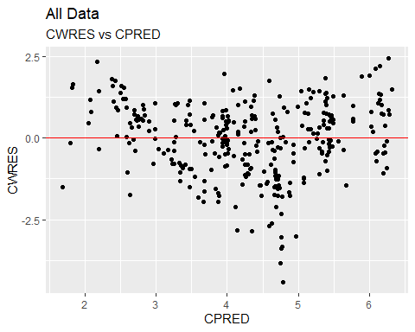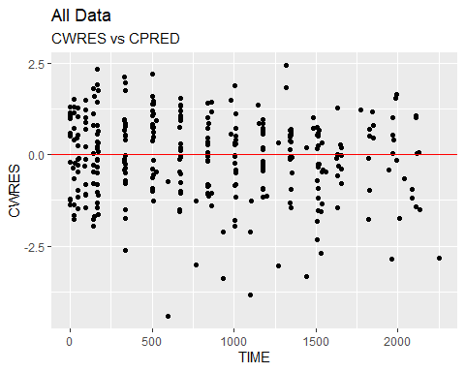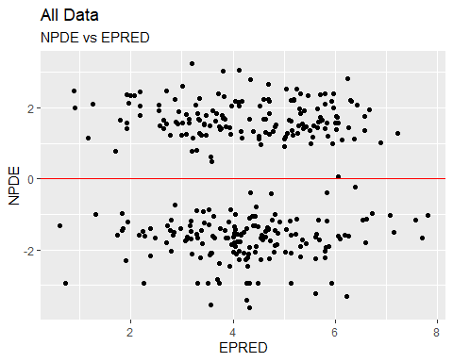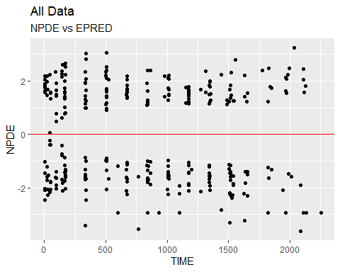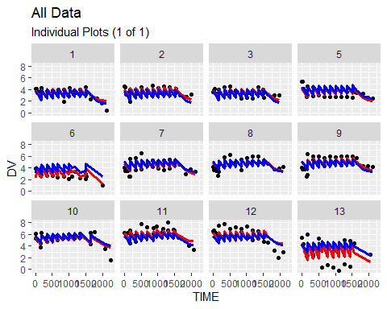

################################################################################  
## Xpose plots; Need to print otherwise running a script won't  
## show xpose plots  
################################################################################  
xpdb <- xpose_data_nlmixr(fit) ## first convert to nlmixr object  
  
print(dv_vs_pred(xpdb) +  
 ylab("Observed Nimotuzumab Concentrations (ug/mL)") +  
 xlab("Population Predicted Nimotuzumab Concentrations (ug/mL)"))

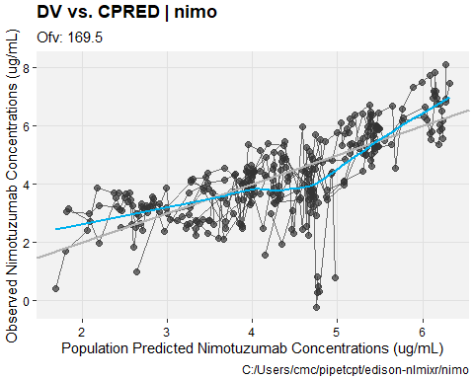

print(dv_vs_ipred(xpdb) +  
 ylab("Observed Nimotuzumab Concentrations (ug/mL)") +  
 xlab("Individual Predicted Nimotuzumab Concentrations (ug/mL)"))

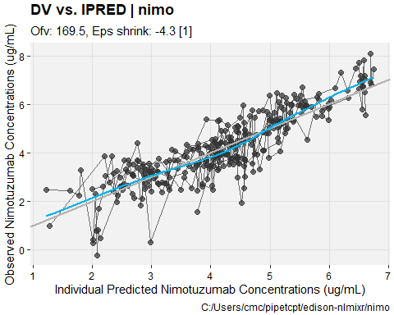

print(res_vs_pred(xpdb) +  
 ylab("Conditional Weighted Residuals") +  
 xlab("Population Predicted Nimotuzumab Concentrations (ug/mL)"))

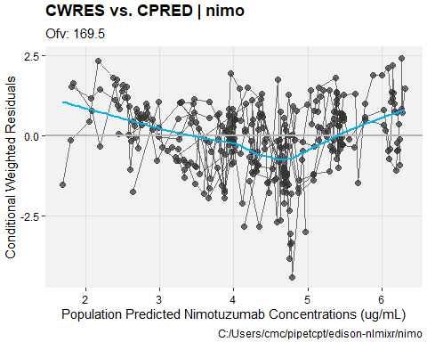

print(res_vs_idv(xpdb) +  
 ylab("Conditional Weighted Residuals") +  
 xlab("Time (h)"))

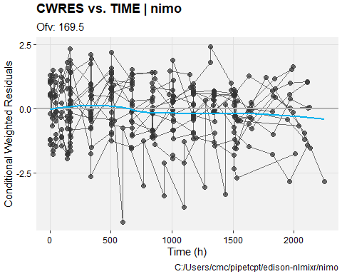

print(prm_vs_iteration(xpdb))

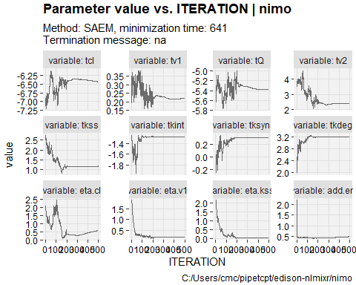

print(absval_res_vs_idv(xpdb, res = 'IWRES') +  
 ylab("Individual Weighted Residuals") +  
 xlab("Time (h)"))

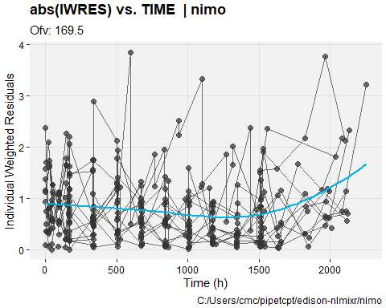

print(absval_res_vs_pred(xpdb, res = 'IWRES') +  
 ylab("Individual Weighted Residuals") +  
 xlab("Population Predicted Nimotuzumab Concentrations (ug/mL)"))

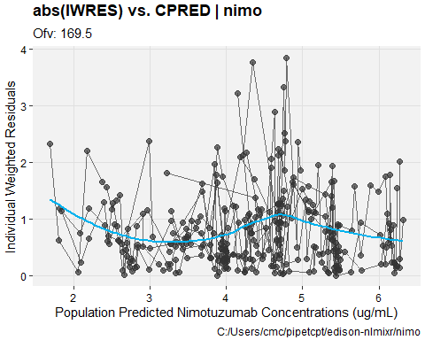

print(ind_plots(xpdb, nrow=3, ncol=4) +  
 ylab("Predicted and Observed Nimotuzumab concentrations (ug/mL)") +  
 xlab("Time (h)"))

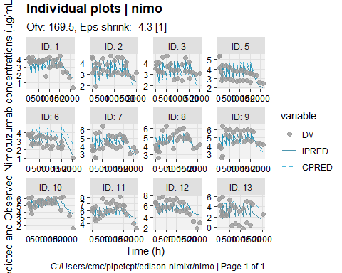

print(res_distrib(xpdb) +  
 ylab("Density") +  
 xlab("Conditional Weighted Residuals"))

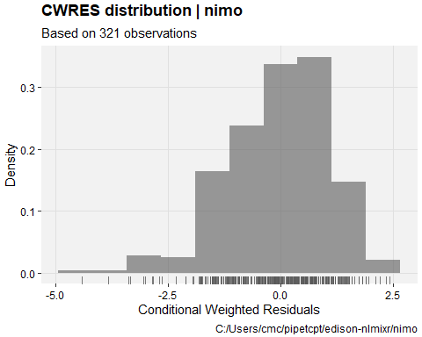

################################################################################  
##Visual Predictive Checks  
################################################################################  
vpc.ui(fit,n=500,stratify=c("dos"), show=list(obs_dv=T),  
 bins = c(-0.5,0,25,75,100,200,400,600,750,900,1100,1200,1400,1600,1900,2150,2300),  
 ylab = "Nimotuzumab Concentrations (ug/mL)", xlab = "Time (h)")  
#> $rxsim = original simulated data  
#> $sim = merge simulated data  
#> $obs = observed data  
#> $gg = vpc ggplot  
#> use vpc(...) to change plot options  
#> plotting the object now

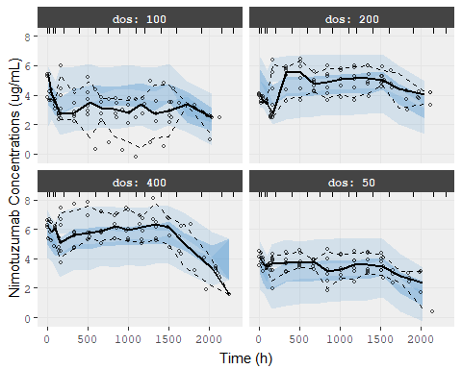

vpc.ui(fit,n=500, show=list(obs_dv=T),  
 bins = c(-0.5,0,25,75,100,200,400,600,750,900,1100,1200,1400,1600,1900,2150,2300),  
 ylab = "Nimotuzumab Concentrations (ug/mL)", xlab = "Time (h)")  
#> $rxsim = original simulated data  
#> $sim = merge simulated data  
#> $obs = observed data  
#> $gg = vpc ggplot  
#> use vpc(...) to change plot options  
#> plotting the object now

