What was the command you run to use the nse scripts?

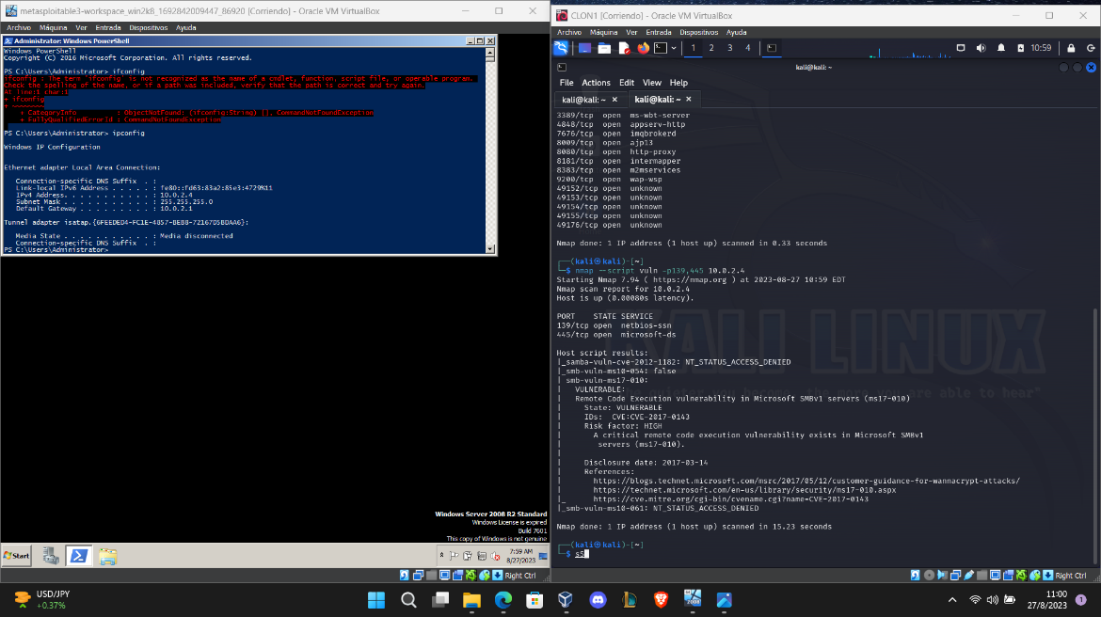

What did the script tell you?

The script told me the machine has a “Remote code execution vulnerability SMBv1 Server (ms17-010)”

Which metasploit module did you use to attack this machine?

Eternal Blue

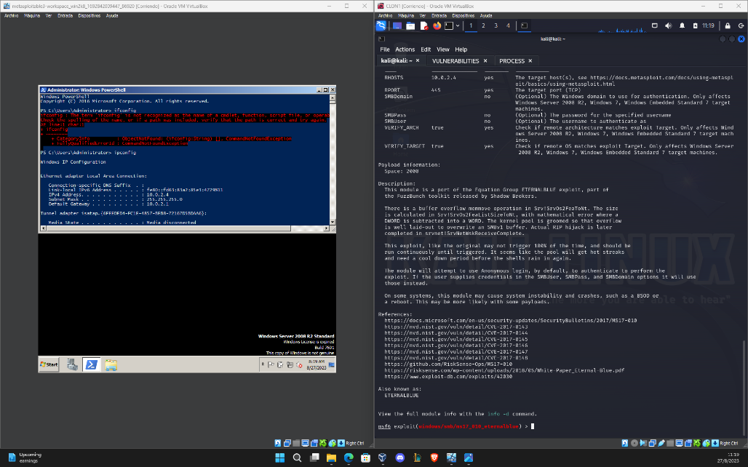

What options did you have to change? Include all changes?

Most of the settings are on default the only change is my RHOST i add “10.0.2.4”

What was the user level access gained when the shell spawned? Be sure to include a screenshot of your name echoed into the remote machine's terminal, along with your meterpreter shell prompt visible.

