We can observe that in the scan using NMAP it is a little more, it is a little more specific with the information of all the ports found and it gives you a little information about them, it even shows you some files.

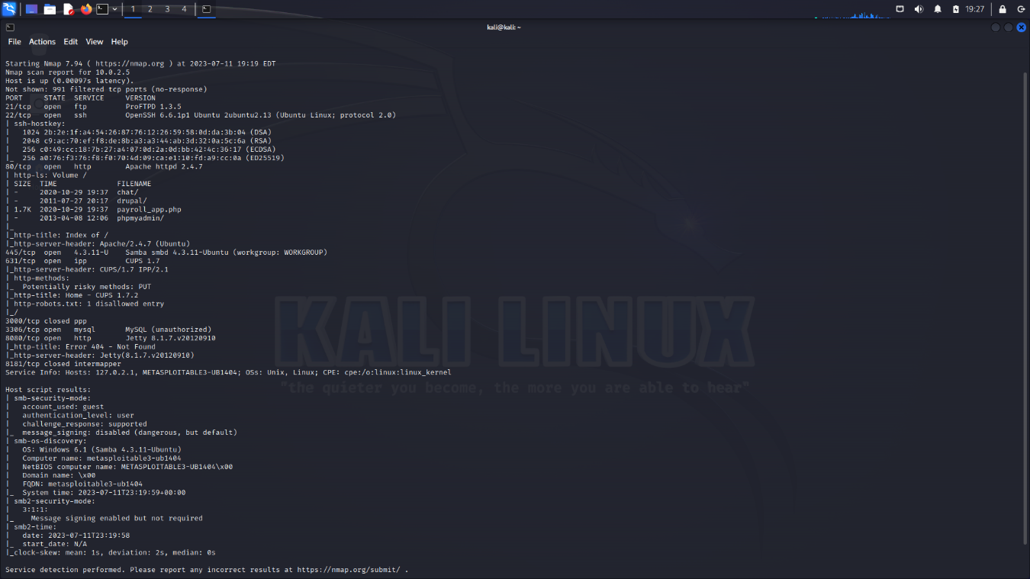

On the other hand the rustscan the information that I can observe is less detailed and simpler if I already have some knowledge this can help me to deduce and not get lost among so much information even the service and the syn-ack reason that is part of the 3 way will kill you handshake to make or close connections between two devices

