Based on this Nmap scan, some potential methods to obtain shell access include:

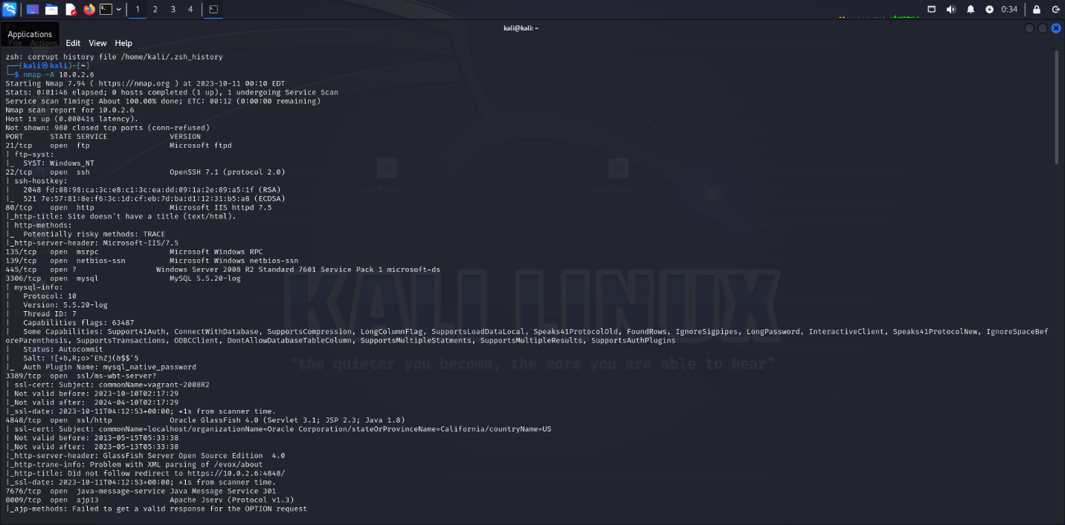

- Leveraging the vulnerable Jenkins version on port 8080 through remote command execution, a reverse bash shell could be obtained.

- Guessing or cracking the MySQL credentials on port 3306 to connect and execute operating system commands through the MySQL console.

- Performing a brute force attack on weak SSH accounts on port 22 could allow guessing a password and gaining SSH shell access.

- Exploiting remote code execution vulnerabilities in the Apache web server on port 80, a web shell could be deployed.

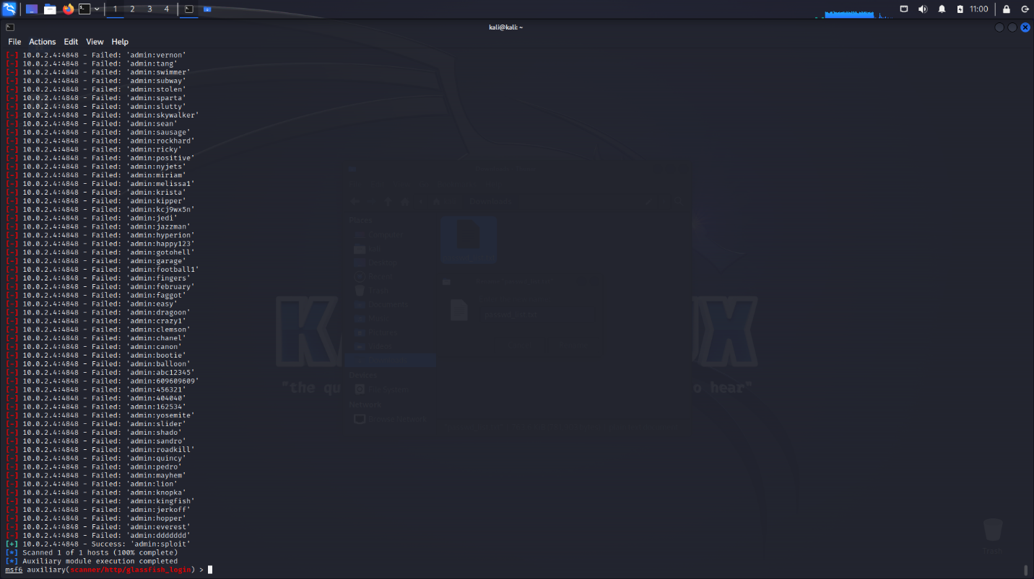

- Exploiting potential RCE vulnerabilities in the AJP service on port 8009 through manipulated requests to get a remote shell.

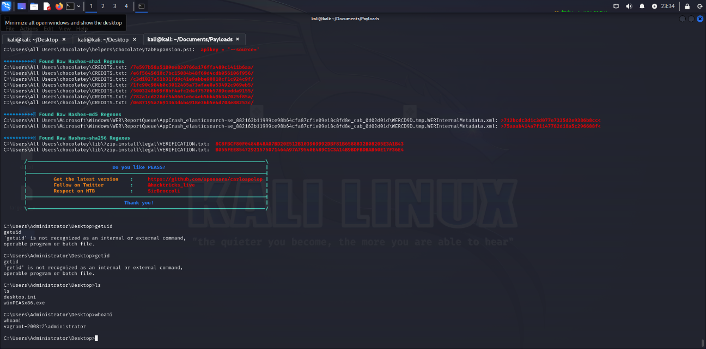- Pivoting from any initial access gained, identifying other internal vectors to escalate privileges.

