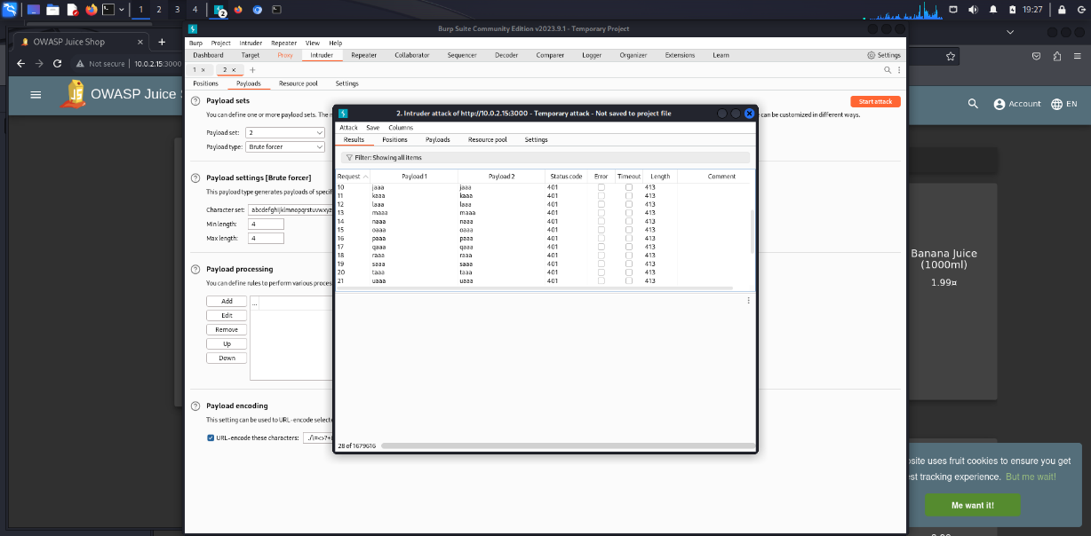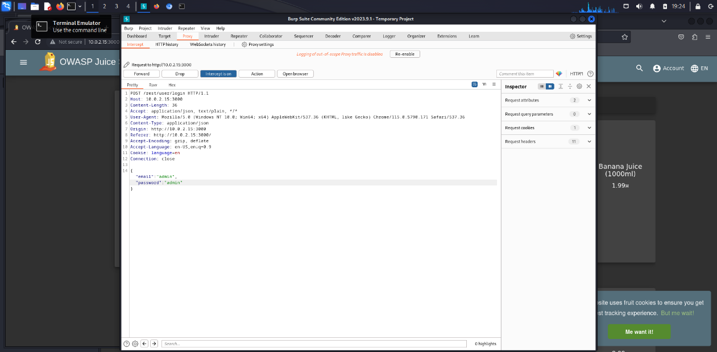The BurpSuite program is a very useful tool that can serve as a filter or proxy. It could also be said that it will help us review the traffic, packets or requests that are made in the browser. I also found that it can be used to carry out attacks and can be executed. payloads and at the same time import text files that can be used as payloads, I would consider that it would have more uses but these for the moment are my impressions without having reviewed the internet for exactly what it is used for