# Computer Vision HW6: Report

The snapshot of my code result is as the following image:

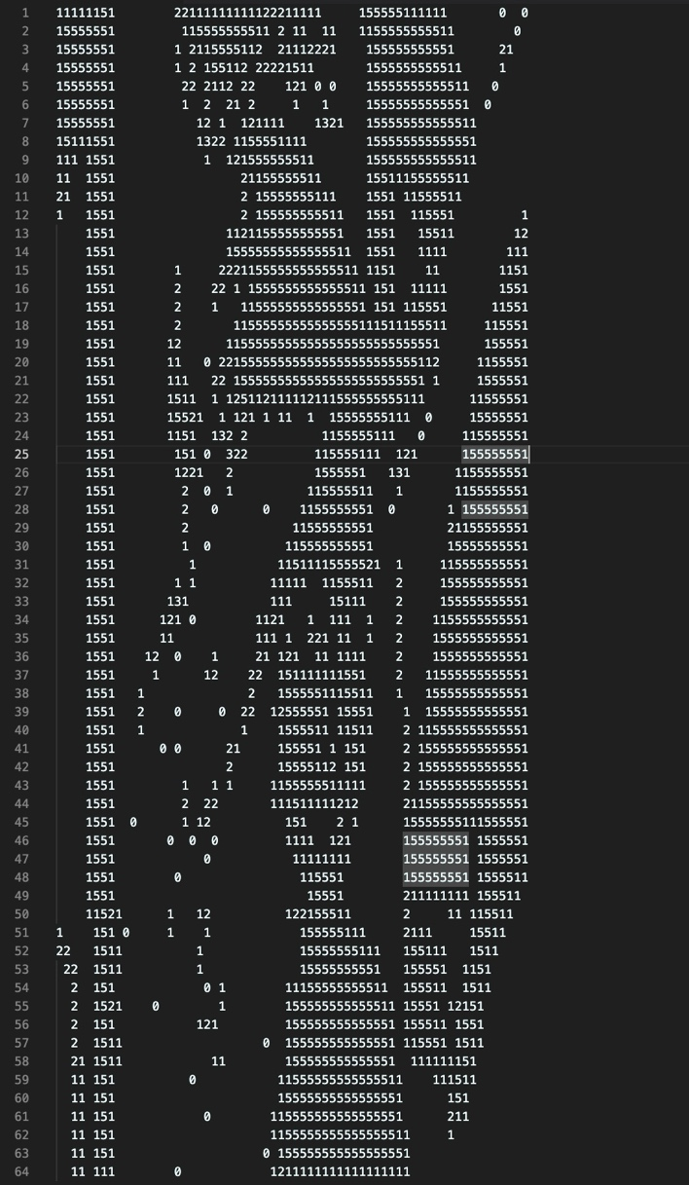

The main code structure of the .ipynb file consists of the following parts (each part is a code cell, with detailed description in the preceding markdown cell):

1. Import the libraries
2. The 2 primitive functions that we used to count the Yokoi connectivity number
3. Read in the image by cv2.imread() as usual
4. downsampling
5. Calculate the Yokoi connectivity number by first obtaining the value of each index in the neighborhood, then plug in to the 2 primitive functions we have defined in step 2, print after each row is processed.

A really detailed explanation for each step is covered in the markdown cells, so I’ll just paste the screenshots and give brief explanation here.

For the primitive function , our aim is to determine whether a three-pixel corner neighborhood is connected in a particular way, so we use three symbols ‘q’, ‘r’, ‘s’ to represent the 3 situations, and check to return which symbol by definition:

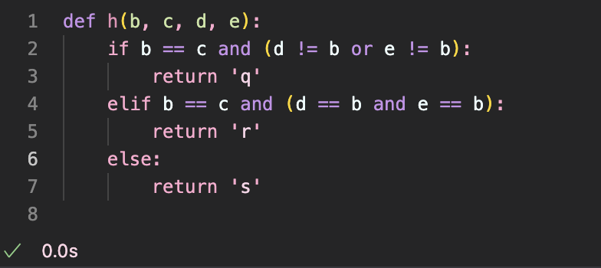[1]

For the primitive function , we just implement it as definition:

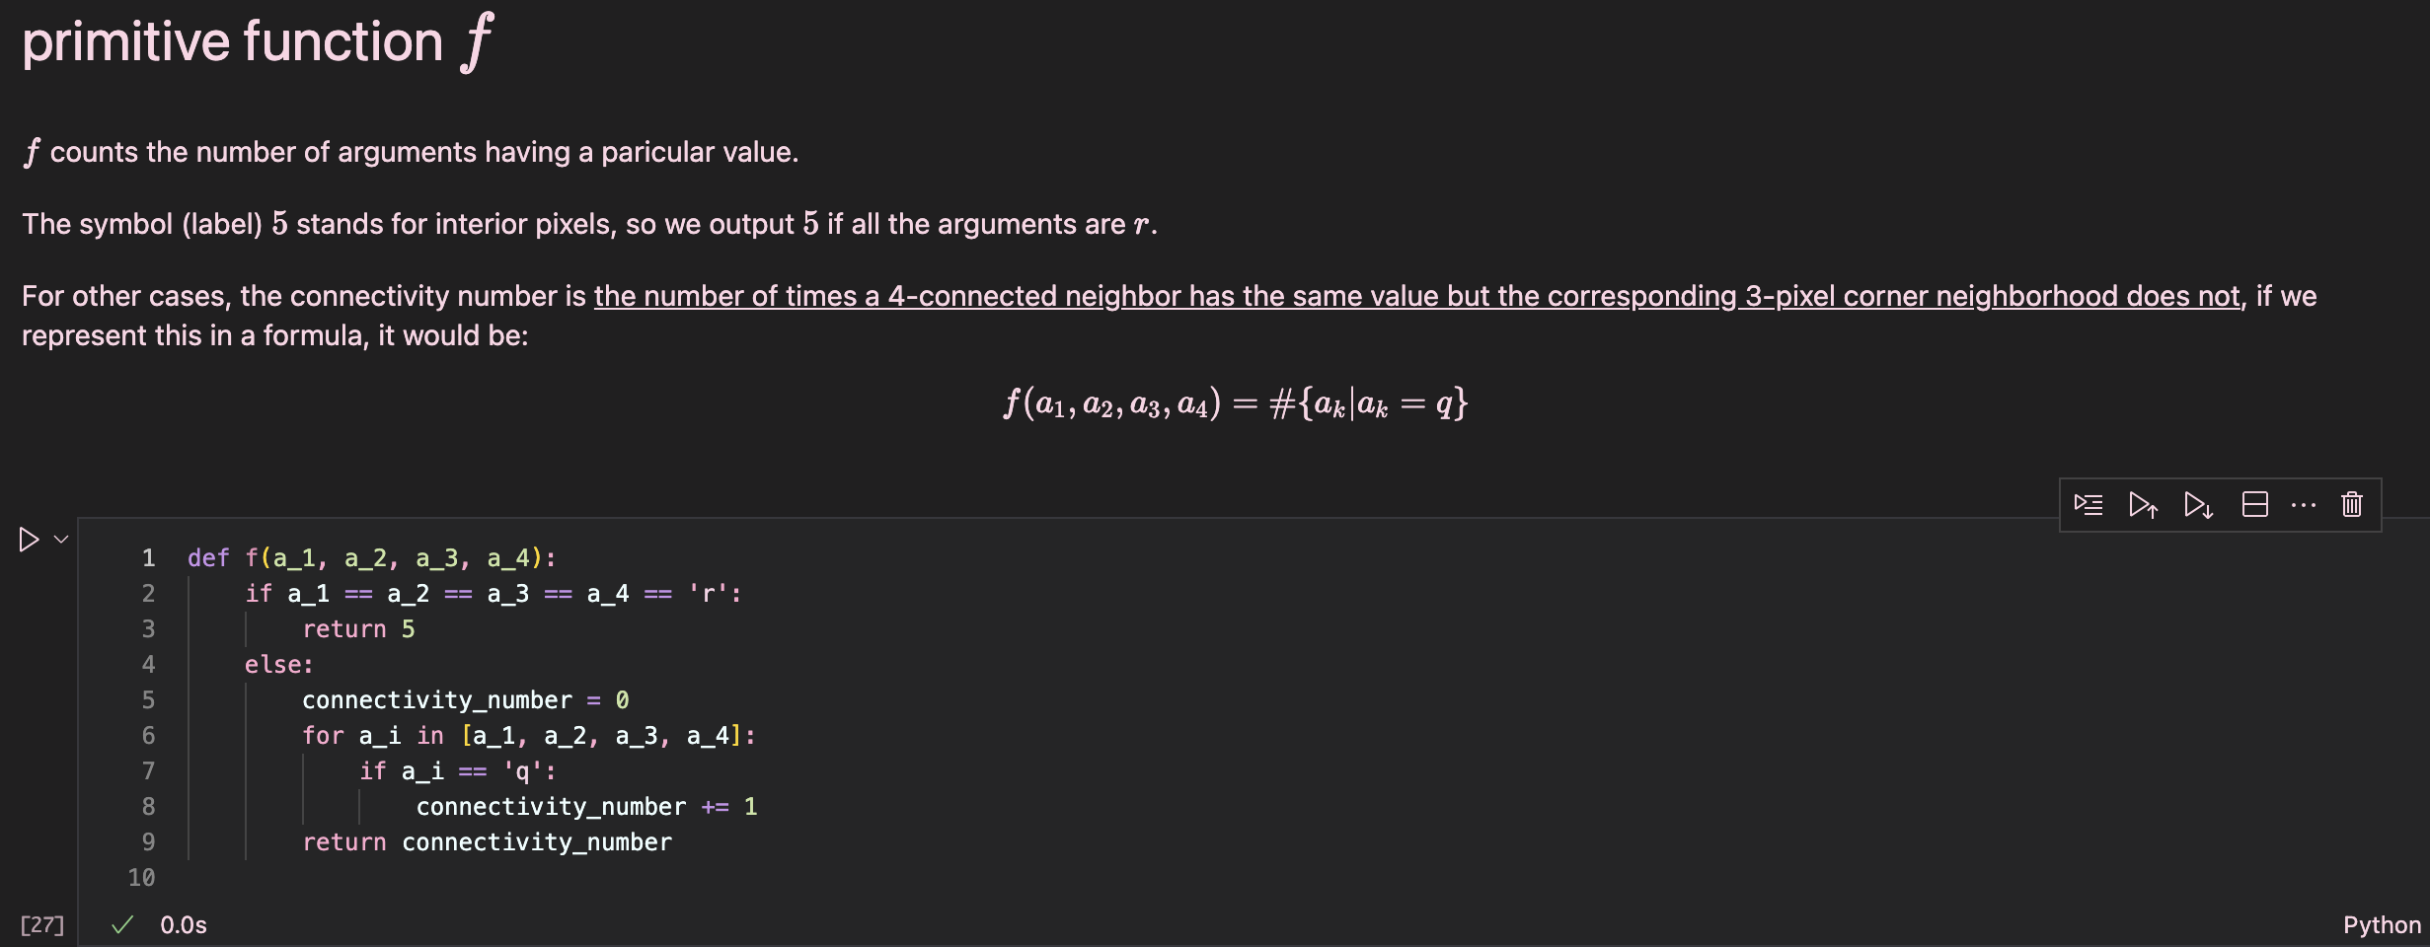

After the 2 primitive functions are defined, we do the downsampling part:

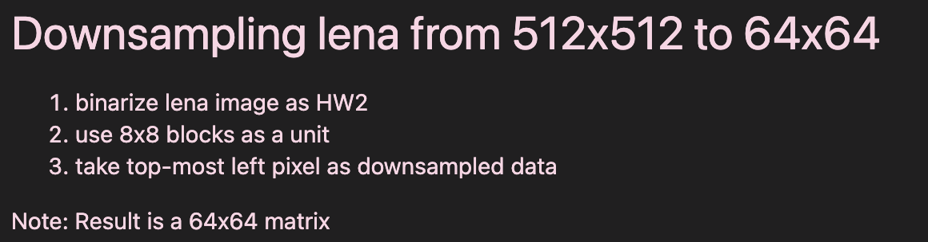

We start by binarizing the lena image as usual:

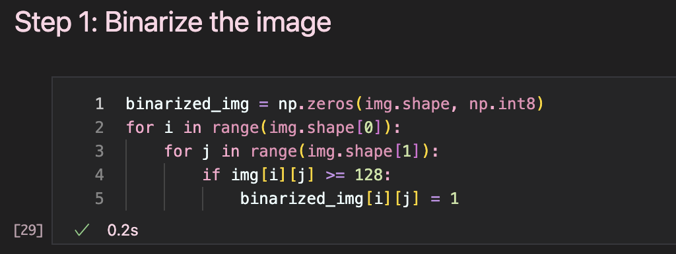

Then the downsample process is just assigning each downsampled pixel by the corresponding topmost left pixel of the 8x8 block in the original binarized image:

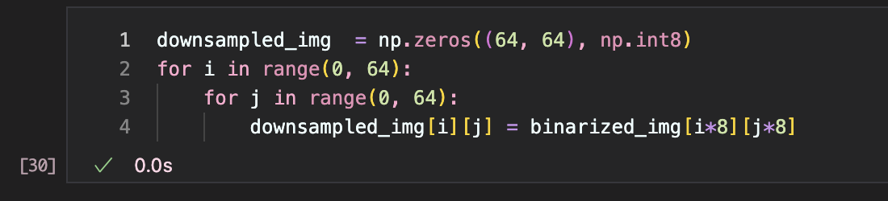

Finally we calculate the Yokoi connectivity number, to print out the results, we print after each row is proceeded, so we create an empty string after each iteration of i:

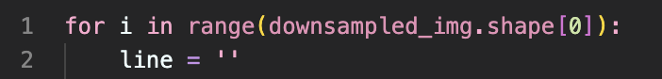

Then we get the values of each pixel in the neighborhood, with the indexing like below:

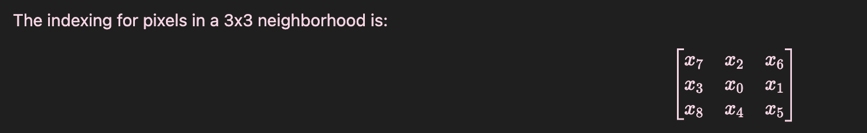

To obtain these values, cases that may contain indexes out of the image should be taken into consideration:

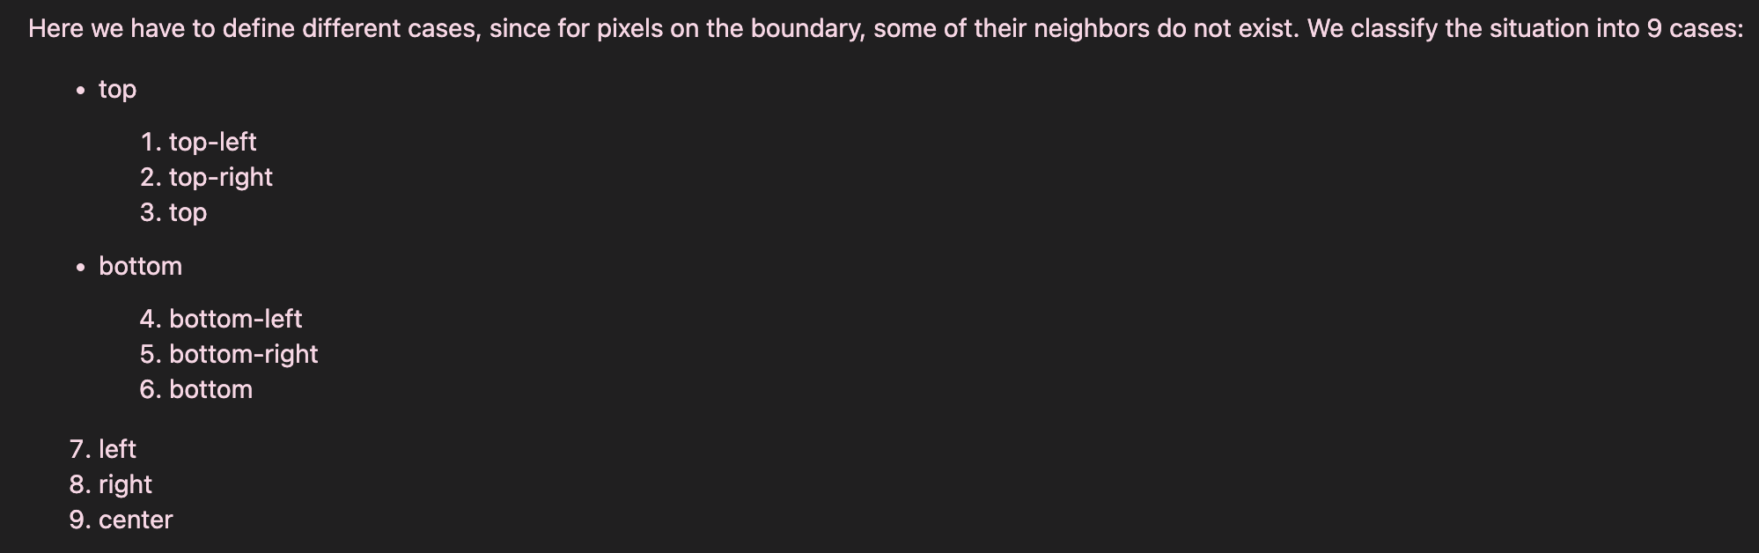

For foreground pixels, we define the values by cases differently, and we set the nonexist pixels’ values to zero (due to the report length, here I only present the first 3 cases that represents the top row):

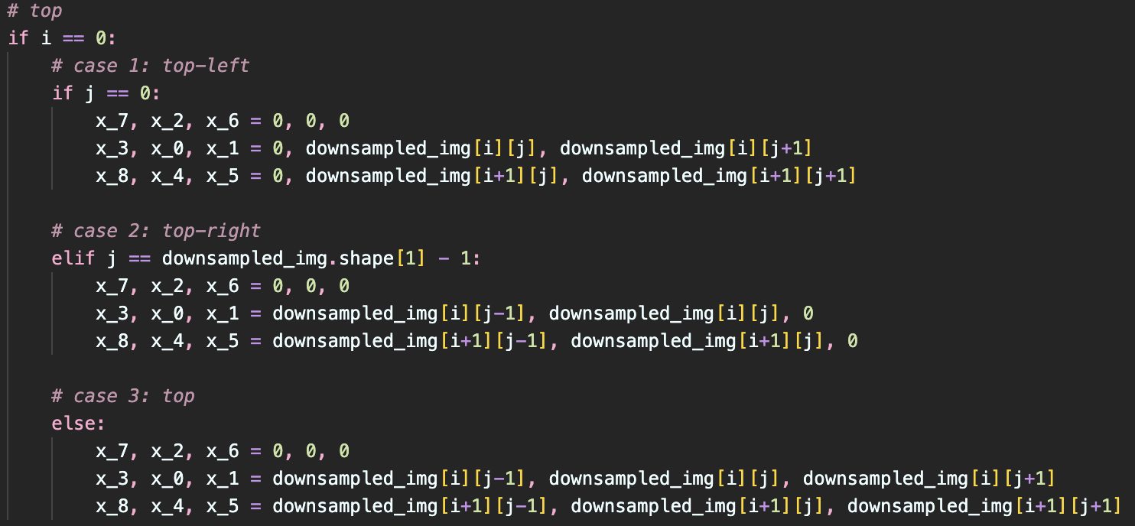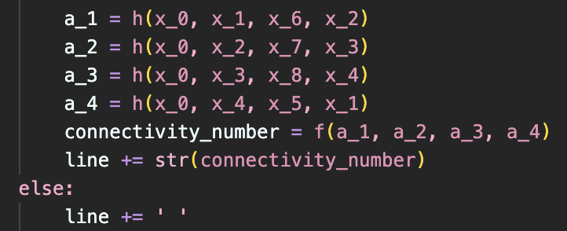

The last part is to call the functions and derive the connectivity number by definition, and concatenate the result to the string of the current row.

1. The definition written in mathematical equations, and examples of each returning value is contained in the corresponding markdown cell.