# Result:



(Gaussian noise, amp = 10)

SNR = 13.61167933031741



(box 3x3) (box 5x5) (median 3x3)

SNR = 17.758953655483033 SNR = 14.872069111938153 SNR = 17.6783910321545



(median 5x5) (opening then closing) (closing then opening)

SNR = 16.018095018433286 SNR = 13.279032782904412 SNR = 13.203517744226176



(Gaussian noise, amp = 30)

SNR = 4.056464660634249



(box 3x3) (box 5x5) (median 3x3)

SNR = 12.530317742185797 SNR = 13.298491072687423 SNR = 11.07863635288467

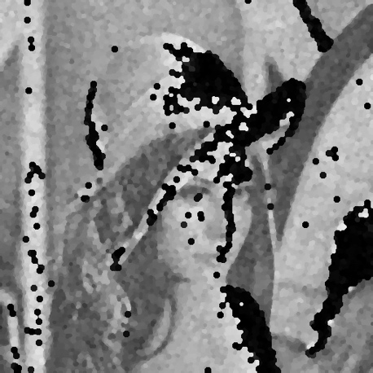

(median 5x5) (opening then closing) (closing then opening)

SNR = 12.90216675003 SNR = -5.863700567522756 SNR = -4.206302520618325



(salt and pepper, prob = 0.1)

SNR = -1.8993703672097175



(box 3x3) (box 5x5) (median 3x3)

SNR = 6.538182950530176 SNR = 8.698883639675685 SNR = 15.526709052018514

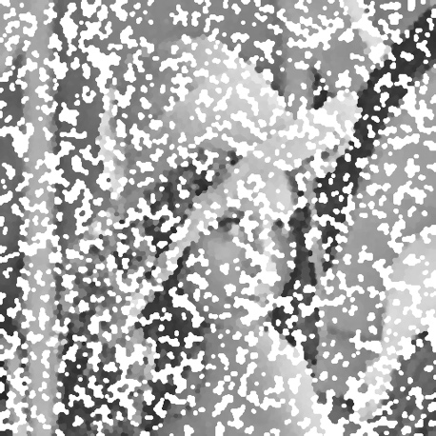

(median 5x5) (opening then closing) (closing then opening)

SNR = 15.809263877647005 SNR = -1.5450143663807747 SNR = -2.546296411553107



(salt and pepper, prob = 0.05)

SNR = 1.0465169944356754



(box 3x3) (box 5x5) (median 3x3)

SNR = 9.566878535232938 SNR = 11.257866464393391 SNR = 19.348865257837666



(median 5x5) (opening then closing) (closing then opening)

SNR = 16.43482504931115 SNR = 6.486651891089071 SNR = 5.447182550355941