# ML homework 4: question 11

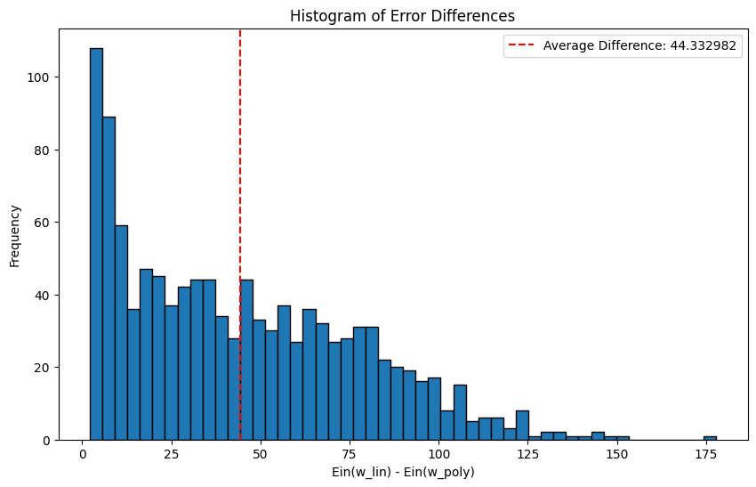

## Meaning:

From this plot we can see that the differences are mostly small positive values, which means that the error we got using linear regression is slightly greater than the error we got using polynomial transform.

This is because by using polynomial transform, we can use more parameters to fit our data, making our model more flexible to capture the nonlinear relationships among the features, thus, we can draw a function that is nearer to fitting all the examples over the $64$ points.

However, the difference between the two approaches are not large, owing to our small dataset and small number of features, since under this situation, it is possible to find a line that nearly fits the points in a low dimensional space.

## Code:

