# ML homework 4: question 12

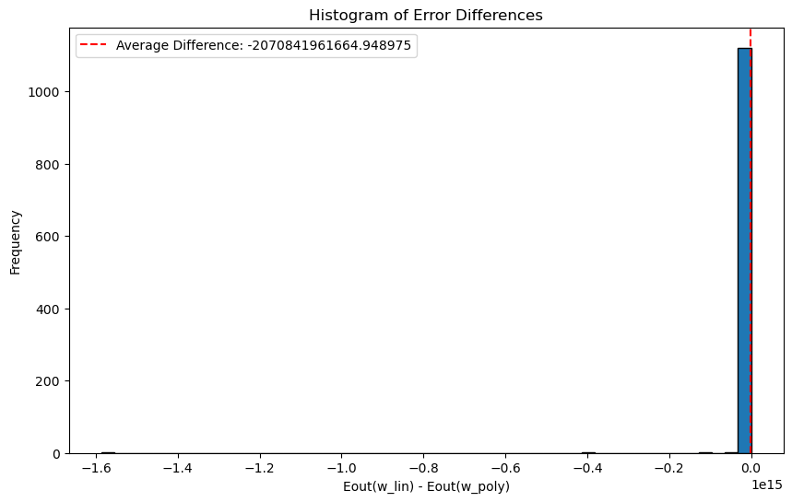

## Meaning:

From the plot we can see that the differences are all negative, indicating that we’re getting way more bigger $E_{out}(w_{poly})$ than $E_{out}(w_{LIN})$, this may due to we’re using too many features to fit our data. The original data we have might lie in a smaller space, so overfitting occurs, hence generating enormous out of sample error.

## Code:

