# HTML homework 5: q10 report

The resulting plot is as follows:

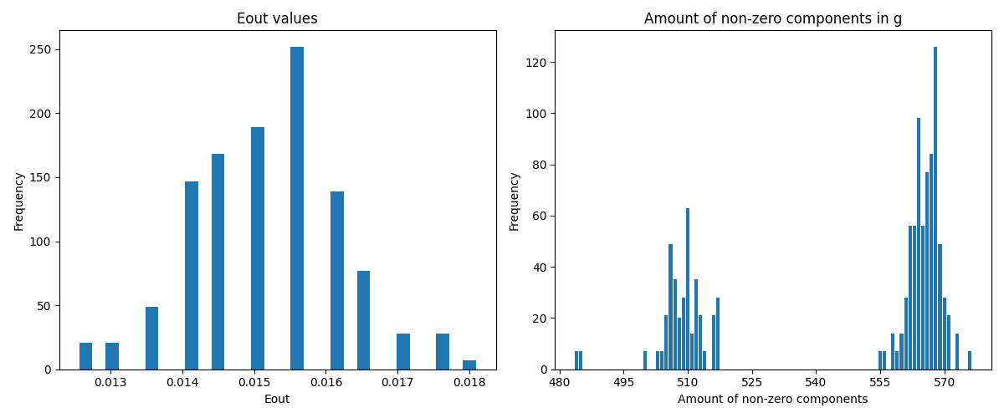

Some additional information that I printed in order to do the comparison between this question and question 11:

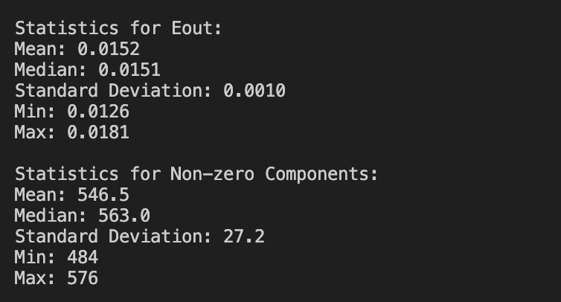

## Code[1]:

Preprocessing the dataset:

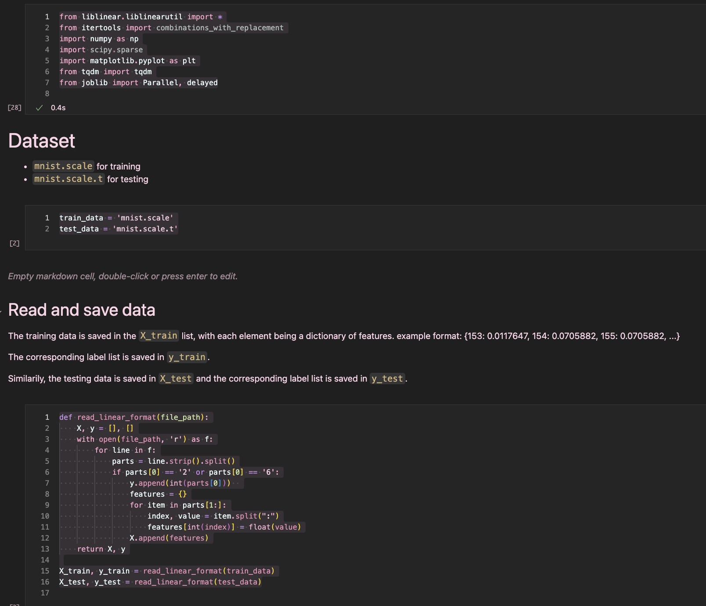

Error function:

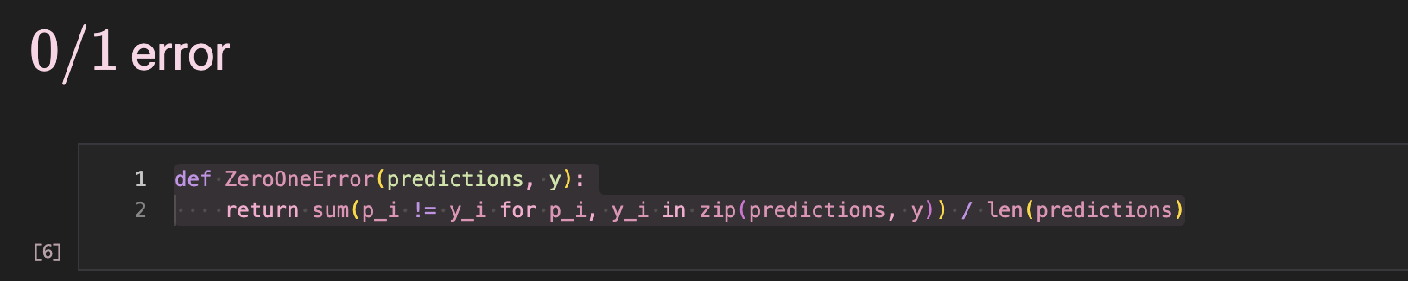

Explanation of deriving the relationship between :

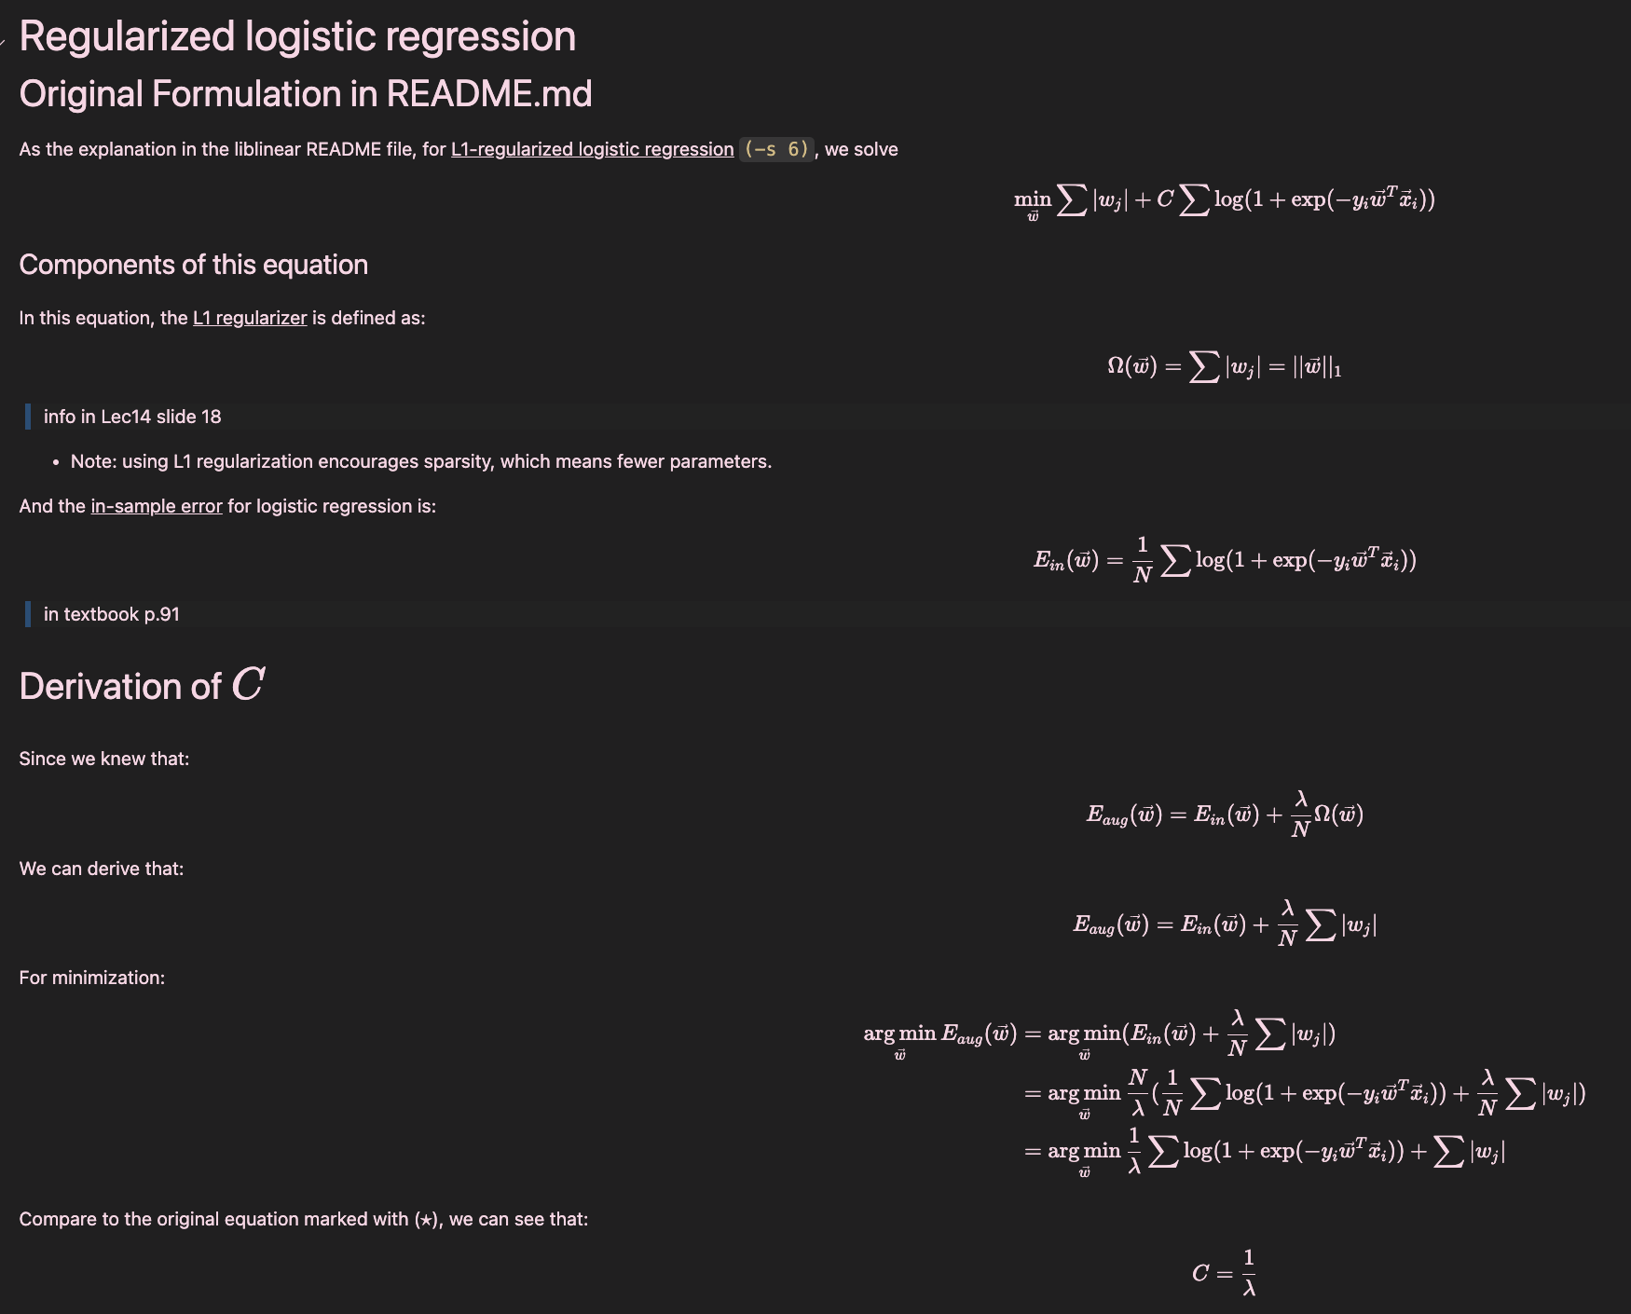

Some additional information:

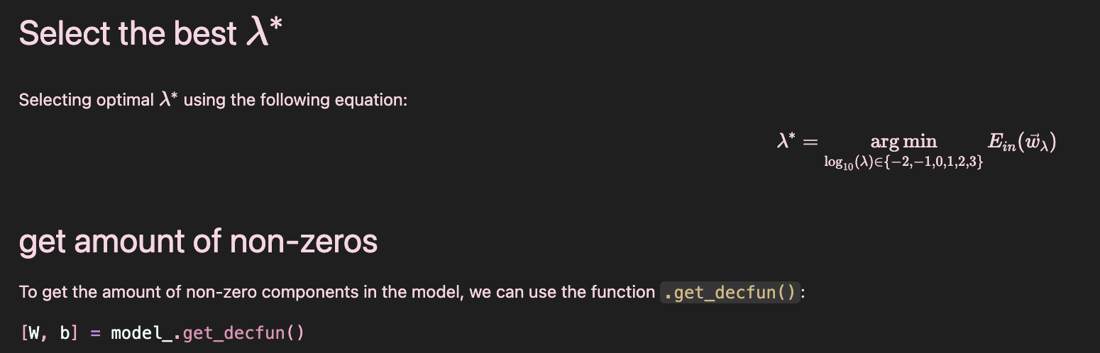

Main code:

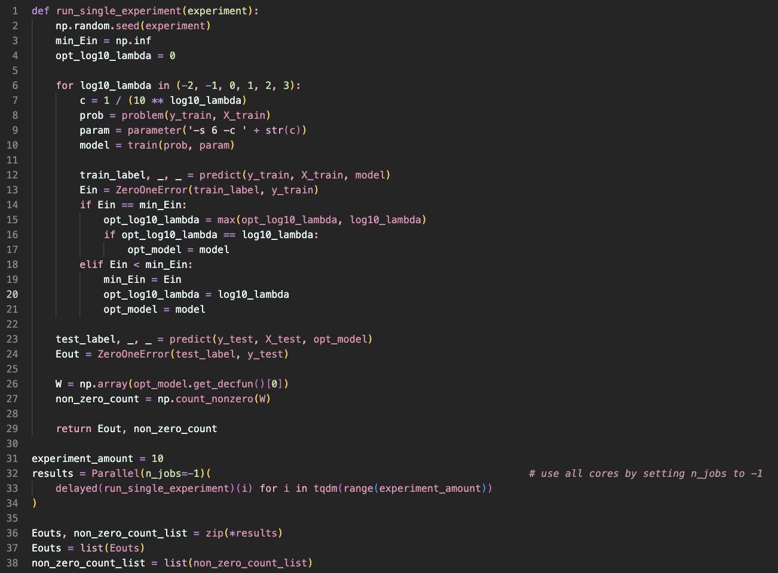

Plotting:

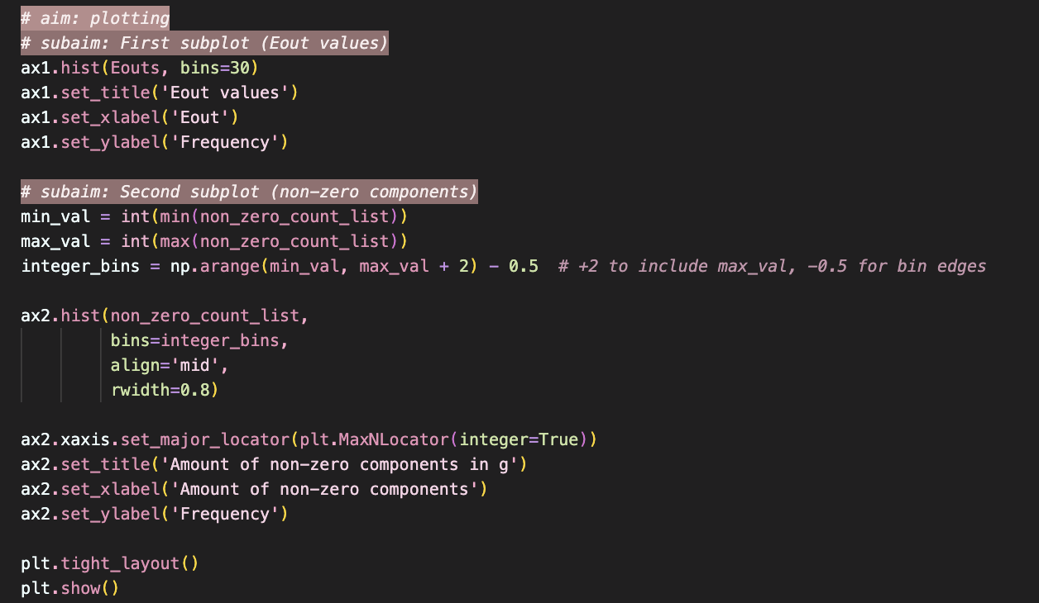

1. Most of the screenshots here are from my .ipynb file, since I wrote the explanations here, however, I ran the code in a .py file (which has equivalent contents), and part of the screenshot is from this file.