# HTML homework 5: q12 report

The resulting picture is as follows:

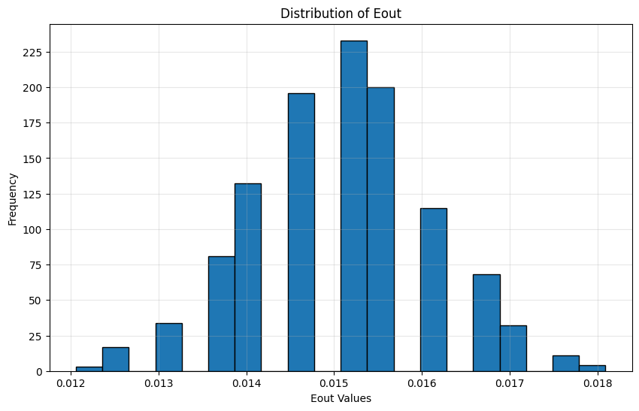(q12)

To find the difference, the plot below is the result of the previous problem:

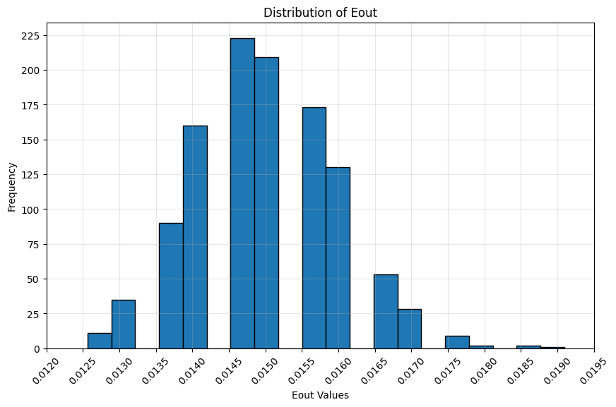(q11)

From the two plots we can see that the subtrain / validation split is more dispersed, and the variability of the 3-fold cross validation is smaller.

The reason why the subtrain / validation split is more dispersed may due to the fact that the validation set size is not that big compared to the 3-fold version. In the previous question, the validation set size is 3876, and in this question, using 3-fold splits the training set into 3 sets, with each about 3959 examples, which is slightly higher. Also, $E_{CV}$ is calculated by the mean error over using each of the 3 sets as the validation set, therefore these 2 reasons introduce stability in the 3-fold version.

On the other hand, the subtrain / validation split relies only on one split, if the validation set is not that representative, our selection of $λ$ may be biased, this would magnify the effect of the unstableness in the previous question.

## Code:

The markdown screenshot below describes the modification of this problem, other parts like reading in the data and the error function…, are the same as problem 10: