Challenge protocol
The participants are allotted a budget of "virtual cash" allowing them to "purchase" all the training data labels at the price of 1 ECU (experimental cash unit) per label. They can place queries to the server by providing a list of samples for which they desire to purchase the label. Upon receipt of the labels, their account of virtual cash is debited. The participants are free to choose the number of queries and the number of samples per query. An experiment terminates when all the budget is spent or the challenge deadline is reached. To monitor progress, the participants are asked to provide predictions for all the labels every time they place a query, including the known and unknown labels of the training examples and the labels of the test examples.
When query, an predict and a sample should be done:
- Predict - Using the examples with known labels (at first use the seed example, which has a positive label), train a predictor and provide prediction scores for ALL the examples of the dataset (including those used for training). Any sort of numeric prediction score is allowed, larger numerical values indicating higher confidence in positive class membership.
- Sample - Choose among the remaining unlabeled examples those for which you want the purchase labels. You may only query examples in the first half of the dataset (training examples). If you query test examples, you will not receive those labels (and not be charged either).
The goal is to purchase as few labels as possible with "virtual cash" while getting as good performance as possible.
Handwriting Recognition Data Set
There are 35070 instances in which every instance have 92 attributes and 1 unknown label what should be predicted. The possible values for the label are 1 and -1. At first, we know the first instance's label is 1.
Strategy
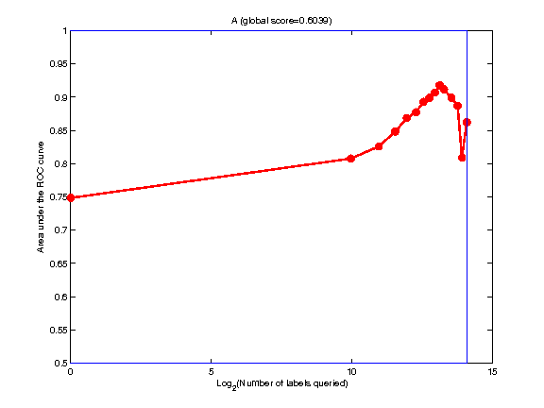
Use k classifiers to train k predictors every time when we get queried labels for sampled instances. For other instances:
Use these predictors to provide prediction scores, then there will be k scores for every instance.
Determine the finale prediction score for every one to be the average of these scores.
command: vote prediction1 prediction2 ... > prediction
Determine the unreliability of the final score to be the variance of these scores.
Chose some instances with most unreliable scores to be queried in the next time.
command:
sample2 prediction1 prediction2 ... > all (most_unreliable_samples_in_order)
awk '{if ($1 <= 17535) print}' all > half (samples in training data set)
head -n the_number_of_samples_to_be_queried half > sample
Strategy with CVote
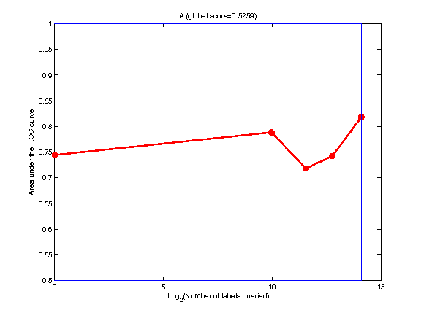
All the same with that above, but determine the final prediction score for every one by CVote.
Strategy with clustering(to be tried)
Test the quality of small cluster at first, the all are the same as that above except that:
Use small clusters to help the classifiers.
Strategy in VerifA(Win Result)
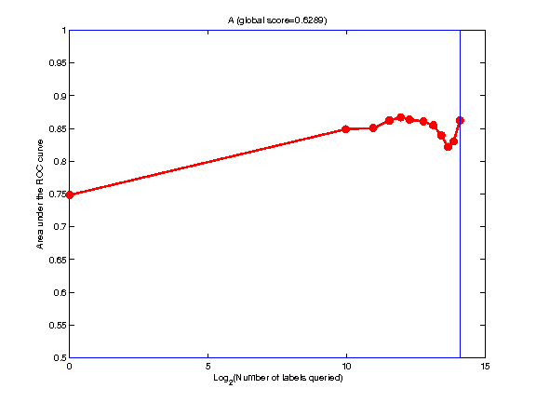
Use 3 classifiers ( Bayes, J48 and SVM) to train 3 predictors every time when we get queried labels for sampled instances. For other instances:
Use these predictors to provide prediction scores, then there will be 3 scores (B, J, S) for every instance.
Determine the finale prediction score for every one to be the average of these scores.
Determine the unreliability of the finale score to be |B-J+S|.
Chose some instances with most unreliable scores to be queried in the next time.
Strategy in ExpA(Unknown Result)
All are the same as that in VerifA except that:
The first predictions and samples are determined by using NaiveKMeans.
The following unreliability of the final score is -|B+J+S|/3 at first and is |B-J| at last.

