实验报告
姓名 | 黄萍萍 | 学号 | 16272203 | 班级 | 16272412
专业 | 网络工程 |  | 课程名称 | 《计算机组成原理课程设计》
任课老师 | 吴国华 | 指导老师 | 吴国华 | 机位号
实验序号 | 8 | 实验名称 | 实验8 实现R型指令的CPU设计实验
实验时间 | 2018/6/4 | 实验地点 | 1-225 | 实验设备号
一、实验设计与程序
- 模块设计说明
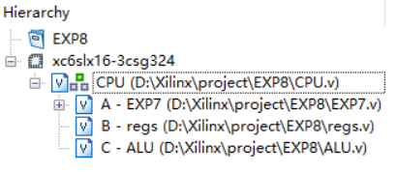
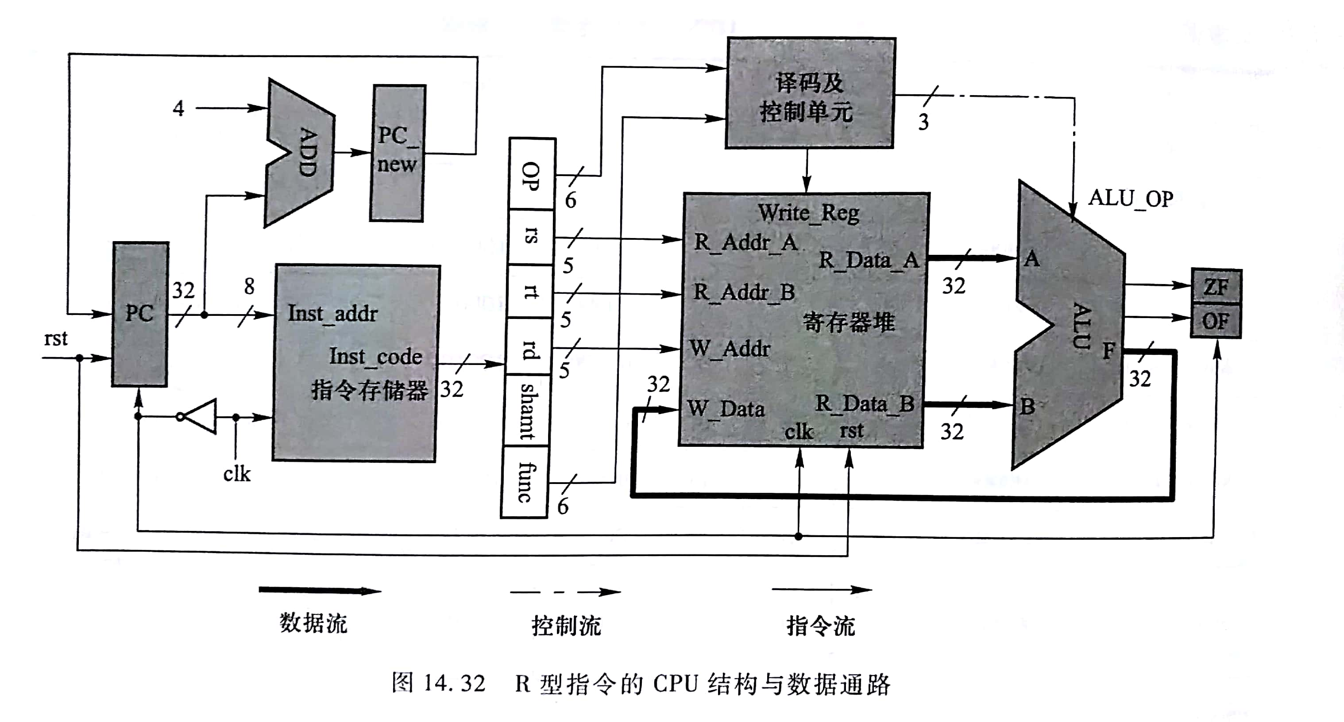
顶层CPU模块调用ALU、寄存器堆、取指令模块实现取指令、译码、运算、存取的操作
- 实验程序源代码及注释等

顶层CPU.v模块
`timescale 1ns / 1ps
module CPU(clk,rst,sw,led,ZF,OF);
output reg[7:0]led;
input clk,rst;
input [1:0]sw;
output OF;
output ZF;
reg Write_Reg;
wire [31:0]inst_code;
wire [31:0]R_Data_A,R_Data_B,W_Data;
reg [4:0]R_Addr_A,R_Addr_B,W_Addr;
reg [2:0] ALU_OP;
EXP7 A(clk,rst,inst_code);
regs B(R_Addr_A,R_Addr_B,R_Data_A,R_Data_B,clk,rst,Write_Reg,W_Addr,W_Data);
ALU C(ALU_OP,R_Data_A,R_Data_B,W_Data,ZF,OF);
always @(posedge clk or negedge clk)
begin
if(clk)
begin
#5
if(inst_code[31:26]==0)
begin
Write_Reg<=0;
R_Addr_A<=inst_code[25:21];
R_Addr_B<=inst_code[20:16];
W_Addr<=inst_code[15:11];
case(inst_code[5:0])
6'b100000:ALU_OP<=3'b100;
6'b100010:ALU_OP<=3'b101;
6'b100100:ALU_OP<=3'b000;
6'b100101:ALU_OP<=3'b001;
6'b100110:ALU_OP<=3'b010;
6'b100111:ALU_OP<=3'b011;
6'b101011:ALU_OP<=3'b110;
6'b000100:ALU_OP<=3'b111;
default:ALU_OP<=0;
endcase
end
else
begin
Write_Reg<=0;
ALU_OP<=0;
R_Addr_A<=0;
R_Addr_B<=0;
W_Addr<=0;
end
end
else
begin
Write_Reg<=1;
end
end
always@(*)
case(sw)
0:led = W_Data[7:0];
1:led = W_Data[15:8];
2:led = W_Data[23:16];
3:led = W_Data[31:24];
default:led = 0;
endcase
endmodule

运算ALU.v模块
`timescale 1ns / 1ps
module ALU(ALU_OP,A,B,F,ZF,OF);
input [2:0] ALU_OP;
input [31:0]A,B;
output reg [31:0]F;
output reg OF;
output reg ZF;
reg _C32;
always @(*)
begin
case(ALU_OP)
3'b000:begin F=A&B; OF=1'b0; end
3'b001:begin F=A|B; OF=1'b0; end
3'b010:begin F=A^B; OF=1'b0; end
3'b011:begin F=~(A|B); OF=1'b0;end
3'b100:begin {OF,F}=A+B;end
3'b101:begin {_C32,F}={1'b1,A}-{1'b0,B};OF=A[31]^B[31]^F[31]^(~_C32);end
3'b110:begin if(A<B)F=32'b1;else F=32'b0; OF=1'b0; end
3'b111:begin F=B<<A;OF=1'b0; end
default:begin F=32'b0;OF=1'b0;end
endcase
end
always @(*)
begin
if(F==32'b0)
ZF=1'b1;
else
ZF=1'b0;
end
endmodule

寄存器堆regs.v模块
`timescale 1ns / 1ps
module regs(R_Addr_A,R_Addr_B,R_Data_A,R_Data_B,CLK,Reset,Write_Reg,W_Addr,W_Data );
input [4:0] R_Addr_A,R_Addr_B,W_Addr;
input CLK,Reset,Write_Reg;
output [31:0]R_Data_A,R_Data_B;
input [31:0]W_Data;
reg [31:0]REG_Files[0:31];

integer i;
initial
begin
for (i = 0; i < 32; i = i + 1)
REG_Files[i] = 0;
end

assign R_Data_A=REG_Files[R_Addr_A];
assign R_Data_B=REG_Files[R_Addr_B];

always@(negedge CLK or posedge Reset)
begin
if(Reset)
begin
for(i=0;i<32;i=i+1)
REG_Files[i]<=32'b0;
end

else
begin
#5;
if(Write_Reg)
REG_Files[W_Addr]<=W_Data;
end
end
endmodule

取指令EXP7.v模块
`timescale 1ns / 1ps
module EXP7(clk,rst,inst_code);
input clk;
input rst;
output wire [31:0]inst_code;

reg[7:0] pc;
wire [7:0]pcnew;

Inst_ROM my(
.clka(clk), // input clka
.addra(pc[7:2]), // input [5 : 0] addra
.douta(inst_code) // output [31 : 0] douta
);
assign pcnew = pc+4;
always@(posedge rst or negedge clk)
begin
if(rst)
pc <= 0;
else
pc <= pcnew;
end

endmodule

二、实验仿真
- 仿真代码
`timescale 1ns / 1ps
module test;
// Inputs
reg clk;
reg rst;
reg [1:0] sw;

// Outputs
wire [7:0] led;
wire ZF;
wire OF;
//wire [31:0]inst_code;
// Instantiate the Unit Under Test (UUT)
CPU uut (
.clk(clk),
.rst(rst),
.sw(sw),
.led(led),
.ZF(ZF),
.OF(OF),
//.inst_code(inst_code)
);
always #50 clk=~clk;
initial begin
// Initialize Inputs
clk = 0;
rst = 1;
sw = 0;
// Wait 100 ns for global reset to finish
#20;
rst = 0;
sw=0;
end
endmodule
- 仿真波形
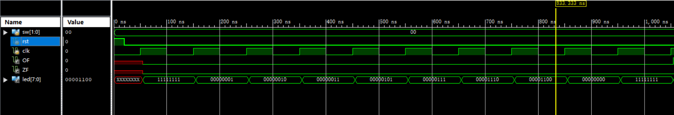

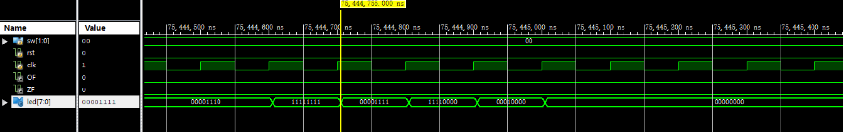

- 仿真结果分析
实验结果结果与真值表相同，仿真正确。

三、电路图
