实验报告
姓名 | 黄萍萍 | 学号 | 16272203 | 班级 | 16272412
专业 | 网络工程 |  | 课程名称 | 《计算机组成原理课程设计》
任课老师 | 吴国华 | 指导老师 | 吴国华 | 机位号
实验序号 | 9 | 实验名称 | 实验9 实现R-I型指令的CPU设计实验
实验时间 |  | 实验地点 | 1-225 | 实验设备号
一、实验设计与程序
- 模块设计说明
- 顶层模块RICPU实现模块调用，时钟沿的逻辑关系，将读出的指令译码，调用各RAM,ALU,IF_M实现指令的功能实现。
- IF_M实现从pc到指令存储器的读取并让pc指向下一条指令，输出当前指令内容。
- RAM存储器模块，存放数据，可读可写
- ALU运算模块

- 实验程序源代码及注释等
module RICPU(
input clk,
input clk_ram,
input rst,
output [31:0] A, B,
output [31:0] ALU_F,
output [6:0] MW,
output reg FR_ZF, FR_OF,
output [31:0] Mem_R_Data
);
reg Write_Reg;
reg Mem_Write;
reg [2:0] ALU_OP;

wire [31:0] Inst_code;
wire [5:0] op_code; // Inst_code
wire [4:0] rs_addr;
wire [4:0] rt_addr;
wire [4:0] rd_addr;
// wire [4:0] shamt;
wire [5:0] func;

wire [15:0] imm;
wire [31:0] imm_Data;

wire OF, ZF;
wire [31:0] ALU_A, ALU_B;
wire [31:0] Reg_Data_B;
wire [4:0] Reg_W_Addr;
wire [31:0] Reg_W_Data;

wire [6:0] Mem_Addr;

//I
reg [0:0] rd_rt_s;
reg [0:0] imm_s;
reg [0:0] rt_imm_s;
reg [0:0] alu_mem_s;

assign op_code = Inst_code[31:26];
assign rs_addr = Inst_code[25:21];
assign rt_addr = Inst_code[20:16];
assign rd_addr = Inst_code[15:11];
// assign shamt = [10:6];
assign func = Inst_code[5:0];
assign imm = Inst_code[15:0];
assign Mem_Addr = {1'b0,ALU_F[5:0]};

assign Reg_W_Addr = (rd_rt_s) ? rt_addr : rd_addr;
assign imm_Data = (imm_s) ? {{16{imm[15]}},imm}: {{16{1'b0}},imm};
assign ALU_B = (rt_imm_s) ? imm_Data : Reg_Data_B;
assign Reg_W_Data = (alu_mem_s) ? Mem_R_Data : ALU_F;
assign MW = Mem_Addr;
assign A = ALU_A;
assign B = ALU_B;
ALU theALU (
.A(ALU_A),
.B(ALU_B),
.ZF(ZF),
.OF(OF),
.F(ALU_F),
.ALU_OP(ALU_OP)
);

IF_M IFM (
.clka(clk),
.rst(rst),
.Inst_code(Inst_code)
);

register REGS(
.clk(~clk),
.Reset(rst),
.R_Addr_A(rs_addr),
.R_Addr_B(rt_addr),
.W_Addr(Reg_W_Addr),
.W_Data(Reg_W_Data),
.Write_Reg(Write_Reg),
.R_Data_A(ALU_A),
.R_Data_B(Reg_Data_B)
);

RAM theRAM (
.clka(clk_ram), // input clka
.wea(Mem_Write), // input [0 : 0] wea
.addra(Mem_Addr), // input [6 : 0] addra
.dina(Reg_Data_B), // input [31 : 0] dina
.douta(Mem_R_Data) // output [31 : 0] douta
);

always @(*)
begin
ALU_OP = 3'b000;
Write_Reg = 1'b0;
Mem_Write = 1'b0;
rd_rt_s = 1'b0;
rt_imm_s = 1'b0;
alu_mem_s = 1'b0;
if(op_code==6'b000000)
begin
Write_Reg = 1'b1;
case (func)
6'b100000: ALU_OP = 3'b100;
6'b100010: ALU_OP = 3'b101;
6'b100100: ALU_OP = 3'b000;
6'b100101: ALU_OP = 3'b001;
6'b100110: ALU_OP = 3'b010;
6'b100111: ALU_OP = 3'b011;
6'b101011: ALU_OP = 3'b110;
6'b000100: ALU_OP = 3'b111;
default: ALU_OP = 3'b000;
endcase
end
else
begin
Write_Reg = 1'b1;
rd_rt_s = 1'b1;
rt_imm_s = 1'b1;
imm_s = 1'b0;
case (op_code)
6'b001000://addi rt, rs, imm
begin
imm_s = 1'b1;
ALU_OP = 3'b100;
end
6'b001100://andi rt, rs, imm
begin
ALU_OP = 3'b000;
end
6'b001110://xori rt, rs, imm
begin
ALU_OP = 3'b010;
end
6'b001011://sltiu rt, rs, imm
begin
ALU_OP = 3'b110;
end
6'b100011:// lw rt, offset(rs)
begin
imm_s = 1'b1;
alu_mem_s = 1'b1;
ALU_OP = 3'b100;
end
6'b101011:// sw rt, offset(rs)
begin
imm_s = 1'b1;
Write_Reg = 1'b0;
ALU_OP = 3'b100;
Mem_Write = 1'b1;
rd_rt_s = 1'bz;
alu_mem_s = 1'bz;
end
default: ALU_OP = 3'b000;
endcase
end
end

always @(negedge clk)
begin
FR_ZF <= ZF;
FR_OF <= OF;
end
endmodule

//EXPR 7
module IF_M(
input [0:0] clka,
input [0:0] rst,
output [31:0] Inst_code
);
wire [31:0] douta;
wire [5:0] addra;
reg [31:0] PC;
wire [31:0] PC_new;

IROM Inst_addr (
.clka(clka), // input clka
.addra(addra), // input [5 : 0] addra
.douta(douta) // output [31 : 0] douta
);
assign PC_new = PC + 4;
assign Inst_code = douta;
assign addra = PC[7:2];
always@(posedge clka or posedge rst)
begin
if(rst)
begin
PC[31:0]<=32'd0;
end
else
begin
PC<=PC_new;
end
end
endmodule

module ALU(A, B, ZF, OF, F, ALU_OP);
input [2:0] ALU_OP;
input [31:0] A, B;
output reg [31:0] F;
output reg ZF, OF;
reg C32;
always @(*)
begin
case(ALU_OP)
3'd0:begin //and
F = A&B;
OF = 0;
end
3'd1:begin //or
F = A|B;
OF = 0;
end
3'd2:begin //xor
F = A^B;
OF = 0;
end
3'd3:begin //nor
F = ~(A|B);
OF = 0;
end
3'd4:begin //add
{C32, F} = A + B;
OF = A[31]^B[31]^F[31]^C32;
end
3'd5:begin //sub
{C32, F} = A - B;
OF = A[31]^B[31]^F[31]^C32;
end
3'd6:begin //slt
if (A<B)
begin
F = 32'd1;
end
else
begin
F = 32'd0;
end
OF = 0;
end
3'd7:begin //sll
F=B<<A;
OF=0;
end
default:begin
F=A;
OF = 0;
end

endcase
if (F == 32'd0)
begin
ZF = 1;
end
else
begin
ZF = 0;
end
end
endmodule

module register(clk, Reset, R_Addr_A, R_Addr_B, W_Addr, W_Data, Write_Reg, R_Data_A, R_Data_B
);
input clk;
input Reset;
input Write_Reg;
input [4:0] R_Addr_A, R_Addr_B, W_Addr;
input [31:0] W_Data;

output [31:0] R_Data_A;
output [31:0] R_Data_B;

reg [31:0] REGISTERS[0:31];

integer i;
assign R_Data_A = (R_Addr_A==5'b00000)? 32'h0000_0000 : REGISTERS[R_Addr_A];
assign R_Data_B = (R_Addr_B==5'b00000)? 32'h0000_0000 : REGISTERS[R_Addr_B];
always @(posedge clk or posedge Reset)
begin
if(Reset)
begin
for(i=0; i<=31; i=i+1)
begin
REGISTERS[i]<=32'h0000_0000;
end
end
else
begin
if(Write_Reg && (W_Addr != 5'b00000))
begin
REGISTERS[W_Addr]<=W_Data;
end
else
begin
REGISTERS[W_Addr]<=REGISTERS[W_Addr];
end
end
end
endmodule

二、实验仿真
- 仿真代码
`timescale 1ns / 1ps

module TESTRICPU;

// Inputs
reg clk;
reg clk_ram;
reg rst;

// Outputs
wire [31:0] ALU_F;
wire FR_ZF;
wire FR_OF;
wire [31:0] A, B;
wire [31:0] Mem_R_Data;
wire [6:0] MW;

// Instantiate the Unit Under Test (UUT)
RICPU uut (
.clk(clk),
.clk_ram(clk_ram),
.rst(rst),
.ALU_F(ALU_F),
.FR_ZF(FR_ZF),
.FR_OF(FR_OF),
.A(A),
.B(B),
.MW(MW),
.Mem_R_Data(Mem_R_Data)
);
always #4 clk = ~clk;
always #1 clk_ram = ~clk_ram;
initial begin
// Initialize Inputs
clk = 0;
clk_ram = 0;
rst = 0;

// Wait 100 ns for global reset to finish
#4;
rst = 1;

#4;
rst = 0;
end

endmodule

- 仿真波形
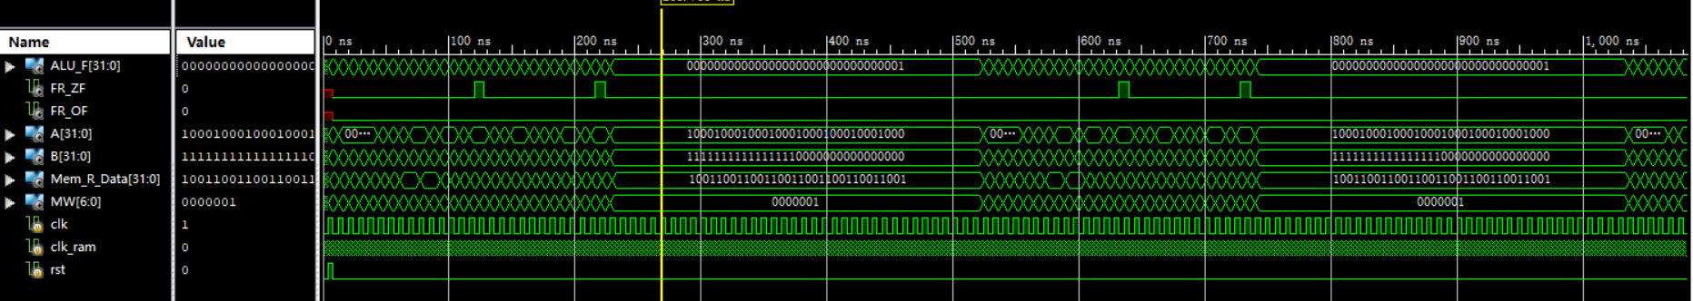
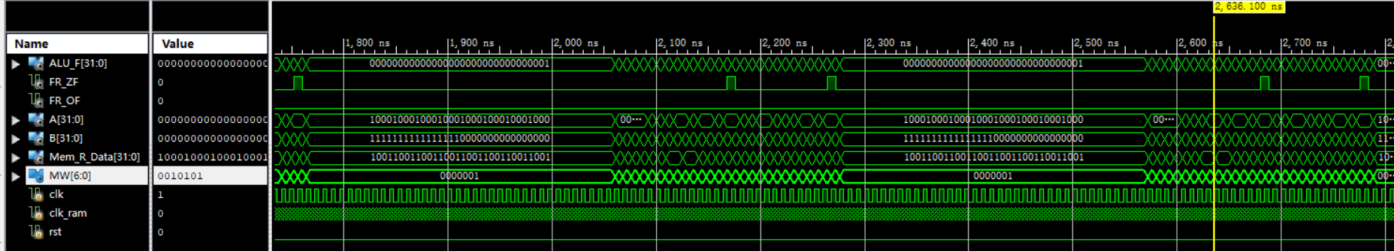

- 仿真结果分析
实验结果结果与真值表相同，仿真正确。
三、电路图
