实验报告
姓名 | 黄萍萍 |  | 学号 | 16272203 | 班级 | 16272412
专业 | 网络工程 |  |  | 课程名称 | 《计算机组成原理课程设计》
任课老师 | 吴国华 | 指导老师 |  | 吴国华 | 机位号
实验序号 | 2 | 实验名称 |  | 实验
实验时间 |  | 实验地点 |  | 1-225 | 实验设备号
一、实验设计与程序
- 模块设计说明

- 实验程序源代码及注释等
顶层模块top.v
`timescale 1ns / 1ps
module top(Addr,Write_Reg,choose,CLK,Reset,A_B,LED);

input [4:0]Addr;
input Write_Reg,CLK,Reset,A_B;
input [1:0]choose;
output reg [7:0]LED;

wire [31:0]R_Data_A,R_Data_B;
reg [31:0] W_Data;
reg [4:0]R_Addr_A,R_Addr_B;

regs REG1(R_Addr_A,R_Addr_B,R_Data_A,R_Data_B,CLK,Reset,Write_Reg,Addr,W_Data );

always@(*)
begin
R_Addr_A = 0;
R_Addr_B = 0;
W_Data = 0;
LED = 0;
if(!Write_Reg)
begin
if(A_B)
begin
R_Addr_A=Addr;
case(choose)
2'b00:LED=R_Data_A[7:0];
2'b01:LED=R_Data_A[15:8];
2'b10:LED=R_Data_A[23:16];
2'b11:LED=R_Data_A[31:24];
default:LED=8'b0;
endcase
end
else
begin
R_Addr_B=Addr;
case(choose)
2'b00:LED=R_Data_B[7:0];
2'b01:LED=R_Data_B[15:8];
2'b10:LED=R_Data_B[23:16];
2'b11:LED=R_Data_B[31:24];
default:LED=8'b0;
endcase
end
end

else
begin
case(choose)
2'b00:W_Data=32'h0000_000F;
2'b01:W_Data=32'h0000_0DB0;
2'b10:W_Data=32'h003C_C381;
2'b11:W_Data=32'hFFFF_FFFF;
default:W_Data=32'h0;
endcase

end

end
endmodule

底层模块regs.v
`timescale 1ns / 1ps

module regs(R_Addr_A,R_Addr_B,R_Data_A,R_Data_B,CLK,Reset,Write_Reg,W_Addr,W_Data );
input [4:0] R_Addr_A,R_Addr_B,W_Addr;
input CLK,Reset,Write_Reg;
output [31:0]R_Data_A,R_Data_B;
input [31:0]W_Data;
reg [31:0]REG_Files[0:31];

integer i;
initial
begin
for (i = 0; i < 32; i = i + 1)
REG_Files[i] = 0;
end

assign R_Data_A=REG_Files[R_Addr_A];
assign R_Data_B=REG_Files[R_Addr_B];

always@(posedge CLK or posedge Reset)
begin
if(Reset)
begin
for(i=0;i<32;i=i+1)
REG_Files[i]<=32'b0;
end

else
begin
if(Write_Reg)
REG_Files[W_Addr]<=W_Data;
end
end
endmodule

二、实验仿真
- 仿真代码
`timescale 1ns / 1ps
module top_1;

// Inputs
reg [4:0] Addr;
reg Write_Reg;
reg [1:0] choose;
reg CLK;
reg Reset;
reg A_B;

// Outputs
wire [7:0] LED;

// Instantiate the Unit Under Test (UUT)
top uut (
.Addr(Addr),
.Write_Reg(Write_Reg),
.choose(choose),
.CLK(CLK),
.Reset(Reset),
.A_B(A_B),
.LED(LED)
);

always
begin
#50;
CLK = ~CLK;
end

initial begin
CLK=0;

// Initialize Inputs
Addr = 0;
Write_Reg = 0;
choose = 0;
CLK = 0;
Reset = 1;
A_B = 0;

// Wait 100 ns for global reset to finish
#20;

// Add stimulus here
Addr = 5'd0;
Write_Reg = 1;
choose = 0;
Reset = 0;
A_B = 0;
#50;//xie [0]=0000_000F

Addr = 5'd0;
Write_Reg = 0;
choose = 0;
Reset = 0;
A_B = 1;
#50;//11111111

Addr = 5'd1;
Write_Reg = 1;
choose = 1;
Reset = 0;
A_B = 0;
#50;//xie [1]=0000_0DB0

Addr = 5'd1;
Write_Reg = 0;
choose = 0;
Reset = 0;
A_B = 0;//10110000
#50;

Addr = 5'd1;
Write_Reg = 0;
choose = 1;
Reset = 0;
A_B = 0;//00001101
#50;

//等上跳沿
#50
Addr = 5'd3;
Write_Reg = 1;
choose = 3;
Reset = 0;
A_B = 0;
#50;//xie [3]=FFFFFFFF

Addr = 5'd3;
Write_Reg = 0;
choose = 3;
Reset = 0;
A_B = 0;
#50;//11111111

end
endmodule
- 仿真波形
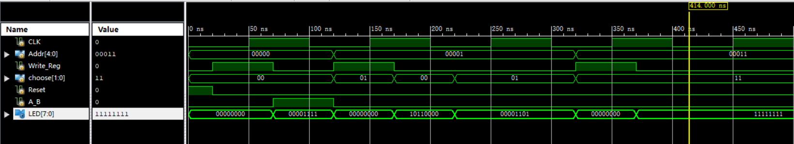

- 仿真结果分析
实验结果结果与真值表相同，仿真正确。

三、电路图
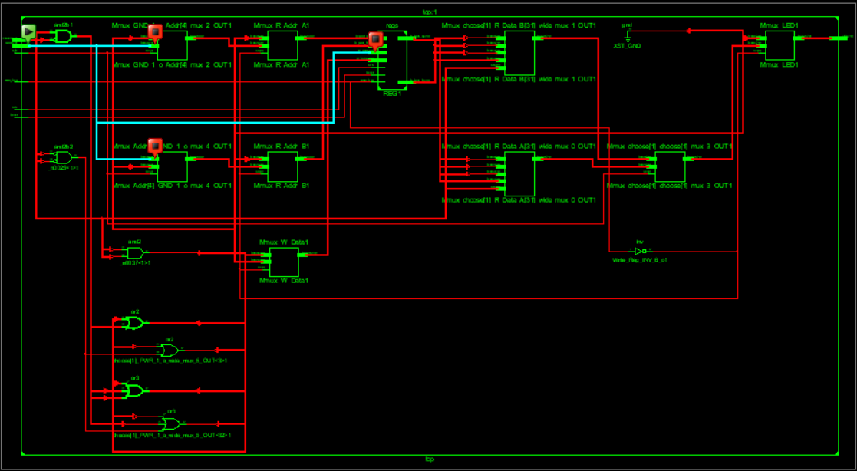
四、引脚配置（约束文件）
NET"Addr[4]" LOC="T5";
NET"Addr[3]" LOC="V8";
NET"Addr[2]" LOC="U8";
NET"Addr[1]" LOC="N8";
NET"Addr[0]" LOC="M8";
NET"Write_Reg" LOC="V9";
NET"choose[1]" LOC="T9";
NET"choose[0]" LOC="T10";
NET"CLK" LOC="C9";
NET"Reset" LOC="D9";
NET"A_B" LOC="C4";

NET"LED[7]" LOC="T11";
NET"LED[6]" LOC="R11";
NET"LED[5]" LOC="N11";
NET"LED[4]" LOC="M11";
NET"LED[3]" LOC="V15";
NET"LED[2]" LOC="U15";
NET"LED[1]" LOC="V16";
NET"LED[0]" LOC="U16";

五、思考与探索
- 实验结果记录：
Addr[4:0] Write_Reg choose[1:0] CLK Reset A_B LED[7:0]
T5 V8 U8 N8 M8 V9 T9 T10 C9 D9 C4 V15 U15 V16 U16T11 R11N11 M11
- 实验结论：
板卡实验结果与真值表相同。

