

**Customer Retention EDA**

**Submitted by:**

BHAVNA PIPLANI

**ACKNOWLEDGMENT**

This includes mentioning of all the references, research papers, data sources, professionals and other resources that helped and guided me in completion of the project.

1. **Business Problem Framing**

* Customer satisfaction has emerged as one of the most important factors that guarantee the success of online store; it has been posited as a key stimulant of purchase, repurchase intentions and customer loyalty. A comprehensive review of the literature, theories and models have been carried out to propose the models for customer activation and customer retention.
* Five major factors that contributed to the success of an e-commerce store have been identified as: service quality, system quality, information quality, trust and net benefit. The research furthermore investigated the factors that influence the online customers repeat purchase intention.
* The combination of both utilitarian value and hedonistic values are needed to affect the repeat purchase intention (loyalty) positively
* The data is collected from the Indian online shoppers. Results indicate the e-retail success factors, which are very much critical for customer satisfaction.

**Data Sources and their formats**

Data Source file was given in csv format with all the necessary variables for further Data Cleaning.

1. **Explanatory Data Analysis**

Importing the dataset from the source file provided.

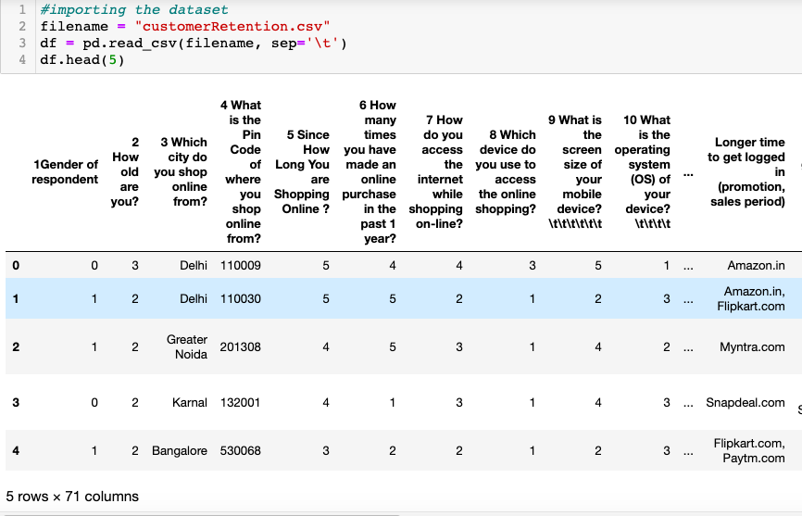

After importing the dataset , checking the datatypes of each column.

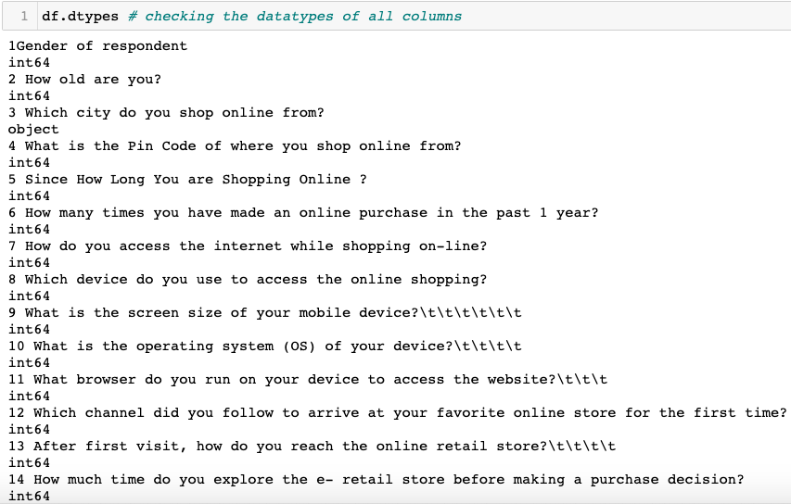

Dataset has 269 rows and 47 columns

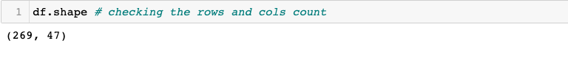

After checking the no. of rows and columns count, we will check the null values if any, column count, datatypes of columns.

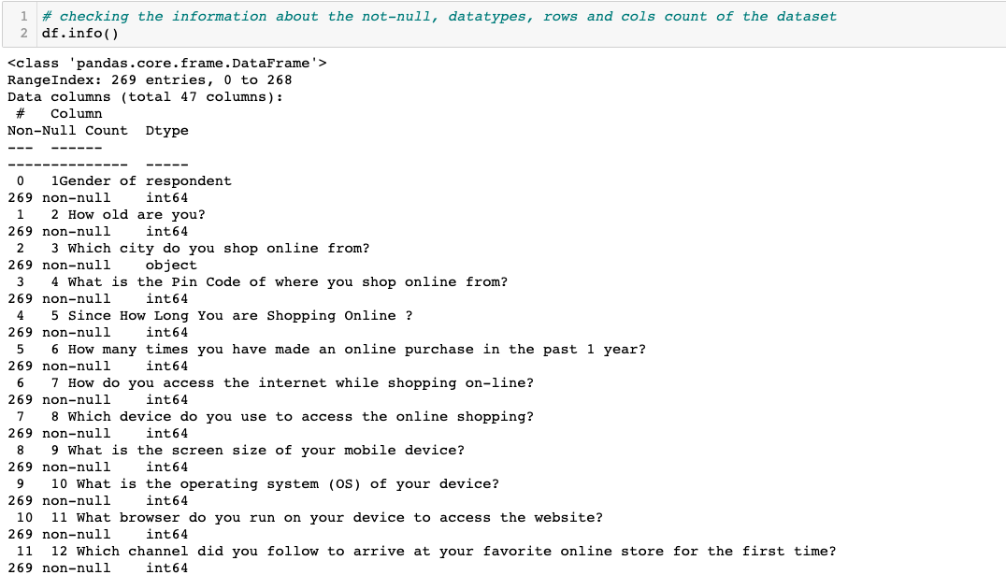

The dataset is looking pretty clean. No data is missing in any of the features as the count for all of them is same and same as number of rows too. There are no missing or null values in the dataset.

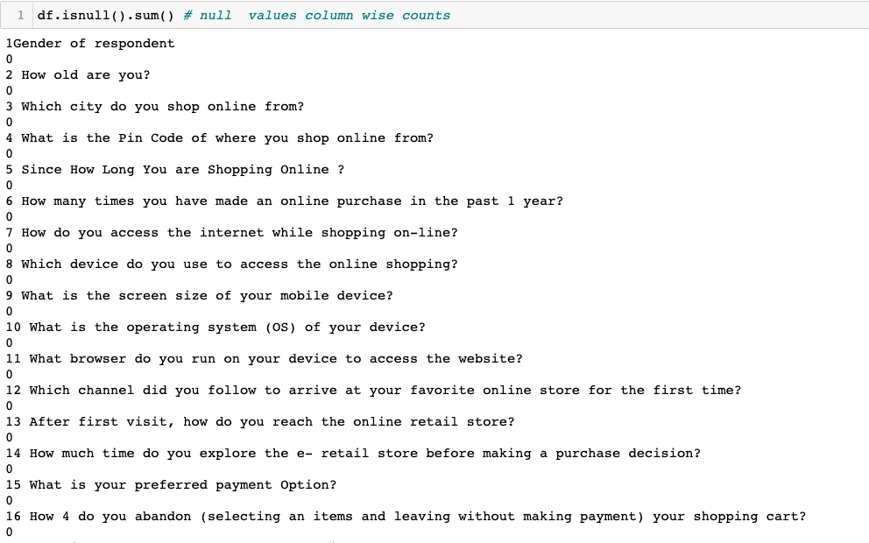

**Data Visualization**

**Univariate Analysis and Bivariate analysis**

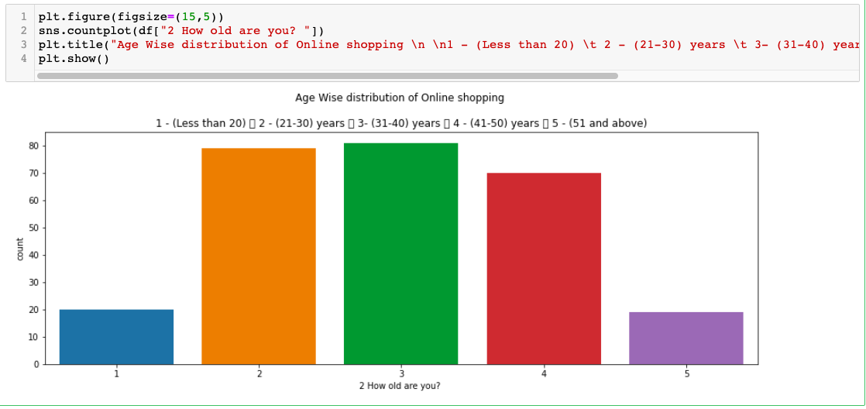

Above countplot shows people of age between 31-40 Shoppe more than others.

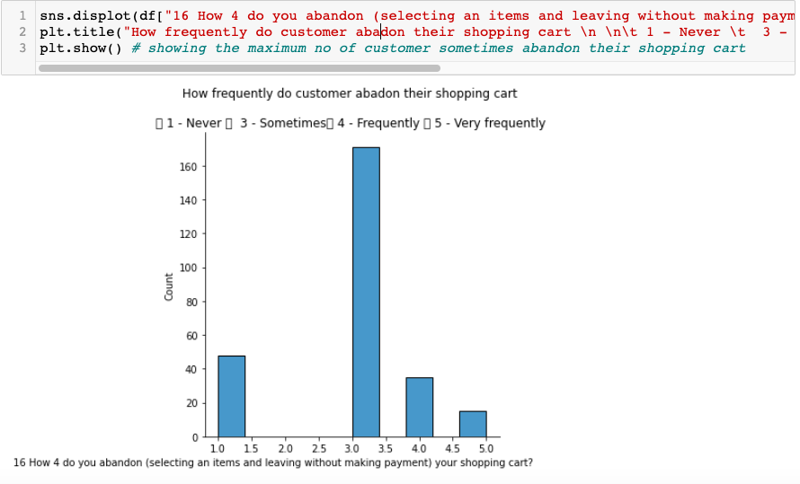

Above displot shows the majority of people abandon their shopping cart sometimes.

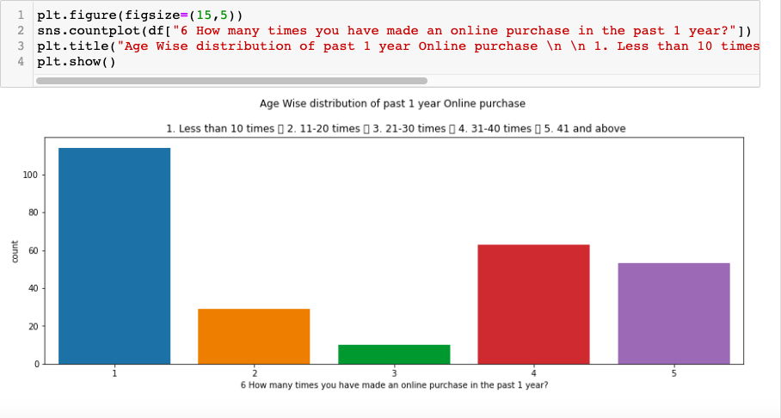

Above countplot shows the maximum customers have done online purchase less than 10 times in a year.

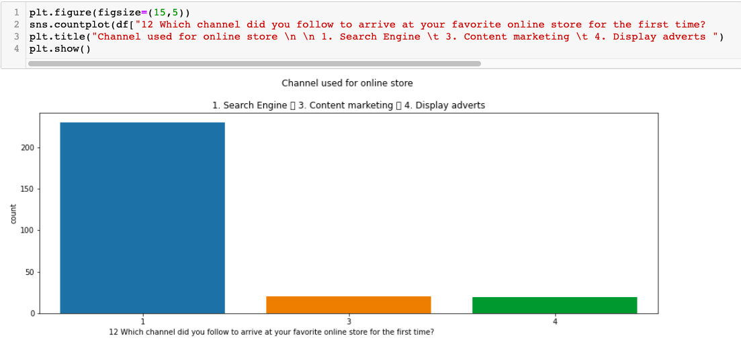

Above countplot shows majority of customer follow search engine to arrive at your favourite online store.

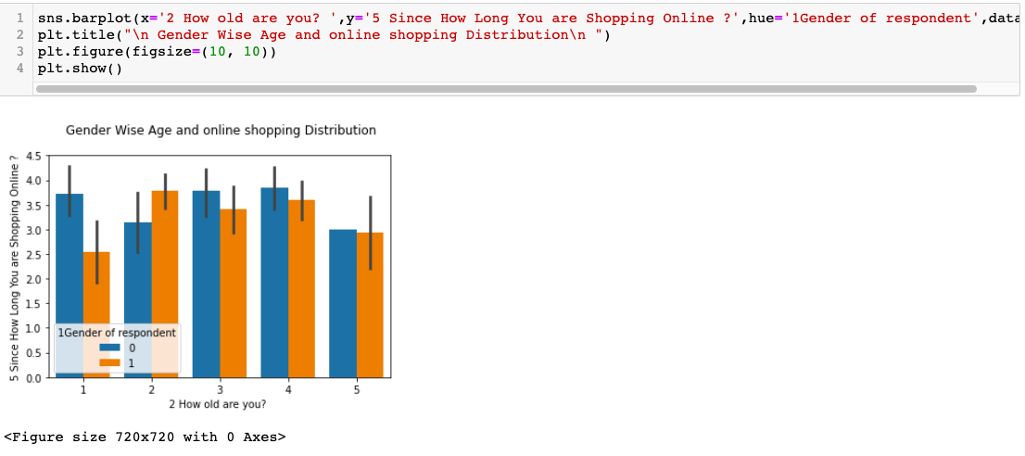

Above barplot shows male of age between 31-40 years have maximum no of years of shopping online .

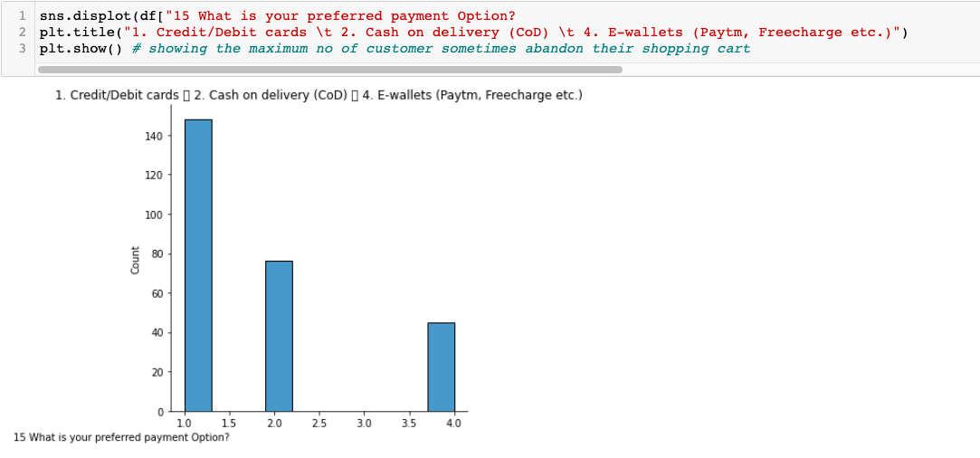

Above displot shows that majority of customer prefer credit/debit cards for payment options.

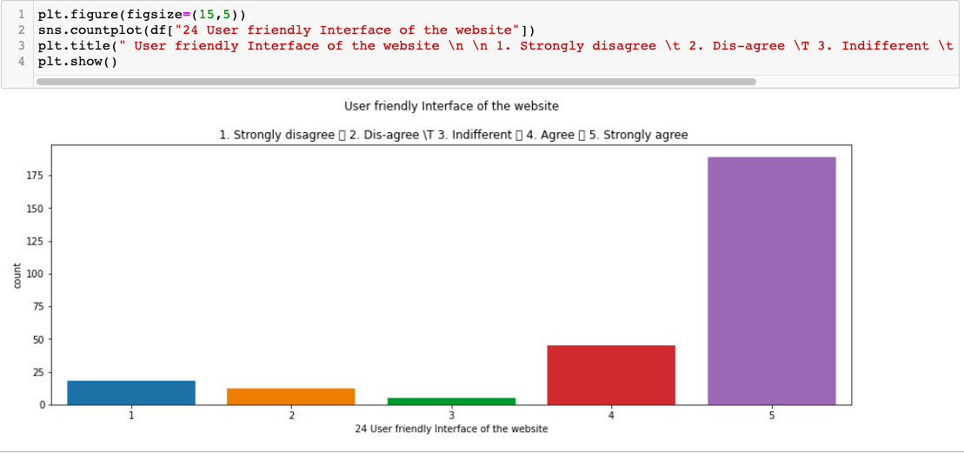

Above countplot shows that mostly customer strongly agree with the user friendly interface of the website.

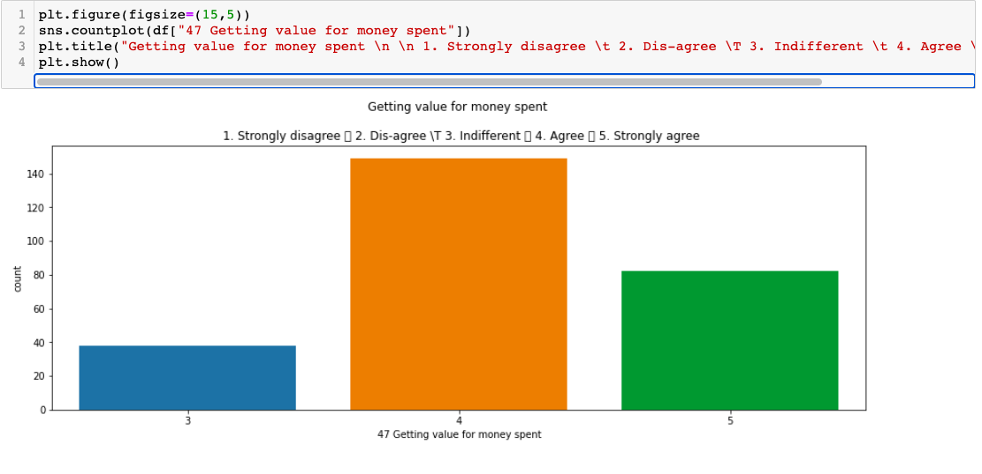

Above countplot shows that majority of customer agree on getting value for money spent

CONCLUSION

Key Findings and Conclusions of the EDA

* people of age between 31-40 Shoppe more than others .
* majority of people abandon their shopping cart sometimes .
* majority of customer follow search engine to arrive at your favorite online store.
* majority of customer prefer credit/debit cards for payment options .
* majority of customer agree on getting value for money spent.

**END OF DOCUMENT**