**Website Edits - Saturday 10th January, 2014**

Hi Amol and Prashant,

These are the items that need further edits:

1. The Google Map API is not working in the “ Current address”, “Previous Address” and “Employer Address” fields.

Panaceatek 12-01-2015 >>

Done.

1. on all Calendars, can we please have a drop-down arrow in the box next to both “Month” and “Year” so that it is easier for the customer to select a different month or year. For example;

Jan ⬇

2015 ⬇

Panaceatek 12-01-2015 >>Done

1. Step 4. Thank you for making the documents at the bottom of Step 4 appear in scrollers.

Can you please change these so that there are a **total of 2** scrollers:

* Scroller 1: “Terms and Conditions, Information Statement and Credit Guide
* Scroller 2: Direct Debit Request and Direct Debit Service Agreement.

Panaceatek 12-01-2015 >>Done

CMS:

1. In “Manage Balance Sheet” please add the facility to add fees when a customer dishonours a payment. Under each scheduled payment, we need to have 3 additional payment fields in the event we need to add extra fees for dishonour, default and following up.

Panaceatek 12-01-2015 >>we have added three fees record from “Manage Balance Sheet” so here you can added fees. When user view loan histroy then we show total amount is (admin amount + dishonour fees + default fees + following up fees); Please clear this change or you want to show different way kindly please provide eg.

1. Could you please make sure that all emails generated by the CMS are cc’d to [team@swiftloans.com.au](mailto:team@swiftloans.com.au) so that we have a record of all outgoing emails. Is it possible to save a copy of emails to a client’s profile?

Panaceatek 12-01-2015 >>Done, you can change any time from global setting under CC record.

https://www.swiftloans.com.au/beta/backend/global-settings/edit/MzI=/MTc=

1. Could you please advise as to whether you have set up the cron file for the “application not completed” email to be sent at 1100HRS and 2030HRS each day?

Panaceatek 12-01-2015 >>

1. Please login on server as WHM

2. Then click on Accoun information url are :<https://221.121.153.131:2087/cpsess2234328331/>

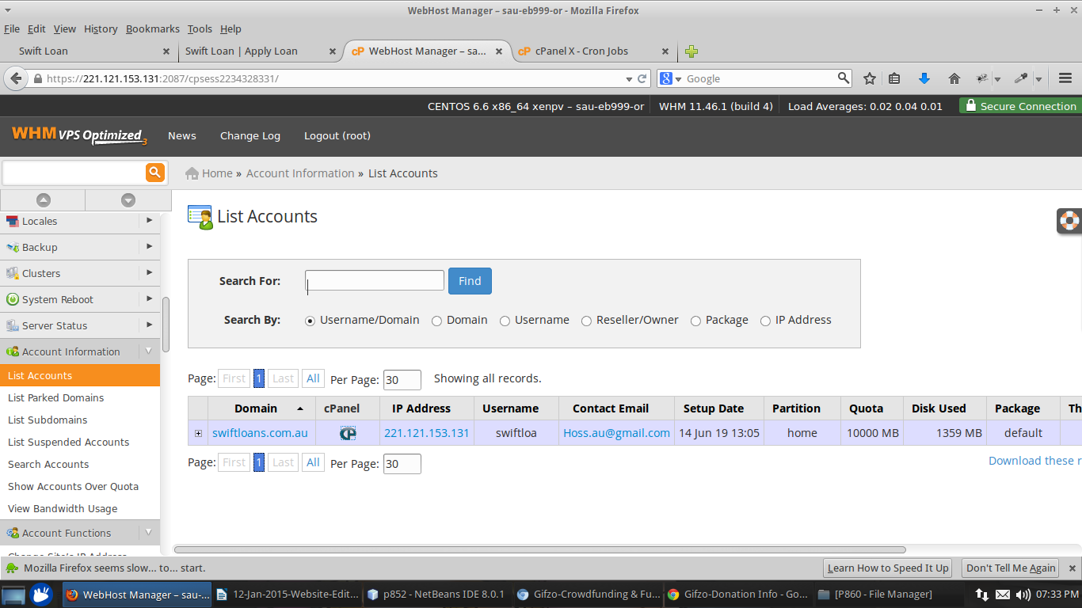

3 Then Click on cpanel after you have find the cron file section under Advanced section

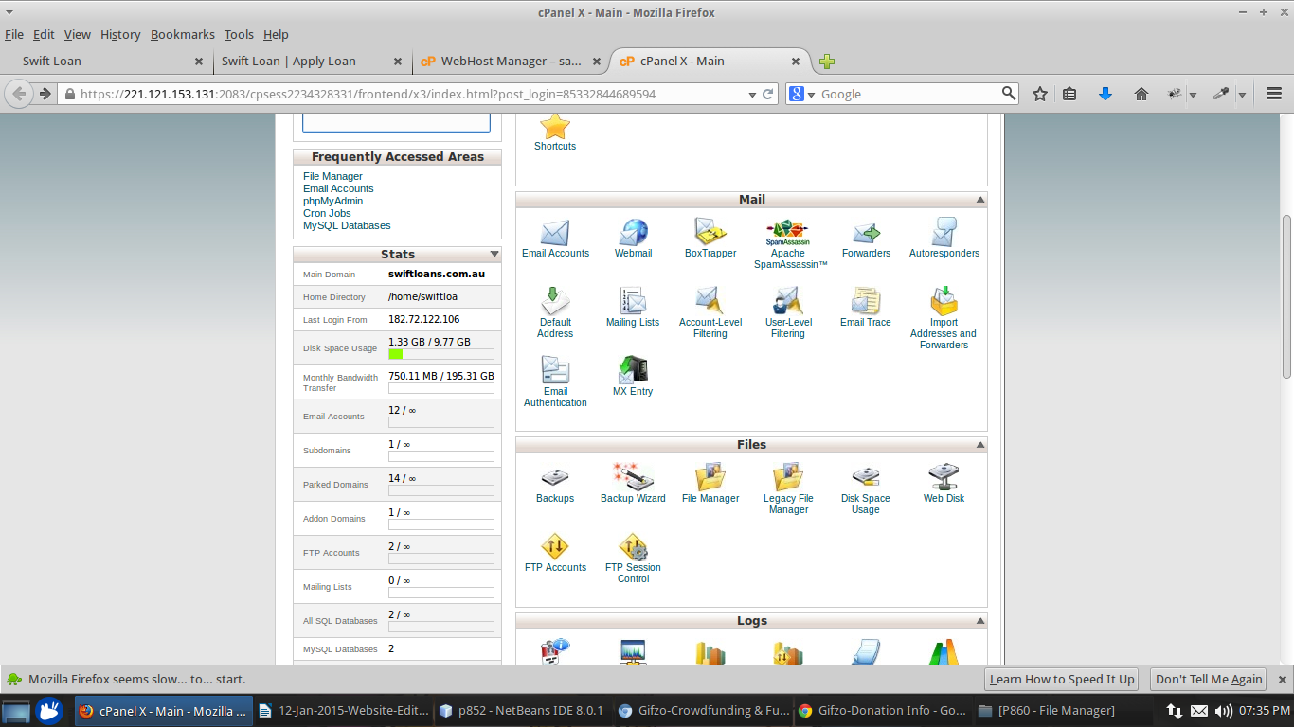

4. After click on cron job you can edit file and set the time zone

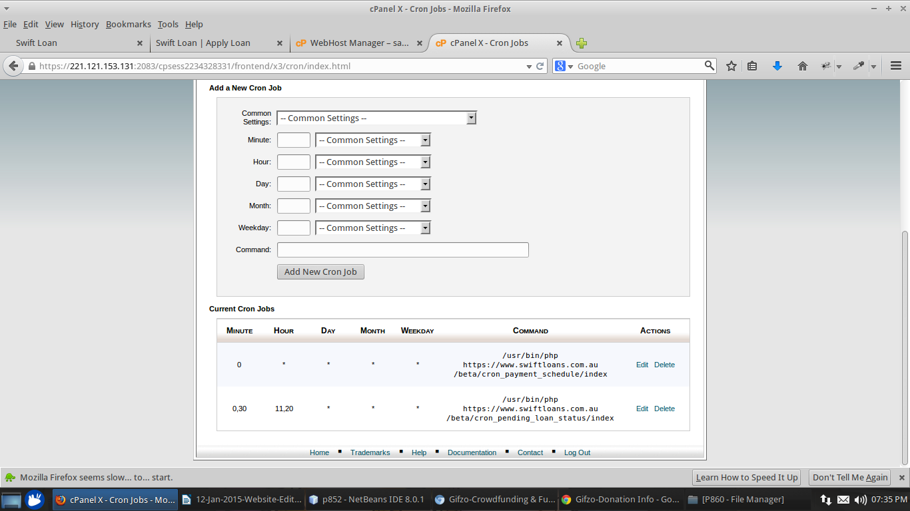

1. Could you please advise as to whether the link in the email” When the loan is approved Business Hours” will link directly to the customer’s VIP Member area?

Panaceatek 12-01-2015 >>In Email template of businessday-loan-approval .

1. Could you please advise as to how we will be able to access client information in the member area? We will need to have a record of each client’s login and password. How can we access this?

Panaceatek 12-01-2015 >>You can find email address and Password of user under the Manage user >> view section.

1. Please change the Sitemap heading on the 5th menu from Fast easy Loans to Fast Easy Loans

Panaceatek 12-01-2015 >> Done

1. Please make the homepage banner automatically scroll

Panaceatek 12-01-2015 >>Done

1. We have sent a video to Prashant showing that in the VIP Member area, the amounts shown in the “Apply Now” Loan repayment schedule do not match up with the amounts shown in the “My loan fees details” table. Can you please address this?

Panaceatek 12-01-2015 >>Done

1. We have sent Prashant a video showing that when a client selects their next pay date in the VIP Member area “Apply now” Section, this date does not transfer over to Step 1 of the application process. Please ensure that these new dates match up.

Panaceatek 12-01-2015 >>Done

1. We have sent Prashant a video showing how we are unable to manager the banners in the CMS. Could you please look into this as we will need to amend the banners regularly.

Panaceatek 12-01-2015 >>Done

1. Iphone 6 image issue. We think this is because on the iPhone6 the site takes several minutes to load. Can we do something to speed up the site loading times especially on safari and ios6.

Panaceatek 12-01-2015 >>Working on it.