_{Jema Technical Services}
(Computer Engineers)
No. 14 Gbamire Street Owode Elede
Ikorodu Rd Lagos State
Tel 09066756483 email: ajemtech@gmail.com
INVOICE
Invoice No. 0010072.
Date: JUL. 30, 2026
Dorman Long Engineering Ltd
11/14 Agege Motor Road
Idi-Oro Mushin Lagos

S/NO | ITEM DESCRIPTION | QTY | RATE | AMOUNT  N
1  2 | ACCESSORIES SUPPLY  Logitech Mouse  Delivery  ACCOUNT DETAILS  Jema Technical Services  0966852016  FCMB | 10 | 18,500 | 185,000.00  3,500.00
 | ONE HUNDRED AND EIGHTY-EIGHT THOUSAND FIVE HUNDRED NAIRA ONLY |  | TOTAL | 188,500.00
 |  |  | ADVANCE
 |  |  | BALANCE | 188,500.00

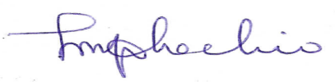
For; Jema Technical Services

