
LIGIL GLOBAL LTD

WE DEAL ON BLASTING,PAINTING,PROCUREMENT,EQUIPMENT LEASING AND FABRICATION

+234 08032718724  ligilglobal@gmail.com
Our Ref ligilglobal TIN: 31222289-0001
OFFICE:
17 Trans Amadi Ind. Layout, Oginigba Town,
Port Harcourt, Rivers State

Your Ref: Dormanlong
Date
September 15, 2026

PROFORMA INVOICE FOR ADHESION PULLOFF GAUGE
ITEMS | QTY | EQUIPMENT | DAYS | Unit Price(N) | TOTAL
1 | 1 | STANDBY FROM ON THE 8th of September till 18th of September 2026 | 9 | 30,000 | 270,000
2 | 1 | Actual Pulloff 21st and 22nd of September | 2 | 100,000 | 200,000
3 |  | SUB-TOTAL |  |  | 470,000
4 |  | VAT(7.5%) |  |  | 35,250
5 |  | TOTAL |  |  | 505,250
6 |  | REMARKS:

ACCOUNT NAME: LIGIL GLOBAL LTD

ACCOUNT NUMBER: 0092149888

BANK: STERLING BANK

Yours faithfully

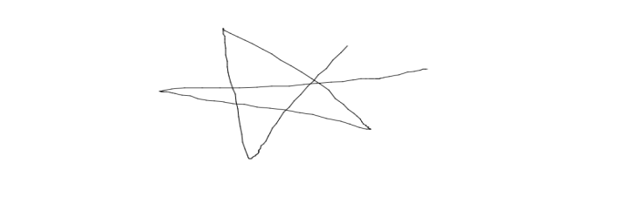
Okomeh Akpos

