# Rock music band creation application documentation

### Application setup

The application executable ( default name – “TQA task.exe”) can be ran as-is, but it will create a file named “data.csv” if there isn’t one already in the same folder.

**Optional**

Optionally, the “data.csv” file containing the variables for use in band creating can be added manually to the folder containing the executable.

The “data.csv” file could be manually created by using spreadsheet software and saving the file as .csv or using a text editor and then renaming the extension to .csv

The “data.csv” file should contain 3 rows and any number of columns. First row should contain adjectives, second row – nouns and the third row – full names. If using a text editor to make the file, then said variables should be split accordingly across the first 3 lines, with the variables in the same row being separated using commas.

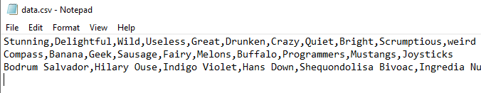

Figure . Example of how a "data.csv" would look in a text editor

### Using the application

The application is navigated by pressing the keys corresponding to the wanted actions.

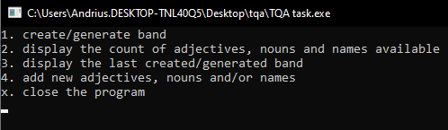

Figure Main menu

For example, the user needs to press 1 to start with creating or generating a band.

However, there is one exception to this. When manually selecting a variable for the band (adjective, noun or a band members name), the user needs to type the value corresponding to the wanted action and then press enter.

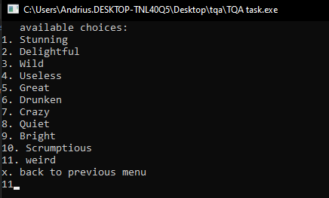

Figure Choosing "weird" as the band adjective

### Limitations

There are a few limitations in how the application deals with the input file and the available adjectives, nouns and names:

* The “data.csv” file is treated as containing correct information with the correct formatting and may cause the application to behave unexpectedly if that is not the case.
* The user can enter anything they want as adjectives, nouns or full names, regardless of it being actual words or names.
* Entered adjectives, nouns and full names will have commas removed.
* There is no way to delete adjectives, nouns or names using the application. They can only be removed by directly editing the “data.csv” file.