

**TECHNICAL APPROVAL COMMITTE**

**GUIDE APPROVAL FORM**

                                                                                          Date:13 /07 / 2023

| **Starting Date of Work** | |  | | |
| --- | --- | --- | --- | --- |
| **Sl. No.** | **Student Name** | **Reg. No.** | **Role** | **Signature** |
| 1 | SARAN S | 7376221SE144 | Team Leader |  |
| 2 |  |  | Team Member |  |
| 3 |  |  | Team Member |  |
| 4 |  |  | Team Member |  |
| 5 |  |  | Team Member |  |
| 6 |  |  | Team Member |  |
| 7 |  |  | Team Member |  |
| 8 |  |  | Team Member |  |
| 9 |  |  | Team Member |  |
| 10 |  |  | Team Member |  |
| **Applying for the work:** | | PROJECT | | |
| **Title of Work** | | Password Checker and Password Strength Genera | | |

**(To be Filled by Faculty In charge)**

**No. of students: ONE**

I acknowledge that I will act as a faculty in charge for the aforementioned students and guide them to complete the work by adopting the guidelines provided.

| **Lab Name:CYBER SECURITY** | **Name & Signature of the Faculty In charge with the date** |
| --- | --- |

|  |
| --- |

**Output:**

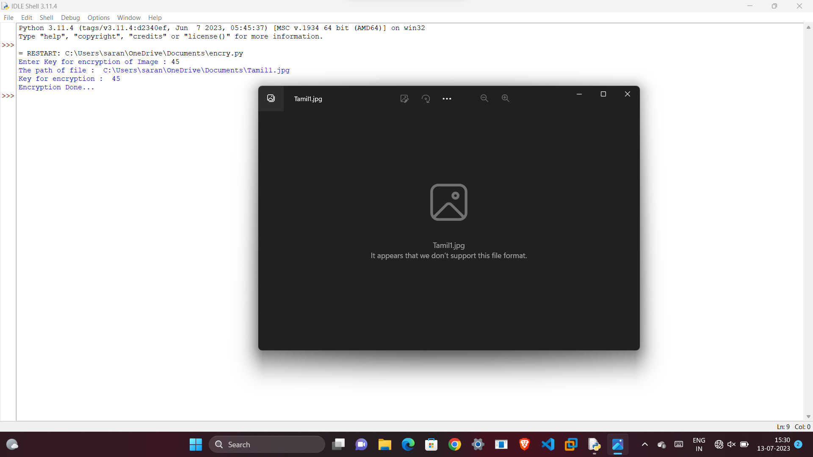

**Idea/Approach Details**

| **METHODOLOGY:**  Here is a methodology for encrypting and decrypting an image with authentication:  1.Choose an encryption algorithm: There are several encryption algorithms available for image encryption, such as XOR operation, visual cryptography, and chaotic maps.  2. Choose an algorithm that suits your needs.Choose an authentication method: Authentication methods can be used to ensure that only authorized users can access the encrypted image. Some common authentication methods include passwords, biometric authentication, and digital signatures.  3.Encrypt the image: Once you have chosen an encryption algorithm, you can encrypt the image using the algorithm. For example, if you are using XOR operation, you can apply the XOR operation to the image and a key to generate the encrypted image.  4.Authenticate the user: To authenticate the user, you can use the chosen authentication method. For example, if you are using a password, you can prompt the user to enter the password before allowing them to access the encrypted image.  5.Decrypt the image: Once the user has been authenticated, you can decrypt the image using the same encryption algorithm that was used to encrypt it. For example, if you used XOR operation to encrypt the image, you can apply the XOR operation to the encrypted image and the key to generate the original image.  6.Verify the authenticity of the decrypted image: To ensure that the decrypted image has not been tampered with, you can use a digital signature or other authentication method to verify its authenticity. |
| --- |
| **ABSTRACT:**  This abstract provides an overview of image encryption and authentication schemes. It highlights the importance of image security and presents recent developments and improvements in the field. The abstract also mentions specific techniques such as message authentication codes, biometric authentication, visual cryptography, and encryption algorithms used in image encryption and authentication schemes. It emphasizes the need for secure image transmission and storage, particularly in cloud frameworks. The abstract concludes by mentioning the use of mathematical logic, such as XOR operations, for encrypting and decrypting images using Python.  Overall, the abstract provides a glimpse into the advancements and techniques used in image encryption and authentication, highlighting the importance of securing images and ensuring their authenticity. |
| **PROBLEM STATEMENT:**  The problem is to develop a secure and efficient methodology for encrypting and decrypting images with authentication. The solution should ensure the confidentiality and integrity of the image data, verify the authenticity of the decrypted image, and be compatible with various image formats. The solution should also be efficient and capable of handling large image files without significant performance degradation. |

**Signature of Faculty In Charge**