Google Search Console Setup — Screenshot SOP
Homing GmbH | Shopify | homingmbh.de
Purpose: Step-by-step training guide for a new trainee. Follow the screenshots in order. This SOP documents the actual Homing GmbH setup flow and the fallback used when DNS/IONOS access is unavailable.

1. Final Setup Target
✓ Shopify primary domain: homingmbh.de
✓ Google Search Console property: https://homingmbh.de/
✓ Ownership verification: completed
✓ Sitemap: https://homingmbh.de/sitemap.xml

2. Screenshot-by-Screenshot Procedure

1. Google Search Console — Start
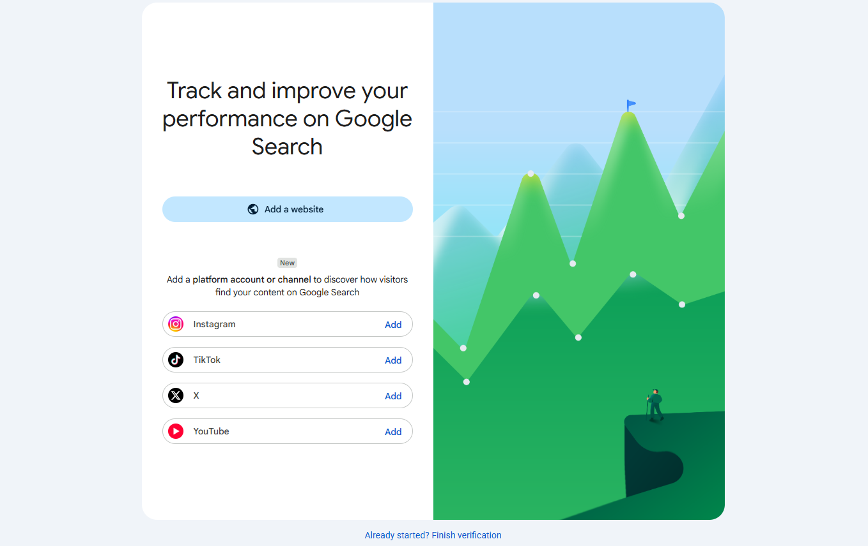
What to do: Open Google Search Console and select Add a website.

2. Select Property Type
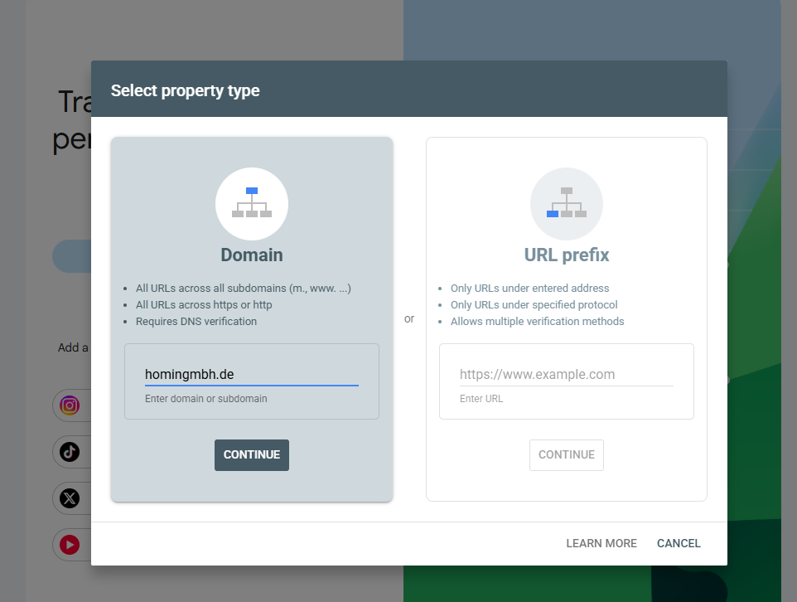
What to do: For a Domain property, enter homingmbh.de without https://. Click Continue.

3. DNS Verification — 1&1 / IONOS
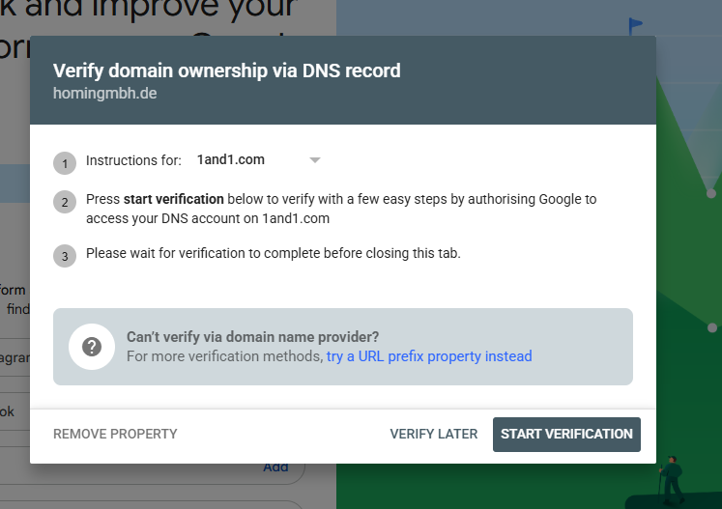
What to do: Google detected 1&1/IONOS. Use Start Verification only if you have access to the existing IONOS account. Otherwise use the URL-prefix fallback.

4. Shopify — Domains
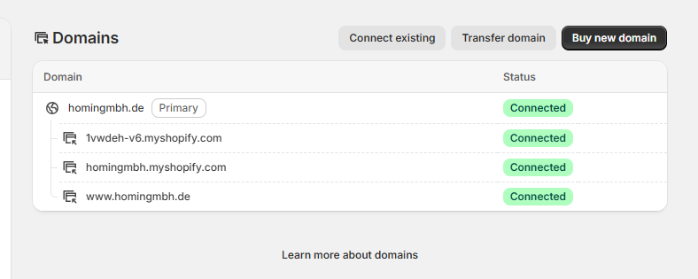
What to do: Shopify Admin → Settings → Domains. Confirm homingmbh.de is Connected and Primary.

5. Google — HTML Tag Verification
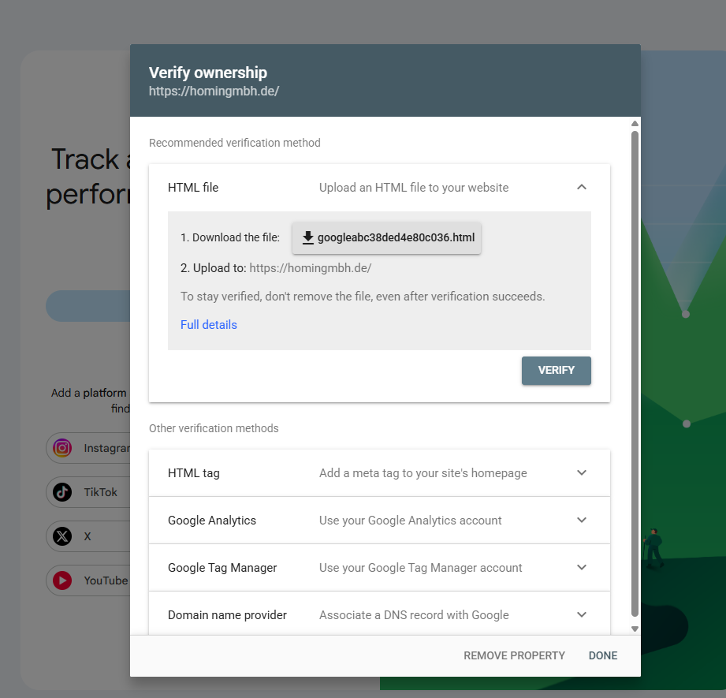
What to do: If DNS verification is unavailable, create URL-prefix property https://homingmbh.de/ and select HTML tag. Copy the complete meta tag.

6. Shopify — theme.liquid
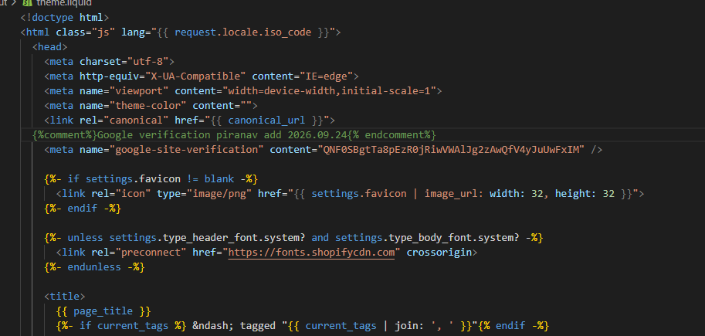
What to do: Shopify Admin → Online Store → Themes → Edit code → layout/theme.liquid. Put the Google meta tag inside <head>, save the active theme, then verify.

7. Example — Verification Failed
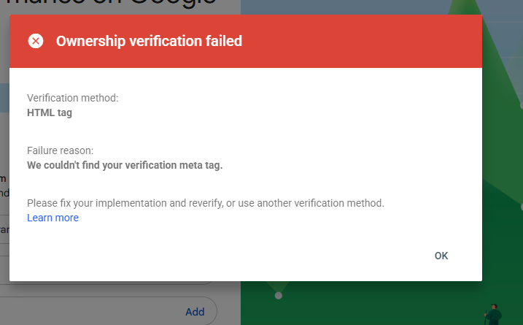
What to do: If Google cannot find the tag, check active theme, exact token, <head> placement, and whether Shopify password protection is blocking the public page.

8. Search Console — Verified Property
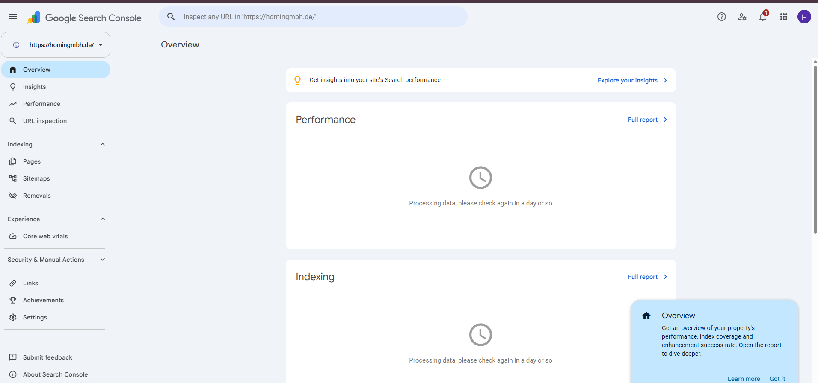
What to do: After verification, the property appears in Search Console. Initial “Processing data” is normal for a new property.

3. Shopify Verification — Exact Location
Shopify Admin → Online Store → Themes → current active theme → Edit code → layout/theme.liquid
<head>
<meta name="google-site-verification" content="YOUR_GOOGLE_TOKEN" />
...
</head>

4. If Verification Fails
☐ Confirm the tag is in the active/published theme.
☐ Confirm it is inside <head>.
☐ Confirm the token exactly matches Google Search Console.
☐ Confirm the property is https://homingmbh.de/.
☐ Open the public homepage while logged out.
☐ Check whether Shopify password protection is serving a password page.
☐ Save the theme and retry verification.

5. After Verification — Sitemap
Google Search Console → Indexing → Sitemaps
Enter: sitemap.xml
Expected URL: https://homingmbh.de/sitemap.xml

6. URL Inspection
Use URL Inspection for the homepage and important pages after the website is ready for public crawling.
• https://homingmbh.de/
• Important collection URLs
• Important product URLs
• About / Contact / other key pages

7. Trainee Completion Record
Field | Value
Date
Trainee
Shopify store
Primary domain
GSC property
Verification method
Sitemap status
Issues / notes

8. Important Rules
• Keep the verification meta tag after successful HTML-tag verification.
• Never put passwords, API keys, or DNS credentials in this SOP.
• Do not create a new DNS account without confirming ownership of the existing domain.
• Do not request indexing for unfinished pages just to create data.
• A new GSC property can initially show “Processing data”; this is normal.

9. Quick Flow
1. Shopify → Settings → Domains → confirm primary domain.
2. GSC → Add property.
3. Use Domain verification if DNS access exists.
4. If no DNS access → URL-prefix → HTML tag → theme.liquid.
5. Save active theme → Verify.
6. GSC → Indexing → Sitemaps → sitemap.xml.
7. Inspect important URLs after the store is public and ready.
8. Record completion and issues.

