Homingmbh.de
Shopify Customer Google Sign-In
Trainee Setup & Verification Guide
Purpose: enable customers to sign in to the Shopify customer account using Google.

Store | Homingmbh.de
Shopify customer account | Google sign-in
Google Cloud project | Homin GmbH - Google Login
Final status achieved | Google OAuth app: In production; Shopify Google sign-in: enabled and storefront option visible

SECURITY RULE: Never put the Google Client Secret in this training document, screenshots, chat messages, tickets, Git repositories, or public files. Store it only in the approved secure configuration.

1. What this setup does
This setup connects Shopify customer accounts with Google OAuth so a customer can choose “Continue with Google” / “Weiter mit Google” from the storefront customer login window.

2. Setup flow
- Open Shopify Admin → Settings → Customer accounts.
- Open Sign in with Google and copy Shopify's required OAuth URLs.
- Create/select the Google Cloud project.
- Configure Google Auth Platform branding and audience.
- Add the Shopify JavaScript origins, redirect URIs, and deauthorize callback URIs.
- Create a Google OAuth Web application client.
- Copy the Client ID and Client Secret into Shopify.
- Publish the Google OAuth app to production.
- Turn on Google sign-in in Shopify.
- Test the storefront login using “Weiter mit Google”.

3. Step-by-step setup

Step 1 — Open Shopify Customer Accounts
Shopify Admin → Settings → Customer accounts → Authentication / Sign in with Google.
Expected: the Shopify page displays the Google setup instructions and the required OAuth URLs.
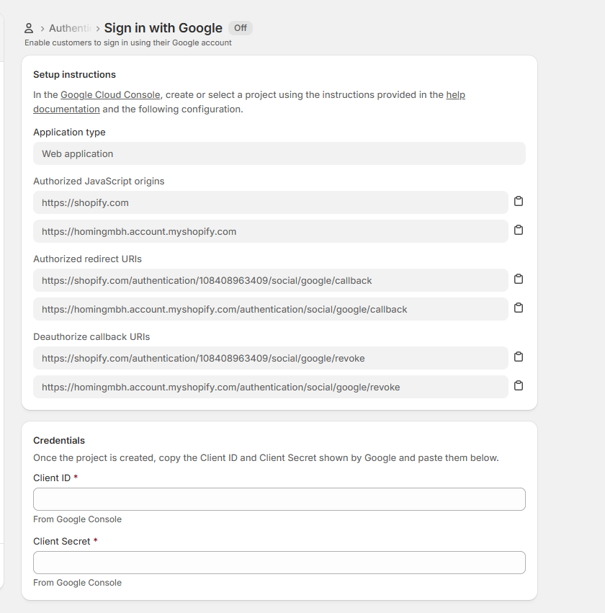
Screenshot 1 — Shopify Sign in with Google setup instructions

Step 2 — Record the Shopify OAuth URLs
Use the exact URLs shown by Shopify. Do not type them from memory. For this store, the important values are:
- JavaScript origin: https://shopify.com
- JavaScript origin: https://homingmbh.account.myshopify.com
- Redirect: https://shopify.com/authentication/108408963409/social/google/callback
- Redirect: https://homingmbh.account.myshopify.com/authentication/social/google/callback
- Revoke: https://shopify.com/authentication/108408963409/social/google/revoke
- Revoke: https://homingmbh.account.myshopify.com/authentication/social/google/revoke

Step 3 — Google Cloud project
Use the Google Cloud project named “Homin GmbH - Google Login”. If creating a new project, keep the project name clear enough for a future trainee to identify its purpose.
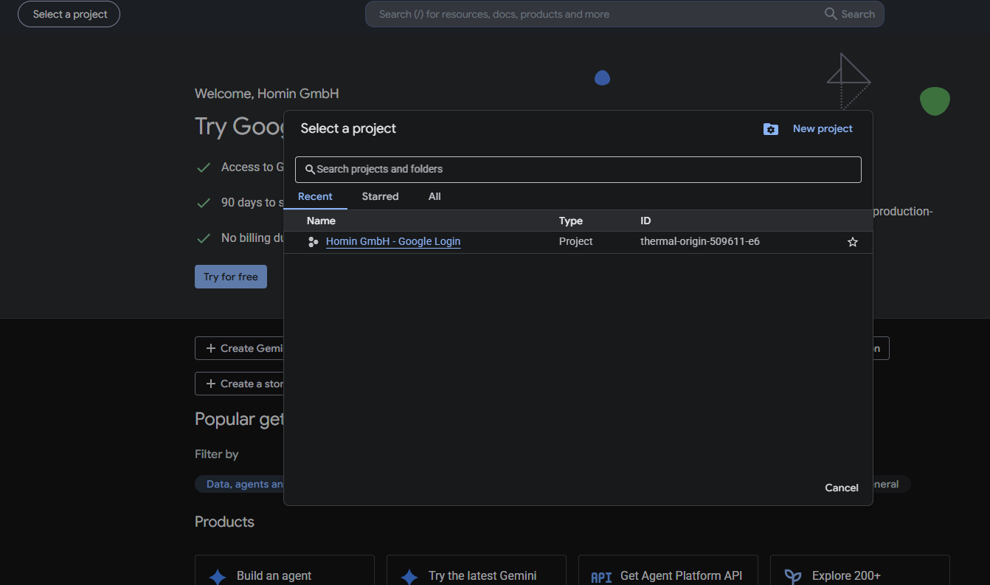
Screenshot 2 — Google Cloud project selection/creation area

Step 4 — Configure Google Auth Platform → Branding
Google Cloud → Google Auth Platform → Branding.
Use the store's public website and published legal-policy pages. The completed configuration used:
- Application home page: https://homingmbh.de
- Privacy policy: https://homingmbh.de/policies/privacy-policy
- Terms of Service: https://homingmbh.de/policies/terms-of-service
- Authorised domain: shopify.com
- Authorised domain: account.myshopify.com
- Authorised domain: homingmbh.de
Important: Google may require the website domain to be authorised/verified before production use.
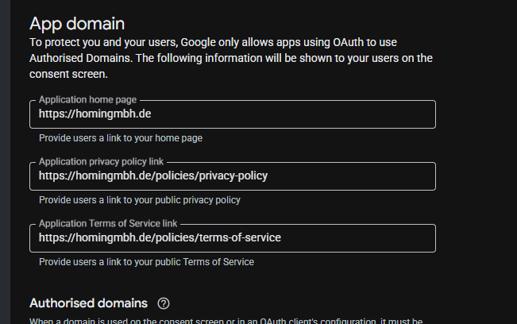
Screenshot 3 — Google Branding → App domain fields
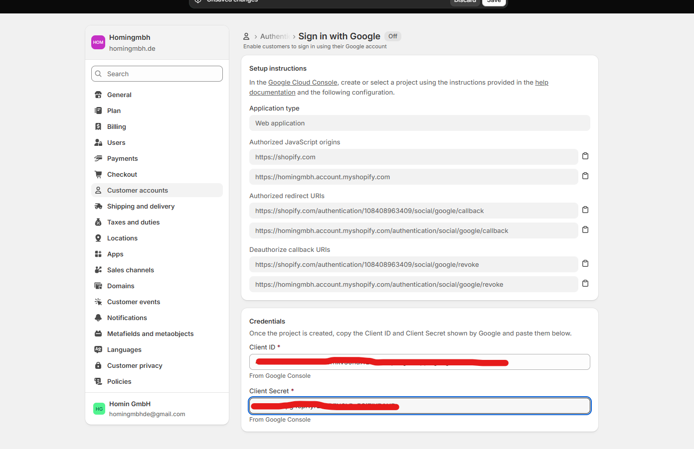
Screenshot 4 — Completed/edited Branding configuration

Step 5 — Set Audience
Google Auth Platform → Audience → User type: External.
For a customer-facing Shopify login, the audience is External because customers use their own Google accounts.
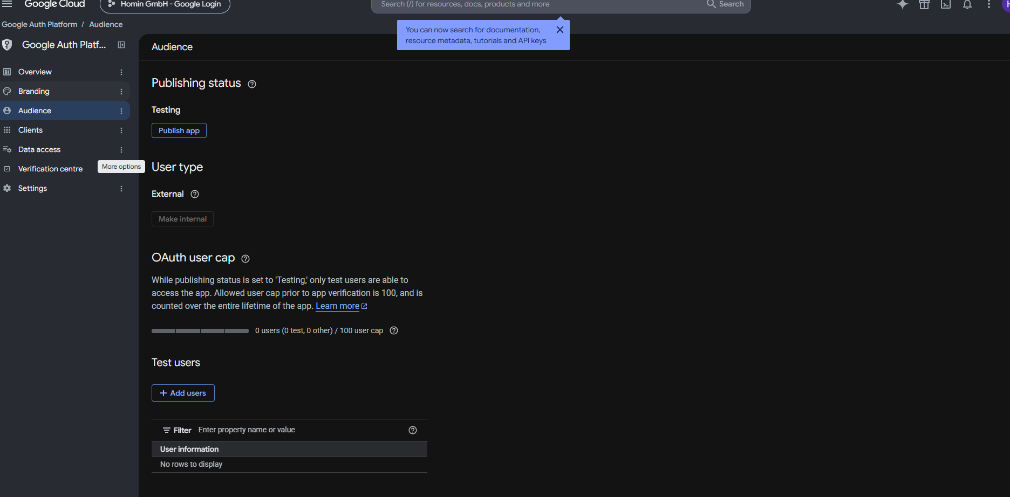
Screenshot 5 — Audience before publishing

Step 6 — Create the OAuth client
Google Auth Platform → Clients → Create client → Application type: Web application.
Enter the exact Shopify JavaScript origins, redirect URIs, and deauthorize/revoke callback URIs from Step 2.
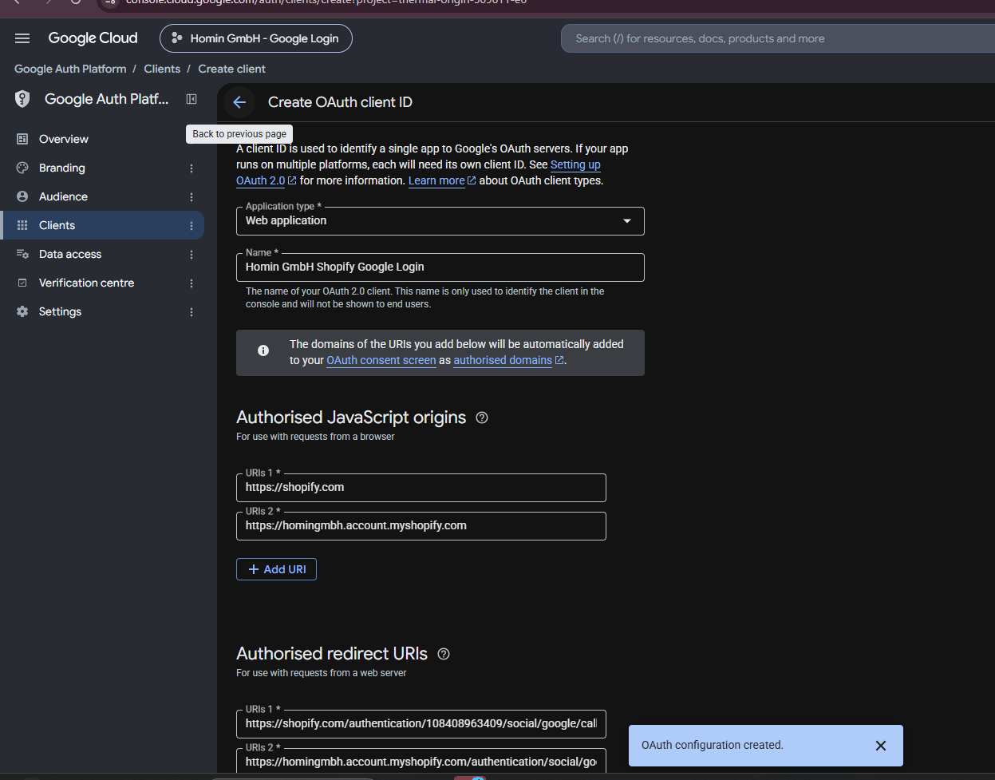
Screenshot 6 — Google OAuth client configuration with Shopify URLs

Step 7 — Put Google credentials into Shopify
Return to Shopify → Settings → Customer accounts → Sign in with Google.
Paste the Google OAuth Client ID and Client Secret into the Shopify credential fields.
After saving, verify that the values are populated. Keep the secret private.
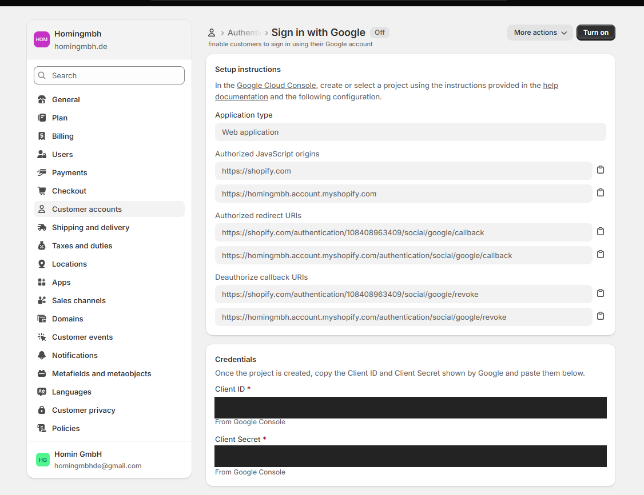
Screenshot 7 — Shopify credential fields (sensitive values redacted for training)
Training copy note: The Client ID and Client Secret are intentionally hidden in this screenshot. A trainee must use the live secure values already stored in the approved system.

Step 8 — Publish the Google OAuth app
Google Auth Platform → Audience → Publish app.
A confirmation dialog appears asking whether to push the app to production. Confirm only after Branding, Audience, and OAuth client configuration are complete.
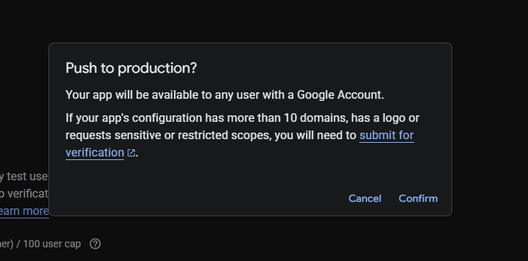
Screenshot 8 — “Push to production?” confirmation
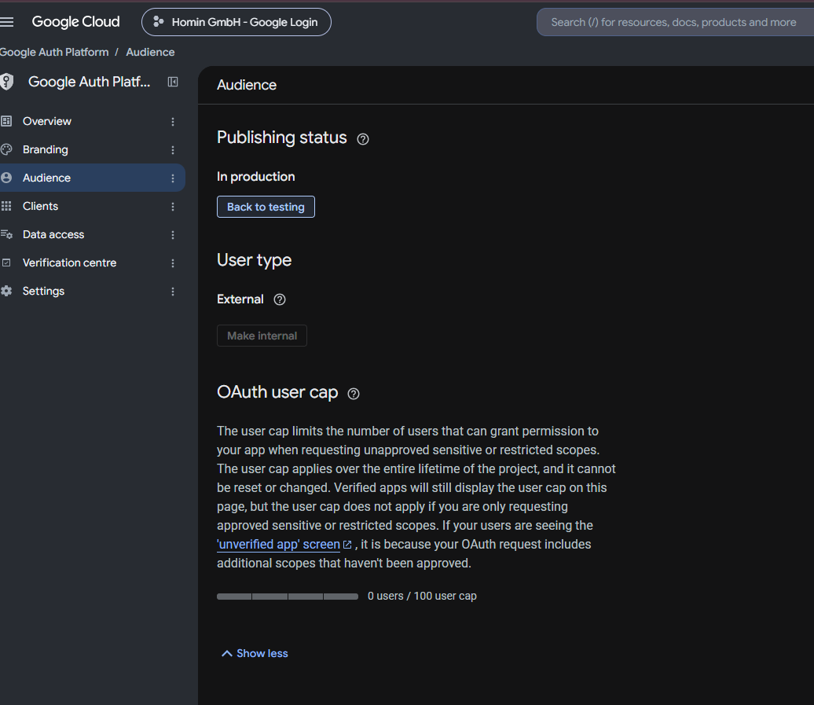
Screenshot 9 — Final Google Auth Platform status: In production

Step 9 — Turn on Google sign-in in Shopify
Return to Shopify → Settings → Customer accounts → Sign in with Google → Turn on.
Expected result: the Shopify Google sign-in status changes from Off to On.
Screenshot 10 — Shopify Google sign-in page; credential values are redacted

Step 10 — Test the storefront
Open https://homingmbh.de and open the customer login/account dialog.
Expected result: the login dialog displays “Weiter mit Google” (Continue with Google).
Click it, select a Google account, complete Google's consent flow if shown, and confirm that the customer is returned to the store and can access the customer account.
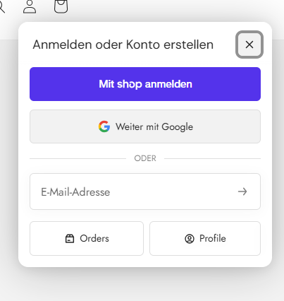
Screenshot 11 — Storefront customer login showing “Weiter mit Google”

4. Final verification checklist
- ☐ Google Cloud project exists and is the correct project.
- ☐ Google Auth Platform → Audience shows In production.
- ☐ User type is External.
- ☐ Branding has the correct home page, privacy policy, and terms URLs.
- ☐ Authorised domains include shopify.com, account.myshopify.com, and homingmbh.de.
- ☐ OAuth client type is Web application.
- ☐ Shopify origins, redirects, and revoke URLs exactly match the Shopify instructions.
- ☐ Client ID and Client Secret are entered in Shopify.
- ☐ Shopify Sign in with Google is turned on.
- ☐ Storefront login shows “Weiter mit Google”.
- ☐ A real test Google account can complete the sign-in and return to the store.

5. Common problems and what to check
Problem | Likely check | Action
Google option not visible in Shopify | Google sign-in status is Off | Open Customer accounts → Sign in with Google and turn it on.
Redirect URI error | A Google OAuth URI differs from Shopify | Copy the URI directly from Shopify and update the Google OAuth client.
Domain/branding warning | homingmbh.de is not authorised or verified | Add the domain in Google Auth Platform and complete any Google verification requirement.
Only test users can sign in | OAuth app is still in Testing | Audience → Publish app after required configuration is complete.
Google login opens but does not return correctly | Origin/redirect mismatch or stale OAuth configuration | Compare every origin and redirect URI character-for-character.
Client secret exposed | Credential was pasted into chat, email, screenshot, or public repository | Treat it as compromised and rotate/regenerate the OAuth client secret, then update Shopify.

6. Important security rules for trainees
- Never share the Client Secret in screenshots, chat, email, tickets, or documentation.
- Never commit OAuth secrets to GitHub or other source-control repositories.
- Do not change redirect URIs unless the Shopify instructions require a change.
- If a credential must be replaced, use the approved secure credential process and update Shopify immediately.
- When documenting a completed setup, redact Client ID/Secret values from screenshots where practical.

7. Official reference pages
Google — Manage OAuth App Branding: https://support.google.com/cloud/answer/15549049?hl=en
Google — OAuth verification requirements: https://support.google.com/cloud/answer/13464321?hl=en
Google — Get started with Google Auth Platform: https://support.google.com/cloud/answer/15544987?hl=en
Google — Manage OAuth Clients: https://support.google.com/cloud/answer/15549257?hl=en
Shopify — Adding store policies: https://help.shopify.com/en/manual/checkout-settings/refund-privacy-tos

8. Handover record
Completed configuration: Google Sign-In for Shopify customer accounts on homingmbh.de.
Final observed result: storefront customer login displayed “Weiter mit Google”.
Date of this guide: 24 September 2026.
If Shopify or Google changes the UI, use the same configuration principles but always copy the current OAuth URLs shown by Shopify rather than relying on an old screenshot.

