C5 — Fix GA4 Purchase Tracking on ledsone.co.uk
Task ID: BP-unknown
Priority: YELLOW - TASK
Date: 2026-10-27
Due: Fri 30 Oct
Status: 50% — Investigation complete, fix pending

Task Description
GA4 property 408110563 records 2,043 organic sessions over 90 days while Search Console shows ~1,500–1,700 organic clicks weekly. Verify measurement ID and confirm purchase events include Shopify order number.

Step 1 — Shopify Customer Events (Pixel Audit)
Checked Settings → Customer Events. Found 5 Google-related pixels active simultaneously — this is a risk for duplicate or conflicting data.
Pixels found:
• Google & YouTube (Server + Web) ✓
• Google ads conversion Tracking (Web only)
• Infinite Google Ads (Web only)
• Infinite Google Ads Pixel (Web only)
• Setup Tracking Pixel (Web only)
Risk: Multiple Google pixels can cause session inflation and duplicate conversion counts.
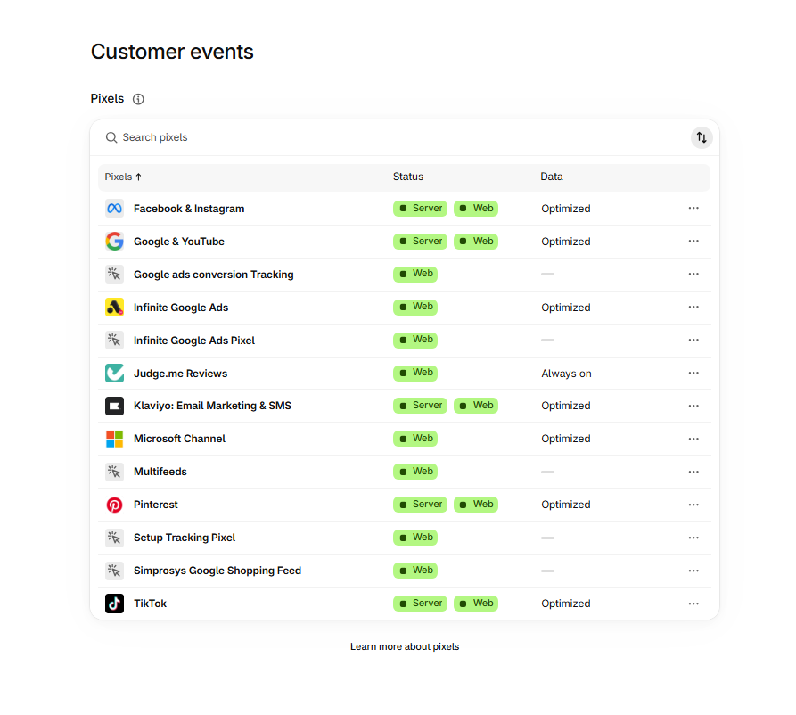
Shopify Customer Events — 5 Google pixels active simultaneously

Step 2 — Google & YouTube Pixel Detail
Clicked into Google & YouTube pixel. Data access was granted June 2026. No Measurement ID visible here — opened the app to get it.
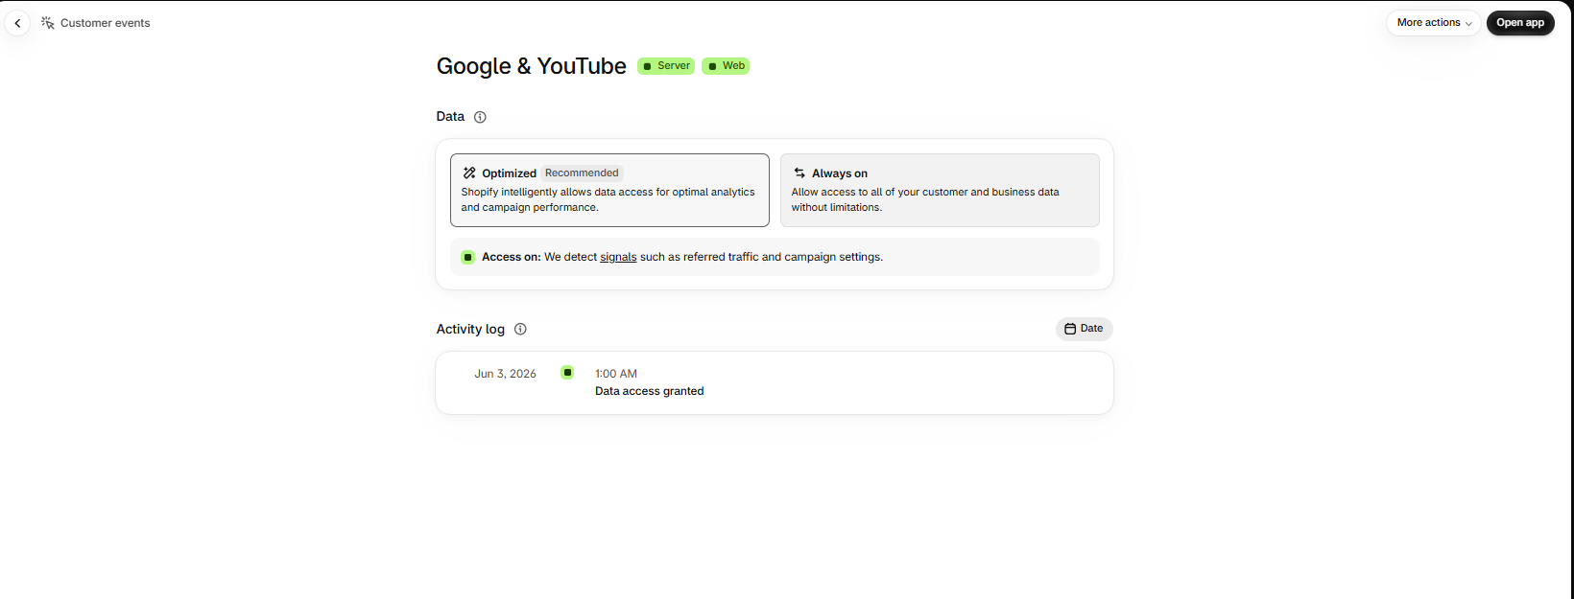
Google & YouTube pixel — data access granted Jun 2026

Step 3 — Measurement ID Confirmed
Opened the Google & YouTube app. Found the connected GA4 property:
• Google Analytics: G-YXN7NVRK1K (LEDSone neww)
• Google Ads: 4503486236 (LEDSone)
• Google Merchant Center: 5308512543
• Account: ledwebuk@gmail.com
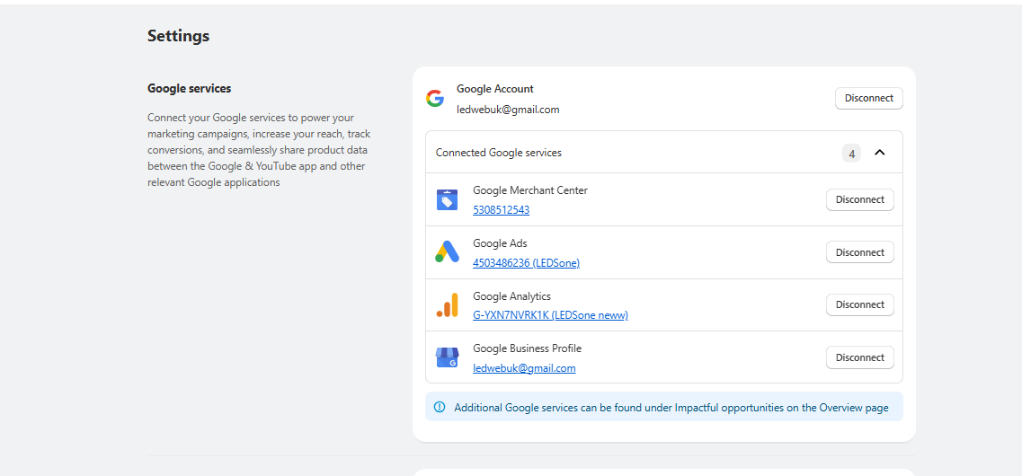
Google & YouTube app — Measurement ID G-YXN7NVRK1K confirmed

Step 4 — GA4 Property List Audit
Opened GA4. Found multiple properties under Ledsone LTD WebSite account:
• LEDSone neww (408110563) — Active, Shopify connected ✓
• Ledsone.co.uk - GA4 (268394549) — No data ✗
• LEDSONE UK - A4 Anal... (339887409) — Unknown
• ledsone_test (308114878) — Test property
• Electricalsone (197758311) — Separate site
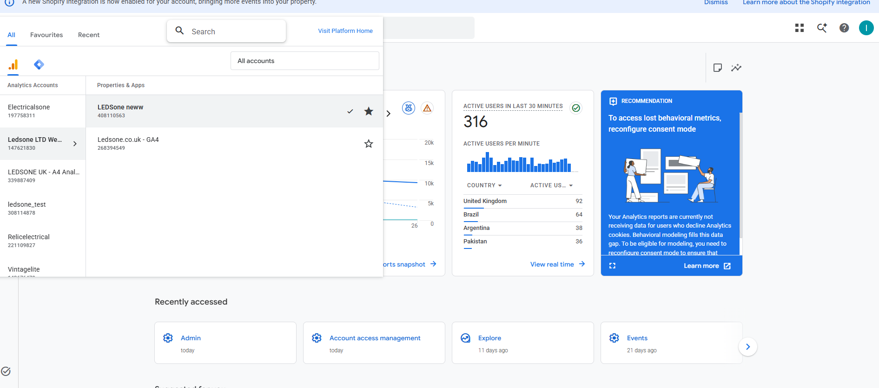
GA4 — All properties listed under Ledsone LTD WebSite

Step 5 — Wrong Property Check (268394549)
Checked Ledsone.co.uk - GA4 (268394549) — appeared to be the real property by name.
Finding: 'No data received in past 48 hours' — this property is NOT connected to anything. Can be ignored.
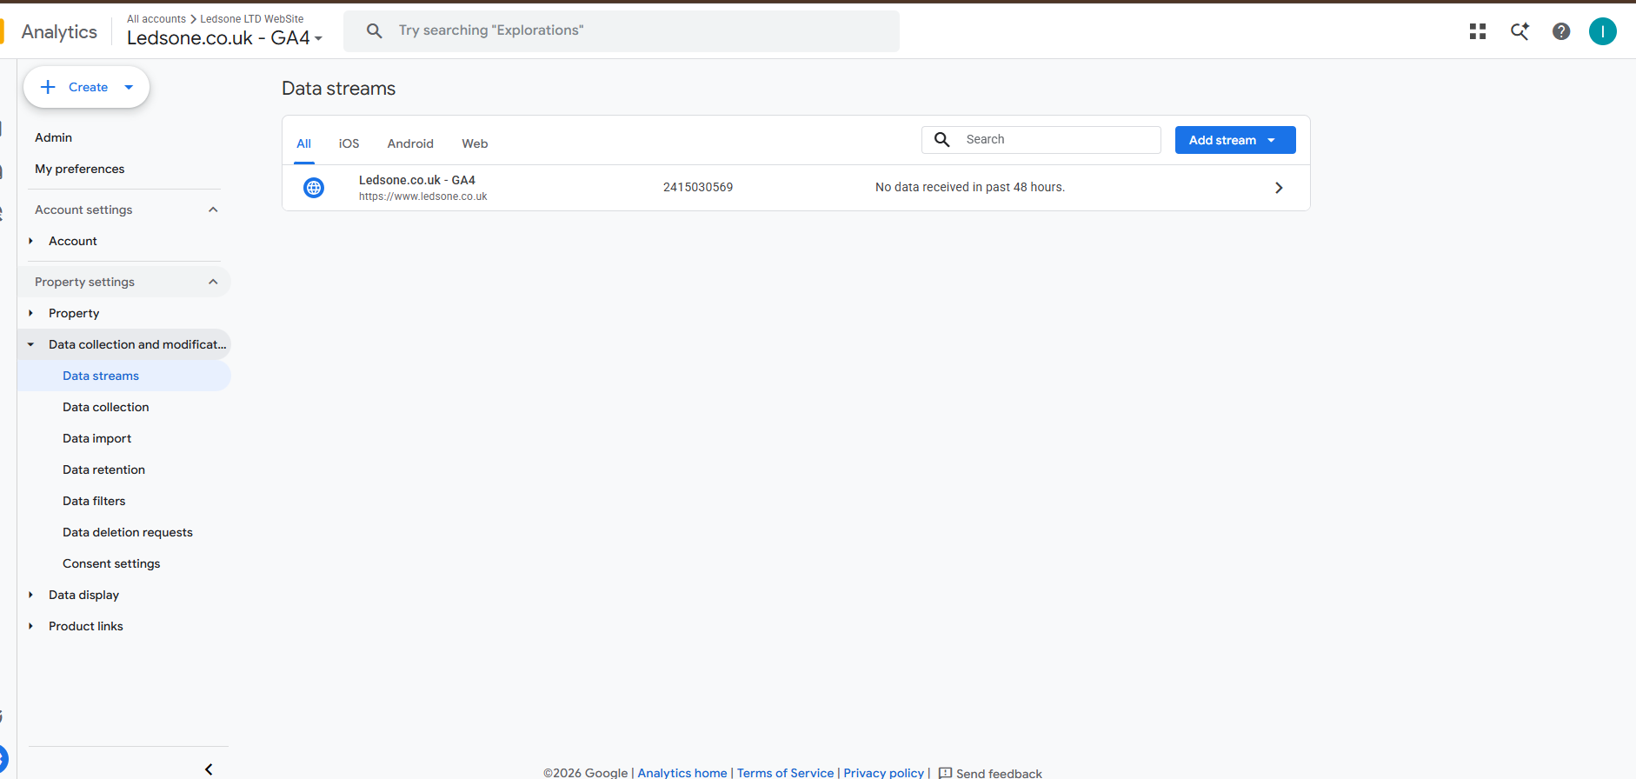
Ledsone.co.uk - GA4 (268394549) — no data received, wrong property

Step 6 — LEDSone neww Stream Confirmed Active
Checked stream details for LEDSone neww (408110563):
• Stream URL: https://ledsone.co.uk/ ✓
• Measurement ID: G-YXN7NVRK1K ✓
• Status: Data collection is active in past 48 hours ✓
• Enhanced measurement: ON
Conclusion: Shopify is connected to the correct property. Measurement ID is correct.
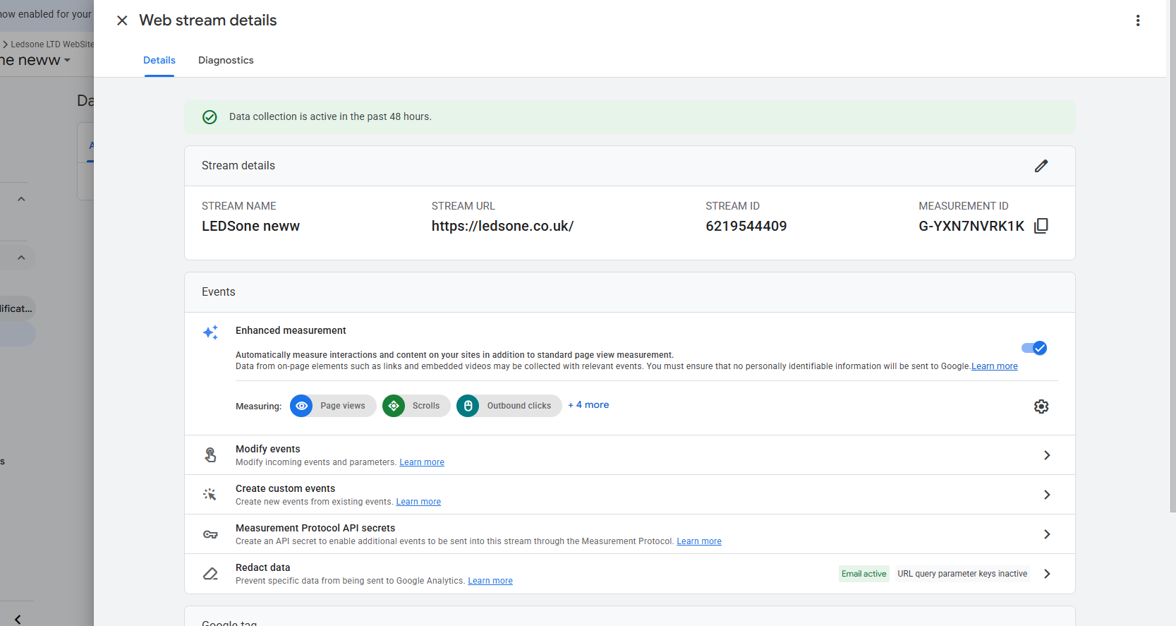
LEDSone neww — web stream active, correct URL, G-YXN7NVRK1K confirmed

Step 7 — Consent Settings Check
Checked Admin → Data collection → Consent settings.
Result: Excellent
• Behavioural analytics consent signals: Active ✓
• Advertising consent signals: Active ✓
• No issues detected
Consent mode is NOT the cause of the data gap.
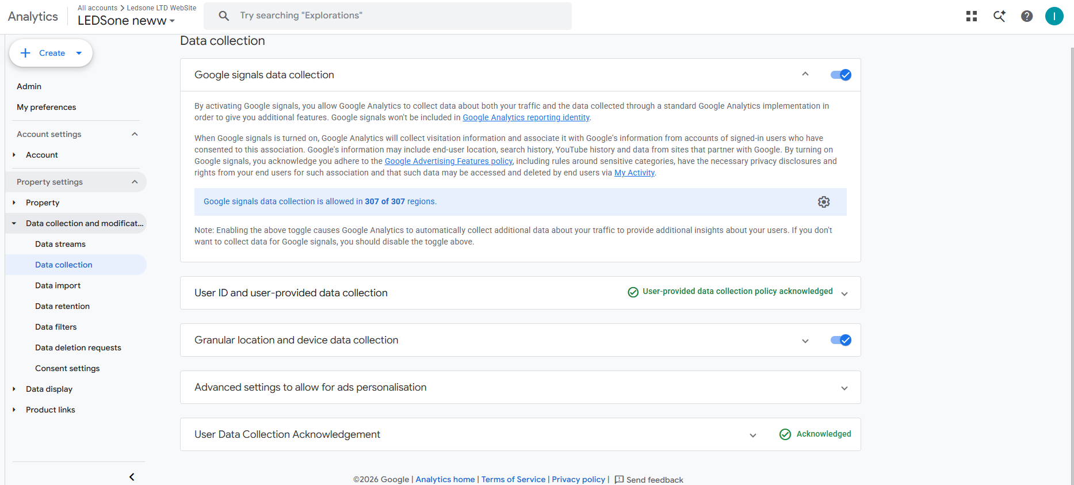
Consent settings — Excellent, all signals active

Step 8 — Traffic Acquisition (Session Campaign View)
Opened Reports → Acquisition → Traffic acquisition. Initial view showed Session campaign — organic fragmented. Switched to default channel group for accurate breakdown.
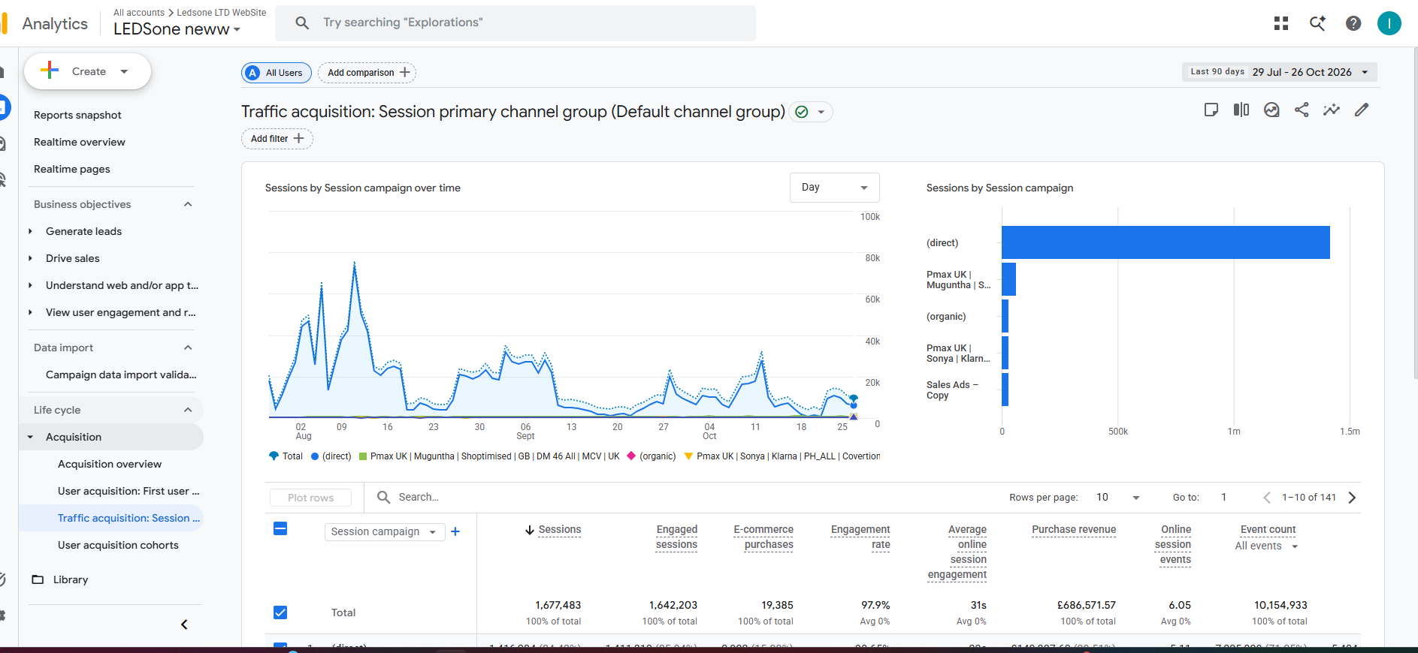
Traffic acquisition — session campaign view (initial)

Step 9 — Root Cause Found (Default Channel Group)
Switched to Session default channel group — full 90-day breakdown revealed the real problem.
Last 90 days (29 Jul – 26 Oct 2026):
• Direct: 1,416,284 sessions — 84.43% ← ABNORMAL
• Cross-network: 158,063 — 9.42%
• Organic Social: 42,681 — 2.54%
• Organic Search: 30,798 — 1.84% | 948 purchases | £37,250.89
• Unassigned: 25,309 — 1.51%
• Total: 1,677,483 sessions | 19,385 purchases | £686,571.57
84.43% Direct is not normal. Normal e-commerce benchmark is 20–30%. Organic visitors are losing referrer data and being counted as Direct.
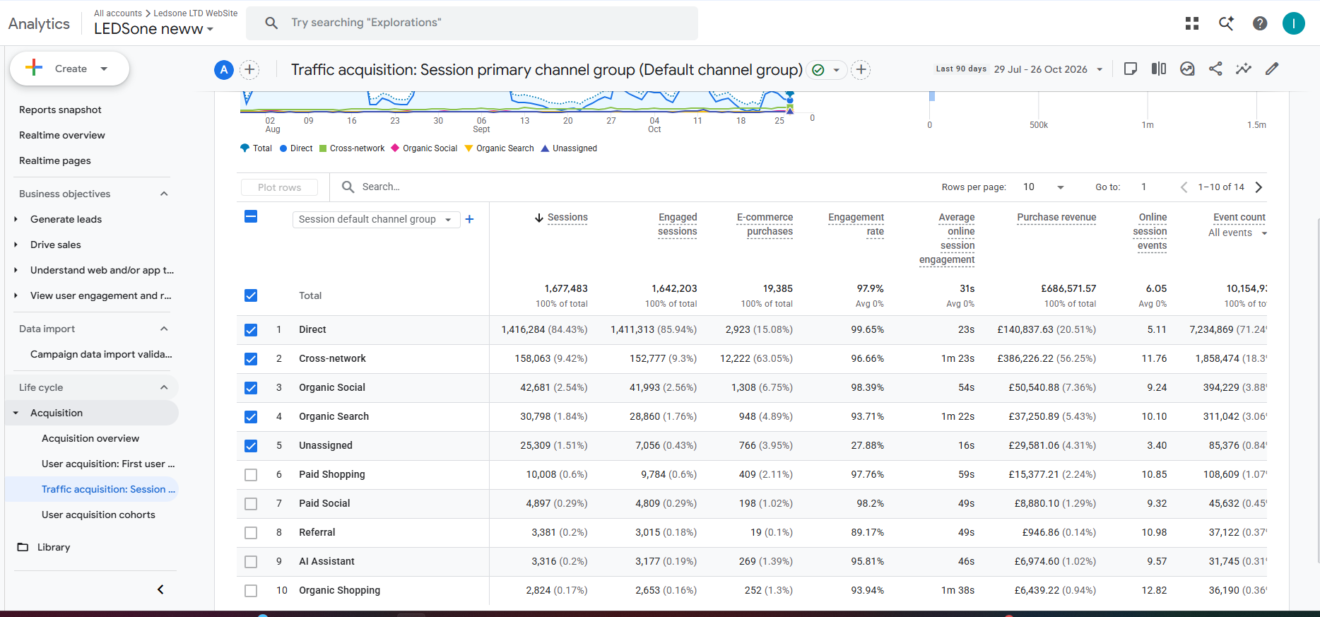
Traffic acquisition — default channel group — 84% Direct confirmed

Root Cause Summary
Referrer data is being lost before GA4 receives it. Most likely cause: redirect chains (e.g. ledsone.co.uk → www.ledsone.co.uk) strip the HTTP referrer header. GA4 sees no source/medium and defaults to Direct.
What IS working:
• GA4 connected and active ✓
• Correct measurement ID ✓
• Purchase events firing (948 purchases, £37k organic revenue) ✓
• Consent mode configured correctly ✓

Next Steps
Priority | Action
HIGH | Test redirect chain — does ledsone.co.uk redirect to www? Does referrer survive?
HIGH | GA4 DebugView — open incognito, click Google result, check source/medium recorded
MEDIUM | Review 5 simultaneous Google pixels — check for session inflation
MEDIUM | UTM tag internal links to recover 25k Unassigned sessions

