C5 - Fix GA4 Purchase Tracking on ledsone.co.uk
Task ID: BP-8917
Date: 2026-10-27 to 2026-10-28
Due: Fri 30 Oct
Investigated by: Piranavan
Status: DONE - Investigation complete + double firing confirmed + fix applied 28 Oct 2026 12:27

Original Task Description
"Piranavan: fix GA4 purchase tracking on ledsone.co.uk so organic conversions can be counted. GA4 property 408110563 records 2,043 organic sessions over 90 days, while Search Console shows approximately 1,500-1,700 organic clicks weekly - suggesting roughly 9 of every 10 organic visits go unrecorded. Verify the GA4 measurement ID in the Shopify theme/pixel aligns with the web stream and confirm purchase events include the Shopify order number."
Two specific things asked:
1. Verify GA4 measurement ID in Shopify aligns with the web stream
2. Confirm purchase events include the Shopify order number

Final Verdict
The tracking issue described in the original task no longer exists. During investigation, an additional critical problem was found and fixed: GA4 was double counting every purchase due to two apps both firing purchase events to the same GA4 property.
Original Claim | Verified Result | Status
GA4 only 2,043 organic sessions in 90 days | GA4 shows 31,128 organic sessions | NOT CONFIRMED - was wrong data
9 of 10 organic visits unrecorded | GA4 (31,128) > Search Console (18,700) - healthy | NOT CONFIRMED - tracking working
Measurement ID correct | G-YXN7NVRK1K confirmed in Shopify | CONFIRMED
Purchase events include Shopify order number | Numeric transaction IDs confirmed in GA4 | CONFIRMED
NEW FINDING: GA4 double counting | GA4 19,487 vs Shopify 11,009 purchases (90 days) | FOUND AND FIXED 28 Oct

Why the Original 2,043 Figure Was Wrong
Option A - Already fixed before task was assigned
Infinite Google Ads (server-side tracking) was installed September 2025 to fix a Shopify tracking gap after Shopify updates in June 2025. The 2,043 figure was from before this fix.
Option B - Wrong GA4 property was checked
- LEDSone neww (408110563) - connected to Shopify, active
- Ledsone.co.uk - GA4 (268394549) - no data, not connected
The 2,043 may have come from checking property 268394549.
Option C - Both A and B combined.
All three scenarios lead to the same conclusion: tracking is working correctly now.

Full Investigation - Step by Step (26 Steps Total)

Step 1 - Shopify Customer Events (Pixel Audit)
Checked Shopify Settings > Customer Events.
Found 5 Google-related pixels active simultaneously:
- Google & YouTube (Server + Web)
- Google ads conversion Tracking (Web only)
- Infinite Google Ads (Web only)
- Infinite Google Ads Pixel (Web only)
- Setup Tracking Pixel (Web only)
Risk flagged: Multiple Google pixels active at the same time can cause session inflation and duplicate conversion counts.
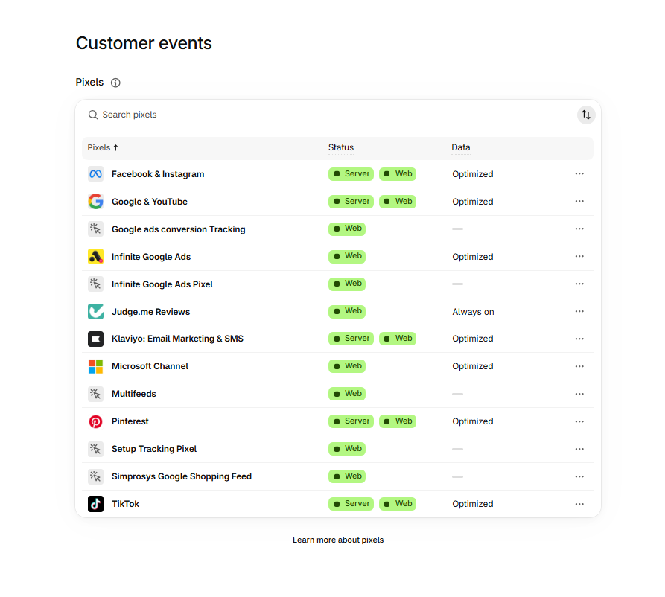
Step 1 - Shopify Customer Events - 5 Google pixels active simultaneously

Step 2 - Google & YouTube Pixel Detail
Clicked into Google & YouTube pixel. Data access granted June 2026. Connected to ledwebuk@gmail.com. No Measurement ID visible at pixel level - opened the app to check.
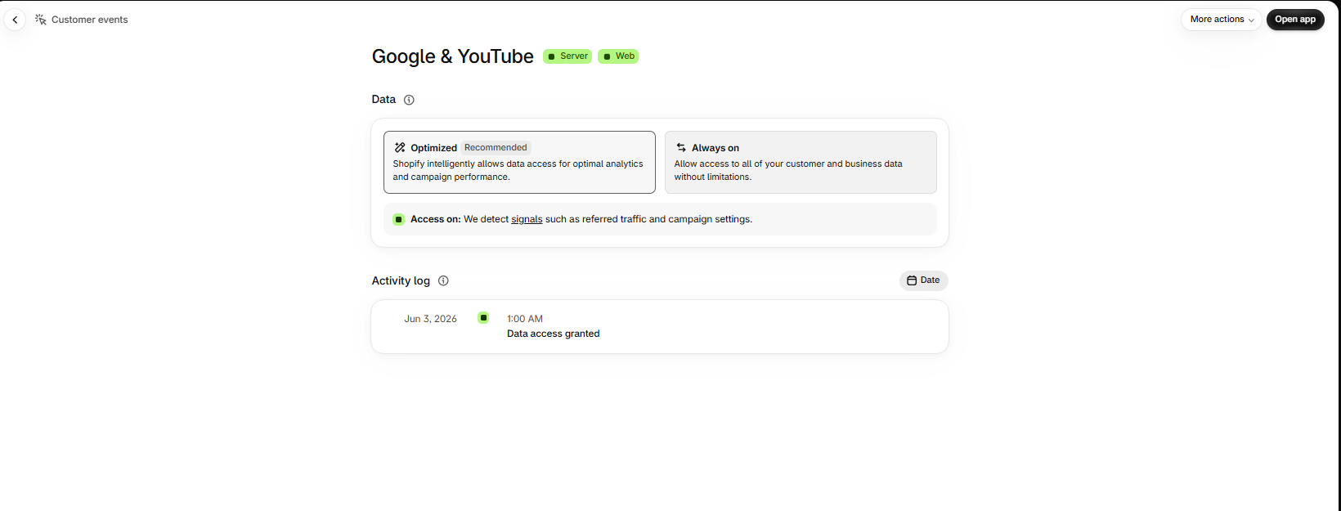
Step 2 - Google & YouTube pixel - data access granted Jun 2026

Step 3 - Measurement ID Confirmed in Google & YouTube App
Opened the Google & YouTube app. Confirmed connected services:
- Google Analytics: G-YXN7NVRK1K (LEDSone neww) - CORRECT
- Google Ads: AW-904743911
- Google Merchant Center: 5308512543
- Account: ledwebuk@gmail.com
Measurement ID G-YXN7NVRK1K is correctly connected to the right GA4 property.
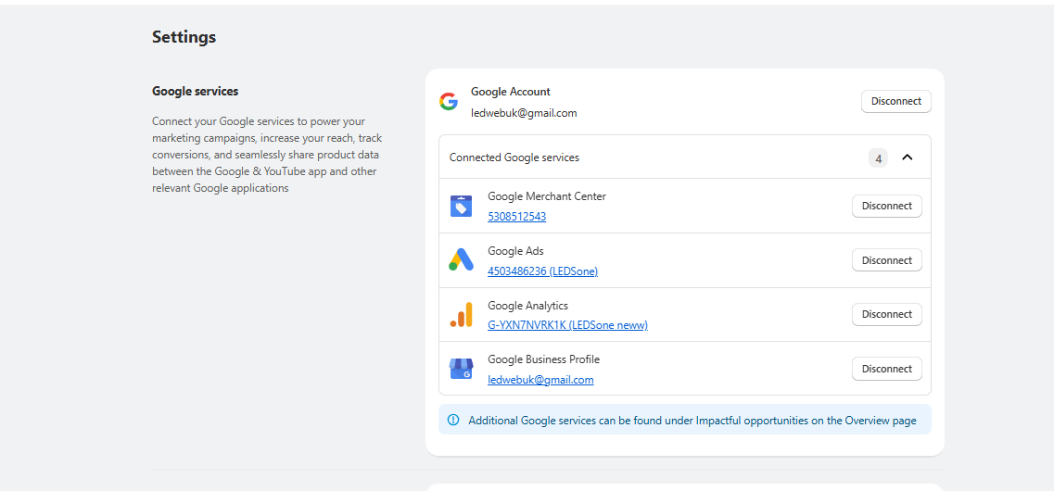
Step 3 - Google & YouTube app - G-YXN7NVRK1K confirmed connected to LEDSone neww

Step 4 - GA4 Property List Audit
Opened GA4. Multiple properties found under Ledsone LTD WebSite account:
Property Name | Property ID | Status
LEDSone neww | 408110563 | Active - Shopify connected - CORRECT property
Ledsone.co.uk - GA4 | 268394549 | No data received - NOT connected
LEDSONE UK - A4 Anal... | 339887409 | Unknown
ledsone_test | 308114878 | Test property only
Electricalsone | 197758311 | Separate site - not ledsone.co.uk

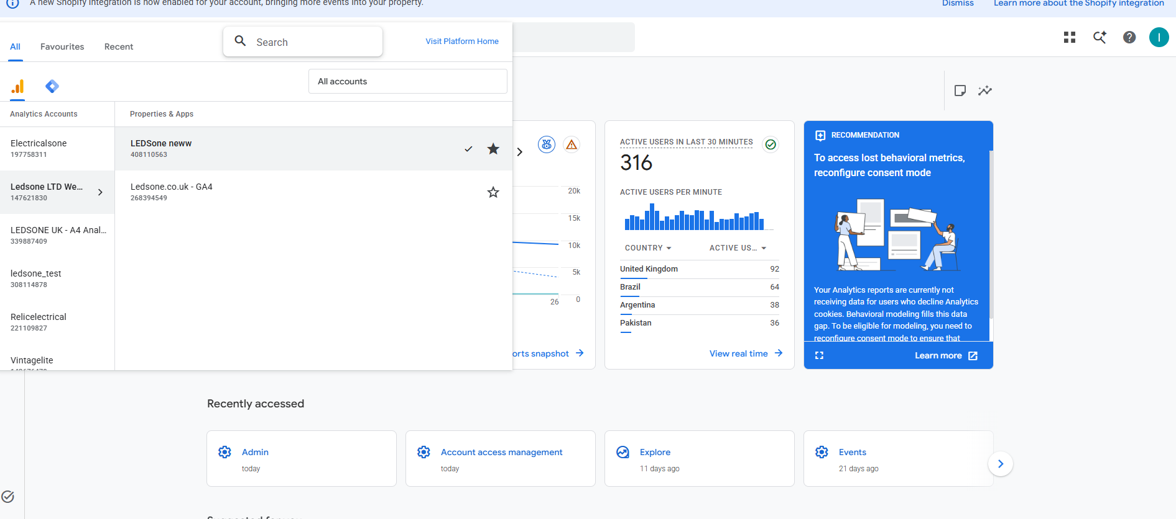
Step 4 - GA4 property list - multiple properties found

Step 5 - Wrong Property Identified (Source of 2,043 Figure)
Checked Ledsone.co.uk - GA4 (268394549) - this property was named to look like the real one.
Result: 'No data received in past 48 hours'
This property is not connected to anything. This is almost certainly the source of the original 2,043 organic session figure in the task description. Whoever checked GA4 before assigning this task was looking at the wrong property.
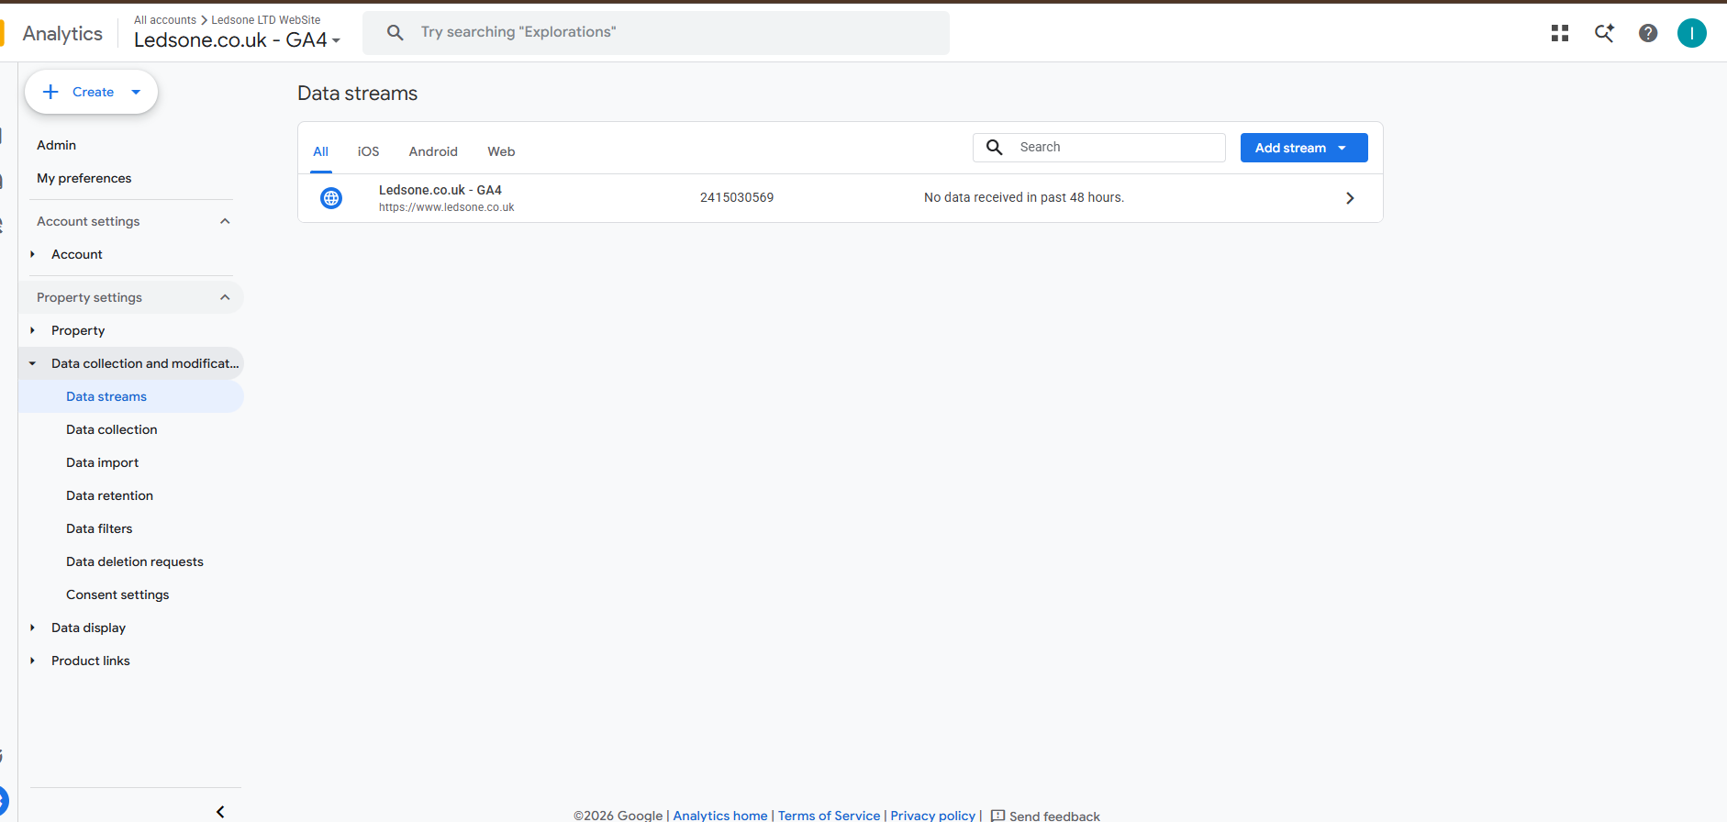
Step 5 - Wrong property 268394549 - no data received - explains the 2,043 figure

Step 6 - Correct Stream Confirmed Active
Checked web stream details for LEDSone neww (408110563):
- Stream Name: LEDSone neww
- Stream URL: https://ledsone.co.uk/
- Stream ID: 6219544409
- Measurement ID: G-YXN7NVRK1K
- Status: Data collection is active in past 48 hours
- Enhanced measurement: ON (Page views, Scrolls, Outbound clicks + 4 more)
Shopify is connected to the correct property. Measurement ID is correct.
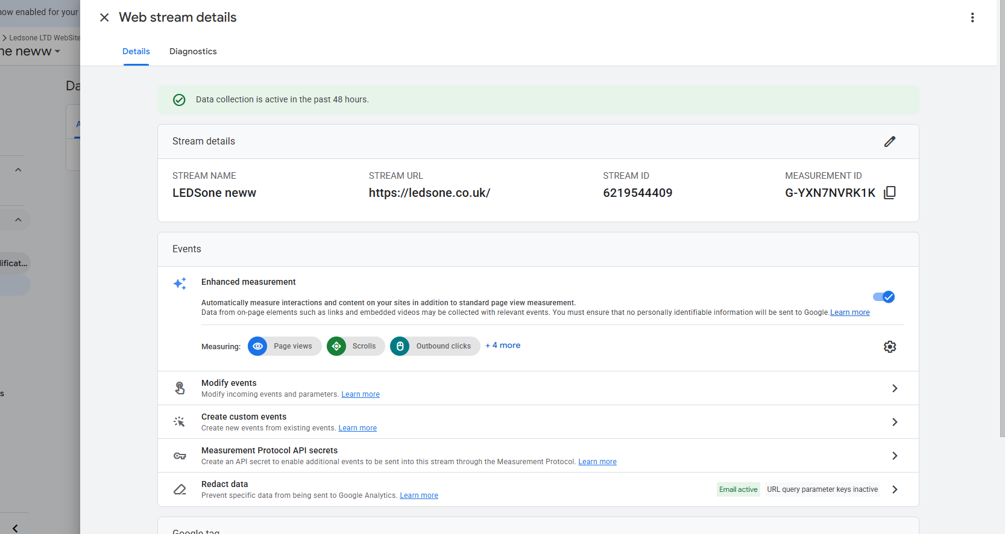
Step 6 - LEDSone neww stream - active, correct URL, G-YXN7NVRK1K confirmed

Step 7 - Consent Settings Check
Checked GA4 Admin > Data collection > Consent settings.
Result: Excellent
- Behavioural analytics consent signals: Active
- Advertising consent signals: Active
- No issues detected
Consent mode is NOT the cause of any data gap.
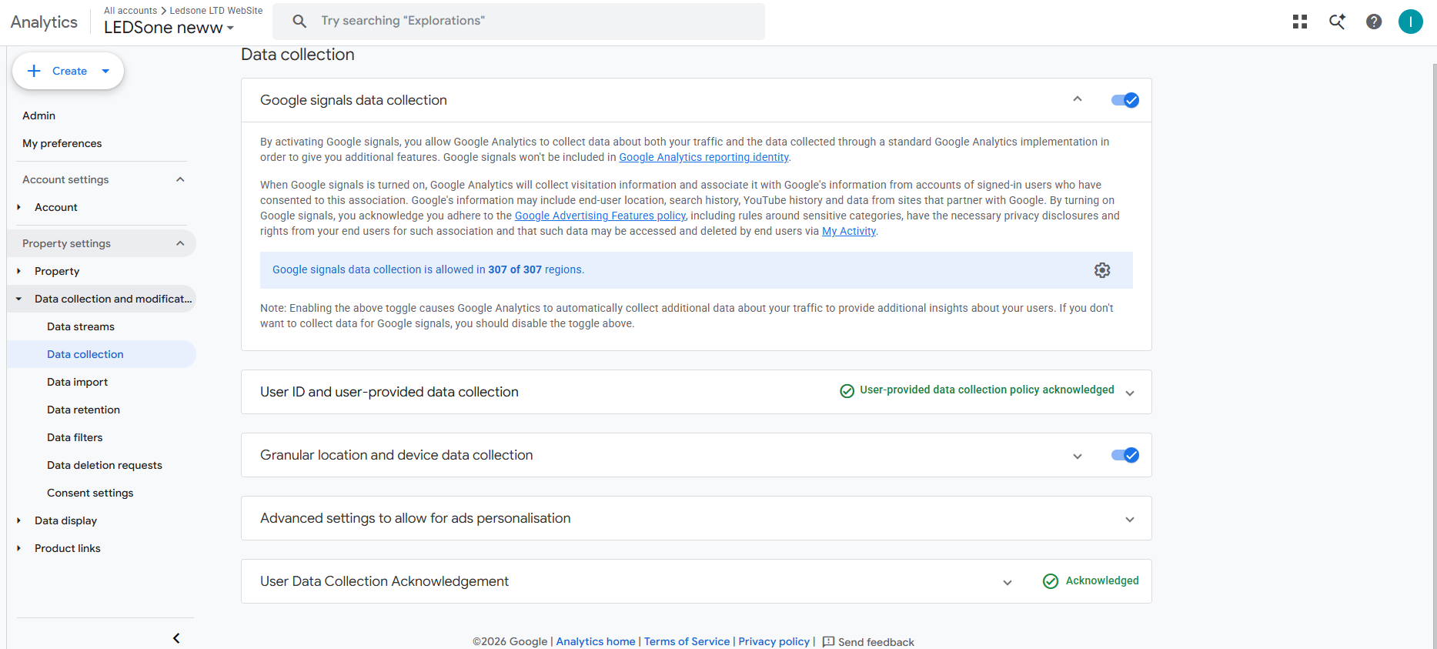
Step 7 - Consent settings - Excellent, all signals active

Step 8 - Traffic Acquisition Initial View
Opened GA4 Reports > Acquisition > Traffic acquisition. Initial view showed Session campaign - organic data was fragmented across many campaigns making it hard to read. Switched to Session default channel group.
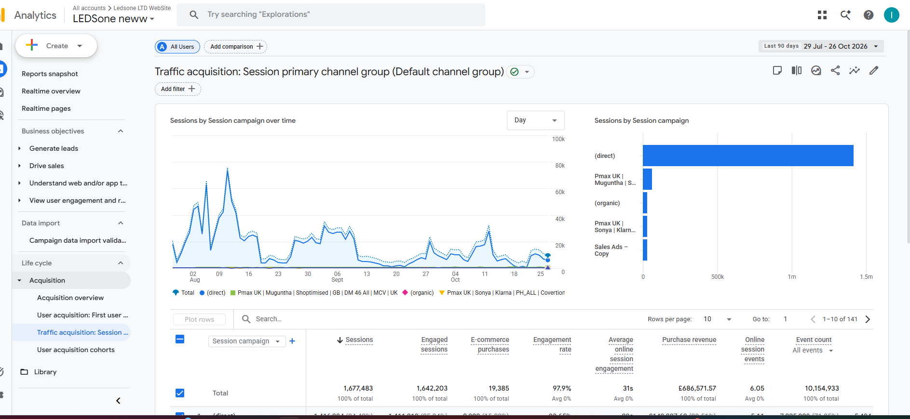
Step 8 - Traffic acquisition - session campaign view (initial, fragmented)

Step 9 - 84% Direct Traffic Found
Switched to Session default channel group. Last 90 days (29 Jul - 26 Oct 2026):
Channel | Sessions | Percentage | Purchases | Revenue (GBP)
Direct | 1,399,906 | 84.33% | 2,937 | 141,843
Cross-network | 160,702 | 9.68% | 12,275 | 388,367
Organic Social | 42,793 | 2.58% | 1,312 | 51,109
Organic Search | 31,128 | 1.88% | 965 | 37,680
Unassigned | 25,215 | 1.52% | 774 | 30,171
TOTAL | 1,660,072 | 100% | 19,487 | 691,698

84% Direct traffic flagged as abnormal (normal benchmark: 20-30%). Investigated to find root cause.
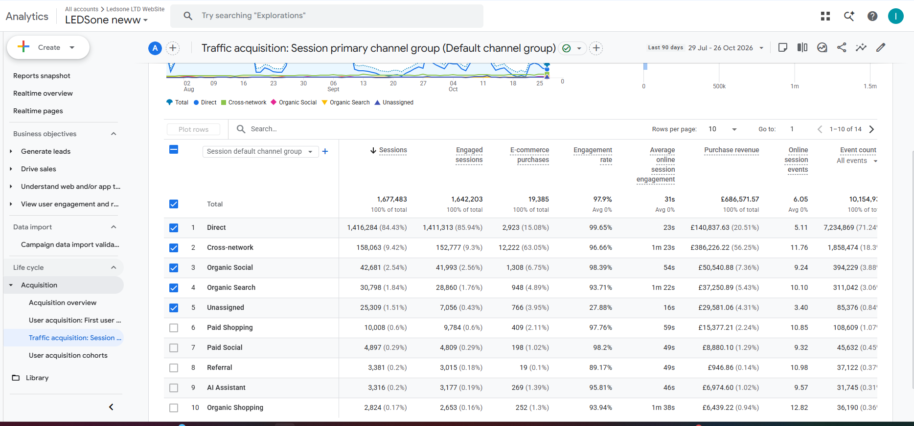
Step 9 - Traffic acquisition - default channel group - 84% Direct found

Step 10 - Redirect Chain Test
Tested http://ledsone.co.uk in incognito browser to check if redirect chain was stripping referrer headers and causing sessions to appear as Direct.
Result: Only 1 redirect - http://ledsone.co.uk to https://ledsone.co.uk
- No www redirect
- Clean single hop
Redirect chain is NOT the cause of 84% Direct traffic.
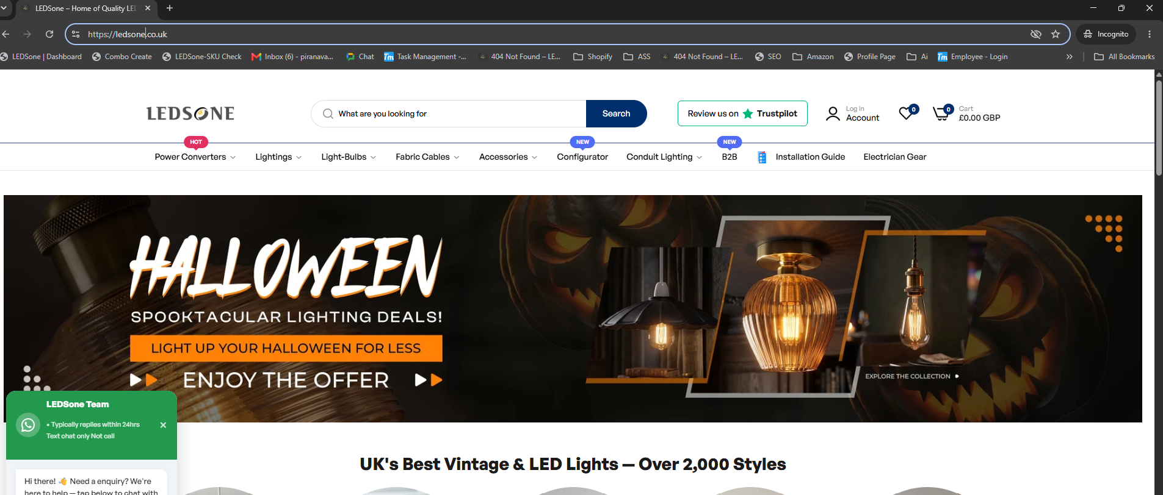
Step 10 - Redirect chain test - single hop only, not causing referrer loss

Step 11 - GA4 DebugView Check
Opened GA4 Admin > DebugView to check real-time session source recording. Debug Device showed 0 connected devices. Page view event visible but session source not readable without Tag Assistant. Proceeded to install Tag Assistant Chrome extension.
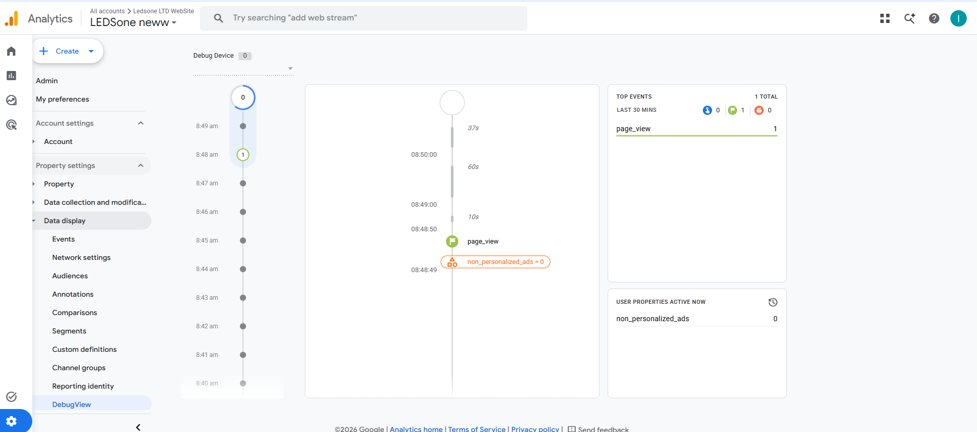
Step 11 - GA4 DebugView - page_view event visible, no device connected yet

Step 12 - Tag Assistant Installed
Installed Tag Assistant Chrome extension. Connected browser to ledsone.co.uk.
Tags found firing on ledsone.co.uk:
- GTM-KJGF2S5Q - Infinite Google Ads GTM Container
- G-YXN7NVRK1K
- AW-904743911
- 3 more tags = 5 tags total firing
Finding: Infinite Google Ads has its own GTM container injecting multiple tags separately from Shopify native pixels.
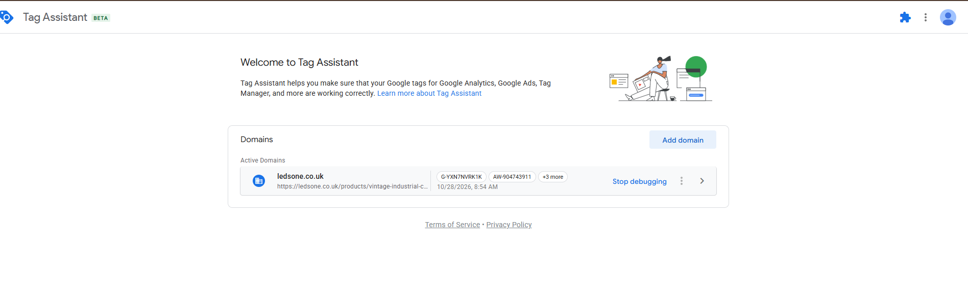
Step 12 - Tag Assistant - GTM-KJGF2S5Q (Infinite Google Ads) found on ledsone.co.uk

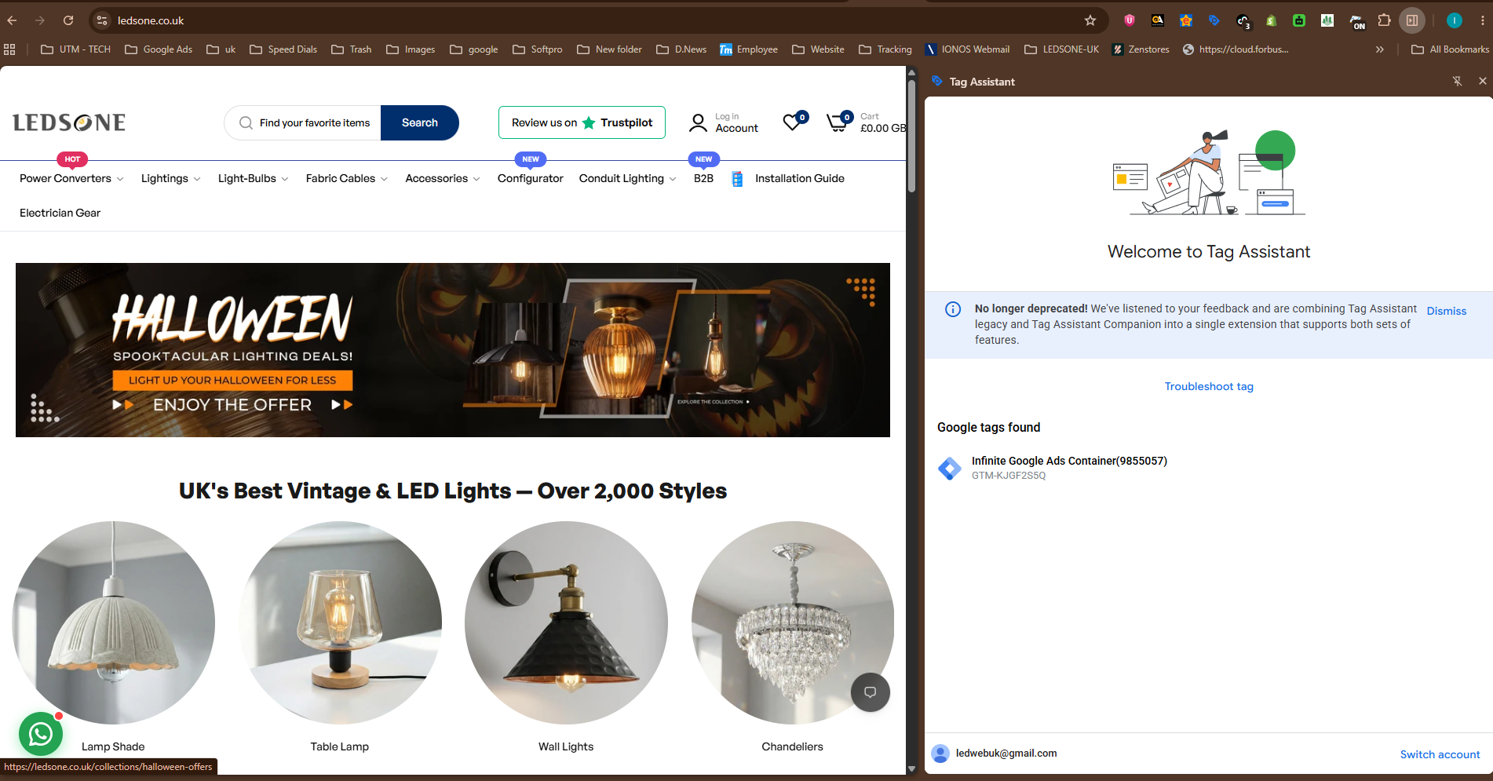
Step 12b - Tag Assistant extension - 5 Google tags confirmed firing

Step 13 - Infinite Google Ads App Investigation
Checked Shopify Admin > Apps > Infinite Google Ads.
- Installed: September 19, 2025
- Purpose: Accurate Google Ads Conversion Tracking & Google Tag Manager
- Billing: $19.99/month
- Pixels: Connected (Optimized)
- Extensions: 1 active (Online Store)
- Activity: No activity in last 30 days
Investigated why this app exists alongside Google & YouTube app.
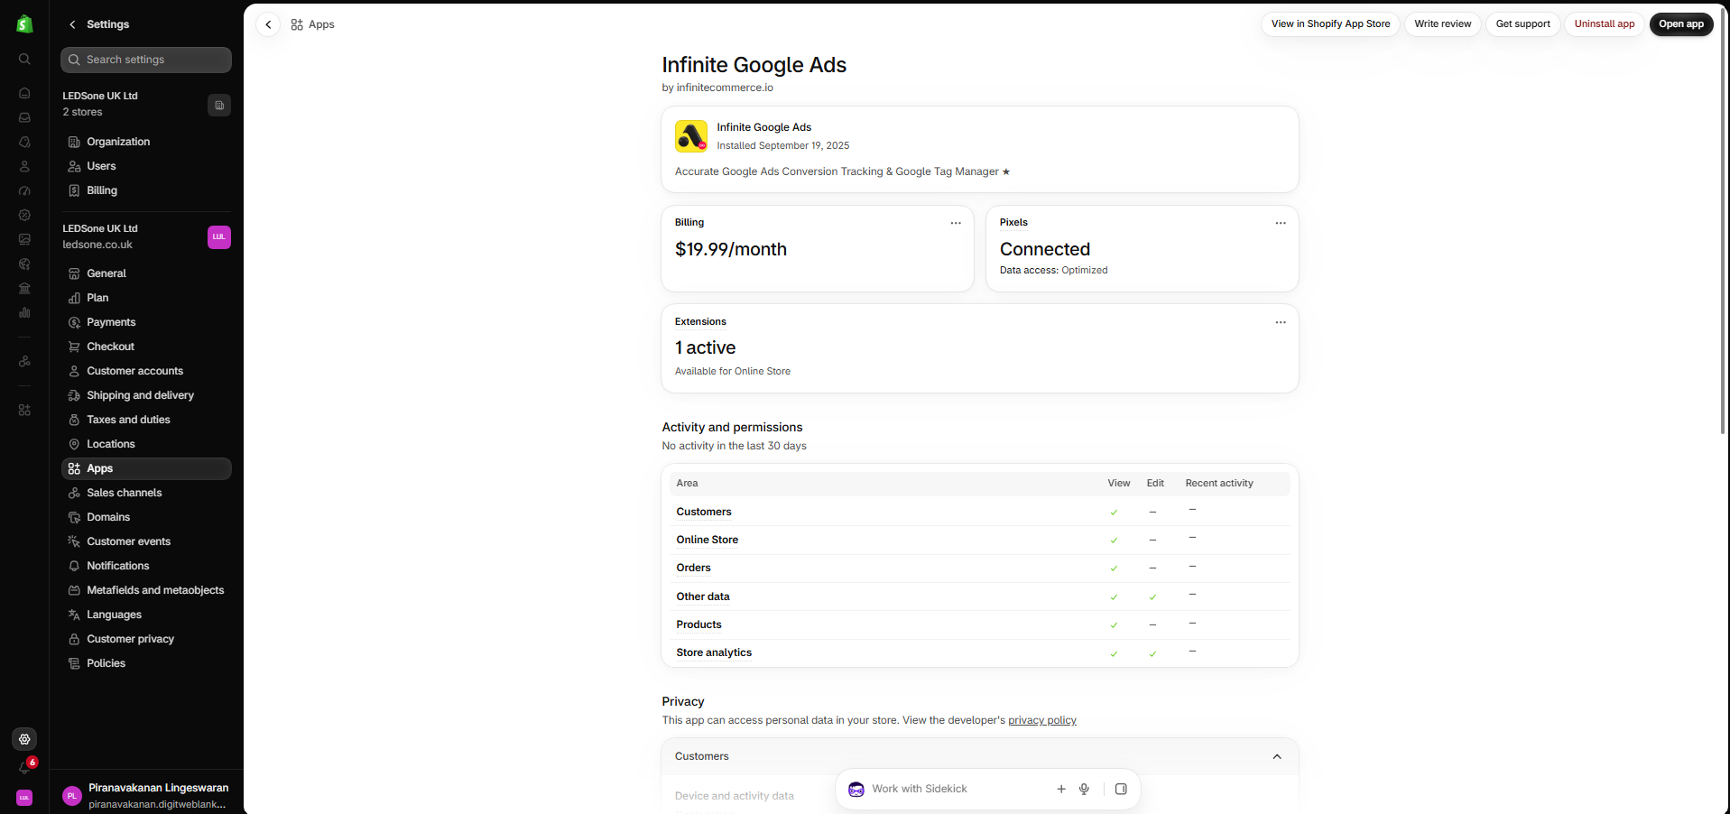
Step 13 - Infinite Google Ads app - $19.99/month, installed Sep 2025

Step 14 - Infinite Google Ads Account Verified
Opened the Infinite Google Ads app settings to check connected accounts.
- Ads Account: LEDSone / 4503486236
- GTM Account: ledsone uk ltd
- GTM Container: GTM-KJGF2S5Q
- Google Pixel ID: AW-904743911
Same Google Ads account (AW-904743911) as the Google & YouTube app. Initially appeared as a duplicate setup - team was consulted to confirm.
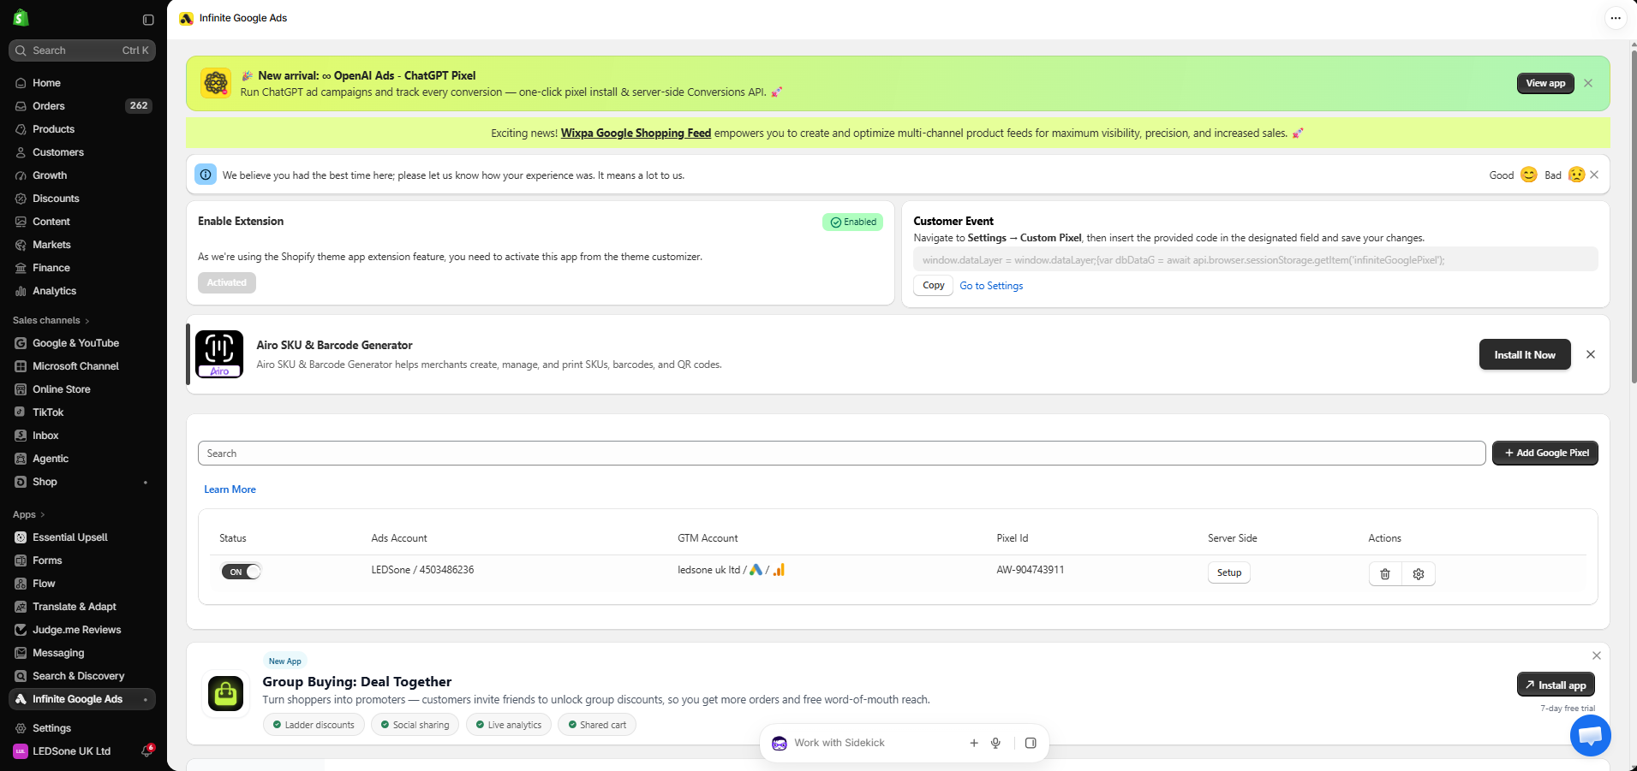
Step 14 - Infinite Google Ads - connected to LEDSone AW-904743911

Step 15 - Team Confirmation (Why Infinite Google Ads Was Installed)
Asked the team why this app exists alongside Google & YouTube.
Jefri (Google Ads manager):
"After the Shopify updates around June 2025, conversion data stopped showing up properly on Google Ads and Shopify. Our old gtag setup was not working like it used to, so we installed the Infinite Google Ads app to fix the tracking."
Sonya (Digital):
"The Infinite series of apps provide server-side conversion tracking and first-party data collection. Due to iOS privacy restrictions and browser ad-blockers, standard browser-based pixels often miss 20% to 30% of actual e-commerce transactions. By shifting the tracking from the browser to the server side, this setup ensures data accuracy across the entire marketing ecosystem."
Sajeepan:
"We are using the Infinite Google Ads app to support multiple conversion tracking setups across our 3 GMC configurations. Some conversions were not being recorded correctly, potentially due to tracking changes and browser cookie restrictions. The app is intended to improve tracking reliability and conversion reporting."
Conclusion: App is intentional, critical, and must NOT be removed.
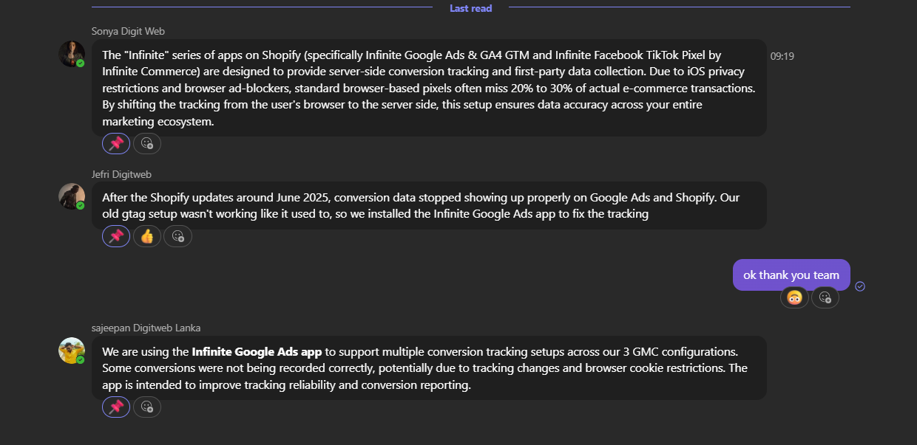
Step 15 - Team confirmation - server-side tracking intentional, installed after Jun 2025 Shopify break

Step 16 - 84% Direct Verified as Server-Side Behaviour (7-Day Check)
Checked if Direct traffic was consistently high across all 7 days (to confirm it is not a spike).
Last 7 days:
- Direct: 50,894 sessions (65.58%)
- Cross-network: 15,685 (20.21%)
- Organic Social: 3,621 (4.67%)
- Organic Search: 2,629 (3.39%)
Direct is consistently 65%+ every single day - flat dominant line across the whole week. This confirms server-side tracking behaviour, not a random issue or spike.
Also noted: Direct has 65% of sessions but only 14% of purchases - server-side sessions are mostly non-converting visits. Real converting traffic is correctly attributed under Cross-network and Organic channels.
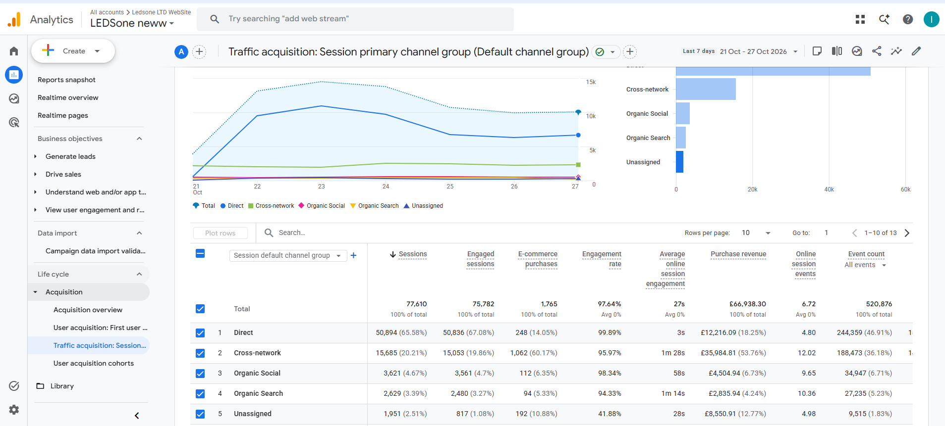
Step 16 - GA4 last 7 days - Direct consistently 65% every day confirming server-side pattern

Step 17 - Google Ads vs GA4 Conversion Comparison
Cross-checked Google Ads conversions (last 30 days) against GA4 to verify server-side tracking is adding real value:
Conversion Action | Source | Count (30 days) | Value (GBP)
Purchase (Google Analytics GA4) | GA4 browser-side | 5,515 | 182,025
Purchase (InfinitePi) | Infinite Google Ads server-side | 2,842 | 98,782
G-Google Shopping App Purchase | Website / browser | 2,991 | 97,539
LEDSone neww add_payment_info | GA4 | 1,946 | 72,046

Server-side captures 2,842 additional purchases worth 98,782 GBP that browser GA4 missed.
Without Infinite Google Ads, 98k in conversions would be invisible to Google Ads.
This confirms the app is working as intended and is critical to keep.
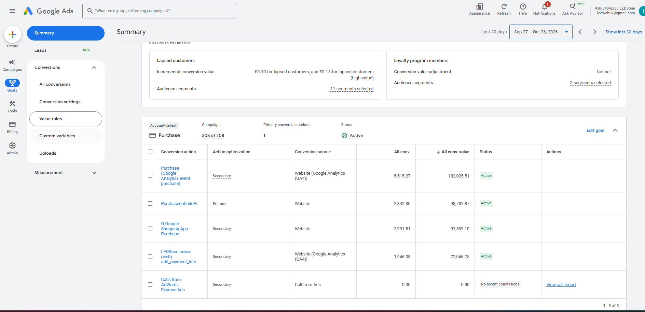
Step 17 - Google Ads conversions - server-side InfinitePi adds 2,842 purchases (98k GBP)

Step 18 - GA4 E-Commerce Purchases by Product
Checked GA4 Monetisation > E-commerce purchases to verify purchase events are firing at product level.
Last 7 days:
- Total items viewed: 42,447
- Items added to cart: 6,806
- Items purchased: 5,680
- Revenue: 66,468.57 GBP
Purchase events are firing correctly at product level.
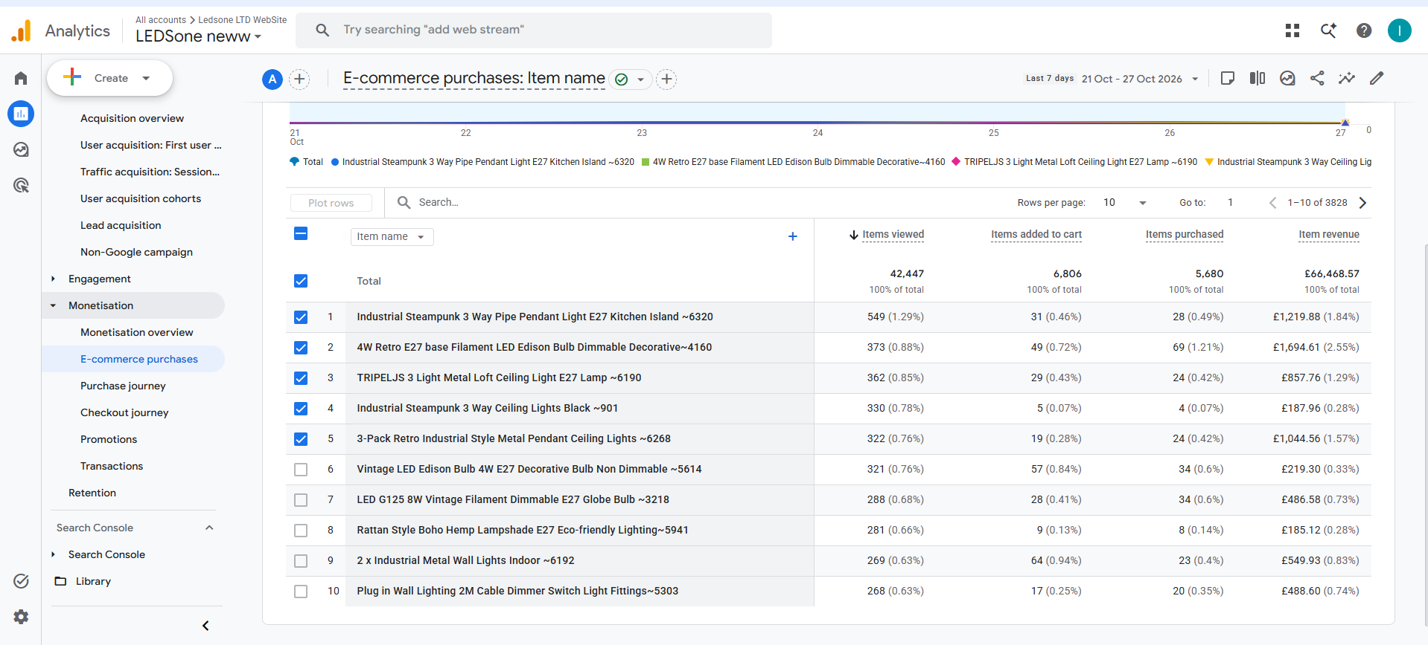
Step 18 - GA4 E-commerce purchases by item - 5,680 purchased, 66,468 GBP revenue

Step 19 - Transaction IDs Checked (Shopify Order Numbers)
Checked GA4 Monetisation > Transactions. Last 7 days: 1,765 purchases, 66,938 GBP.
ID Type | Example | What It Is | Status
Numeric | 13738544857474 | Real Shopify order number | Correct - from Google & YouTube
UUID | 54cd4d4a-2e18-4675-9c24-aaf9522266a7 | Random ID generated by Infinite Google Ads | Duplicate - investigated in Steps 21-25
Not set | - | Missing transaction ID | 8 purchases, low priority

Shopify order numbers are passing correctly for browser-tracked purchases. UUID format is from Infinite Google Ads server-side. Further investigation below confirmed these UUIDs are causing double counting.
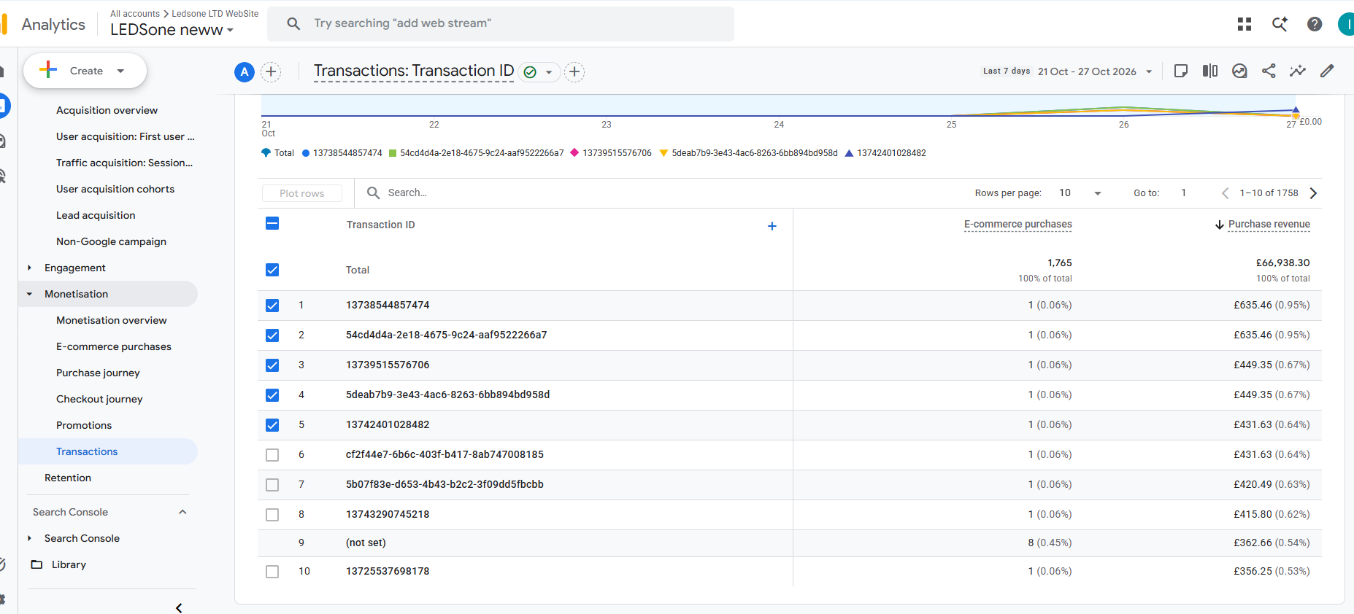
Step 19 - GA4 Transactions - numeric Shopify order IDs and UUID server-side IDs visible

Step 20 - Final Cross-Platform Verification (90 Days)
Platform | Metric | 90-Day Value
GA4 | Organic Search Sessions | 31,128
Search Console | Total Clicks (Google only) | 18,700
Difference | GA4 > GSC by 12,428 sessions | Normal - explained below

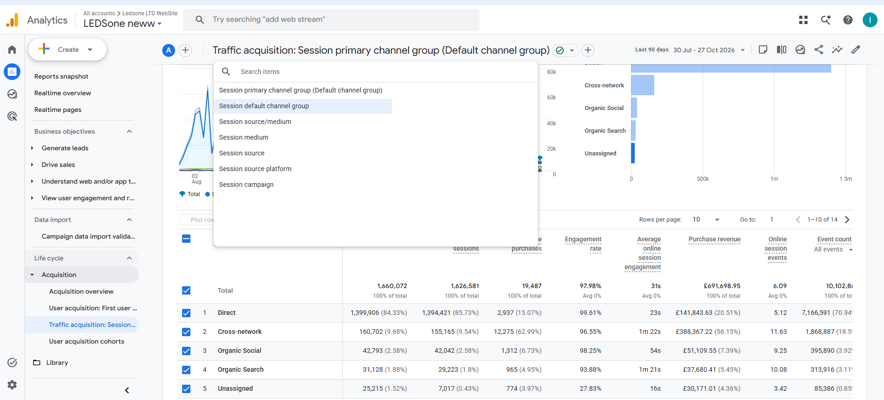
Step 20a - GA4 last 90 days - Organic Search 31,128 sessions

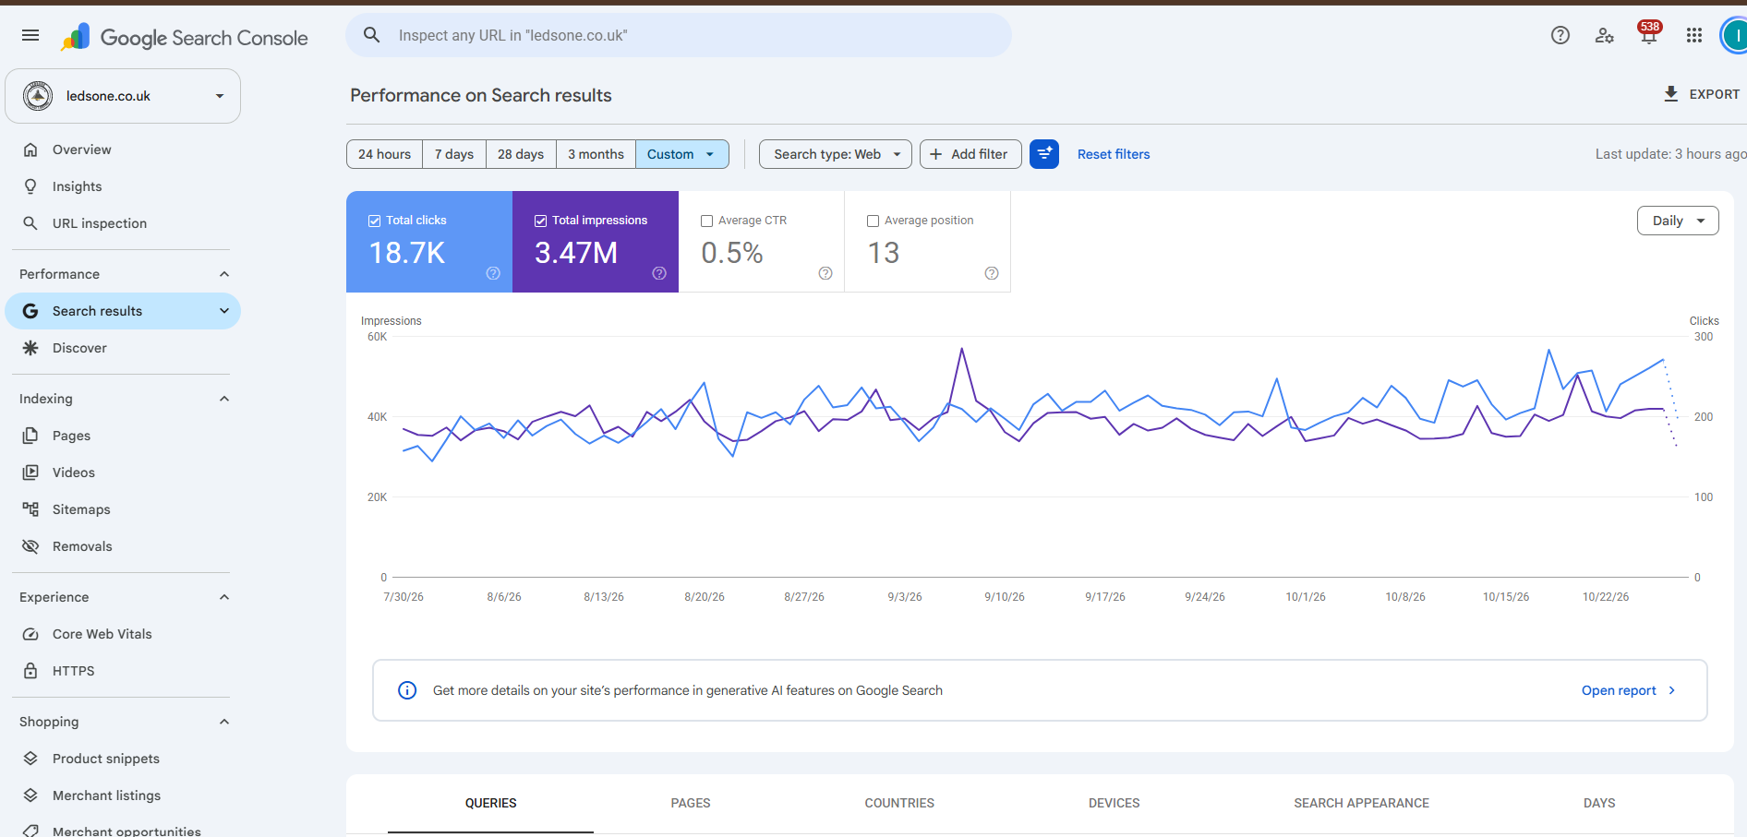
Step 20b - Search Console last 90 days - 18,700 total clicks

Why GA4 > Search Console Is Normal
Search Console counts clicks from Google Search only.
It does NOT count visitors from Bing, Yahoo, DuckDuckGo, or any other search engine.
GA4 Organic Search counts ALL search engines: Google + Bing + Yahoo + DuckDuckGo + all others.
Comparison:
- Search Console: 18,700 = Google clicks only
- GA4 Organic: 31,128 = Google + all other search engines
- Difference of 12,428 = non-Google organic traffic (Bing, Yahoo, etc)
GA4 showing MORE than Search Console = tracking working correctly.
GA4 showing LESS than Search Console = tracking broken.
The original task claimed GA4 showed only 2,043 sessions - that figure was from the wrong property (268394549).

Step 21 - GA4 Purchase Double Counting Discovered (Critical)
While verifying transaction IDs, revenue totals did not match Shopify:
90-day comparison:
- GA4 purchases: 19,487
- Shopify orders: 11,009
- Ratio: 1.77x (GA4 almost double)
7-day revenue comparison:
- GA4 total revenue: 66,938.30 GBP
- Shopify revenue: 38,288.74 GBP
- Ratio: 1.75x overcounting
This indicated every order was being counted approximately twice in GA4.

Step 22 - GA4 Explore: Matching Revenue Pairs Found
Created GA4 Explore with:
- Dimension: Transaction ID
- Metric: Purchase revenue (E-commerce)
- Date: 20-26 Oct 2026
- Sort: Revenue descending
Result: Same revenue amounts appearing under two different IDs - one numeric, one UUID.
Numeric ID (Google & YouTube) | UUID (Infinite Google Ads) | Revenue | Verdict
13738544857474 | 54cd4d4a-2e18-4675-9c24-aaf9522266a7 | 635.46 GBP each | SAME ORDER - double counted
13725537698178 | 3223d257-9a7b-41d0-b6a1-3e9bae8bb0cd | 356.25 GBP each | SAME ORDER - double counted
13720674599298 | d919d983-8760-4306-93de-50272749d046 | 349.65 GBP each | SAME ORDER - double counted

Step 23 - Shopify Order Search: Numeric ID Verified
Searched Shopify Orders for numeric transaction ID: 13738544857474
Result: Order #LED70041 found
- Customer: Danielle Lloyd
- Total: 635.46 GBP
- Status: Paid, Fulfilled
- Channel: Online Store
CONFIRMED: Numeric IDs are real Shopify order numbers sent by Google & YouTube app.
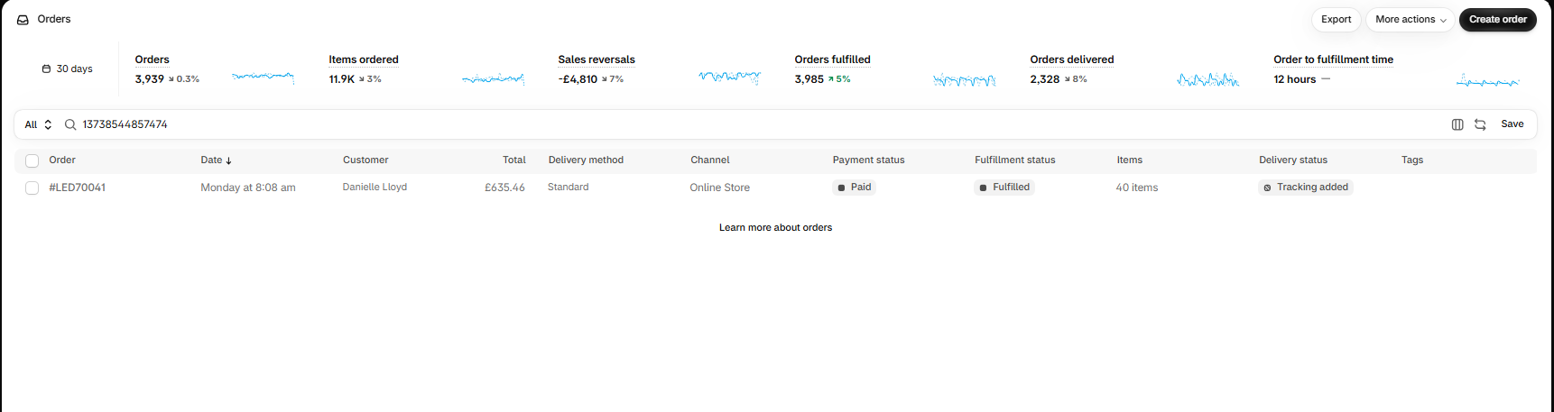
Step 23 - Shopify order search - 13738544857474 found as Order #LED70041, 635.46 GBP

Step 24 - Shopify Order Search: UUID Returns Nothing
Searched Shopify Orders for UUID: 54cd4d4a-2e18-4675-9c24-aaf9522266a7
Result: No orders found
CONFIRMED: UUID is a randomly generated ID by Infinite Google Ads. It does not exist in Shopify. It refers to the same order as #LED70041 but with a fake ID that GA4 cannot match to the numeric ID - so GA4 counts it as a completely separate purchase.
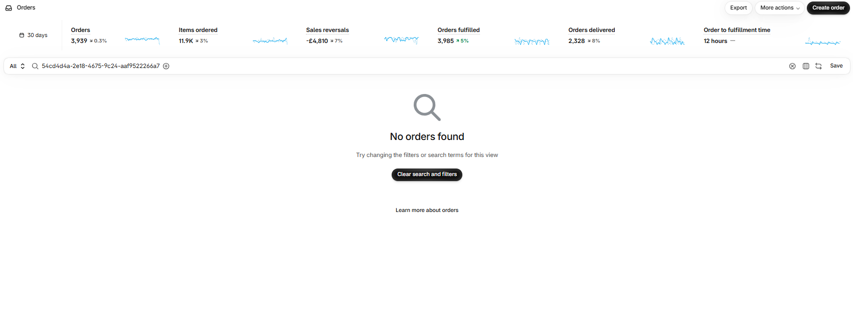
Step 24 - Shopify order search - UUID 54cd4d4a returns no orders - fake ID confirmed

Step 25 - Root Cause: Both Apps Had GA4 Measurement ID Entered
Checked settings of both apps to find exactly where the duplicate GA4 event originated:
App | GA4 Measurement ID | Transaction ID Format | Action Required
Google & YouTube (browser-side) | G-YXN7NVRK1K - entered via official Shopify integration | Shopify numeric order number | Keep - correct official connection
Infinite Google Ads (server-side) | G-YXN7NVRK1K - manually entered in Setup GA4 field | Random UUID | Remove - causing double counting

The Infinite Google Ads app had G-YXN7NVRK1K manually entered in its Setup GA4 section. This caused it to send a GA4 purchase event for every order - in addition to Google & YouTube already doing the same. Because the transaction IDs are different (numeric vs UUID), GA4 cannot deduplicate them and counts both as separate purchases.
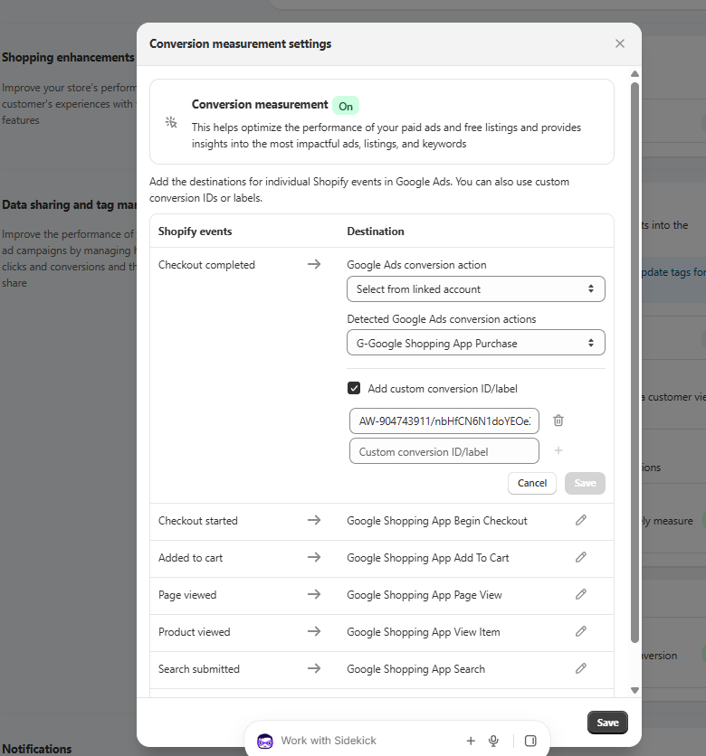
Step 25 - Google & YouTube app conversion settings - separate from GA4, controls Google Ads only

Step 26 - Fix Applied: GA4 Measurement ID Removed from Infinite Google Ads
Location: Shopify > Apps > Infinite Google Ads > Settings > Setup GA4
Action taken on 28 Oct 2026 at 12:27:
Clicked the trash icon next to G-YXN7NVRK1K in the Measurement Id field > Saved.
Result: Measurement Id field is now empty. Infinite Google Ads will no longer send purchase events to GA4.
What was NOT affected by this change:
- Google Ads pixel AW-904743911 - still active and tracking
- Purchase Label / InfinitePi server-side conversions (98k GBP/month) - still active
- GTM container GTM-KJGF2S5Q - still active
- Dynamic Remarketing Pixel - still active
- Google & YouTube app GA4 tracking - still active and correct
Only the duplicate GA4 purchase event from Infinite Google Ads was removed.
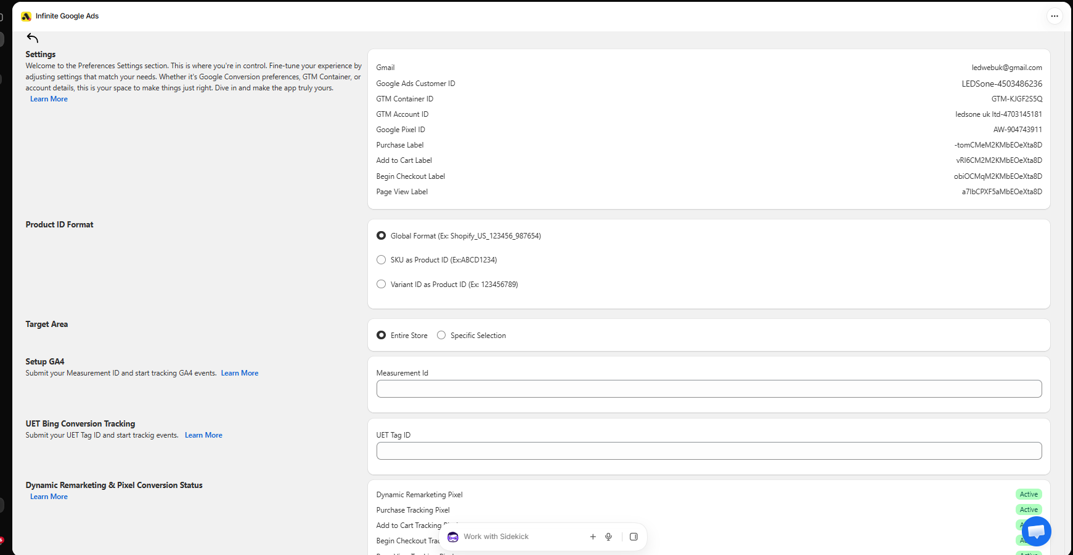
Step 26 - Fix applied: G-YXN7NVRK1K removed from Infinite Google Ads Setup GA4 field - field now empty

Verification Plan - Check on 5 Nov 2026
The fix was applied 28 Oct 2026. GA4 takes 24-48 hours to fully reflect changes.
Check on 5 Nov 2026 (7 days after fix) for a clean verification window.
How to verify:
1. Go to GA4 > Explore > create Free-form exploration
2. Dimension: Transaction ID | Metric: Purchase revenue | Date: 29 Oct - 5 Nov
3. Sort by revenue descending
Expected results if fix worked:
- UUID rows (54cd..., 3223d..., d919d...) should be gone or near zero
- Only numeric Shopify order IDs remaining
- GA4 total revenue should be close to Shopify revenue (within 5-10%)
If UUID rows still appear on 5 Nov, further investigation of GTM container GTM-KJGF2S5Q will be required.

Final Conclusion - All Checks
Check | Result | Status
GA4 measurement ID in Shopify | G-YXN7NVRK1K confirmed in Google & YouTube app | PASS
GA4 property receiving data | LEDSone neww (408110563) - active and collecting | PASS
Organic sessions vs Search Console | GA4 31,128 > GSC 18,700 - healthy, includes all search engines | PASS
Purchase events firing | 5,680 items/week confirmed in E-commerce report | PASS
Shopify order numbers in transactions | Numeric ID 13738544857474 = Order #LED70041 verified | PASS
84% Direct traffic explained | Server-side tracking from Infinite Google Ads - intentional | PASS
Server-side Google Ads conversions | 2,842 extra purchases (98k GBP/month) - unaffected by fix | PASS
Consent mode | Excellent - all signals active | PASS
Redirect chain | Clean - 1 hop only (http to https) | PASS
GA4 double counting fixed | Removed G-YXN7NVRK1K from Infinite Google Ads 28 Oct 12:27 | FIXED - verify 5 Nov

Sheet Response
Column I (Status): DONE
Column J (Note):
GA4 double counting fixed 28 Oct. Both Infinite Google Ads + Google & YouTube were sending purchase events to GA4 (same ID G-YXN7NVRK1K) - every order counted twice. GA4 showed 66,938 GBP vs Shopify 38,288 GBP (7 days, 1.75x overcounting). Fix: removed GA4 measurement ID from Infinite Google Ads > Setup GA4 field. Google Ads server-side tracking (InfinitePi, 98k GBP/month) unaffected. Verify 5 Nov - UUID rows should disappear from GA4 transactions.
Column K (Proof link):
https://github.com/piranavakanandigitweblanka-lgtm/piranav_aios/blob/main/bot-tasks/C5-ga4-tracking/C5-GA4-Tracking-Investigation-2026-10-28-FINAL.docx

