Find the stock-hiding rule, write proposal → send to Muguntha
Hi Muguntha,
I've investigated the stock visibility issue for listing 5543 (terminal box conduit fittings). Here are my updated findings and a proposal for your decision.
The Problem
Three variants are showing as unavailable on the website despite having stock in the warehouse:
SKU | Inventory System (UK Unit3) | Shopify Shows
PCGZ20MO (2-Way) | 3 units | 0 — unavailable ❌
PCGZ20MY (3-Way) | 3 units | 0 — unavailable ❌
PCGZ20ML (L 2-Way) | 0 units | 0 — unavailable
PCGZ20MT (1-Way) | 6 units | 6 — available ✓
Important Update on Root Cause
My initial thought was that UK Unit3 was not being mapped to Shopify. However, PCGZ20MT (1-Way) proves that UK Unit3 is syncing correctly — it shows 6 in the inventory system and 6 in Shopify.
So the issue is specific to PCGZ20MO and PCGZ20MY. The likely causes are one of the following:
- Reserved/committed stock — the 3 units may be allocated to a pending order or pre-existing reservation, leaving 0 available to sell
- A minimum stock buffer set on those specific SKUs, holding back units with 3 or fewer
- A channel-specific rule or app blocking those variants from showing as available on the website
Proposal
Could you check with the warehouse or the inventory sync team whether:
- Units of PCGZ20MO and PCGZ20MY in UK Unit3 are reserved against any orders
- There is a stock buffer or safety stock rule applied to these SKUs
I have not made any changes. Please advise on the next step and I will act on your decision.
I am also notifying Arudchelvi separately as the same rule may be affecting stock visibility on eBay and Amazon.
Best regards,
Piranav

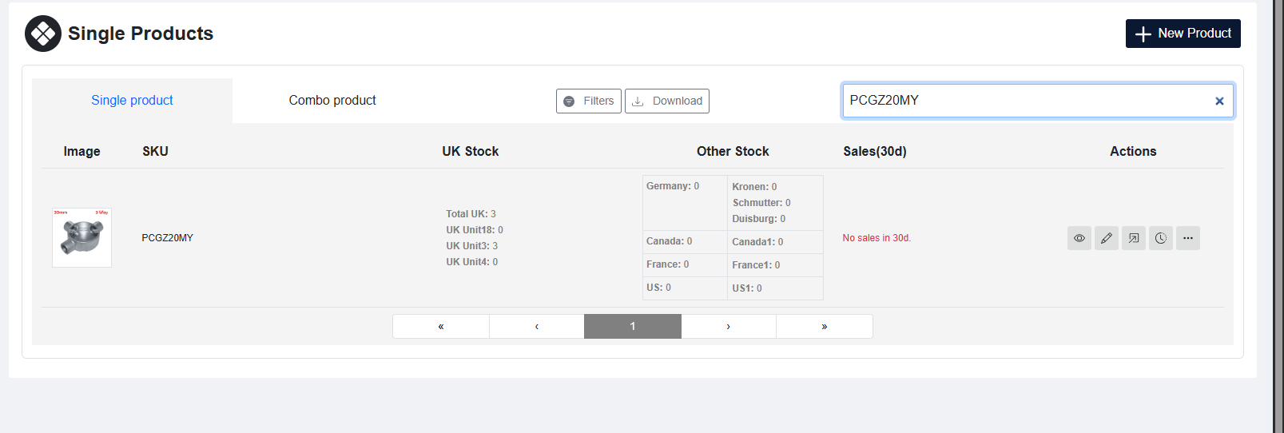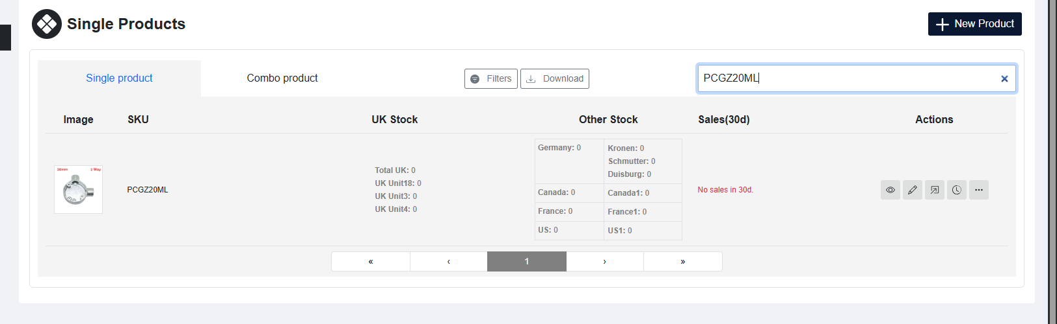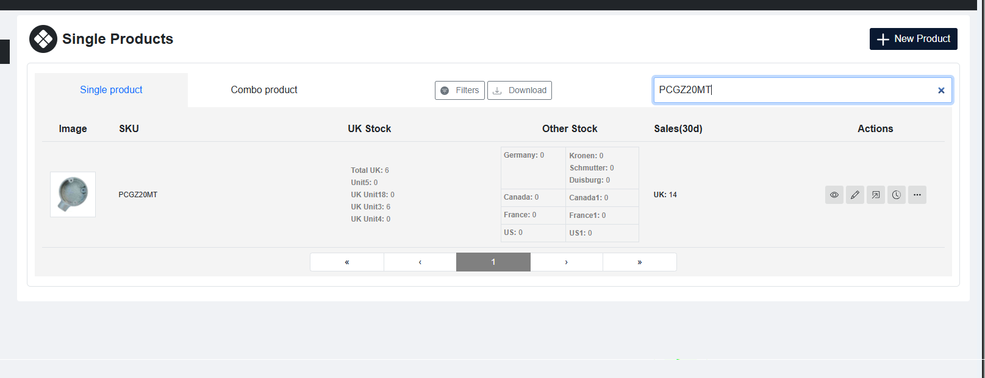

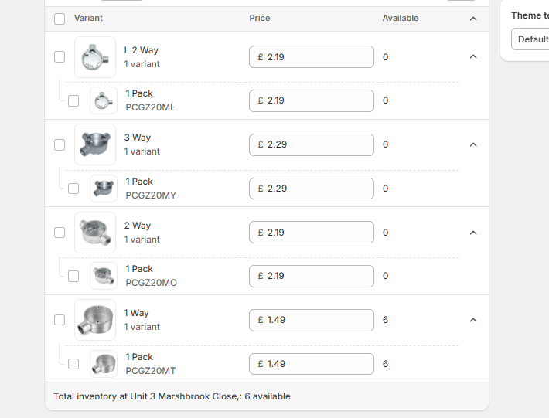
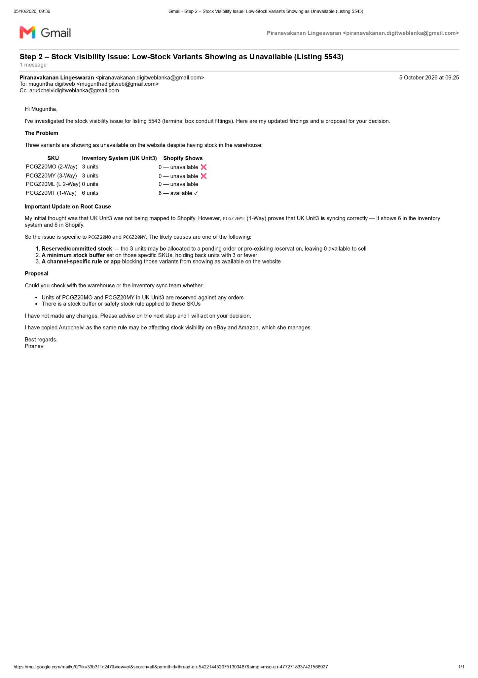
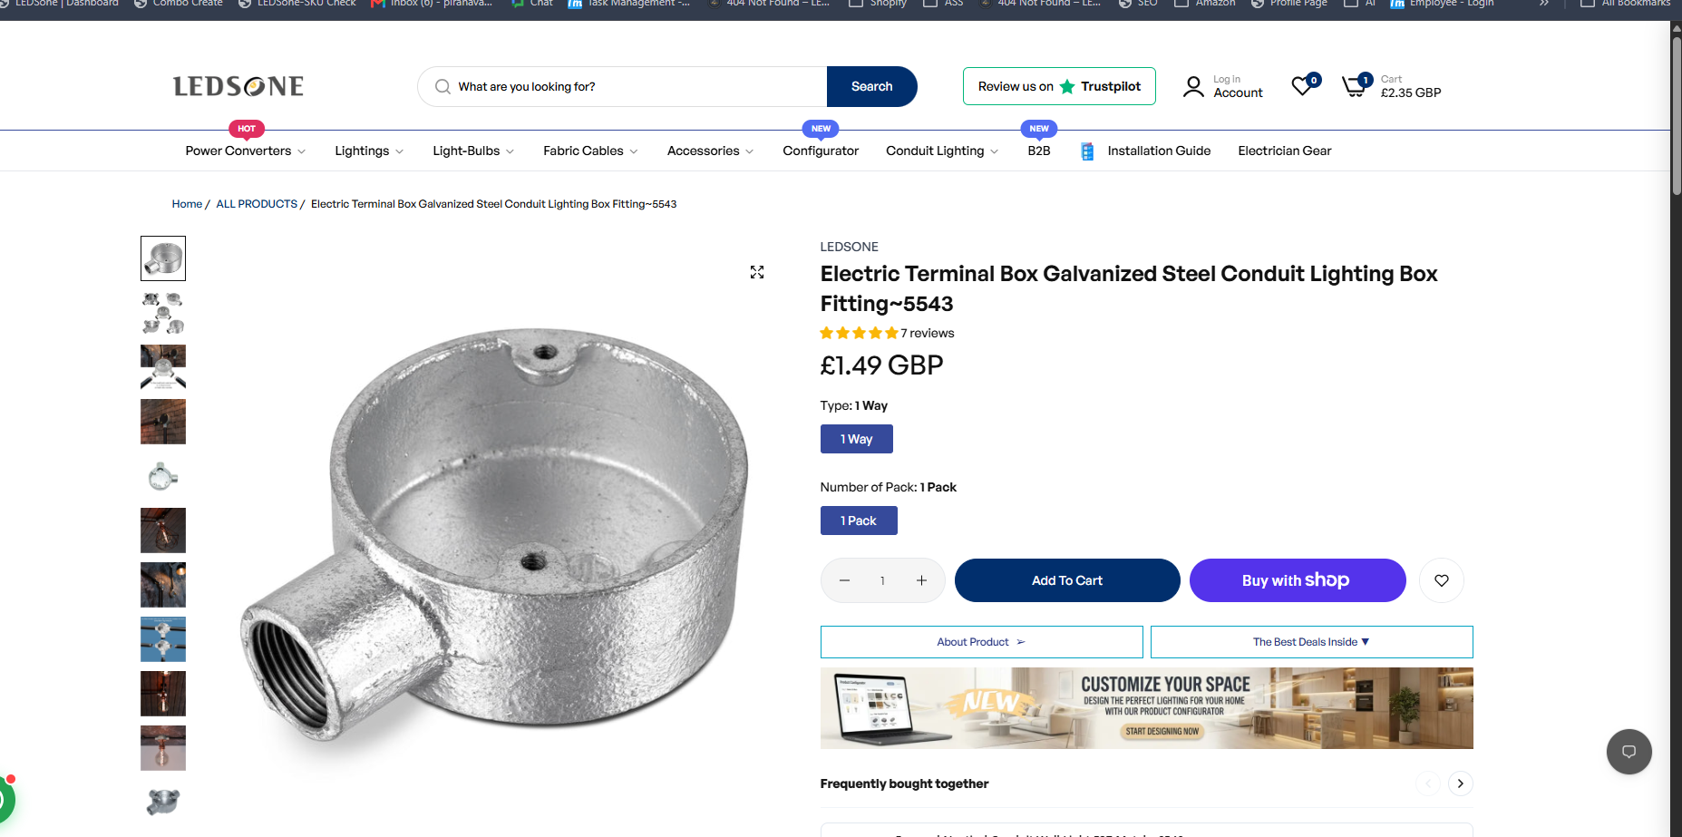

At my listing show only stock product and when other variation will re stock out show in the listing agin

