Collection Cleanup — E27 & B22 Base Bulb
Date: 2026-09-30 | Store: ledsone.co.uk | Prepared by: Piranav / URAI

Main Goal
Remove products from the wrong bulb collections so that:
• E27 Base Bulb collection contains only correct E27 screw bulbs
• B22 Base Bulb collection contains only correct B22 bayonet bulbs
• No product information was changed other than specified tags/collection membership

Section A — Collection Verification (Step 1 & 2)
Before touching anything, both collections were checked to confirm whether they are Automated or Manual, and their current product counts were recorded.

A1 — E27 Base Bulb Collection
Field | Value
Collection type | Automated
Condition | Tag includes E27 Base Bulb + Inventory stock > 0
Screenshot time | 15:22:09

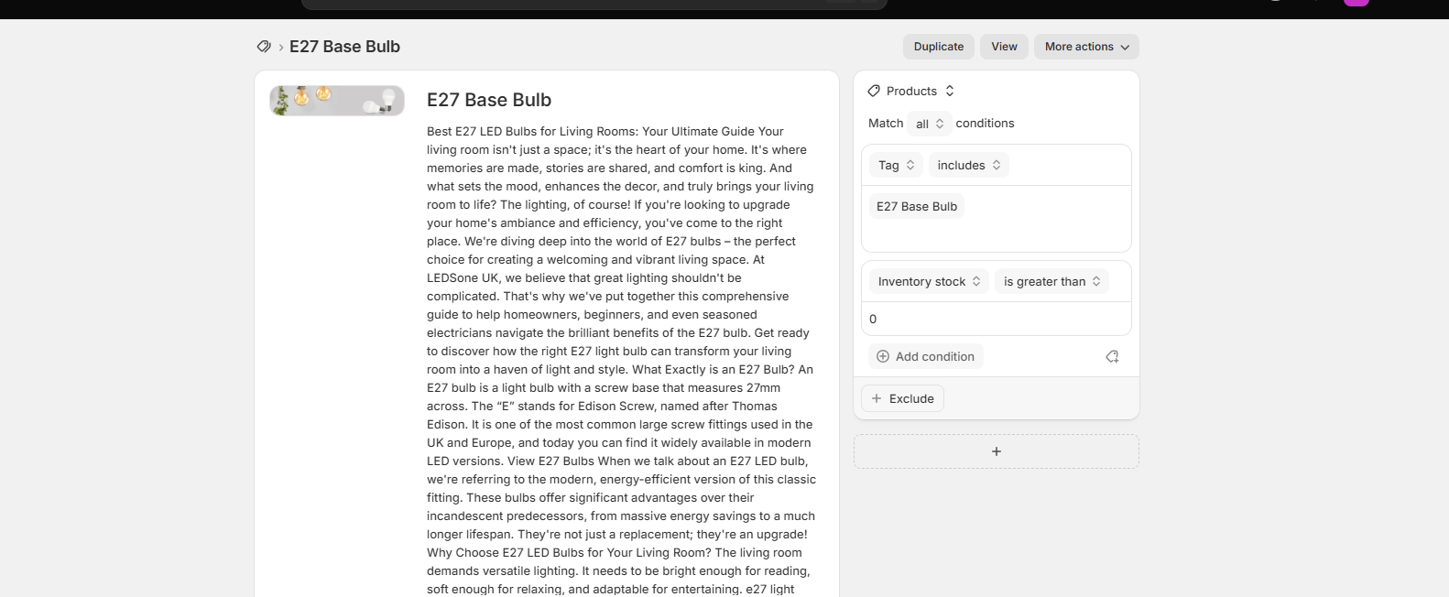
SS1 (15:22:09) — E27 Base Bulb collection — Automated, conditions visible

A2 — B22 Base Bulb Collection
Field | Value
Collection type | Automated
Condition | Tag includes B22 Base Bulb + Inventory stock > 0
Screenshot time | 15:24:36

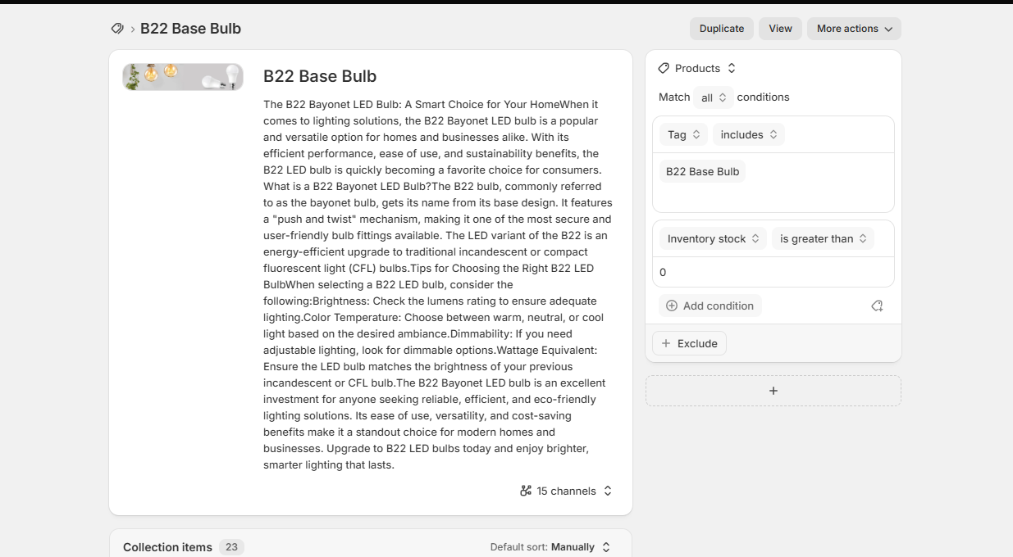
SS2 (15:24:36) — B22 Base Bulb collection — Automated, conditions visible

Section B — Backup: Existing Tags for All Affected Products
Before making any changes, the current tags for every affected product were recorded as backup.
Official Backup Google Doc: Backup - E27-B22 collection tags - 28 Sep 2026 | Link: https://docs.google.com/document/d/1-mhh6ls89QZHC5HEq2u1rNQMWhM6avRPFLRTel4w2fw/edit

B1 — Change 1 — B22 bulb incorrectly tagged E27
Tags recorded: B22 bulb with E27 LED Bulbs + E27 Base Bulb + B22 LED Bulbs + B22 Base Bulb all present

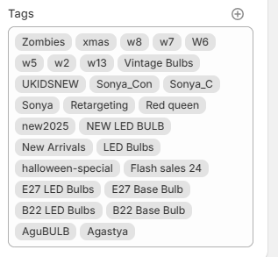
SS3 (15:47:21) — Backup: B22 product incorrectly carrying E27 Base Bulb + E27 LED Bulbs tags

B2 — Change 2 — E27 bulb incorrectly tagged B22
Tags recorded: E27 bulb with E27 LED Bulbs + E27 Base Bulb + B22 LED Bulbs + B22 Base Bulb all present

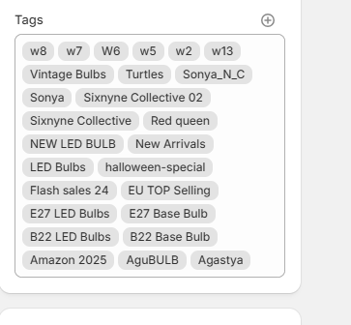
SS4 (15:48:17) — Backup: E27 product incorrectly carrying B22 Base Bulb + B22 LED Bulbs tags

B3 — Change 3 — E27 Pendant incorrectly in B22
Tags recorded: Wire Cage Pendant E27 with FILTB22-Base + BASEB22 + B22 Base Bulb tags

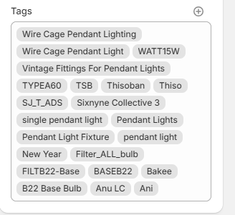
SS5 (15:49:17) — Backup: E27 pendant carrying B22 Base Bulb tag

B4 — Change 5 — B22 ST64 with E27 Base Bulb tag
Tags recorded: B22 ST64 bulb with E27 LED Bulbs + E27 Base Bulb + E27 tags present

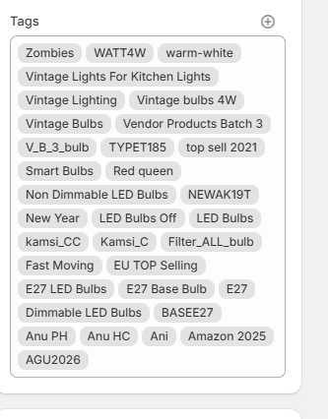
SS6 (15:50:19) — Backup: B22 ST64 incorrectly carrying E27 Base Bulb tag

B5 — Change 6 — E27 T130 with B22 Base Bulb tag
Tags recorded: E27 T130 60W with E27 Base Bulb + BASEE27 + B22 Base Bulb all present

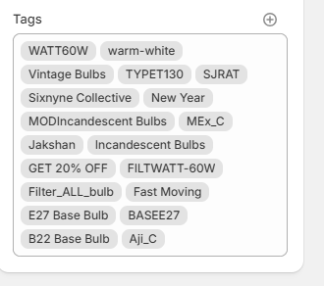
SS7 (15:52:33) — Backup: E27 T130 incorrectly carrying B22 Base Bulb tag

B6 — Change 7 — B22 GLS with E27 LED Bulbs tag
Tags recorded: B22 GLS wall light with B22 LED Bulbs + B22 Base Bulb + E27 LED Bulbs present

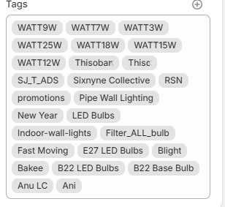
SS8 (15:53:27) — Backup: B22 GLS product incorrectly carrying E27 LED Bulbs tag

B7 — Additional Backup Snapshot
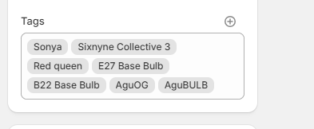
SS9 (15:51:49) — Backup: Additional product tags recorded before changes

Section C — Changes Made (6 Confirmed Fixes)
Each change was screenshotted BEFORE saving and sent to URAI for approval. Changes saved only after approval.

Change 1 — B22 Bulb: Remove E27 Base Bulb + E27 LED Bulbs
Field | Detail
Product | B22 LED Stick Bulb Dimmable 10W 15W 20W T37 Cool White Bayonet~1023
Problem | B22 bayonet bulb was tagged with E27 Base Bulb and E27 LED Bulbs
Fix | Removed: E27 Base Bulb, E27 LED Bulbs
Change 4 status | SKIPPED — pending warehouse confirmation

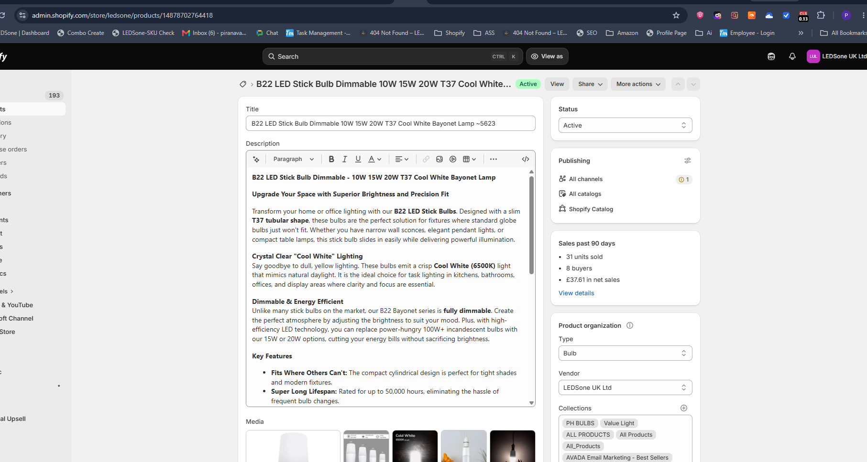
SS10 (16:03:50) — Change 1: B22 LED Stick Bulb product page opened

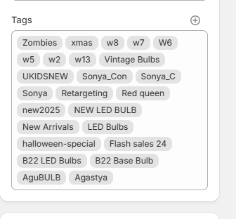
SS11 (16:03:20) — Change 1: Tags BEFORE — B22 bulb carrying B22 Base Bulb + B22 LED Bulbs (no E27 remaining after fix)

Change 2 — E27 Bulb: Remove B22 Base Bulb + B22 LED Bulbs
Field | Detail
Product | LED Light Bulb E27 T7 Bright White Stick Bulb Screw Frosted Inter Corn Bulb~4993
Problem | E27 screw bulb was tagged with B22 Base Bulb and B22 LED Bulbs
Fix | Removed: B22 Base Bulb, B22 LED Bulbs

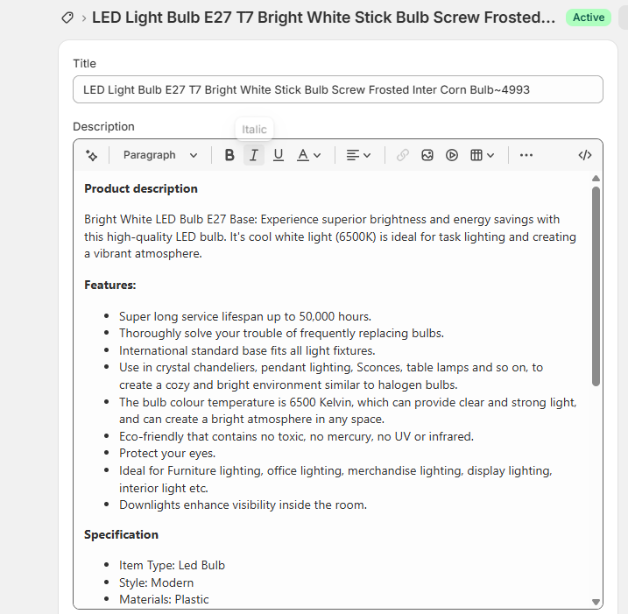
SS12 (16:05:49) — Change 2: E27 T7 product page — description confirms E27 Base

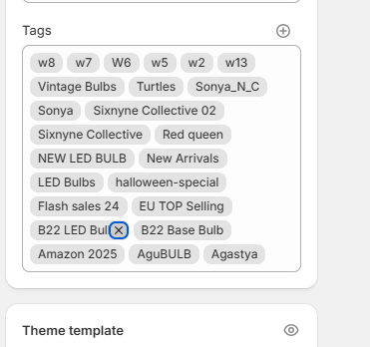
SS13 (16:05:17) — Change 2: Removing B22 LED Bulbs tag (X clicked)

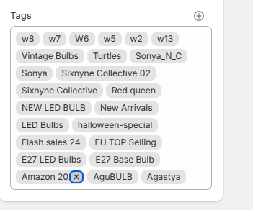
SS14 (16:07:13) — Change 2: Removing remaining wrong tag

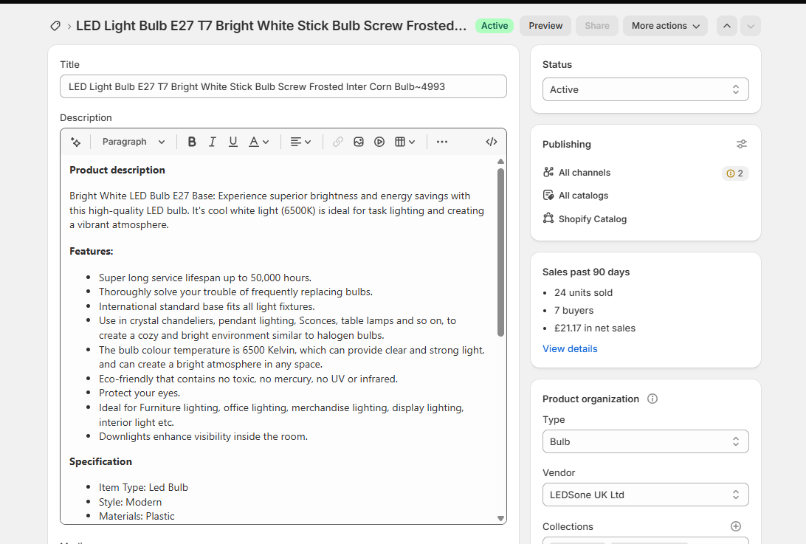
SS15 (16:08:04) — Change 2: E27 T7 product final state before save

Change 3 — E27 Pendant: Remove B22 Base Bulb
Field | Detail
Product | Industrial Balloon Wire Cage Pendant Light E27~1376
Problem | E27 pendant light incorrectly tagged with B22 Base Bulb
Fix | Removed: B22 Base Bulb
Note | Additional tags require URAI approval before changing

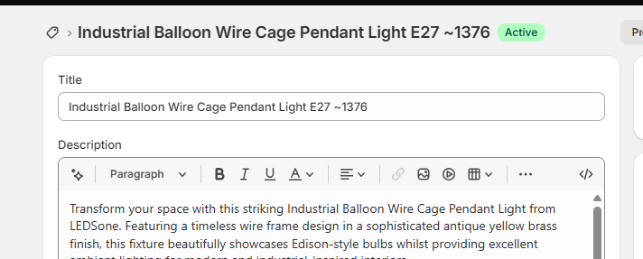
SS16 (16:09:49) — Change 3: Wire Cage Pendant E27~1376 product page

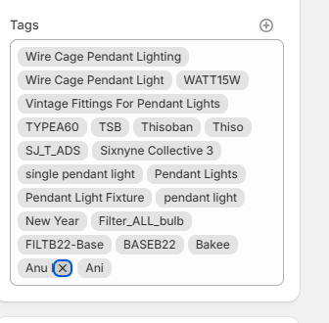
SS17 (16:09:39) — Change 3: Removing B22 Base Bulb tag (Anu X clicked)

Change 4 — ⚠ SKIPPED: Vintage Amber LED Filament Bulb 4W B22~1045
⚠ DO NOT CHANGE — Conflicting product information. SKU LDST185E274 must be confirmed with warehouse/product owner before any tag change.

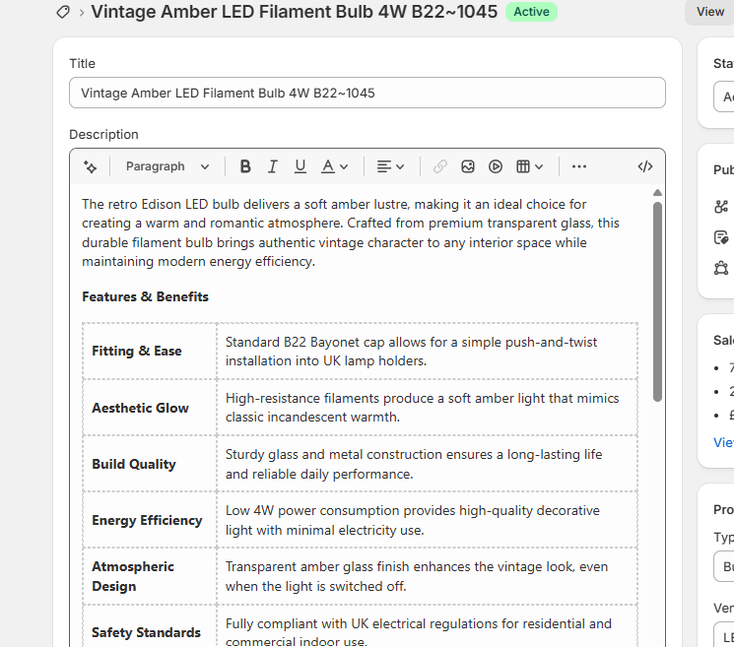
SS18 (16:13:42) — Change 4 SKIPPED: Vintage Amber B22~1045 — conflicting SKU info, awaiting warehouse confirmation

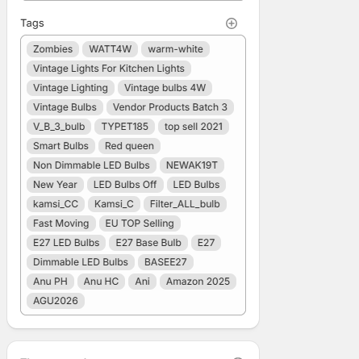
SS19 (16:13:24) — Change 4: Tags recorded for reference only — no change made

Change 5 — B22 ST64: Remove E27 Base Bulb
Field | Detail
Product | B22 ST64 8W Vintage Light Bulb Amber Glass~175
Problem | B22 ST64 bayonet bulb had E27 Base Bulb tag
Fix | Removed: E27 Base Bulb

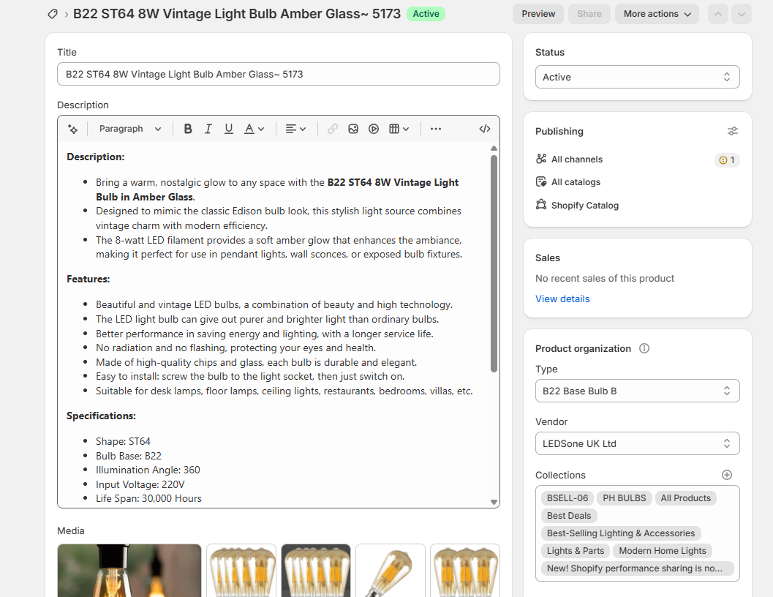
SS20 (16:20:27) — Change 5: B22 ST64 Vintage Amber Glass product page

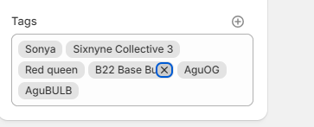
SS21 (16:20:17) — Change 5: Removing B22 Base Bulb tag (B22 Base Bu X clicked)

Change 6 — E27 T130: Remove B22 Base Bulb
Field | Detail
Product | E27 T130 60W Dimmable Vintage Light Filament Bulb~3070
Problem | E27 T130 bulb had B22 Base Bulb tag
Fix | Removed: B22 Base Bulb

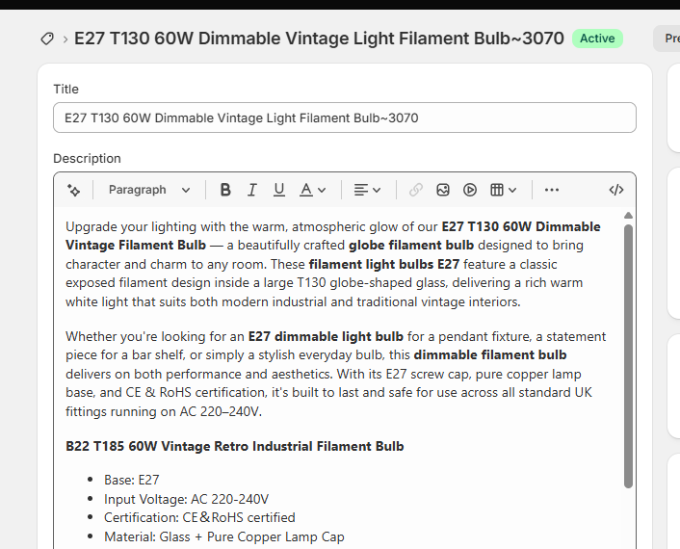
SS22 (16:21:49) — Change 6: E27 T130 product page — description confirms E27 base

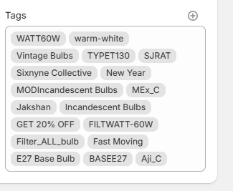
SS23 (16:21:39) — Change 6: Tags after removing B22 Base Bulb — E27 Base Bulb + BASEE27 remain

Change 7 — B22 GLS: Remove E27 LED Bulbs
Field | Detail
Product | LED GLS 9W B22 Light Bulbs Cool White Energy Saving~4154
Problem | B22 GLS bulb had E27 LED Bulbs tag incorrectly
Fix | Removed: E27 LED Bulbs

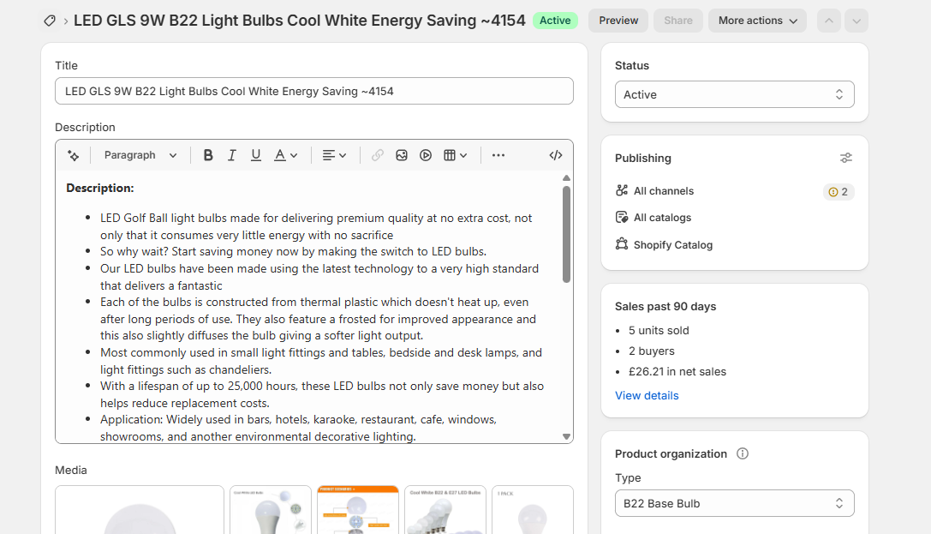
SS24 (16:23:02) — Change 7: LED GLS 9W B22 product page — Type confirms B22 Base Bulb

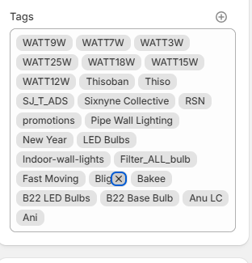
SS25 (16:22:54) — Change 7: Removing E27 LED Bulbs / Blight tag (X clicked)

Section D — Verification After Changes
After saving all changes (~5 min wait), both collections were checked to confirm correct product counts and that wrong products were removed.

D1 — B22 Base Bulb Collection — Post-Change Check
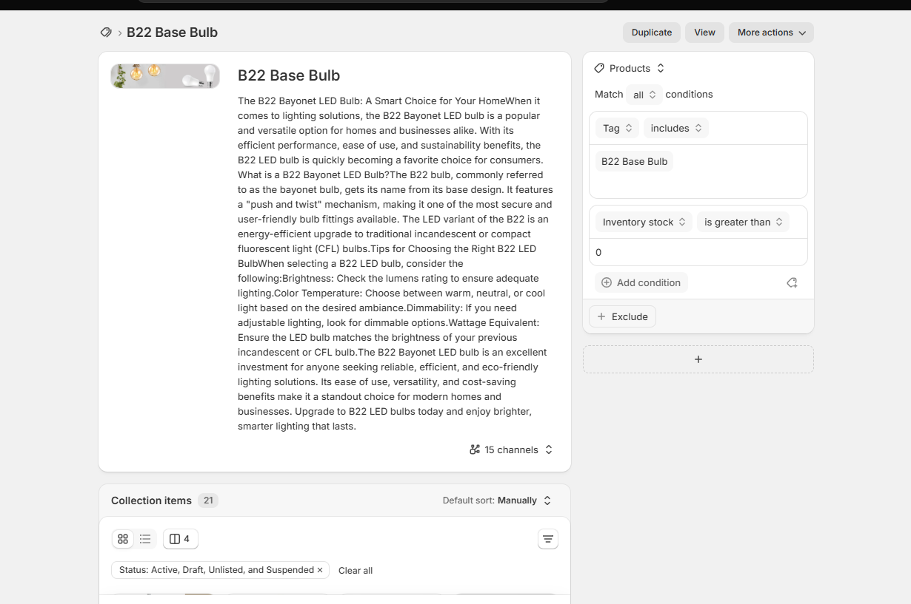
SS26 (16:26:35) — B22 Base Bulb collection page after changes

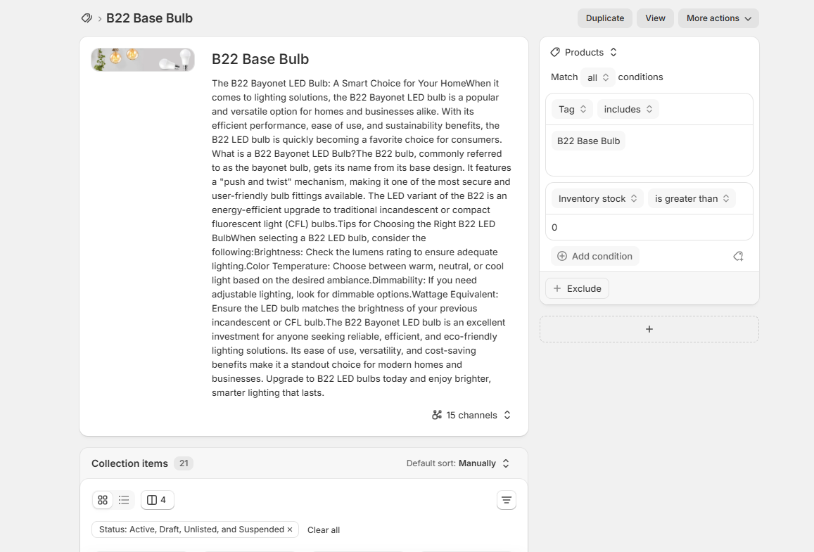
SS27 (16:28:59) — B22 Base Bulb collection — automated conditions confirmed still intact

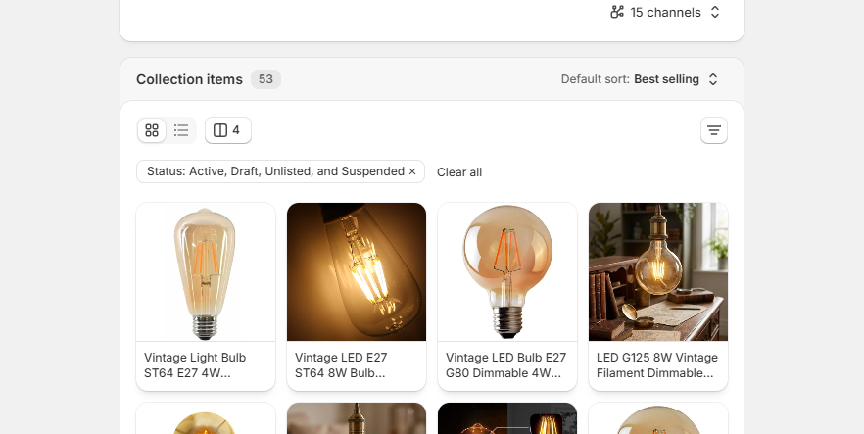
SS28 (16:29:15) — B22 Base Bulb — Collection Items: 53 products, sorted Best Selling

D2 — E27 Collection — Post-Change Check (JSON)
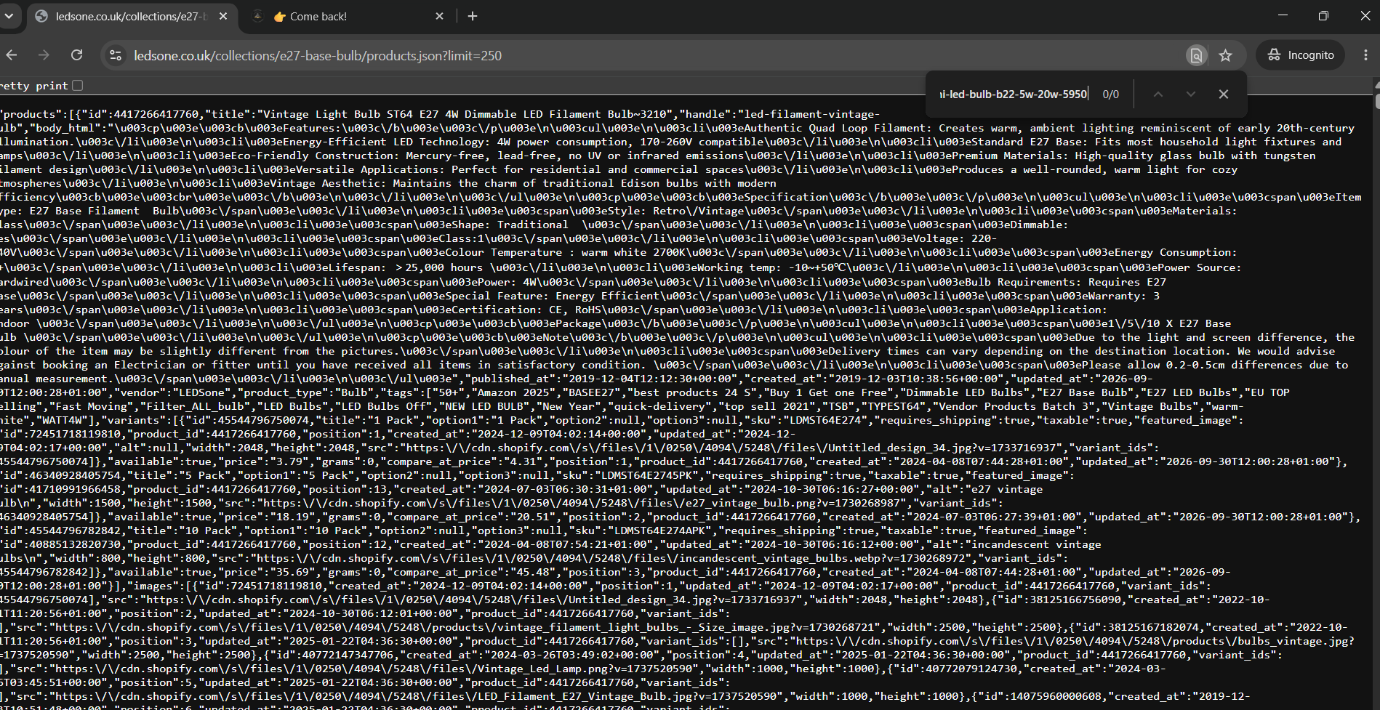
SS29 (16:31:05) — E27 collection JSON verification — product list confirmed

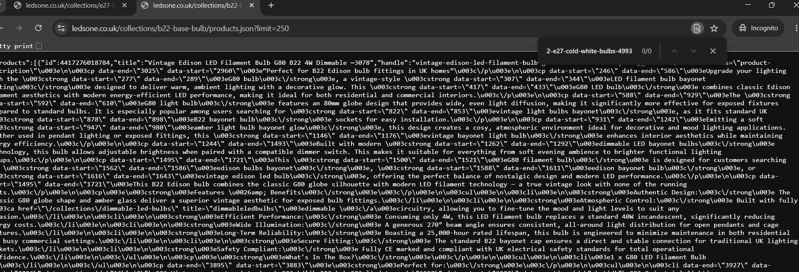
SS30 (16:31:29) — E27 collection JSON — second verification view

Section E — Bonus: E27 Product URL/SEO Cleanup (~4993)
Separate task discovered during cleanup: product ~4993 had B22 in its URL, SEO title and meta description. Fixed separately.

Field | Before | After
URL handle | ...b22-e27-cold-white-bulbs-4993 | ...e27-cold-white-bulbs-4993
Page title | Mini White Led Bulb B22 5W To 20W | Mini White LED Bulb E27 5W To 20W
Meta description | ...B22 Base...6500k... | ...E27 Base...6500K...

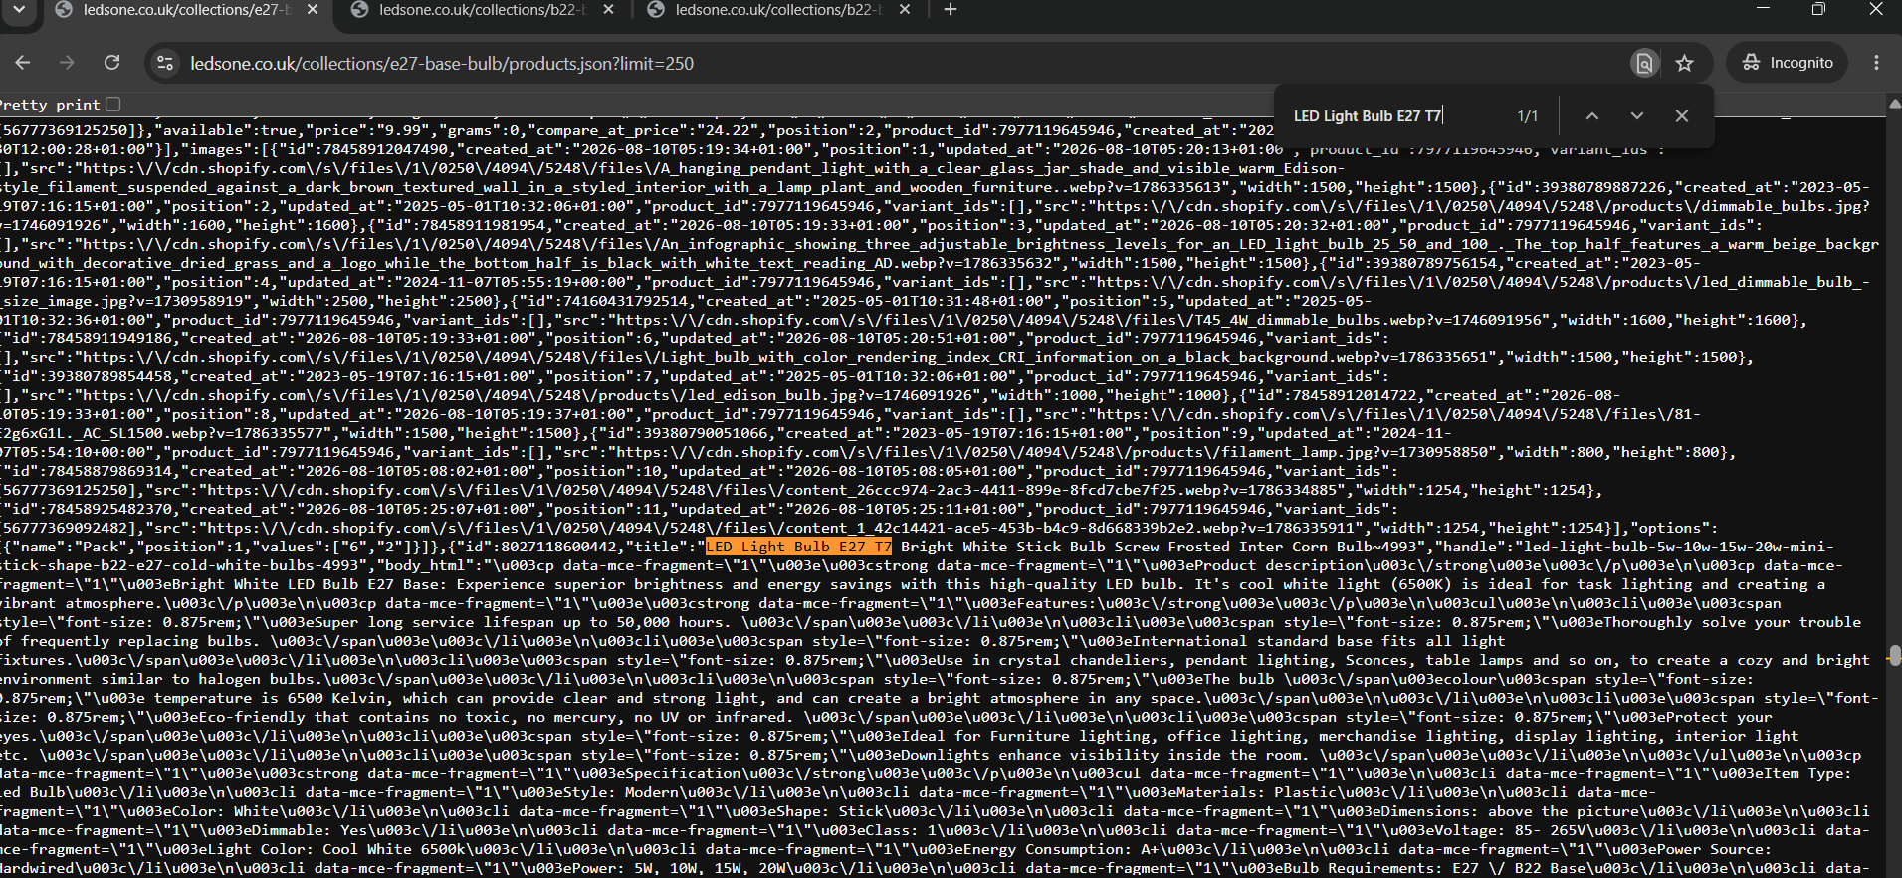
SS31 (16:35:23) — SEO section BEFORE: URL, title, meta all showing B22

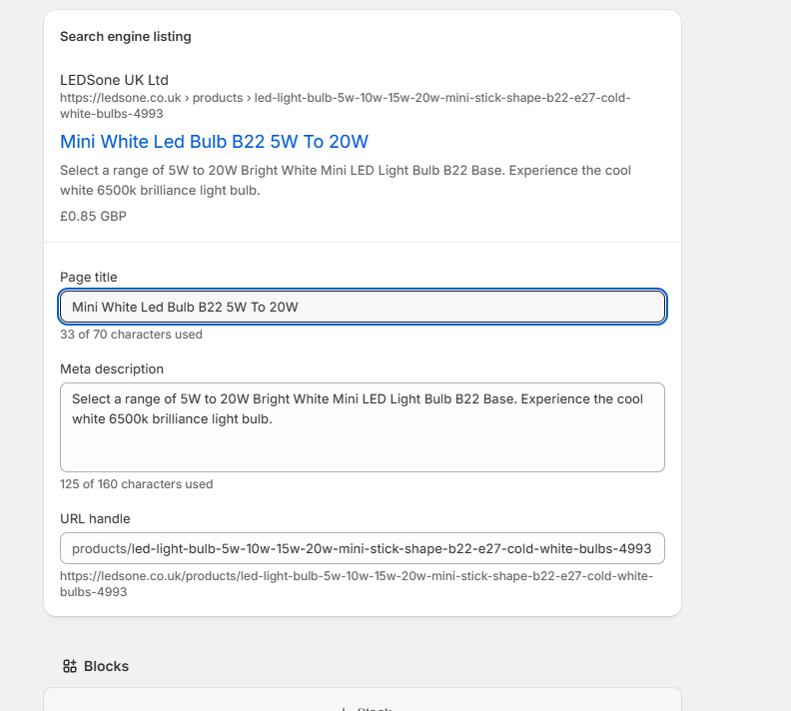
SS32 (16:43:00) — BEFORE state: B22 in title + meta + URL handle

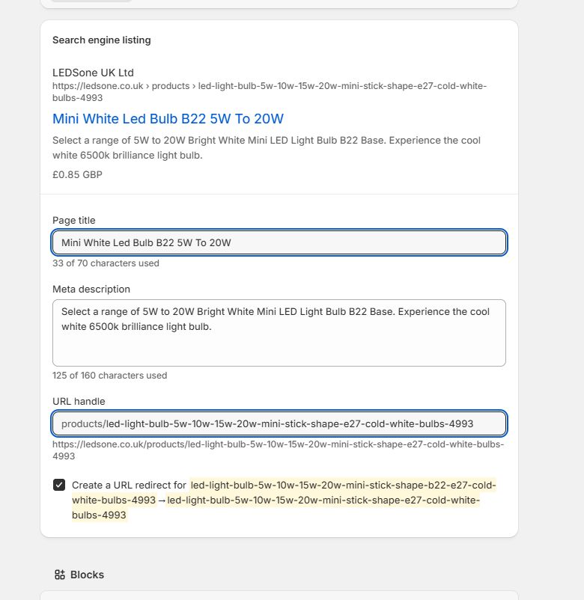
SS33 (16:43:51) — URL fixed to e27, Shopify redirect auto-created

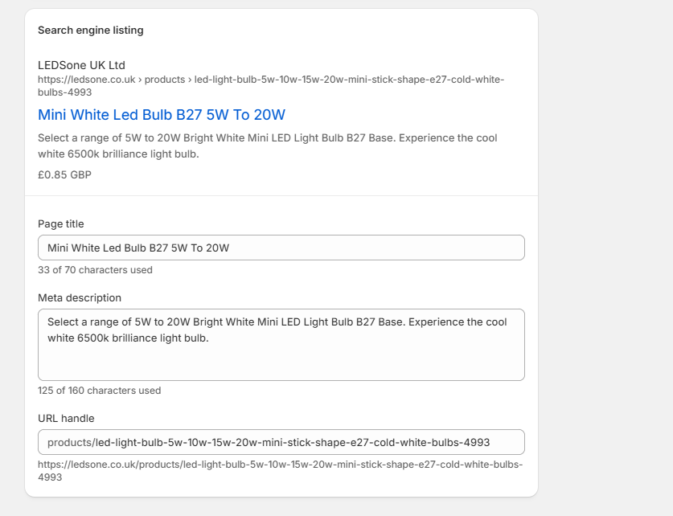
SS34 (16:45:12) — ⚠ TYPO: title/meta changed to B27 instead of E27 — caught and corrected

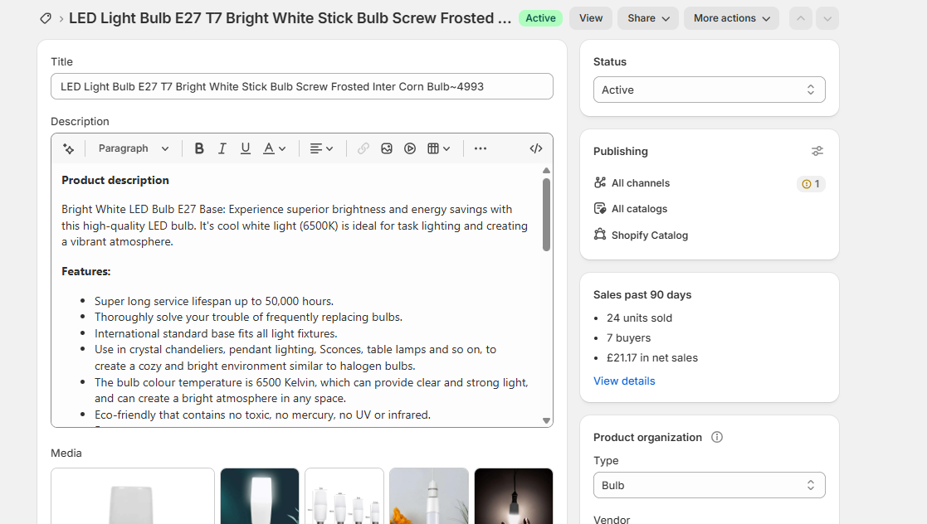
SS35 (16:46:43) — FINAL CORRECT: product description confirms E27 Base

Final Summary Checklist
Item | Status
Section A — E27 collection verified (Automated) | ✅ DONE
Section A — B22 collection verified (Automated) | ✅ DONE
Section B — Tags backup for all 6 products | ✅ DONE
Change 1 — B22 bulb: E27 Base Bulb + E27 LED Bulbs removed | ✅ DONE
Change 2 — E27 bulb: B22 Base Bulb + B22 LED Bulbs removed | ✅ DONE
Change 3 — E27 Pendant: B22 Base Bulb removed | ✅ DONE
Change 4 — Vintage Amber B22~1045: SKIPPED | ⚠ PENDING warehouse confirmation
Change 5 — B22 ST64: E27 Base Bulb removed | ✅ DONE
Change 6 — E27 T130: B22 Base Bulb removed | ✅ DONE
Change 7 — B22 GLS: E27 LED Bulbs removed | ✅ DONE
Section D — B22 collection verified post-change (53 items) | ✅ DONE
Section D — E27 collection verified post-change (JSON) | ✅ DONE
Bonus — E27 ~4993 URL/SEO corrected B22→E27 | ✅ DONE
URAI approval before each Save | ✅ DONE

Overall Status: PASS (6 of 7 changes complete — Change 4 held pending warehouse)

