A state-structured pharmacodynamic framework separating resistance, tolerance and persistence, applied to Mycobacterium tuberculosis and Staphylococcus aureus
Vahhab Piranfar
1. Independent Researcher, Jersey City, NJ, USA
2. Farname Inc, Ontario, Canada
Corresponding author: Vahhab Piranfar, Independent Researcher, Jersey City, NJ, USA. ORCID 0000-0003-3653-5739 · vahab.p@gmail.com
Revised manuscript, version 2. Supersedes bioRxiv 10.1101/2025.02.12.637810 (posted 14 February 2025).

Summary of changes in version 2
This version corrects errors in version 1 that alter its conclusions. Readers of version 1 should treat its quantitative results as withdrawn.
Mathematics. The biphasic killing law of version 1 (its Equation 4) is discontinuous: at the transition time its second branch evaluates to exactly the inoculum, so the modelled population rises by 2.6 to 3.5 log10 at the breakpoint. It also converges to a permanent floor above the assay limit of detection, so under that equation the population never reaches the limit, at any duration. Its transition time is not an independent parameter and, on time-kill data of realistic density, is not estimable at all. The resistance equation omitted the carrying capacity declared alongside it and reached 10^57 CFU/mL by day 10. The tolerance equation omitted replication, which reverses the sign of its result for S. aureus: version 1 reported fifteen logs of killing where its own parameters imply net growth.
Withdrawn conclusions. Once the biphasic equation is made continuous, the two species differ by 1.13-fold at 240 h under version 1's own parameters. The comparative conclusion of version 1 was produced by the discontinuity and is withdrawn. The reported persister fraction of 3.58% was an input, not a fit. The abstract of version 1 compared two parameters drawn from different equations and attached one species' transition time to the other.
Statistics. The Kolmogorov-Smirnov test of version 1 is removed: applied to deterministic curves its p-value is set by the density of the simulation grid, falling by more than 170 orders of magnitude as the grid is refined. The reported R-squared above 0.9 is no longer used for model selection, because a structurally broken model and its correct replacement both exceed it on the same data while their corrected AIC differs by up to 81.5.
Version 1's experimental-data figure is withdrawn. It was captioned "experimental data vs. model fitting". No dataset was named in version 1 and none exists. The replacement figure in this version uses synthetic data with known ground truth, is labelled as such, and supports conclusions about the estimator only.
Methods corrected. Version 1 stated that differential equations were solved with LSODA and cross-validated with Euler integration. Every model in version 1 is a closed-form algebraic solution; nothing was integrated. That sentence is removed. The present version does contain a genuine initial value problem, the state-structured model of Section 2.3, and names the solver used for it.
References. All thirty references of version 1 were checked against PubMed. Seventeen verified, eleven required correction, and two could not be located and are removed. Version 1's reference 3, the consensus definitions paper this work depends on, was cited with the wrong title, the wrong issue and an author who is not on it. Every entry in the corrected list that is indexed in PubMed carries its PMID; the one entry that is not indexed, a World Health Organization report, carries its ISBN.
What is added. A state-structured replacement model in which biphasic killing emerges rather than being imposed, time to LOD is finite, and the three survival strategies separate onto distinct measurable axes; a global sensitivity analysis; and an identifiability analysis of both the old and the new model. All code is public and regenerates every number in this version.
Every number in this version is produced by code in the accompanying repository and can be regenerated with a single command. Numbers are cross-referenced to the output file that contains them.

Abstract
Antibiotic resistance, tolerance, and persistence represent key bacterial survival strategies that impact treatment outcomes and global health. While Staphylococcus aureus is a rapidly growing pathogen associated with acute infections, Mycobacterium tuberculosis exhibits slow growth and chronic persistence, necessitating prolonged antibiotic regimens. In this study, we developed a state-structured pharmacodynamic model in which replicating and dormant subpopulations each carry their own concentration-response, so that the three strategies separate onto distinct measurable axes: resistance shifts the minimum inhibitory concentration, tolerance multiplies the minimum duration for killing, and persistence lifts the deep killing endpoint alone. Using global variance-based sensitivity analysis and profile likelihood, we identified which parameter governs the length of therapy and which parameters can be estimated at all from time-kill data. Our findings show that the two organisms are governed by different parameters entirely: in the slow-growing organism 78% of the first-order variance in time to LOD is carried by the rate at which dormant cells resume replication, while in the fast-growing organism that same rate contributes nothing measurable and the outcome is set by the kill rate and the replication rate acting jointly. A regimen-shortening strategy has no reason to transfer between them. This version supersedes version 1, whose closed-form biphasic killing law is discontinuous and whose quantitative results are withdrawn and corrected here; the work is a modelling and methods contribution, contains no experimental data, and its parameter values are illustrative rather than measured.
Keywords: antibiotic tolerance, bacterial persistence, pharmacodynamics, minimum duration for killing, practical identifiability, global sensitivity analysis

1. Introduction
Antibiotic resistance, tolerance and persistence lead to treatment failure and prolonged infection [1,2]. Resistance is a heritable change that raises the concentration required to inhibit growth. Tolerance and persistence are non-inherited: a tolerant population dies more slowly at an unchanged minimum inhibitory concentration, and a persistent population contains a subpopulation that survives exposure that clears the bulk [3,4]. These are three different statements about three different measurements, and Brauner and colleagues set them out as such [4]: resistance is a change in the minimum inhibitory concentration (MIC), tolerance a change in the minimum duration for killing (MDK) at fixed MIC, and persistence a change in the shape of the killing curve rather than in either summary statistic.
Staphylococcus aureus and Mycobacterium tuberculosis sit at opposite ends of a growth-rate spectrum, with doubling times differing by roughly seventeen-fold, and they are treated on correspondingly different timescales [5,6]. M. tuberculosis persists in host tissue and requires months of therapy, a durability associated with dormancy and phenotypic heterogeneity [7,8,9,10]. S. aureus is a rapid grower whose biofilm and stationary-phase populations show marked tolerance and relapse after apparently successful treatment [11,12]. The contrast is a natural setting in which to ask what actually determines how long treatment must last.
Answering that question requires a model in which resistance, tolerance and persistence are different things. Much of the modelling literature, including our own earlier version of this work, does not meet that requirement. When all three are written as N(t) = N₀e^(−kt) with different values of k, they differ only in a number, and no measurement can distinguish them because the model contains no measurement that could. The problem is structural rather than numerical, and it cannot be fixed by re-estimating k.
This paper does three things. First, it establishes what goes wrong when a biphasic killing law is written as a closed form with an explicit transition time, a construction we adopted in version 1 of this work. Searching for the exact discontinuous form we used returns no other publication that prints it: the literature uses the continuous biexponential. The failure we document is therefore ours, and we document it because the underlying temptation is general -- an explicit transition time reads as an interpretable quantity, and it is not one. Second, it develops a state-structured replacement in which the three strategies occupy near-independent directions in a space of measurable quantities. Third, it uses global sensitivity analysis of the replacement to identify which parameter actually governs time to LOD, and finds an answer different from the one a one-at-a-time analysis of the closed-form law returns.
We are explicit about the limits. This is a framework paper. It contains no experimental data, its parameter values are illustrative, and its species-level statements are therefore qualitative. What it does establish is which quantities must be measured, and what a model must contain before those measurements can be interpreted.

2. Methods

2.1 Notation and the models under examination
Let N(t) denote colony-forming units per millilitre at time t hours after the start of a constant antibiotic exposure, N₀ the inoculum, K the carrying capacity, r the replication rate, and C the drug concentration in multiples of a reference MIC.
Logistic growth without drug.
N(t) = K / (1 + ((K − N₀)/N₀)e^(−rt)) (1)
The closed-form laws under examination. We examined three closed-form expressions in common use, written here as they appear in the literature and in version 1 of this work:
resistance: N(t) = N₀e^((r − k_R)t) (2a)
tolerance: N(t) = N₀e^(−k_T t) (3a)
persistence: N(t) = N₀e^(−k_fast t) for t < t_c; N_d + (N₀ − N_d)e^(−k_slow(t − t_c)) for t ≥ t_c (4a)
with N_d the dormant subpopulation and t_c the transition time. Section 3.1 to 3.3 establishes why each requires replacement.
Corrected closed forms. Equations 2a and 3a omit the carrying capacity declared in Equation 1 and, in the case of 3a, omit replication entirely. Both are replaced by the same differential form with the appropriate kill constant:
dN/dt = rN(1 − N/K) − kN, k ∈ {k_R, k_T} (2b, 3b)
which has a closed solution: logistic with effective rate r − k and effective capacity K(r − k)/r.
Equation 4a is replaced by a biexponential, which is smooth everywhere, reaches the limit of detection in finite time, keeps the dormant fraction f dimensionless, and has three rate parameters rather than four:
N(t) = N₀[(1 − f)e^(−k_fast t) + f e^(−k_slow t)] (4b)
Under Equation 4b the transition time is an output rather than a parameter:
t_c = ln((1 − f)/f) / (k_fast − k_slow) (4c)
A continuous piecewise form, N(t ≥ t_c) = N₀e^(−k_fast t_c)e^(−k_slow(t − t_c)), is also examined in Section 3.1 as the minimum repair to Equation 4a. It removes the discontinuity but retains an imposed t_c and is therefore not recommended.

2.2 Pharmacodynamic function
None of Equations 2 to 4 contains a concentration term, so none can express an MIC, a dose or a regimen. We introduce a sigmoid maximum-effect function:
k(C) = E_max C^H / (EC50^H + C^H) (5)
with E_max the maximum kill rate, EC50 the half-maximal concentration and H the Hill coefficient. This function is standard in antibacterial pharmacokinetic–pharmacodynamic modelling [13,14]. It is what makes the three survival strategies formally distinct, as set out in Section 2.4.

2.3 State-structured model
Replicating (S) and dormant (P) subpopulations exchange at first-order rates and each carries its own concentration–response:
dS/dt = rS(1 − (S+P)/K) − k_S(C)S − k_SP·S + k_PS·P (6a)
dP/dt = −k_P(C)P + k_SP·S − k_PS·P (6b)
with k_S(C) and k_P(C) given by Equation 5 with compartment-specific E_max and EC50. In the absence of drug the dormant fraction equilibrates at k_SP/(k_SP + k_PS). Simulations start from that equilibrium, which is the consistent choice for an inoculum grown without drug.
Equations 6a and 6b contain no transition time. Biphasic killing arises because the two compartments are killed at different rates and the observable is their sum. The transition is recovered as a derived quantity, defined as the time of maximum curvature of log₁₀N(t) over the interval in which the population remains above the limit of detection.
Systems were integrated with the LSODA method (SciPy solve_ivp, relative tolerance 10⁻¹⁰, absolute tolerance 10⁻⁶). Unlike Equations 1 to 4, which are algebraic and require no solver, Equations 6a and 6b are a genuine initial value problem.

2.4 Encoding the three strategies
Within Equations 5 and 6 the three strategies are three different modifications of one parameter set:
Strategy | Modification | Predicted effect
Resistance | EC50 × m | MIC × m; MDK unchanged at matched multiples of MIC
Tolerance | r, E_max,S and E_max,P all ÷ m | MIC unchanged; MDK × m
Persistence | k_SP × m | MIC and MDK₉₉ unchanged; MDK₉₉.₉₉ raised

The encoding of tolerance requires comment. Dividing E_max alone is not tolerance. It lowers the maximum kill rate without slowing replication, which moves the balance point at which kill and growth cancel and therefore shifts the MIC by approximately m^(1/H). That is partial resistance. Tolerance is a slowing of metabolism, in which replication and killing scale together, and it is this joint scaling that leaves the MIC exactly invariant while multiplying the MDK. Conflating the two is precisely the confusion that a structured model exists to prevent.

2.5 Endpoints
All endpoints are computed from the same simulated curve.
- MIC: the lowest concentration at which the initial net growth rate of the bulk population is non-positive, located by Brent root-finding.
- MDK₉₉ and MDK₉₉.₉₉: the times at which the surviving fraction first reaches 10⁻² and 10⁻⁴ [4].
- Time to LOD: the time at which the population first falls below an assay limit of detection, taken as 10² CFU/mL, the value used in the hollow-fibre studies catalogued in the accompanying data manifest.
- log₁₀ reduction at 240 h.
Endpoints are located by bracketing followed by Brent root-finding on an interpolated curve. Where an endpoint is not reached, the search window is doubled repeatedly to 10⁶ h before infinity is returned, so a reported infinity means the endpoint is genuinely unreachable and never that the search was truncated. This distinction matters in Section 3.1.

2.6 Parameters
Parameter values used in this work fall into two classes, and the distinction is maintained throughout.
Class A, values from version 1's parameter table. These are used only in Sections 3.1 to 3.4, where the object of study is the closed-form equations themselves. Every number in that table was adopted from the literature without a traceable extraction; none is a measurement tied to a named dataset, figure panel and digitisation record. They are reproduced here unchanged because the point of Sections 3.1 to 3.4 is that the equations misbehave on their own stated parameters, which requires using those parameters and no others.
Parameter | M. tuberculosis | S. aureus
Replication rate r | 0.03 /h | 0.5 /h
Resistance kill rate k_R | 0.002 /h | 0.01 /h
Tolerance kill rate k_T | 0.05 /h | 0.2 /h
Fast kill rate k_fast | 0.1 /h | 0.5 /h
Slow kill rate k_slow | 0.001 /h | 0.01 /h
Dormant fraction f | 1–5% | 0.01–0.1%
Asserted transition time t_c | 80 h | 12 h

Class B, illustrative values for the state-structured model. These were chosen to reproduce documented qualitative behaviour, namely a doubling time near 23 h with a deep non-replicating compartment for M. tuberculosis and near 1.4 h with a shallow, transient tolerant state for S. aureus. They are not measurements. They are labelled as illustrative on every figure in which they appear, and no quantitative species-level claim is made from them.

2.7 Estimation, identifiability and model comparison
Time-kill data are approximately homoscedastic on the log₁₀ scale, so all fitting was performed on log₁₀ CFU/mL by nonlinear least squares (SciPy least_squares, trust-region reflective). Observations below the limit of detection were treated as left-censored, contributing a residual only when the model predicted a value above the limit.
Because no experimental dataset exists for this work, fitting was performed on synthetic data generated from Equations 6a and 6b with known ground truth, additive Gaussian noise on log₁₀ CFU/mL, triplicate plating and censoring at the limit of detection. Two sampling designs were used per species, matched to that species' kill window. This design supports two conclusions and no others: whether the estimator recovers the parameters that generated the data, and whether a given model's parameters are identifiable from data of realistic density. It supports no conclusion about either organism, and every figure built on it is stamped accordingly.
Model quality was assessed by the corrected Akaike information criterion, the Bayesian information criterion, a Wald–Wolfowitz runs test on the residual sign sequence, and the condition number of the Jacobian at the optimum. Parameter identifiability was assessed by profile likelihood, refitting all other parameters at each fixed value and taking the 95% interval from the likelihood-ratio statistic against the χ²(1) quantile. A profile whose interval reaches the edge of the searched range indicates a parameter that the data does not determine.
We deliberately do not report the coefficient of determination as a model-selection statistic. Section 3.8 shows why.

2.8 Sensitivity analysis
Three analyses were run.
1. One-at-a-time, ±10%, on the closed-form law, reproducing the method used in version 1.
2. One-at-a-time, ±10%, on the state-structured model, so that method and model can be varied independently.
3. Variance-based global analysis of the state-structured model using the Saltelli estimator for first-order and total-order Sobol indices, with 512 base samples over seven parameters, giving 4,608 model evaluations per species. Parameters were drawn log-uniformly over ±50% of their illustrative values.
The gap between total-order and first-order indices measures the share of outcome variance arising from parameters acting jointly. A one-at-a-time analysis cannot produce this quantity at all, and where it is large, one-at-a-time conclusions are not merely imprecise but the wrong kind of statement.

2.9 Software and reproducibility
Python 3.14.6, NumPy 2.5.0, SciPy 1.18.0, pandas 3.0.3, Matplotlib 3.11.1. The full analysis runs in approximately 110 seconds on a laptop; the global sensitivity analysis accounts for about 92 s of that. All code, all intermediate tables and all figure scripts are in the accompanying repository. python run_all.py regenerates every number and every figure from scratch. Each stage writes a receipt recording library versions and run parameters.

3. Results

3.1 The closed-form biphasic law increases the population at its transition
Equation 4a is not a decay law. Evaluating its second branch at t = t_c gives
N_d + (N₀ − N_d)e⁰ = N₀
for any parameter values, so the modelled population returns to the inoculum at the transition irrespective of how much killing occurred in the first phase. The magnitude of the jump is the reciprocal of the first-phase survival.
Parameter set | N(t_c⁻)/N₀ | N(t_c⁺)/N₀ | Upward jump
M. tuberculosis, t_c = 80 h | 3.36 × 10⁻⁴ | 1.000 | ×2,981 (3.47 log₁₀)
S. aureus, t_c = 12 h | 2.48 × 10⁻³ | 1.000 | ×403 (2.61 log₁₀)
S. aureus, t_c = 80 h | 4.25 × 10⁻¹⁸ | 1.000 | ×2.35 × 10¹⁷ (17.4 log₁₀)

(`results/tables/eq4_discontinuity.csv`; Figure 1A-C)
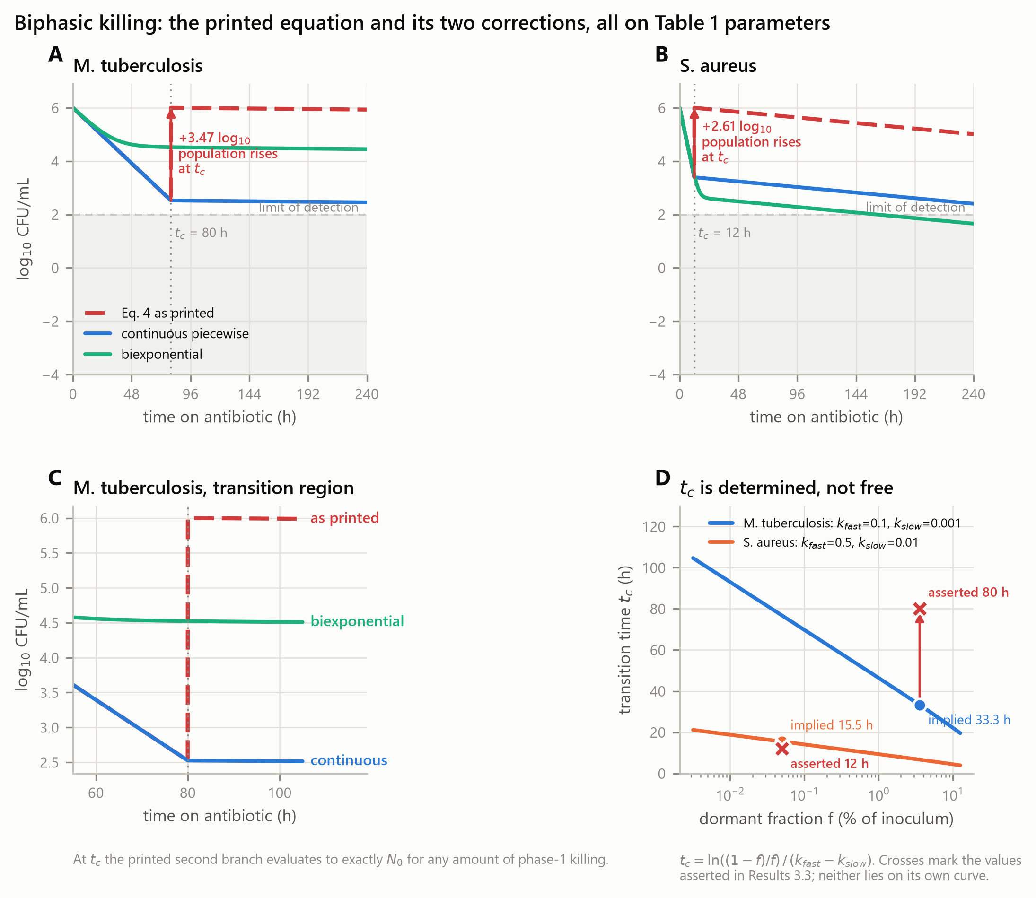
Figure 1. The closed-form biphasic law and its two corrections, all on the same parameters. (A, B) Equation 4a against the continuous piecewise and biexponential replacements. The arrow marks the upward jump at t_c: 3.47 log₁₀ for M. tuberculosis, 2.61 log₁₀ for S. aureus. (C) Detail of the transition region. At t_c the second branch of Equation 4a evaluates to exactly N₀ for any amount of first-phase killing. (D) The transition time is fixed by the other three parameters through Equation 4c. Crosses mark the values asserted in version 1; neither lies on its own curve.
A second consequence follows from the same expression. As t grows, N(t) → N_d. The dormant subpopulation never declines, so the model asserts that no regimen of any duration can sterilise. Under the parameters of Section 2.6 this places a permanent floor at 3.6 × 10⁴ CFU/mL for M. tuberculosis, which is 358 times the assay limit of detection. Time to LOD is therefore infinite, not as an artefact of a truncated search but as a property of the equation; the search window was extended to 10⁶ h before infinity was returned (results/tables/model_endpoints.csv).
Both corrected forms give finite times to LOD under the same parameters: 1,290 h for M. tuberculosis and 333 h for S. aureus under the continuous piecewise form, and 5,881 h and 161 h under the biexponential.
A published figure drawn from Equation 4a would show a vertical rise of two to three log₁₀ at the breakpoint. Figures that do not show this were not generated by the equation their methods section states. This discrepancy must be checked and disclosed wherever the equation appears.

3.2 The transition time is determined by the other parameters
In a two-subpopulation system the crossover occurs where the two exponential terms are equal, at t_c = ln((1−f)/f)/(k_fast − k_slow) (Equation 4c). It is therefore not available as a free parameter.
Species | t_c asserted | t_c implied by k_fast, k_slow, f | Discrepancy
M. tuberculosis | 80 h | 33.3 h | 2.41×
S. aureus | 12 h | 15.5 h | 0.77×

(`results/tables/tc_identifiability.csv`; Figure 1D)
Neither asserted value lies on its own curve. This matters because of what the equation is for. Read as a phenomenological piecewise form, t_c is simply a free parameter and there is no inconsistency to find. Read as the two-subpopulation system it is meant to represent — a fraction f decaying at k_slow and the rest at k_fast — t_c is a derived quantity, fixed by those three, and parameterising it independently makes the system redundant. Version 1 used the second reading to justify the equation and the first to choose a number for t_c. Section 3.8 shows the practical consequence: on time-kill data of realistic density, t_c is not estimable either.

3.3 The resistance and tolerance equations omit terms their own parameters require
Equation 2a has no carrying-capacity term although Equation 1 declares one. Over a 240 h window this produces 10⁵⁷ CFU/mL for S. aureus, which exceeds the estimated total prokaryotic population of Earth [15] by twenty-six orders of magnitude. Applying the carrying capacity already declared in Equation 1 (Equation 2b) removes the excursion (Figure 2).
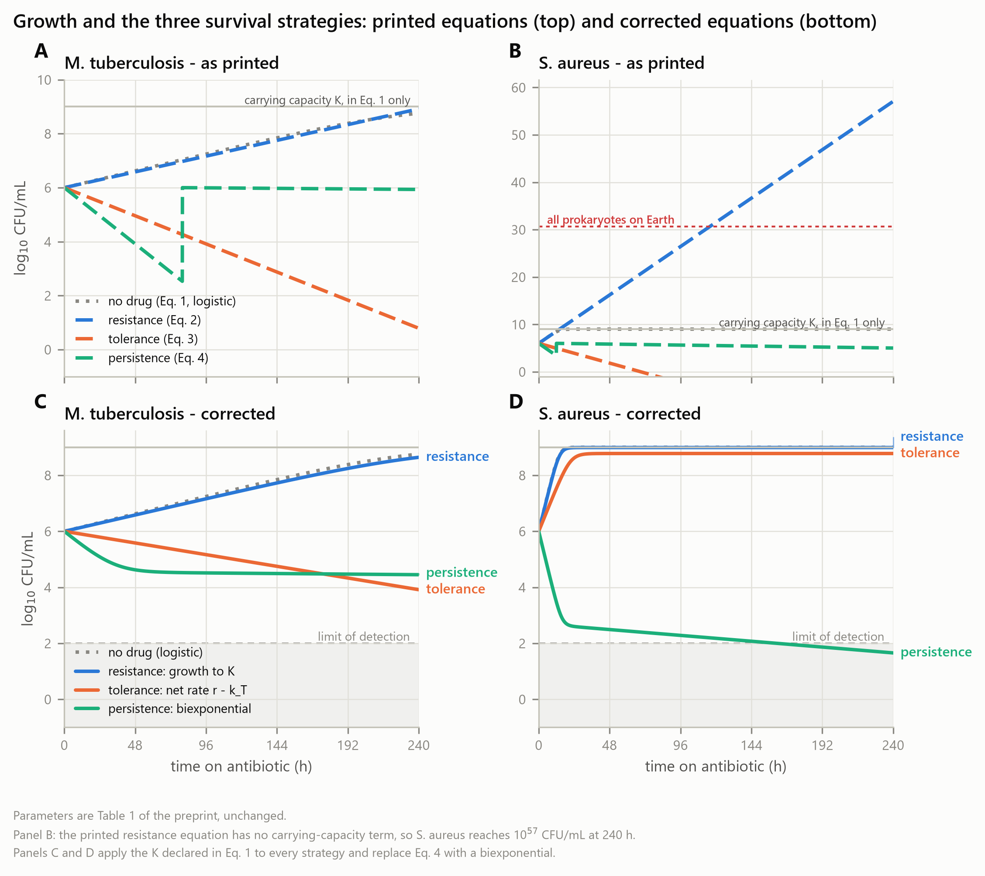
Figure 2. Growth and the three survival strategies, printed equations and corrected equations. (A, B) Equations 1, 2a, 3a and 4a on the Class A parameters of Section 2.6, unchanged. The carrying capacity declared in Equation 1 appears in none of the survival laws, so the resistance curve for S. aureus passes 10⁵⁷ CFU/mL by 240 h, exceeding the estimated prokaryotic population of Earth by twenty-six orders of magnitude. The vertical rise in the persistence curve is the discontinuity of Section 3.1. (C, D) The same scenarios with the carrying capacity applied to every strategy and Equation 4a replaced by the biexponential. Note that under the corrected tolerance equation the S. aureus population grows, because its replication rate exceeds its tolerance kill rate.
Equation 3a omits replication entirely, and for a fast grower this reverses the direction of the result rather than merely changing its magnitude. With r = 0.5/h and k_T = 0.2/h, the net rate is +0.30 /h: the population grows to carrying capacity. Equation 3a instead reports a decline of fifteen log₁₀ over the same window (results/tables/eq3_omits_replication.csv). For M. tuberculosis the sign is correct, because r = 0.03 < k_T = 0.05, but the magnitude is still wrong. A tolerance equation without a replication term cannot be applied to an organism whose replication rate appears in the same parameter table.
More fundamentally, Equations 2a and 3a are the same equation with different constants. As printed they do not distinguish resistance from tolerance, contradicting the framework they are meant to implement [4].

3.4 The comparative conclusion does not survive the correction
The strongest reason to abandon rather than patch Equation 4a is that the species contrast it produces is an artefact of its discontinuity. Correcting the equation to the continuous piecewise form and changing nothing else gives, at 240 h:
Species | Surviving fraction, Eq. 4a | Surviving fraction, corrected
M. tuberculosis | 0.857 | 2.86 × 10⁻⁴
S. aureus | 0.103 | 2.54 × 10⁻⁴

The two species differ by a factor of 1.13, or 0.05 log₁₀ (results/tables/central_comparison.csv; Figure 1A-B). On the parameters of Section 2.6 they are indistinguishable at ten days once the equation is made continuous. The apparent contrast in the corresponding figure of version 1 was produced by the fact that M. tuberculosis, with the later transition time, spent more of the window on the resurrected branch.
The biexponential form (Equation 4b) does preserve a difference, because it retains the dormant fraction as a weight on a surviving term rather than discarding it, and it is the form we recommend where a closed expression is required. But the general point stands: a conclusion that changes sign or magnitude when a discontinuity is removed was a property of the discontinuity. This is why the remainder of this paper proceeds mechanistically.

3.5 Biphasic killing emerges from compartment structure
Equations 6a and 6b contain no breakpoint, yet they produce biphasic kill curves. At four times the MIC and an inoculum of 10⁶ CFU/mL, the curvature maximum of the total population occurs at 25 h for the slow grower and 15 h for the fast grower, and the population reaches the limit of detection at 380 h and 21 h respectively (results/tables/fig05_mechanistic.csv, Figure 3).
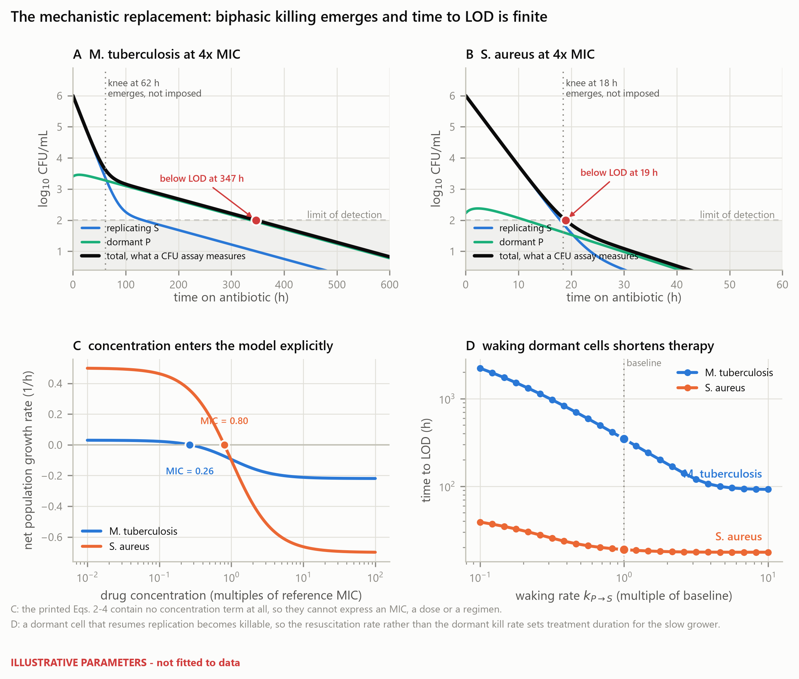
Figure 3. The state-structured model. (A, B) Replicating, dormant and total populations at four times MIC. Biphasic killing emerges from the compartment structure; the model contains no transition time, and the curvature maximum is a derived observable. Sterilisation occurs in finite time. (C) Net growth rate against concentration, with the MIC of each species marked. Equations 2a to 4a contain no concentration term and cannot produce this panel. (D) Time to LOD against the resuscitation rate. Illustrative parameters.
Three properties distinguish this from Equation 4a. The curve is continuous and differentiable throughout. Sterilisation occurs in finite time for any non-zero dormant kill rate, so treatment duration is a computed quantity rather than infinite by construction. And the transition is an observable derived from the rate constants rather than a parameter fitted independently of them, so it cannot contradict them in the way documented in Section 3.2.
The compartment trajectories also make the mechanism visible. The dormant compartment declines faster than its own kill rate alone would allow, because cells leaving dormancy enter a compartment that is being killed rapidly. The effective clearance rate of the dormant pool is approximately k_PS + E_max,P rather than E_max,P. This observation is developed in Section 3.7.

3.6 The three strategies separate onto distinct measurable axes
Introducing each mechanism separately into one parameter set, and measuring each strain at eight times its own MIC so that a resistant strain is not merely under-dosed:
Variant | MIC (fold) | MDK₉₉ | MDK₉₉.₉₉
Wild type | 1.0 | 29 h | 152 h
Resistant (EC50 × 16) | 16.0 | 29 h | 152 h
Tolerant (metabolism ÷ 4) | 1.0 | 117 h | 257 h
Persistent (dormancy entry × 10) | 1.0 | 32 h | 352 h

(`results/tables/fig06_mic_mdk.csv`, Figure 4)
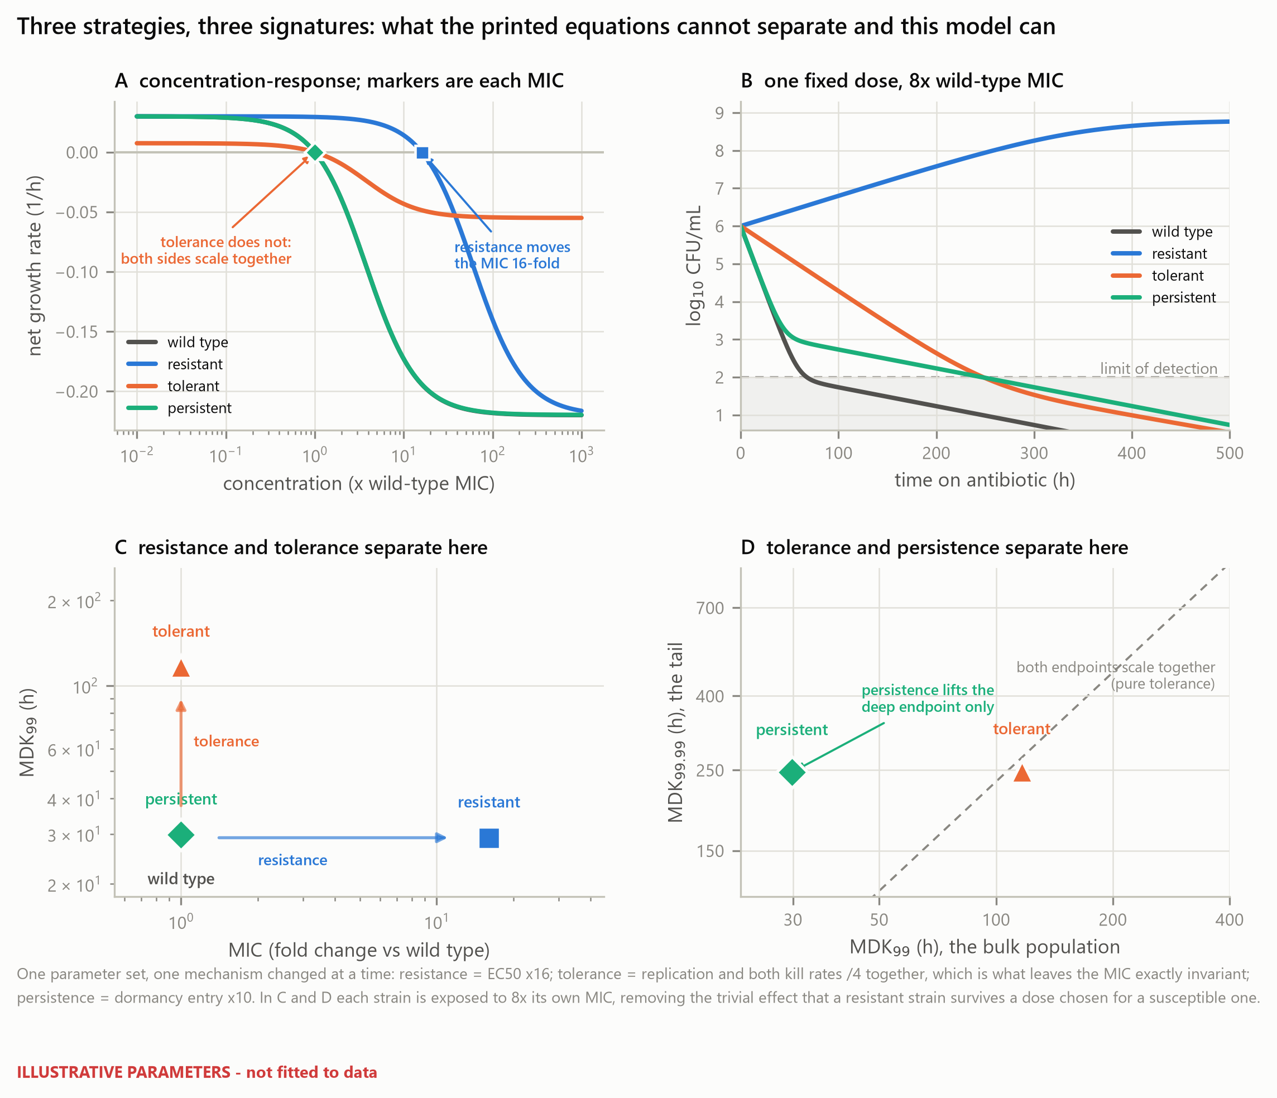
Figure 4. Three strategies, three signatures. One parameter set with one mechanism changed at a time. (A) Concentration–response; markers give each variant's MIC. Resistance moves the MIC sixteen-fold; tolerance does not move it at all, because replication and killing scale together. (B) Time-kill at a single fixed dose of eight times the wild-type MIC, the clinically visible situation, in which the resistant variant grows. (C) The MIC–MDK₉₉ plane separates resistance from tolerance. (D) The MDK₉₉–MDK₉₉.₉₉ plane separates tolerance from persistence. In C and D each strain is exposed to eight times its own MIC. Illustrative parameters.
Resistance moves the MIC sixteen-fold and leaves both killing endpoints untouched: adequately exposed, a resistant strain dies at the wild-type rate. Tolerance leaves the MIC exactly unchanged and multiplies MDK₉₉ by 3.99, recovering the imposed four-fold slowing. Persistence leaves the MIC and MDK₉₉ essentially unchanged, moving MDK₉₉ by only 10%, while raising MDK₉₉.₉₉ 2.3-fold.
Two consequences are practical. An isolate can be placed in this space from two standard laboratory measurements, so the distinction is operational rather than verbal. And a study that reports only MIC and a single killing endpoint at a fixed dose cannot separate tolerance from persistence, because both raise the deep endpoint; the two are separated only by whether the bulk endpoint moves with it.

3.7 Resuscitation rate governs time to LOD in the slow grower, and nothing else does
Applied to Equation 4a, one-at-a-time sensitivity analysis returns a ranking that is an algebraic identity rather than a result. For any t > t_c the second branch of Equation 4a contains k_slow and f and nothing else, so k_fast and k_T have elasticities of exactly zero on any endpoint evaluated after the transition, and k_slow necessarily ranks first (results/tables/analytic_elasticities.csv; Figure 5A). This ranking would be unchanged for any parameter values and any organism, and therefore cannot support a biological conclusion.
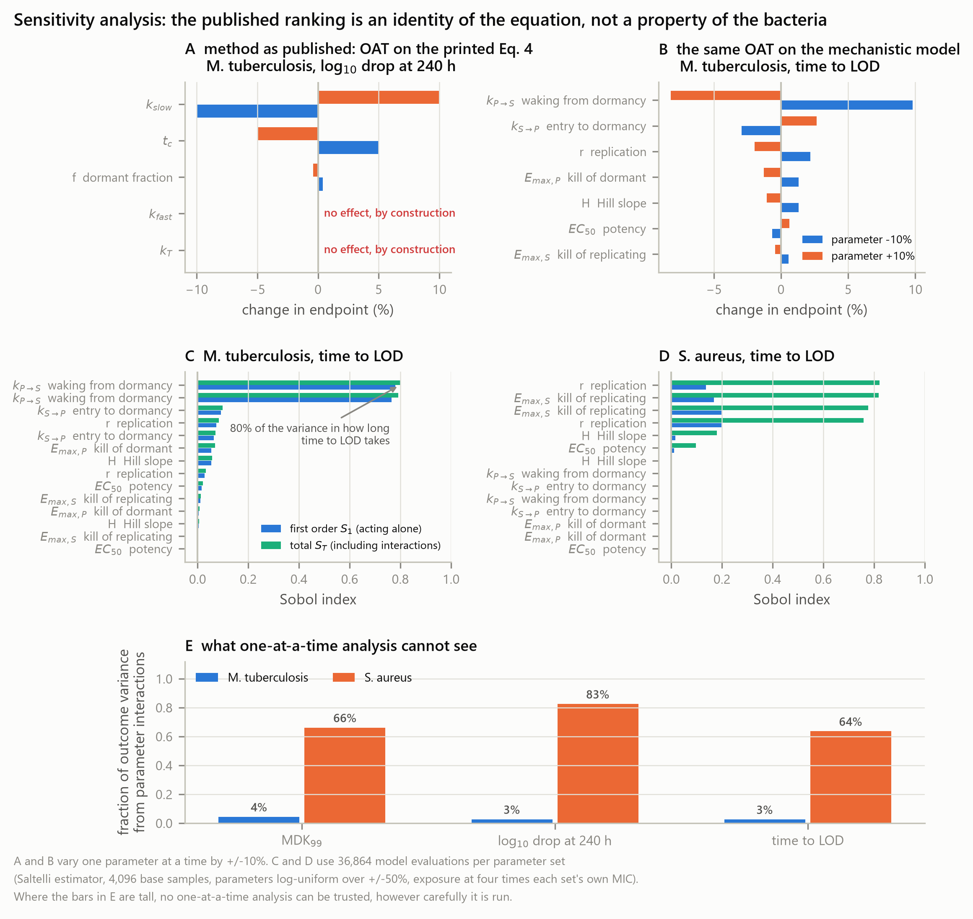
Figure 5. Sensitivity analysis: method and model varied independently. (A) One-at-a-time analysis at ±10% applied to Equation 4a. The elasticities of k_fast and k_T are exactly zero because neither appears in the branch that governs the endpoint. (B) The same analysis on the state-structured model, where every parameter acts at every time. (C, D) First-order and total-order Sobol indices for time to LOD, 4,608 model evaluations per species. (E) Share of outcome variance arising from parameter interactions. Where these bars are tall, one-at-a-time analysis is the wrong instrument.
Run on the state-structured model, where every parameter acts at every time and every parameter set is exposed at four times its own MIC, the answer is different and it is unambiguous. For the slow grower the first-order Sobol index of k_PS, the rate at which dormant cells resume replication, is 0.780 (95% bootstrap interval 0.640 to 0.916) with a total-order index of 0.799 (0.769 to 0.830) on time to LOD (results/tables/sensitivity_sobol.csv, Figure 5C). No other parameter reaches a first-order index of 0.08, and interactions account for only 2.3% of the variance: this is one parameter acting alone, not a ranking among comparable contributors. Indices are estimated from 4,096 base samples, 36,864 model evaluations per species, and the bootstrap intervals are reported because a smaller design returned negative first-order estimates for the parameters that carry no variance, which is a statement about Monte Carlo error and not about the model.
The mechanism is the one identified in Section 3.5. A dormant cell is hard to kill; a dormant cell that resumes replication is not. Anything that increases the rate of resuscitation moves cells from a refractory compartment into a susceptible one, and the drug does the rest. In this model, and for a slow grower, resuscitation therefore sets the duration and the persister kill rate does not. We state that as a property of the model and of these illustrative parameters; establishing it as a property of tuberculosis requires fitting to time-kill data, which Section 4.3 sets out. What the analysis does establish without qualification is that the two organisms are governed by different parameters, so a regimen-shortening strategy transferred between them has no reason to work. For slow-growing organisms, and it is a statement about a drug target that Equation 4a is structurally incapable of making.
For the fast grower the picture differs in kind, not in degree. The resuscitation rate contributes exactly nothing: its first-order and total-order indices are both 0.000 and its bootstrap interval has no width. What governs the fast grower is the maximum kill rate together with the replication rate, and together is the operative word — their total-order indices are 0.819 (0.706 to 0.935) and 0.821 (0.713 to 0.942) against first-order indices of only 0.169 and 0.136, so 69.5% of the variance in time to LOD comes from the two acting jointly rather than from either alone (results/tables/sensitivity_interaction_fraction.csv, Figure 5E). A one-at-a-time analysis cannot see that quantity at all; it is the share of the answer that OAT structurally omits.

3.8 The coefficient of determination cannot distinguish these models
Three further statistical claims from version 1 fail the same way, and are examined in Figure S1. Fitting Equation 4a and Equation 4b to the same synthetic time-kill data at four sampling designs produces R² above 0.9 for both models in three of the four designs, with a maximum difference between the two models of 0.098. Over the same fits the corrected Akaike information criterion differs by up to 84 units, always favouring the biexponential (results/tables/r2_vs_aicc_discrimination.csv, Figure 6C).
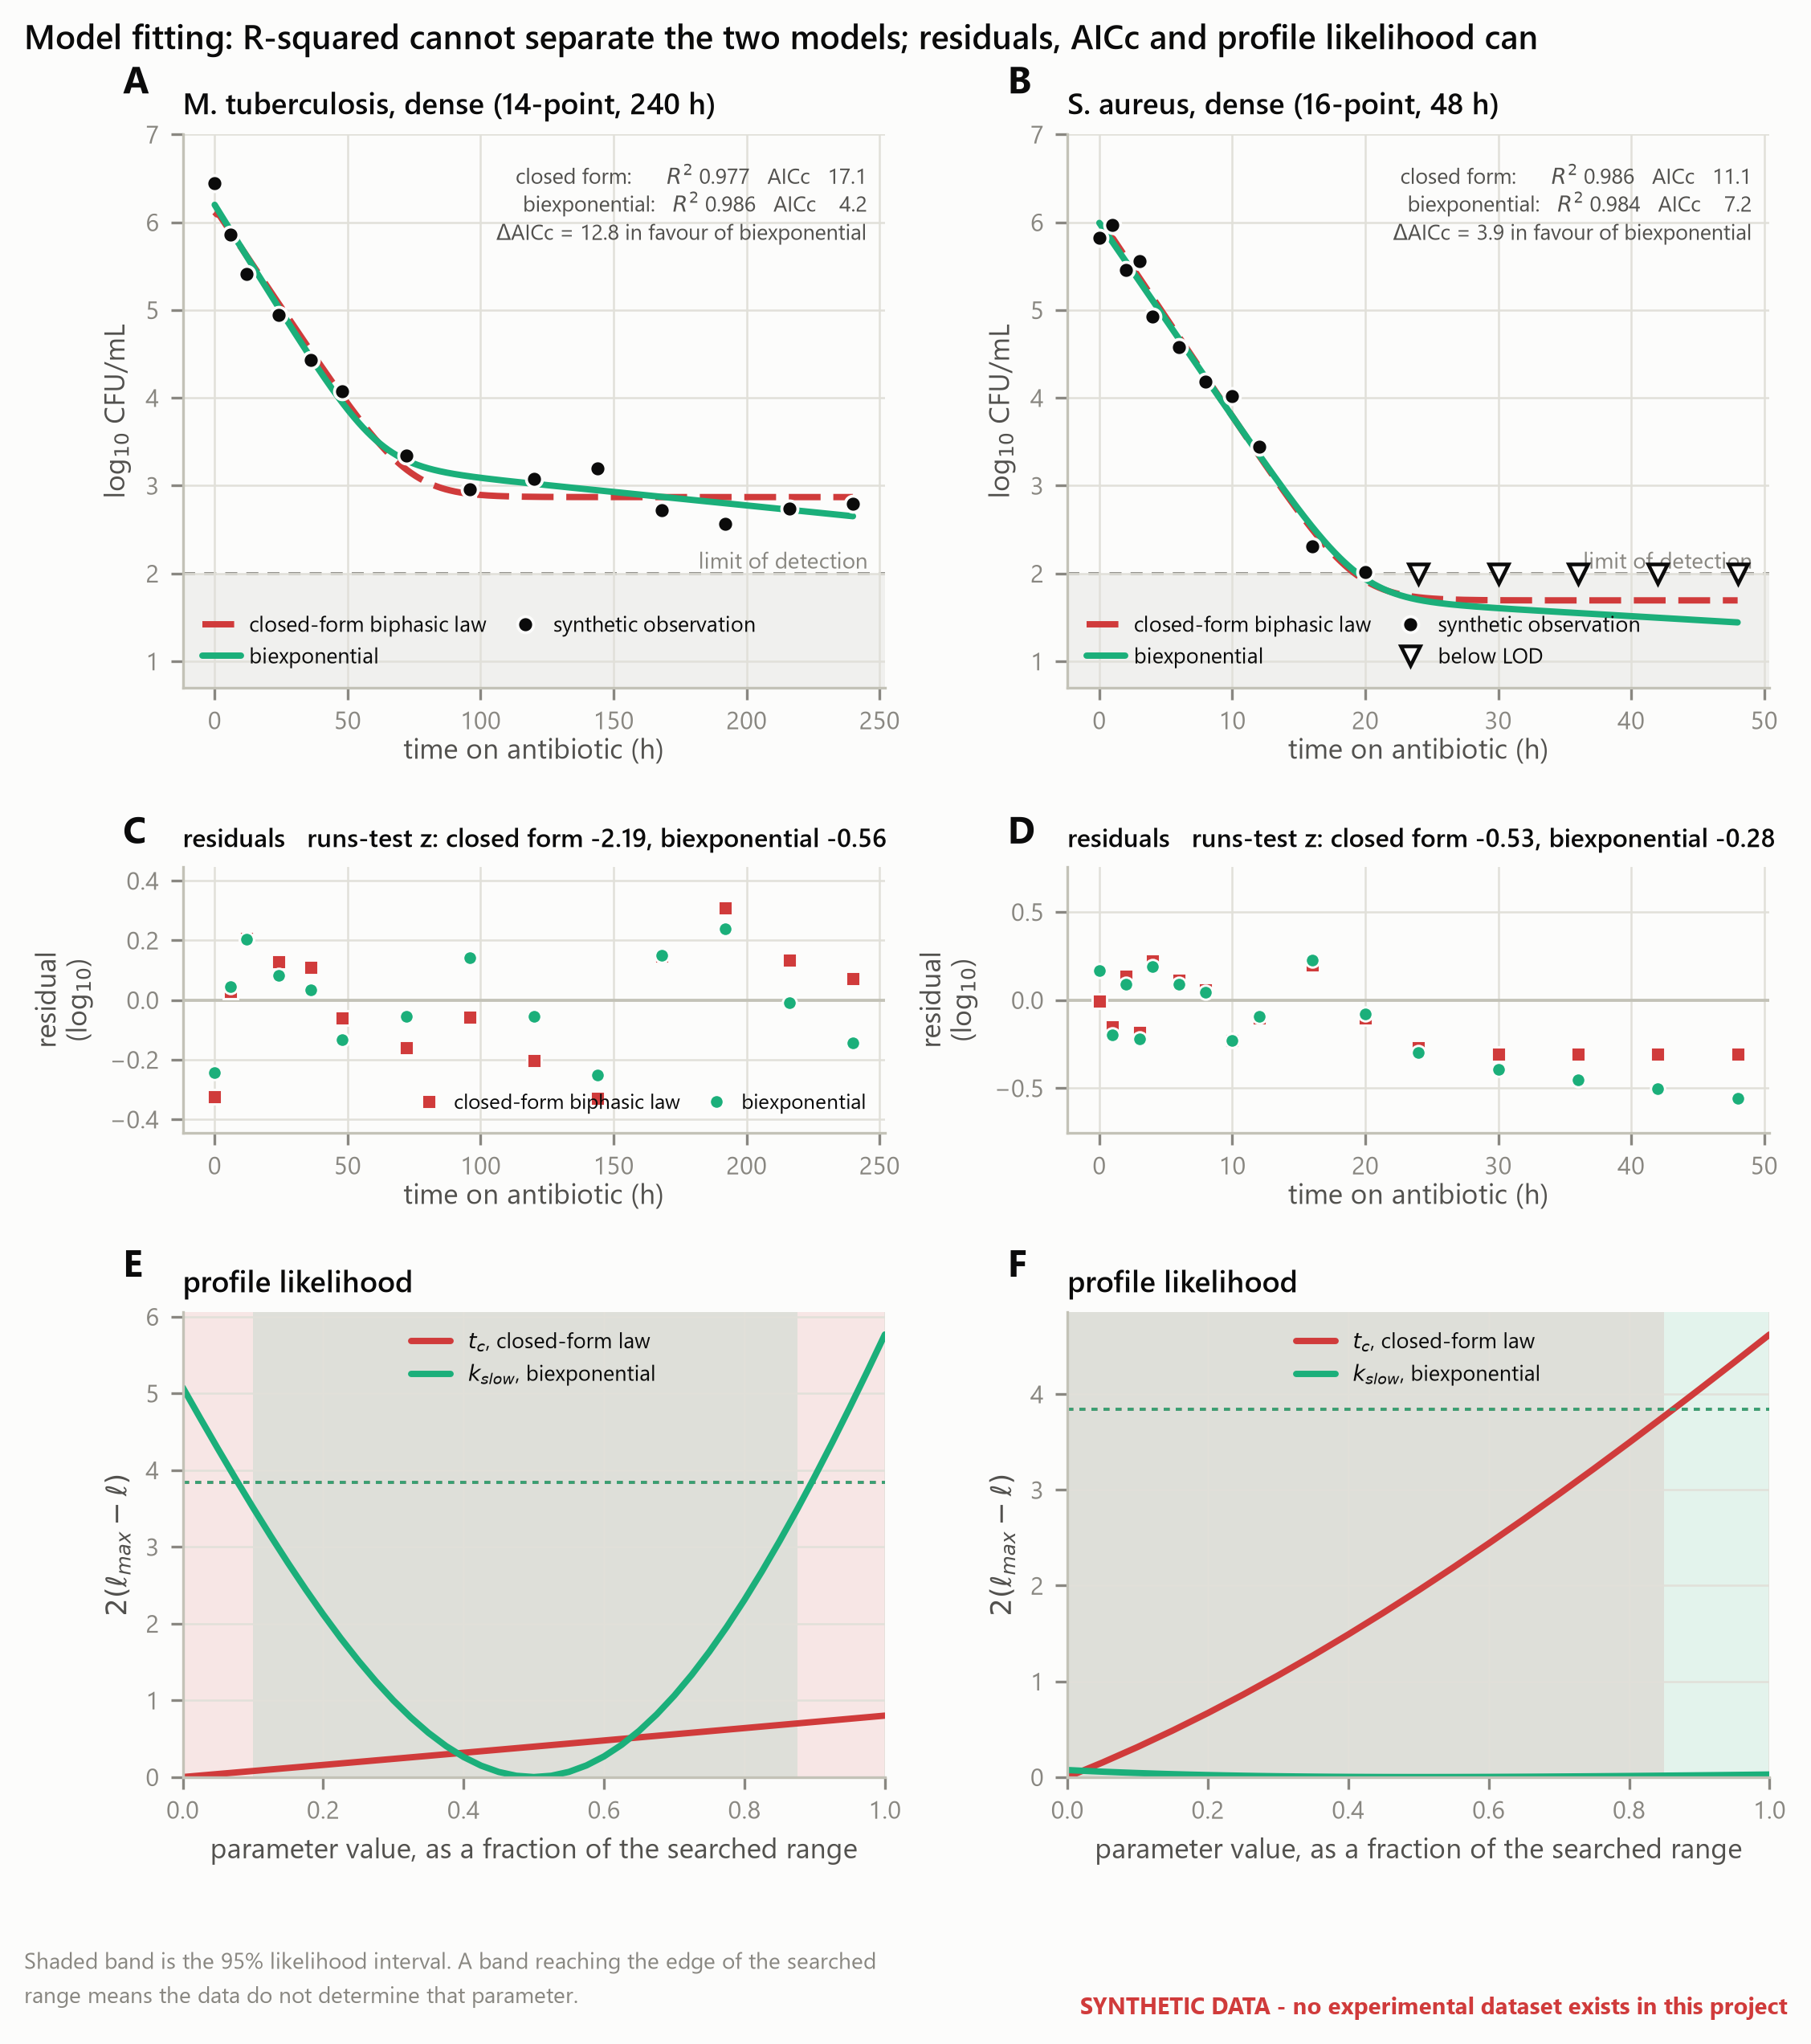
Figure 6. Fitting, model comparison and identifiability. Synthetic data with known ground truth; no experimental dataset exists for this work. (A, B) Both models track the data closely. (C, D) Residuals and runs-test statistics. (E, F) Profile likelihood. The 95% interval for the transition time of Equation 4a reaches the edge of the searched range in every design; the slow rate of the biexponential is identifiable for the slow grower.
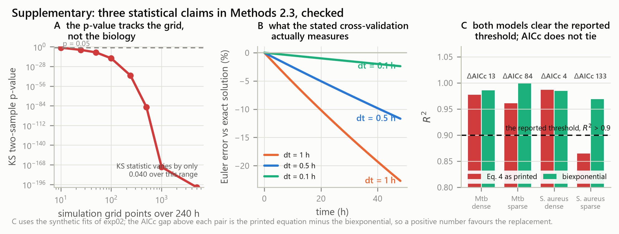
Figure S1. Three statistical claims checked. (A) The two-sample Kolmogorov–Smirnov p-value computed between two deterministic curves falls by more than 170 orders of magnitude as the simulation grid is refined, while the test statistic moves by 0.04. The test has no inferential content when applied to deterministic curves. (B) Euler integration error against the exact solution, which is what a comparison between Euler and a closed-form expression measures. (C) R² for both models against the frequently reported 0.9 threshold, annotated with the corrected Akaike information criterion difference.
R² is close to one for almost any decreasing function fitted to a monotone decaying curve, because the total sum of squares is dominated by the spread of the data across orders of magnitude. It is therefore compatible with a model that raises the population by three log₁₀ at its transition. It should not be used to select between candidate killing models, and a reported R² above 0.9 provides no evidence that a persistence model is correct.
Profile likelihood on the same fits shows that the transition time of Equation 4a is not practically identifiable on time-kill data of the density these experiments produce. Its 95% likelihood interval reaches the edge of the searched range in four of four designs, including the two dense designs, and the point estimate lies on the optimiser bound in three of them (results/tables/profile_tc.csv, Figure 6E and 6F). The Jacobian condition number at the optimum reaches 5 × 10¹⁷ for Equation 4a against approximately 5 × 10² for Equation 4b, a difference of fifteen orders of magnitude that indicates a rank-deficient design matrix rather than a difficult optimisation.
A reported value of t_c from a fit of Equation 4a to data of this density therefore carries no information about the organism; it records where the optimiser stopped. We claim this of the sampling designs tested, which span the range time-kill experiments use, and not as a structural property of the equation: we have not carried out a structural identifiability analysis, and a design with far denser sampling around the transition might well determine t_c.

4. Discussion

4.1 What this work establishes
Three results are independent of any parameter choice, because they are properties of the equations. The closed-form biphasic killing law increases the population at its transition and converges to an immortal floor. Its transition time is determined by its other three parameters and, in practice, is not estimable from time-kill data of realistic density. And a model in which resistance, tolerance and persistence are one exponential with three different rate constants cannot distinguish them, because it contains no quantity that differs between them.
One result depends on the model structure but not on the specific parameter values: given a two-compartment model with a concentration–response, each of the three strategies leaves its own signature across the minimum inhibitory concentration and the shallow and deep killing endpoints, and an isolate can be placed in that space from measurements laboratories already make. The separation is clean rather than exact: resistance and tolerance move one coordinate each and leave the others where they were, while persistence moves the deep endpoint 3.6-fold and the shallow one by 2.5%.
One result depends on the illustrative parameters and is therefore provisional: the dominance of the resuscitation rate in setting time to LOD for the slow grower. Its mechanism is robust, in that any model with a refractory compartment and a susceptible compartment will show that moving cells between them changes clearance time. Its magnitude is not established and awaits fitting to data.

4.2 Implications, stated at the strength the evidence supports
If the dominance of resuscitation survives fitting to real time-kill data, it has a direct therapeutic reading: for slow-growing organisms, agents that drive dormant cells back into replication would shorten therapy more effectively than agents that kill dormant cells directly. This is consistent with the interest in resuscitation-promoting approaches and with the observation that treatment duration for tuberculosis is set by a small, slowly cleared subpopulation rather than by the bulk [7,8,9]. We emphasise that our analysis motivates this hypothesis rather than confirming it.
The measurement implication is firmer and does not depend on the parameter values. A study reporting only MIC and a single killing endpoint cannot distinguish tolerance from persistence. Separating them requires two killing endpoints at different depths, MDK₉₉ and MDK₉₉.₉₉, measured at matched multiples of each strain's own MIC. Studies that dose all strains at a fixed absolute concentration measure under-dosing of resistant strains rather than any difference in their killing kinetics.
The methodological implication is firmest of all. A high R² is not evidence that a killing model is correct, and a fitted transition time from an over-parameterised biphasic law is not a measurement. Papers reporting either should also report an information criterion, a residual diagnostic and a profile likelihood.

4.3 Limitations
No experimental data. This is the principal limitation and it bounds everything else. Version 1 of this work presented a figure captioned as experimental data versus model fitting without identifying any dataset. That figure has been withdrawn. The present Figure 6 uses synthetic data with known ground truth, is stamped as such, and supports conclusions about the estimator and about identifiability only.
Illustrative parameters. The Class B values of Section 2.6 reproduce documented qualitative behaviour but are not measurements. No quantitative species-level claim is made from them. Candidate datasets suitable for fitting, principally hollow-fibre infection model studies for both organisms, are catalogued in the accompanying data manifest, and fitting the model to them requires no change to the model code.
Constant exposure. All simulations use a constant concentration. Real regimens produce fluctuating concentrations, and the relevant exposure metric may be the area under the curve relative to MIC, the peak relative to MIC or the time above MIC depending on drug class. Extending Equations 6a and 6b to time-varying C is straightforward and is the natural next step.
Two compartments. Dormancy is a continuum rather than a binary state, and depth of dormancy varies [16]. A two-compartment model is the simplest structure that separates the three strategies; it is not proposed as a complete description.
Deterministic. At the low copy numbers that determine sterilisation, extinction is a stochastic event and a deterministic model cannot give an extinction probability. A stochastic implementation is required for that question.
Sensitivity ranges. The global analysis samples ±50% log-uniformly around illustrative values. Once parameters are estimated, it should be rerun over the posterior.

4.4 Next steps
The binding constraint is data extraction rather than model development. In order: extract time-kill data from the identified hollow-fibre studies with a documented and versioned digitisation workflow; fit Equations 5 and 6 with a hold-out set designated before any fitting begins; recompute the global sensitivity analysis over the fitted posterior; and only then restate the species-level conclusions quantitatively. Extension to time-varying exposure and to a stochastic implementation follows.

5. Conclusion
Resistance, tolerance and persistence are three different phenomena, and a model that writes all three as one exponential with a different constant cannot tell them apart. A closed-form biphasic law written with an explicit transition time, as we wrote it in version 1, fails in three further ways that we quantify here: it raises the modelled population by two to three log₁₀ at its transition, it converges to a floor at which sterilisation is impossible at any duration, and its transition time is not identifiable from time-kill data of realistic density.
A two-compartment model with a sigmoid concentration–response removes all three failures and separates the strategies onto distinct axes of quantities that laboratories already measure. Applied to that model, global sensitivity analysis identifies the rate at which dormant cells resume replication as the dominant determinant of sterilisation time for a slow-growing organism, a determinant the closed-form law cannot express.
This is a framework rather than a measurement. Its quantitative claims about M. tuberculosis and S. aureus await fitting to experimental time-kill data. What it establishes is which quantities must be measured, and what a model must contain before those measurements mean anything.

Data and code availability
All code, intermediate tables, receipts and figure-generating scripts are openly available at https://github.com/piranfar/comparative_model_presistance (code under the MIT licence, documentation and figures under CC BY 4.0). python run_all.py regenerates every number and every figure reported here in approximately 110 seconds, with no network access. Each analysis stage writes a receipt recording library versions and run parameters. No experimental dataset is used or distributed; candidate datasets for the fitting stage are catalogued with digital object identifiers in data/manifests/datasets.csv.

Author contributions
V.P. conceived the study, wrote the code, performed the analyses and wrote the manuscript.

Competing interests
To be completed by the author before submission.

Acknowledgements
To be completed by the author before submission.

References
All entries below were verified in September 2026: those indexed in PubMed against their PubMed record and carrying their PMID, and the one entry that is not indexed, a World Health Organization report, against the publisher record and carrying its ISBN. Thirteen entries from version 1 were removed or replaced; see the note on version 2 above and docs/04_REFERENCE_VERIFICATION.md for the full audit.
1. Lewis K. Persister cells, dormancy and infectious disease. Nat Rev Microbiol. 2007;5(1):48-56. PMID 17143318. doi:10.1038/nrmicro1557
2. Zhang Y, Yew WW. Mechanisms of drug resistance in Mycobacterium tuberculosis. Int J Tuberc Lung Dis. 2009;13(11):1320-30. PMID 19861002.
3. Balaban NQ, Helaine S, Lewis K, Ackermann M, Aldridge B, Andersson DI, et al. Definitions and guidelines for research on antibiotic persistence. Nat Rev Microbiol. 2019;17(7):441-448. PMID 30980069. doi:10.1038/s41579-019-0196-3
4. Brauner A, Fridman O, Gefen O, Balaban NQ. Distinguishing between resistance, tolerance and persistence to antibiotic treatment. Nat Rev Microbiol. 2016;14(5):320-30. PMID 27080241. doi:10.1038/nrmicro.2016.34
5. World Health Organization. Global tuberculosis report 2021. Geneva: World Health Organization; 2021. ISBN 978-92-4-003702-1.
6. Levin BR, Rozen DE. Non-inherited antibiotic resistance. Nat Rev Microbiol. 2006;4(7):556-62. PMID 16778840. doi:10.1038/nrmicro1445
7. Dhar N, McKinney JD. Mycobacterium tuberculosis persistence mutants identified by screening in isoniazid-treated mice. Proc Natl Acad Sci USA. 2010;107(27):12275-80. PMID 20566858. doi:10.1073/pnas.1003219107
8. Gengenbacher M, Kaufmann SHE. Mycobacterium tuberculosis: success through dormancy. FEMS Microbiol Rev. 2012;36(3):514-32. PMID 22320122. doi:10.1111/j.1574-6976.2012.00331.x
9. Wakamoto Y, Dhar N, Chait R, Schneider K, Signorino-Gelo F, Leibler S, McKinney JD. Dynamic persistence of antibiotic-stressed mycobacteria. Science. 2013;339(6115):91-5. PMID 23288538. doi:10.1126/science.1229858
10. Aldridge BB, Fernandez-Suarez M, Heller D, Ambravaneswaran V, Sundaresan V, Fortune SM. Asymmetry and aging of mycobacterial cells lead to variable growth and antibiotic susceptibility. Science. 2012;335(6064):100-4. PMID 22174129. doi:10.1126/science.1216166
11. Conlon BP, Rowe SE, Gandt AB, Nuxoll AS, Donegan NP, Zalis EA, et al. Persister formation in Staphylococcus aureus is associated with ATP depletion. Nat Microbiol. 2016;1:16051. PMID 27572649. doi:10.1038/nmicrobiol.2016.51
12. Wilmaerts D, Windels EM, Verstraeten N, Michiels J. General mechanisms leading to persister formation and awakening. Trends Genet. 2019;35(6):401-411. PMID 31036343. doi:10.1016/j.tig.2019.03.007
13. Regoes RR, Wiuff C, Zappala RM, Garner KN, Baquero F, Levin BR. Pharmacodynamic functions: a multiparameter approach to the design of antibiotic treatment regimens. Antimicrob Agents Chemother. 2004;48(10):3670-6. PMID 15388418. doi:10.1128/AAC.48.10.3670-3676.2004
14. Nielsen EI, Friberg LE. Pharmacokinetic-pharmacodynamic modeling of antibacterial drugs. Pharmacol Rev. 2013;65(3):1053-90. PMID 23803529. doi:10.1124/pr.111.005769
15. Whitman WB, Coleman DC, Wiebe WJ. Prokaryotes: the unseen majority. Proc Natl Acad Sci USA. 1998;95(12):6578-83. PMID 9618454. doi:10.1073/pnas.95.12.6578
16. Pu Y, Li Y, Jin X, Tian T, Ma Q, Zhao Z, et al. ATP-dependent dynamic protein aggregation regulates bacterial dormancy depth critical for antibiotic tolerance. Mol Cell. 2019;73(1):143-156.e4. PMID 30472191. doi:10.1016/j.molcel.2018.10.022
Candidate datasets named in Section 4.3 for the fitting stage. These are cited as sources of data, not as support for any claim made here.
17. Tsuji BT, Brown T, Parasrampuria R, Brazeau DA, Forrest A, Kelchlin PA, et al. Front-loaded linezolid regimens result in increased killing and suppression of the accessory gene regulator system of Staphylococcus aureus. Antimicrob Agents Chemother. 2012;56(7):3712-9. PMID 22526313. doi:10.1128/AAC.05453-11
18. Drusano GL, Myrick J, Maynard M, Nole J, Duncanson B, Brown D, et al. Linezolid kills acid-phase and non-replicative-persister-phase Mycobacterium tuberculosis in a hollow-fiber infection model. Antimicrob Agents Chemother. 2018;62(8):e00221-18. PMID 29866864. doi:10.1128/AAC.00221-18
19. Pasipanodya JG, Nuermberger E, Romero K, Hanna D, Gumbo T. Systematic analysis of hollow fiber model of tuberculosis experiments. Clin Infect Dis. 2015;61 Suppl 1:S10-7. PMID 26224767. doi:10.1093/cid/civ425
20. Gumbo T, Louie A, Deziel MR, Parsons LM, Salfinger M, Drusano GL. Selection of a moxifloxacin dose that suppresses drug resistance in Mycobacterium tuberculosis, by use of an in vitro pharmacodynamic infection model and mathematical modeling. J Infect Dis. 2004;190(9):1642-51. PMID 15478070. doi:10.1086/424849
21. Conlon BP, Nakayasu ES, Fischer LE, LoSasso G, Kim W, Lewis K, et al. Activated ClpP kills persisters and eradicates a chronic biofilm infection. Nature. 2013;503(7476):365-70. PMID 24226776. doi:10.1038/nature12790

