Results, Discussion and Conclusion
1. Rifampicin tolerance in 217 clinical isolates is scored against an unreported assay floor
Most-probable-number (MPN) readings take only the discrete values of an MPN table (5, 6), a fixed ladder of rungs, not a continuous scale. The day-5 column does not taper towards zero. It stops. Eighteen isolates sit at exactly 23 per mL in the 15-day panel and six in the 60-day panel, and nothing in the file lies below that (Fig. 1A). That is a floor, not a tail, and it is treated as one throughout.
Each isolate therefore carries a fixed budget of killing the assay can see. At 15 days of prior culture the starting densities run from 2,300 to 61,000,000 per mL (3.36 to 7.79 log10), so headroom, the distance from the starting density down to the floor, runs from 2.00 to 6.42 log10 (Fig. 1B, Table 1): both spans are the same 4.42 log10.
Against that budget the three deposited endpoints behave very differently. Every isolate has room for a 90 or a 99 per cent reduction: 0 of 217 fall short in either case. Thirty-three of 217 isolates (15.2 per cent) lack the headroom for the 99.99 per cent endpoint, a four-log reduction that was unobservable for them before rifampicin was added.
All 33 are recorded as not having reached the endpoint, sitting at the assay ceiling: a census rather than an estimate, since the floor censors the count while the ceiling censors time, an isolate not yet at its endpoint after six days being recorded at the last day rather than the day it would have reached. Among the 184 isolates that did have four logs of headroom, 162 are also at the ceiling, 88.0 per cent.
2. The same floor-level reading yields opposite tolerance labels depending on starting density
The deposited tolerance level is a cut-off on the recorded surviving fraction, with no overlap between classes. The thresholds themselves are not deposited; recovered here, at day 5 and 15 days of prior culture, low tolerance covers fractions below 10⁻³, medium 10⁻³ to 10⁻², high above 10⁻². Those cuts reproduce every usable class in the file, 203 of 203 (Table S2). Usable means the 203 of 217 isolates whose label is one of the three ordered classes; the other 14 carry the "MDR" category, which no ordered analysis can place (Table S3). What follows is an argument about the fraction the assay recorded, not about an independent clinical judgement.
Eighteen isolates ended at the floor. They share one reported floor-level observation, but their true final counts are unknown below the floor, so the assay cannot tell their surviving burdens apart down there. That is not the same as saying they were killed to the same degree. Their starting densities span 265-fold, from 23,000 to 6.1 × 10⁶ per mL, so the same terminal reading implies a different range of compatible reductions in each: at least 3.00 log reduction for the isolate that began at 23,000, at least 5.42 logs for the one that began at 6.1 × 10⁶, and in either case the true reduction may be anything from that bound down to complete kill. What the deposit records instead is a single number per isolate, L/N₀, and those recorded fractions span the same 265-fold, from 3.8 × 10⁻⁶ to 1.0 × 10⁻³ (Fig. 1C), because that is what the ratio is. They are upper bounds on survival, not measurements of it.
The labels those eighteen received differ accordingly. Six isolates that began at 23,000 per mL recorded a fraction of 10⁻³ and were classified medium tolerance; twelve that began at 230,000 or above recorded 10⁻⁴ or less and were classified low. A single cut on the starting density alone reproduces all eighteen (Table 2): once a reading is censored at the floor, the starting density fixes which label the published rule is able to return.
3. The floor predicts, before rifampicin is added, which isolates will be mislabeled
Sections 1 and 2 counted isolates. The two boundaries derived in the Methods do more: given only the floor, the class thresholds and each isolate's starting density, they say in advance which isolates are affected, before any day-5 reading is used.
For this assay N_reach = 23 × 10⁴ = 230,000 per mL and N_id = 23/10⁻³ = 23,000 per mL. Applied to the 15-day panel, the first predicts the 33 isolates unable to reach the 99.99 per cent endpoint; the second predicts that of the eighteen isolates whose reading rests on the floor, twelve have only the lowest class compatible and six have more than one. Those are the three counts Sections 1 and 2 report.
Neither boundary predicts which isolates reach the floor; that depends on what rifampicin does. Both predict what a reading at the floor can be made to mean once it happens, and there the agreement with the deposit is exact, isolate by isolate: the set the algebra says has a single compatible class and the set the deposit records in the lowest class are the same set.
What is sharp is the boundary case. Six isolates sit at exactly 23,000 per mL, which is N_id itself. For them L/N₀ equals c₁ exactly, the interval [0, L/N₀] touches the threshold from below and spans two classes, and the strict inequality fails. Those six are precisely the six the deposit records as medium rather than low. A rule written with the inequality the other way would have called all six low and been wrong six times out of six. That is a test the arithmetic could have failed and did not, and it is what licenses using the boundary in advance: given a floor, a set of thresholds and a starting density, the affected isolates can be named before any reading is taken.
The empirical findings are therefore consequences of the definitions rather than properties of this deposit: any dataset reporting a starting density, a floor and a threshold classification can be checked against them.
4. Isoniazid-resistant isolates appear more rifampicin-tolerant, but the effect tracks a thinner inoculum, not resistance
There are two candidate predictors of the deposited label, each tested at two culture ages and two endpoint depths, eight tests in all. Eight tests on one question will throw up a false positive on their own, so they are corrected together as one family. Two survive (Table S4).
The label tracks the growth rate of the isolate. Slower growth goes with a higher tolerance class, and it survives adjustment for starting density (OR 1.096 per day of time to OD 0.4, 95 per cent CI 1.032 to 1.164, p = 0.0030, n = 202; unadjusted OR 1.126, 1.062 to 1.193). The label also tracks isoniazid resistance, until starting density enters the model. Unadjusted, a resistant isolate has 2.32 times the odds of a higher tolerance class (1.30 to 4.12, p = 0.0042); adjusted, the odds ratio falls to 1.31 (0.67 to 2.57, p = 0.42), and the interval no longer excludes one. Starting density is the strongest term in the file: every ten-fold rise in the starting MPN halves the odds of a higher tolerance class (OR 0.480, 0.340 to 0.677, p = 2.9 × 10⁻⁵).
Why the adjustment does that is measurable. Isoniazid-resistant isolates go into this assay at 5.36 log10 against 6.36 for susceptible isolates, ten-fold thinner (Mann-Whitney p = 9.1 × 10⁻¹⁴ (7)), and 22 of the 84 resistant isolates carrying an ordered label lack the headroom for the deepest endpoint, 26.2 per cent, against 9 of 119 susceptible, 7.6 per cent. They are one log short of observable killing before the experiment begins.
In that stratum the two associations part company. Growth holds and still survives correction (OR 1.116, 1.040 to 1.198, p = 0.0024). Resistance returns OR 2.11 (1.07 to 4.16, p = 0.031) nominally, but ranks second in the family of eight and fails its Benjamini-Hochberg critical value of 0.0125. The resistance association therefore leans on isolates that are not independent of one another, and it is already the association that starting density explains away; we report it as the weaker of the two on both counts.
5. Six laboratories given one M. tuberculosis protocol still see six different assay floors
If the effect is a property of assay geometry rather than of clinical sampling, it should appear where one protocol, one strain and one stock are handed out deliberately. Van Wijk and colleagues (2023) ran exactly that exercise, sending a single stock of H37Rv to six blinded laboratories under one written protocol (8, 9). It does.
At ten times the minimum inhibitory concentration of moxifloxacin all six laboratories return a positive kill rate, spanning 5.2-fold, from 0.090 to 0.464 log10 CFU/mL per day (Fig. 2A, Table S5).
The two orderings do not correspond. Rank the laboratories by starting density and the three lowest are exactly the three that recorded crossings, the three highest exactly the three that did not, without exception, a split with probability 1/20 under chance alone, reported as an ordering and not a test (Table S6). Rank them by kill rate and there is no such correspondence (Fig. 2B). Institute F has the highest starting density at 6.53 log10 among treated flasks of this arm, kills faster than four of the other five at 0.223 log10 per day, and records no crossing. Institute E returns the slowest rate of all at 0.090 and also records none.
6. The two boundaries hold in a deposit never used to derive them, in a different organism and drug
Dubey and colleagues (2026) report amoxicillin-clavulanate against Escherichia coli in a hollow-fibre system (10, 11). Their Methods state 100 µL plated with counts per mL, so L = 10 CFU/mL is derived rather than inferred, and the file corroborates the derivation: all 229 genuine counts are multiples of ten, the smallest exactly ten, while 69 further entries read as one, which no 100 µL plate can produce and which are the deposit's placeholder for below the floor.
Across the 20 cultures with a measured day-zero density, headroom runs from 4.85 to 5.45 log10 (Table S7). Endpoints at 1, 2, 3 and 4 logs are reachable for every culture; a 5-log endpoint is unreachable for 5 of 20, a 6-log endpoint for all 20. On data it was not built from, the framework locates the depth at which a sterilisation claim stops being demonstrable.
Two features of that deposit are the failure modes this framework is meant to catch. Its Methods give a nominal inoculum of 10⁵ CFU/mL while the file measures a median of 1.215 × 10⁶, so taking N₀ from the Methods rather than the data would have placed a full order of magnitude into every boundary. And its treated arm reads at or below the floor already at day zero while the paired control reads about 10⁶; the file cannot distinguish a sample drawn after exposure from a placeholder or a transcription error, so the reading is flagged rather than treated as a measured time zero.
7. A second distortion in M. tuberculosis: bacilli invisible to culture, not just below the floor
Everything above is about the floor. One published observation in this organism shows that the floor is not the only reason a colony count understates the population, and the two failures must not be confused.
Evangelopoulos and colleagues counted the same mouse lungs three ways, colony count, a molecular bacterial load from 16S rRNA, and a most probable number, on their way to a different question (12). Under the deepest regimens the colony count reads zero in every animal: in three arms, 18 lungs in all, the plate declared every lung sterile while the most probable number on that same tissue ran from 1,450 to 18,700 per lung. The molecular load can be dismissed as nucleic acid outliving its owner; the most probable number cannot, because it is a culture, and growth in a dilution series requires an organism that is alive and culturable.
That gap is not the detection floor, and the arithmetic says so. For censoring to explain a plate reading of zero against 1,450 organisms in the same tissue, the colony count's floor would have to sit above 1,450 per lung, far less of the homogenate than any lung protocol plates. This is differential culturability, a described phenotype of M. tuberculosis with a literature of its own: resuscitation-promoting-factor-dependent bacilli dominate pre-treatment sputum and rise during chemotherapy (13), both dependent and independent differentially culturable populations are recovered from patients whose solid-medium cultures return nothing (14), and the mechanism has been reproduced experimentally, rifamycin action on ribonucleic acid (RNA) polymerase converting a starved population to over 90 per cent differentially detectable in vitro (15), the same drug class every arm of the Evangelopoulos regimen carries.
Reachability and identifiability are arithmetic on the plated volume; they would hold in an assay with perfect culturability. Differential culturability is biology, acts on the numerator rather than the floor, and nothing here derives or measures it. Neither depends on the other, and they push the same way: a count that is both floored and culture-selective understates the surviving population twice over, and the mouse model that decides which regimens enter clinical trials reads out in colony counts, in exactly this region.
That deposit establishes no floor of its own. Five further M. tuberculosis deposits in the same screen do, and they are not reassuring. Across those five, sputum from pulmonary tuberculosis, axenic culture, an auxotrophic H37Rv panel and two drug-development series, with floors from 13 to 200 CFU/mL, 184 of 310 series could not have demonstrated a four-log reduction however completely the drug worked, and 240 of 310 could not have demonstrated five (Table S8); one could not have shown four logs in a single one of its 123 series. None of these five carries the analysis above, and none is among the five deposits reanalysed in this paper; they say the reachability problem is not a property of one clinical panel.
8. A prospective E. coli experiment confirms the floor artifact: one culture, two plated volumes, two conflicting labels
Every result above reads data somebody else generated for another purpose. This one reads an experiment built to try to break the two boundaries N_reach and N_id, with its predictions written down before a plate was counted. Escherichia coli ATCC 25922, the reference strain the standard names for quality control, against ciprofloxacin at ten times the concentration that stops it growing. Three seeding densities, two plated volumes, three flasks each, 216 plate readings.
The middle arm was seeded on purpose at the 5 × 10⁵ per mL the standard specifies. The densities actually reached were 6.4 × 10⁴, 4.4 × 10⁵ and 3.8 × 10⁶ per mL as arm means, but N₀ is a measurement made once per culture rather than a setting the protocol supplies, so headroom belongs to a flask and everything below is reported per flask. At the 100 µL plating the low arm's three flasks have 4.19, 4.11 and 4.00 logs of headroom, the last exactly at the four-log endpoint. At the standard inoculum plated at 10 µL, the deepest reduction the three flasks could report ran from 3.71 to 3.93 logs, while those same three cultures plated at 100 µL ran from 4.88 to 5.05 (Fig. S5B, Table S9). Every flask is paired with itself across the two platings.
That much is arithmetic. So is the next step. When both platings of one sample rest on their own floors, the two fractions written down are L₁/N₀ and L₂/N₀, so they can fall either side of a class threshold and give one culture two labels. The quantity that could have come out zero is how often a real experiment lands in the window where those two fractions straddle the cut, and it depends on where the cut is (Fig. S5C, Table S10). Put the cut at one per cent and the window is nearly shut. Put it at one in a thousand, where the clinical classification above cuts its lowest class, and six of 54 sample-times receive two different labels from one culture, one in nine. That cut is imported from the tuberculosis classification; it serves here as a ruler for the window's width, not a claim about E. coli biology.
Discussion
Every clinical microbiologist knows that a negative culture taken under antibiotic exposure is not proof of sterility. This paper reports that the number brought in to replace that judgement carries the same defect, and once it is a number, it is harder to see.
The standard is not silent on that choice, and this is the paper's sharpest finding rather than an awkwardness for it. M26-A's own section 1.3.2.5, Volume Transferred, ties the volume to the endpoint with a counting rule: after the defined 99.9 per cent killing, at least ten colonies must remain (16) (for a standard inoculum of 5 × 10⁵ per mL that means at least 20 µL streaked, so a 10 µL streak fails the rule), and section 3.1 separately requires the smallest detectable count to be established by serial dilution. A guideline written in 1999 already required both numbers this paper asks for. The deposits reanalysed here do not meet it, not for lack of care but because the endpoint moved: M26-A nowhere contemplates a four-log call, and the volume rule did not travel with the deeper endpoints.
Take the assay's contribution out and what is left makes biological sense. Growth state predicts the tolerance class before and after adjustment for starting density (isoniazid needs KatG and active cell-wall synthesis (17), rifampicin needs transcription (18)), and a population that is not dividing offers less of what these drugs act on. The classification is reading physiological state, not drug susceptibility.
That axis is the one tuberculosis drug development already leans on. Killing assays of this design rank regimens before they enter trials, and tolerance followed in patients is now being read as within-host evolution (19). If a tolerance classification is partly an inoculum measurement, conclusions drawn from it, that one regimen sterilises faster than another, or that a patient's isolates are becoming more tolerant over therapy, are in part conclusions about how the assay was set up. The correction applied here does not remove the biology; it aims it at the right target. The phenotype that survives the correction is growth state, real, targetable and directly measurable, unlike a fraction read off a floor.
The prospective experiment has a limitation of its own, and it is the one a reader of this paper should raise first. Its samples were diluted in saline and plated; they were not washed, filtered or treated to inactivate the drug, and no carryover control was run. Antibiotic carried onto the plate suppresses colony formation without killing anything, the same class of counting artefact this paper is about, and at the shallow dilutions a culture near its floor is read on, dilution is the only thing containing it. The design is conservative in this respect rather than clean: the larger plated volume carries ten times more drug to the plate, so carryover would shrink the very difference between the two platings that Section 8 reports, not manufacture it. But the experiment cannot exclude carryover, and a repetition should include the control that would.
Several further limitations bound what the analysis can establish; each points at the experiment that would settle the question, and the ones bearing on the claims made are given here, with the rest in the supplement.
This paper has already acted on the first rather than merely declaring it. Flasks from one laboratory share a starting culture; repeat isolates come from a patient already counted. Every conclusion from the two primary deposits was recomputed at the level where the observations really are independent, listed one line at a time rather than summarised (Table S6): twenty survive unchanged, six survive with much wider uncertainty, five do not survive and have already been removed from the text above, and one is withdrawn because the null it was tested against was already false before any data were seen. The ledger is printed so a reader can check the dropping was done rather than promised.
The 15-day and 60-day panels of the clinical deposit contain the same isolates. The comparison between panels is therefore not independent, and it bounds the evidence for a difference rather than establishing it.
Choose the depth of the endpoint to fit the headroom actually available, rather than densifying the inoculum merely to buy more. The inoculum this needs can be worked out before the experiment: seeding above L · max(10^q, 1/c₁) makes both failure modes impossible, the endpoint that was never reachable and the last count that lands on the floor; for this assay that is 230,000 per mL. Seeding higher also changes the experiment, because a denser culture is a different physiological state, and physiological state is what the tolerance label tracks, so where the deep endpoint is wanted, lower the assay floor instead; where the headroom will not carry it either way, the shallower endpoint is the honest one, and growth state belongs on the report whichever is chosen. This is a design decision that is currently not being made.
Treat an endpoint at the floor as a bound, not a value. Analysed as a measurement it manufactures differences between isolates whose final viable burdens the assay could not tell apart, and the same censored reading stands for a different demonstrated kill at every starting density.
Fix the inoculum, or adjust for it, before comparing tolerance across groups. The comparison that motivated this work, resistant against susceptible isolates, is confounded by a ten-fold difference in starting density, and nobody knows why that difference is there. Until it is understood, group comparisons of tolerance in clinical isolates should carry the starting density as a covariate.
Box 2. The minimum information a time-kill assay must report. Five fields that make a reported tolerance endpoint recomputable by a reader. Each is produced by the experiment as run; none asks for new apparatus. What they cost is visible from the other side: of the 78 candidate time-kill datasets assembled for this study, 45 were inspected in full, and of the 40 distinct literature deposits among them, 32 state no assay floor by any route, so most published endpoints cannot be recomputed against their own measurement.
# | Field | What to report | What fails without it
1 | Starting density | N₀ with its method (viable count or MPN value, not an optical density) | the endpoint is a fraction of N₀; OD-derived densities disagreed with the measured ones by up to 1.53-fold within one culture here
2 | Assay floor | L as a value, or the plated volume / dilution design that fixes it | nothing deeper than log10(N₀/L) was ever visible; without L a failed endpoint is arithmetic
3 | Censoring convention | what is written when nothing grows: zero, the floor value, ND, or the lowest table rung | the convention decides whether a floor reading is a bound or a measurement
4 | Endpoint rule | the q in MDK_q and the interpolation between sample times | one kill curve returns different durations under different rules
5 | Physiological state | culture age or growth phase at sampling, as a recorded value | the label tracks state; unrecorded, state is confounded with every group compared

A report carrying all five can be audited against its own floor, which is the test applied to every deposit in this article.
A time-kill guide already exists and this five-field minimum does not replace it: ASTM International (the American Society for Testing and Materials) guide E2315 sets out how to run and report a time-kill procedure in general (organism, media, neutralisation, raw counts) for antimicrobial products broadly, and none of its reporting requirements is L, headroom or a censoring convention specific to a duration endpoint cut on a fraction of the starting count (20). The five fields above are additional to that guide, not a substitute for it, and apply wherever a killing curve is read against an assay floor to score how long killing took rather than only whether it happened.
Conclusion
A plate that grows nothing under antibiotic has never been evidence that the flask was sterile, and the field knows it. The remedy adopted was to stop asking whether the culture went negative and to start asking how far it fell, expressed as a fraction of where it began so that the starting culture could not matter. We find that the fraction stops being a fraction once the population reaches the floor. What the deposit records from that point is L/N₀, which moves with the starting density and not with the surviving population: in this deposit, for fifteen per cent of isolates at the depth the classification uses, and for the eighteen isolates whose recorded label a single threshold on their inoculum reproduces exactly, because for twelve of them no count below the floor would have changed which class the rule could return.
The consequence is that a tolerance call made without its headroom cannot be told apart from an inoculum measurement, and that the phenotype which does survive the correction is physiological state rather than drug susceptibility, not that tolerance is an artefact. Report the starting density and the assay floor. Match the depth of the endpoint to the range actually available. Treat a reading at the floor as a bound. Do those three things and a tolerance classification would mean the same in one laboratory as in the next. Until then, some of what the field calls tolerance cannot be separated from a record of how much culture went into the tube.
What this study adds is a way to see the problem before the plates are poured: two boundaries computed from quantities a time-kill protocol already records, a classification that refuses rather than guesses when the assay cannot decide (Table S11), a five-field minimum that makes any killing endpoint recomputable (Box 2), and a small tool that returns the endpoint a planned assay can support. None of it asks a laboratory for a new measurement; the cost is five numbers written down. The return is a tolerance phenotype that means the same in one laboratory as in the next, and that can bear the weight regimen research already puts on it.
Figure legends
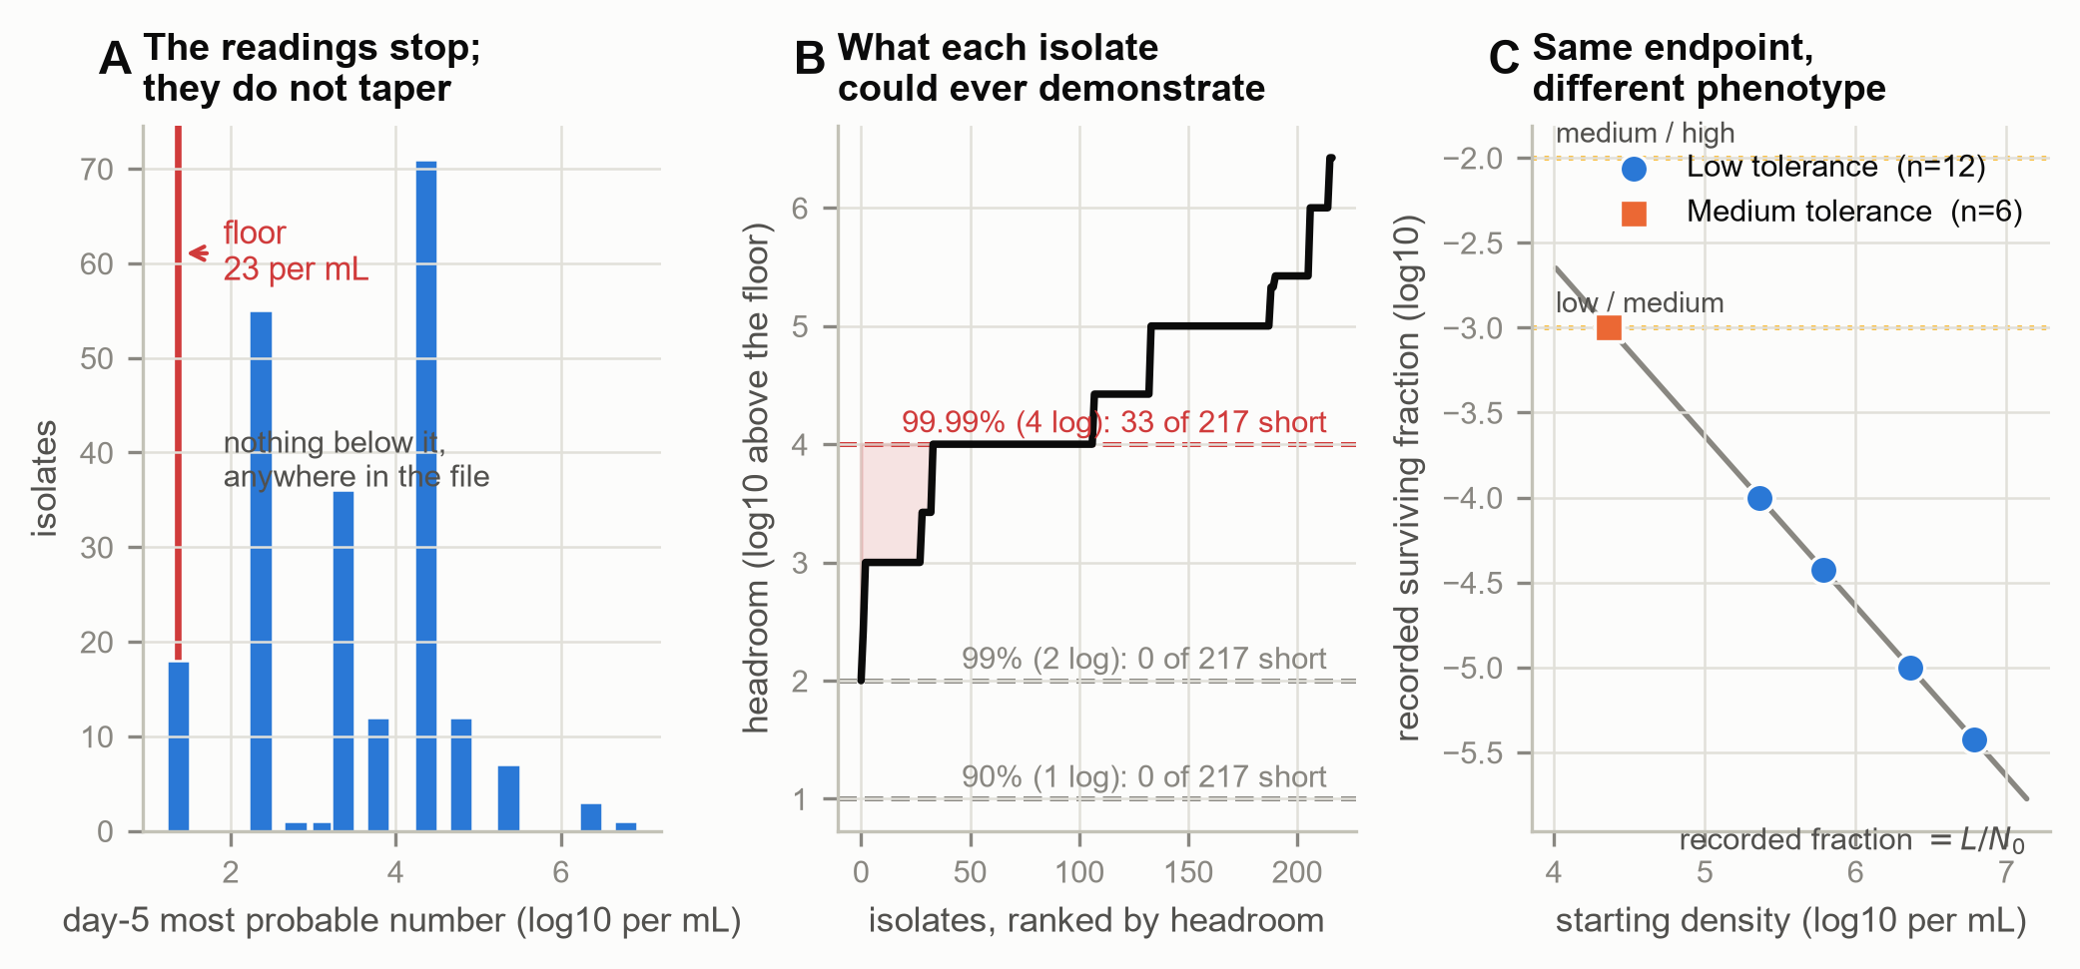
Figure 1. A log-reduction endpoint is bounded by the assay floor, and the bound decides the phenotype. 217 clinical M. tuberculosis isolates under rifampicin, from the deposit that carries the tolerance classification. (A) The distribution of day-5 most probable numbers. It stops at 23 per mL with a pile-up on it rather than tapering, and no value anywhere in the file lies below; that is the behaviour of a floor. (B) Headroom, the distance from each isolate's starting density down to that floor, ranked across isolates, against the depth each tolerance endpoint requires. No isolate is short of the 90 or 99 per cent endpoint. Thirty-three of 217 fall in the shaded band below the 99.99 per cent endpoint, and all 33 are recorded as failing to reach it. (C) The eighteen isolates of the 15-day panel whose day-5 reading was censored at the floor. Their true final counts are unknown below L, so the assay cannot distinguish their final viable burdens; what is plotted is the recorded fraction L/N₀, which is what a censored reading computes, so the 265-fold span in apparent survival is exactly the 265-fold span in starting density. The dotted lines are the deposited classification thresholds. Which side of the low/medium cut an isolate falls on is settled by where it began, not by what the reading measured, though reaching the floor at all required rifampicin to cover that isolate's whole headroom, at least 3.00 logs for the shallowest and 5.42 for the deepest. For the twelve below the cut, no count the assay admits leaves any class but low compatible; for the six that sit exactly on it the compatible range straddles the cut and two classes remain.
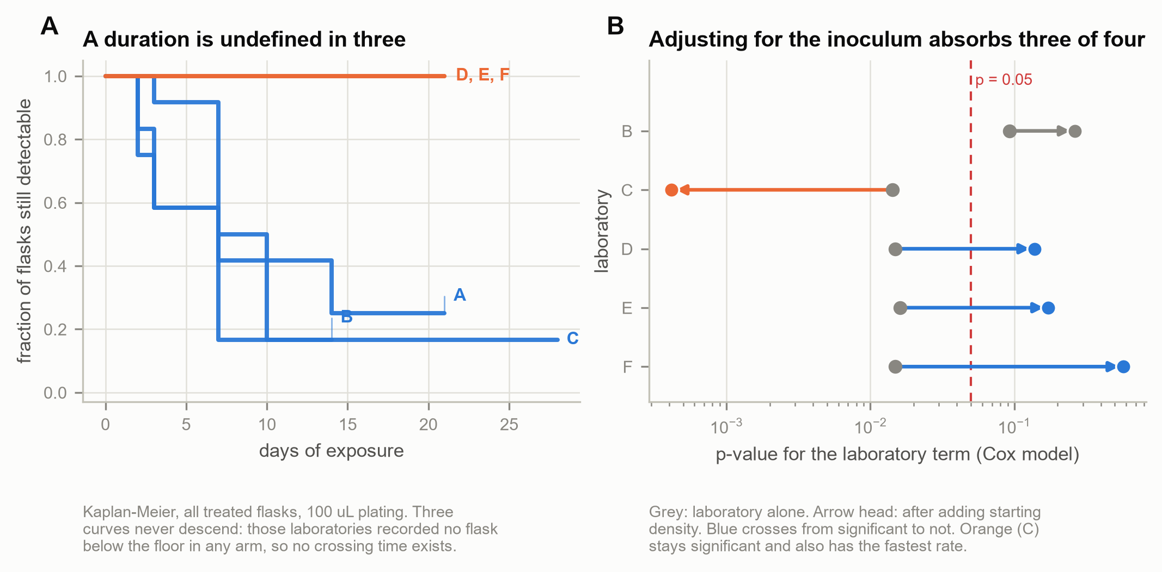
Figure S1. The descriptive survival picture behind Figure 2. The same six laboratories, one written protocol, one stock of M. tuberculosis H37Rv, moxifloxacin at ten times the minimum inhibitory concentration. (A) Kaplan–Meier curves for time to the first observed crossing below the assay floor at the 100 µL plating. Three curves never descend: those laboratories recorded no flask below the floor in any arm at that plating, so their first-crossing times are right-censored throughout. (B) The model-based p-value attached to each laboratory in a descriptive Cox model before (grey) and after (arrow head) starting density is added, showing how far the two predictors overlap. Institute A is the reference, so the model carries five laboratory terms; four of them move toward p = 1 on adjustment (B from 0.093 to 0.264, D from 0.015 to 0.138, E from 0.016 to 0.172 and F from 0.015 to
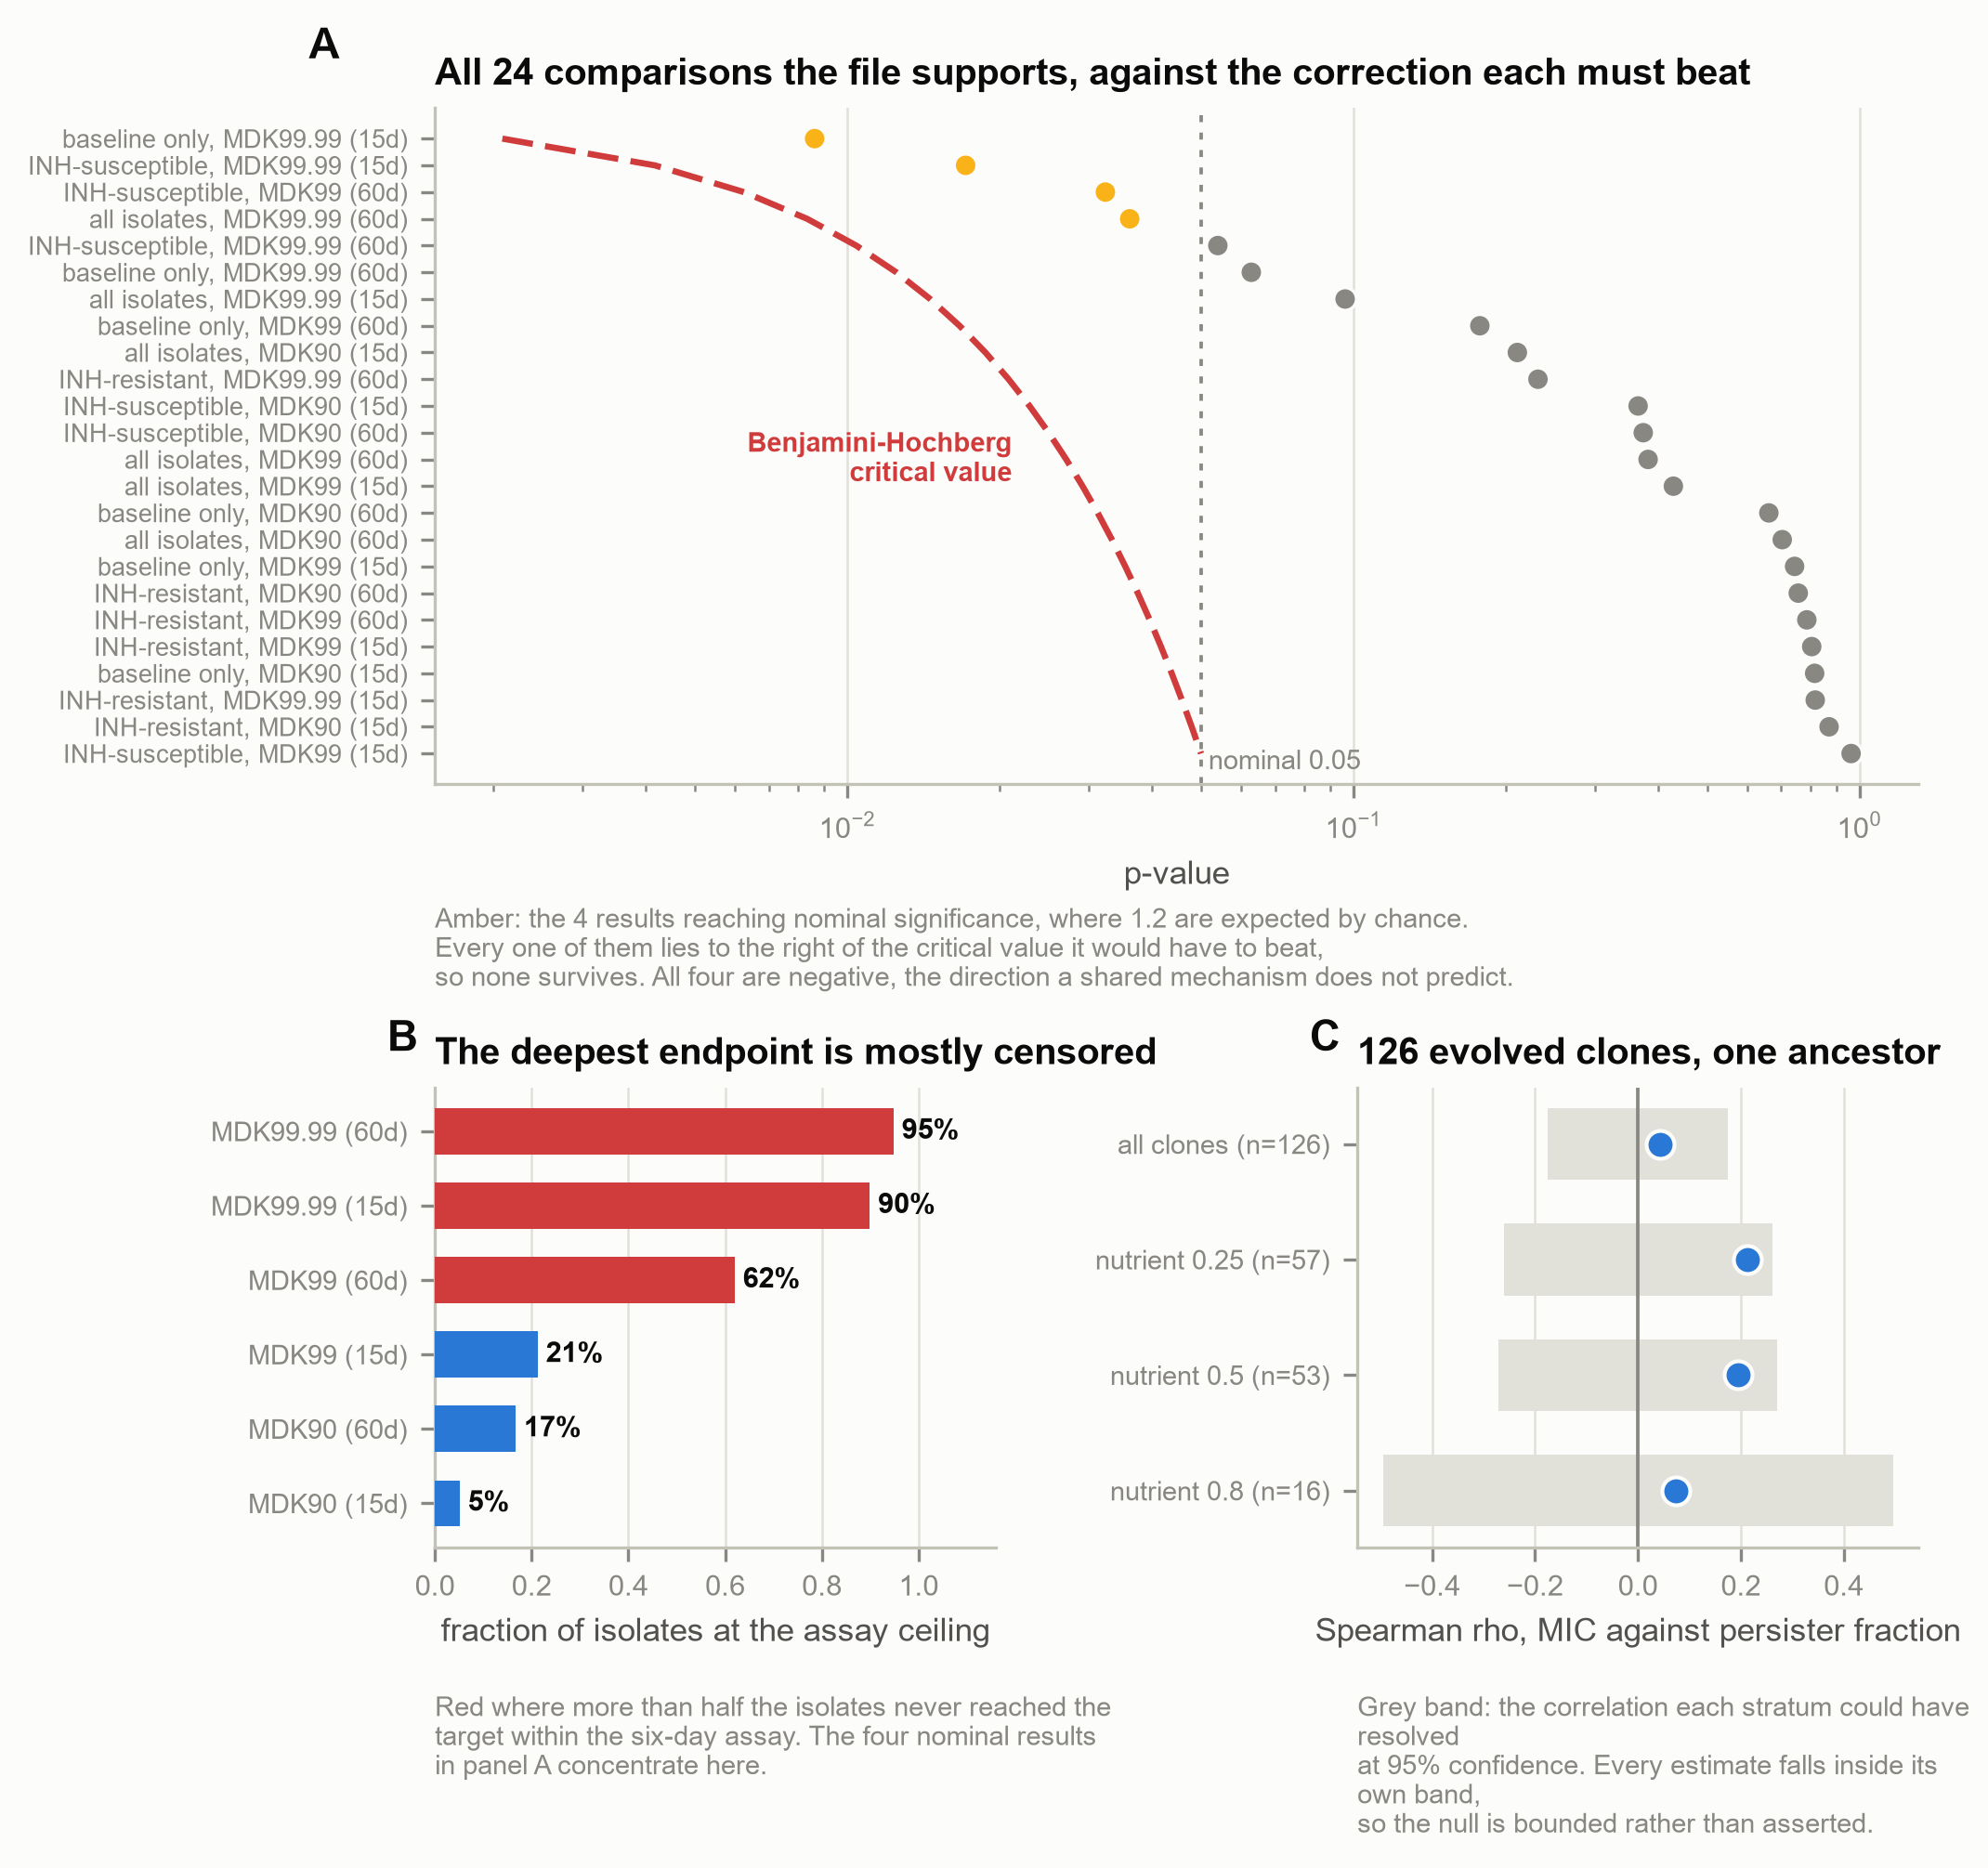
Figure S2. Resistance and tolerance occupy separate axes, in two designs. (A) All 24 comparisons between the concentration axis and the duration axis that the 217-isolate file supports, each against the Benjamini–Hochberg critical value it would have to beat. Amber marks the four reaching nominal significance; none survives. (B) The censoring behind them: the fraction of isolates at the assay ceiling rises with endpoint depth, and the nominal hits concentrate where censoring is heaviest. (C) The same question in 126 evolved E. coli clones, by nutrient stratum.
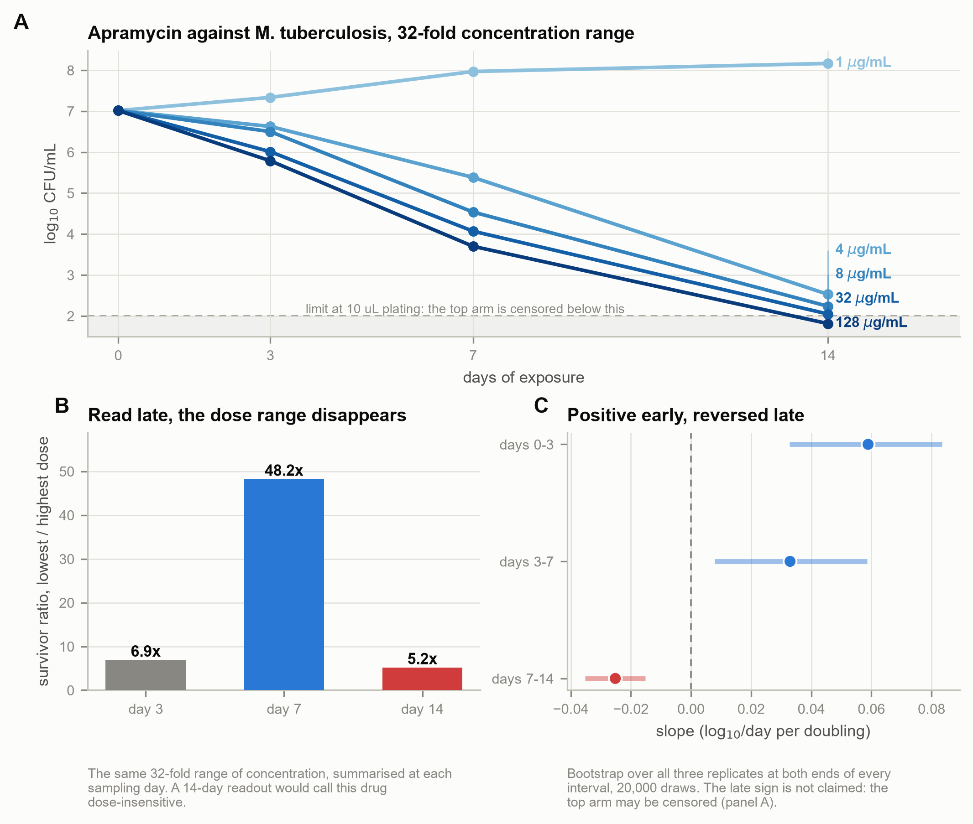
Figure S3. A late endpoint cannot resolve a 32-fold concentration range. Apramycin against M. tuberculosis, five concentrations, triplicate counts. (A) The trajectories, with an assumed floor of 100 CFU/mL (the value 10 µL
Figure S3. A late endpoint cannot resolve a 32-fold concentration range. Apramycin against M. tuberculosis, five concentrations, triplicate counts. (A) The trajectories, with an assumed floor of 100 CFU/mL (the value 10 µL plating would give), drawn as a band; this deposit records no plated volume, so the band is an assumption and is drawn to show what the assumption costs; by day 14 the highest arm lies within it, so its apparent rate over the final interval is a lower bound. (B) The ratio of survivors between the lowest and highest of the four compared concentrations, 4 and 128 µg/mL, at each sampling day, rising to 48.2-fold at day 7 and collapsing to 5.2-fold at day 14. (C) The concentration slope fitted separately in each interval from a replicate-level bootstrap, 20 000 draws.
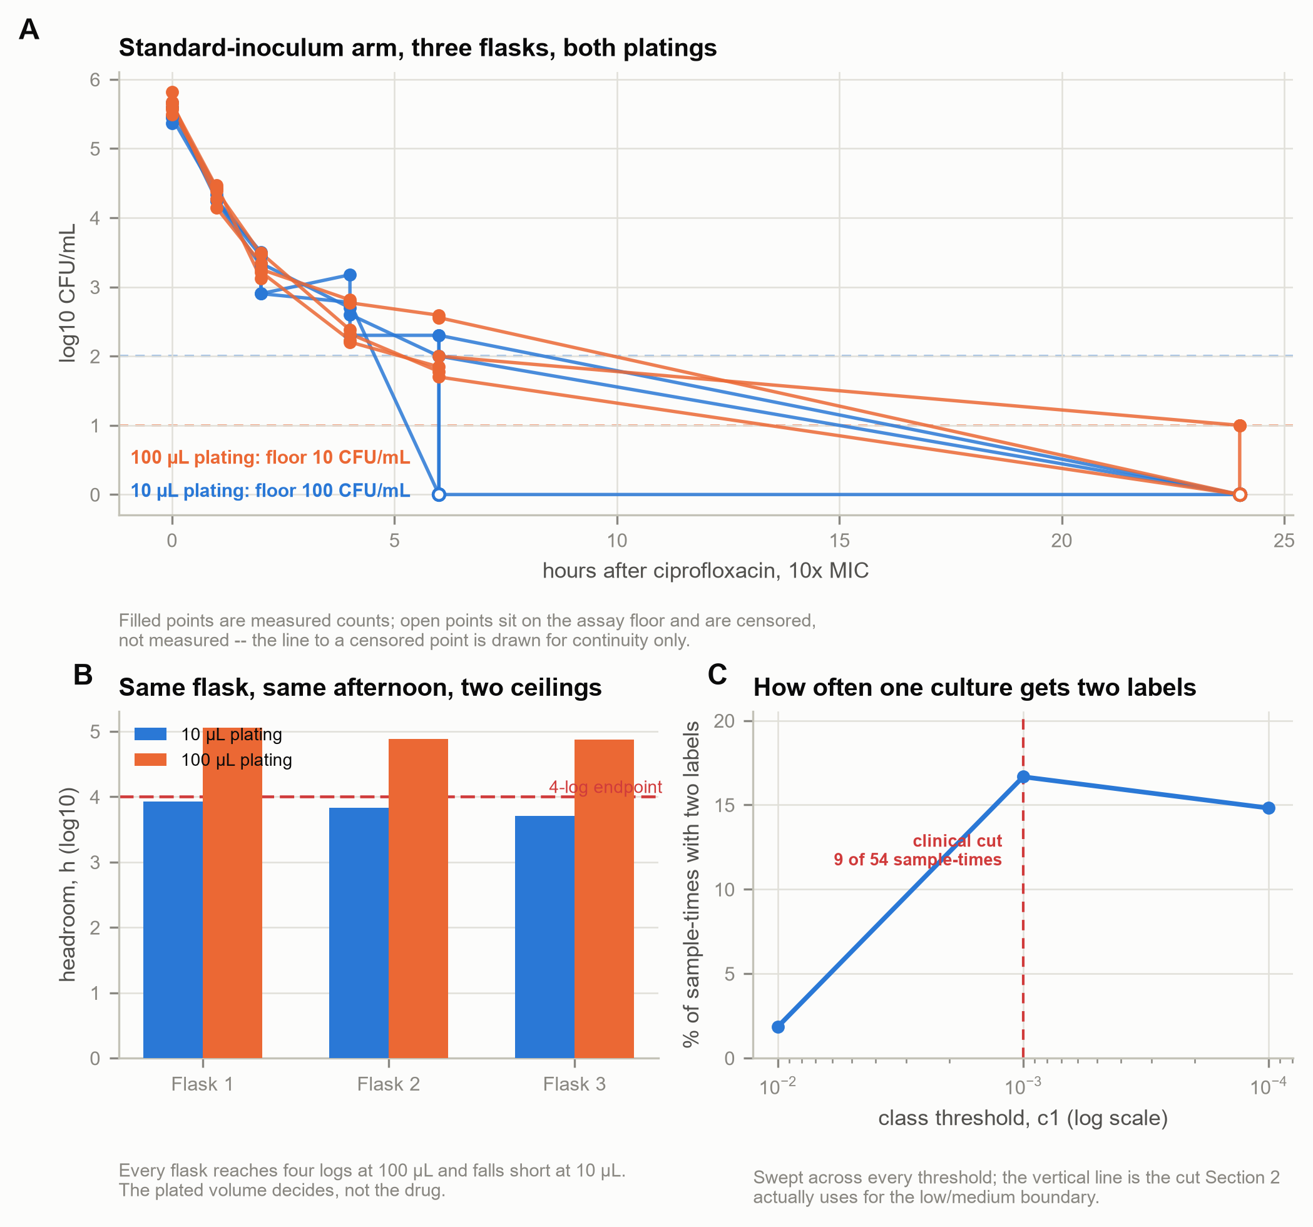
Figure S5. One culture, two plated volumes, two tolerance labels. The prospective experiment's standard-inoculum arm, three flasks, plated at 10 and 100 µL from the same dilution series. (A) Kill curves at both platings; filled points are measured counts, open points sit on the assay floor and are censored. (B) Headroom per flask at each plating against the four-log endpoint: every flask reaches it at 100 µL and falls short at 10 µL. (C) The threshold sweep behind Table S10: the share of sample-times at which the two platings' recorded fractions fall on opposite

