# Code

## Php Folder

## Database.php

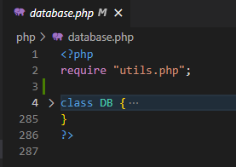

Database.php serves as a singleton and acts as the controller that contacts the database either to get data or modify/change data in the database.

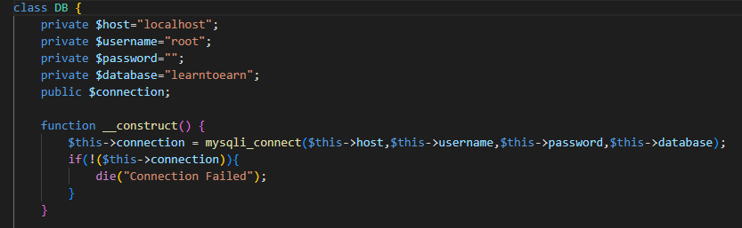

The constuctor is responsible for the connection to the database. It contains name of host(localhost), username(root), password, our database name(learntoearn).

If the connection fails, Connection Failed is printed out.

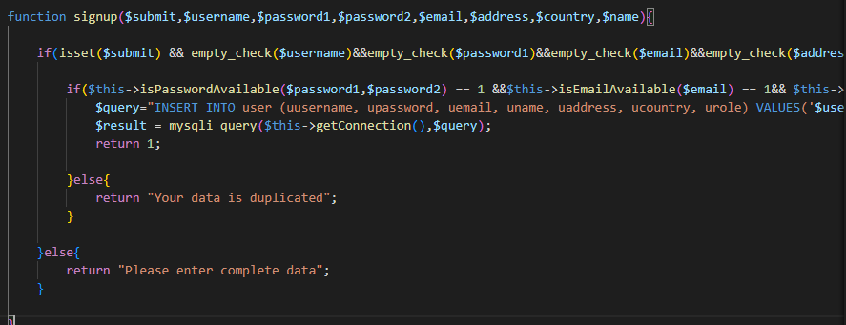

The signup function creates a new user in the database. It contains error handling: 1- Checking if the username entered was entered before, 2- Checking if all data fields were entered.

It also has a layer of security in that it hashes password entered to md5 in the database.

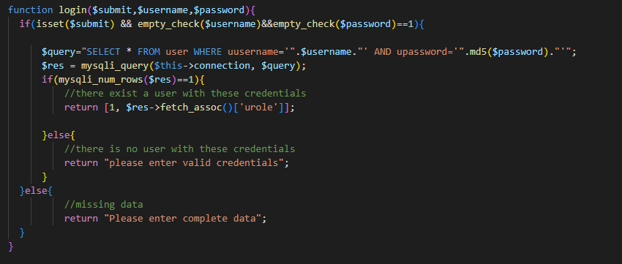

The login function checks if entered username and password are in the database and are correct.

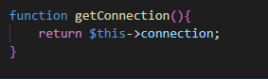

getConnection returns our database connection

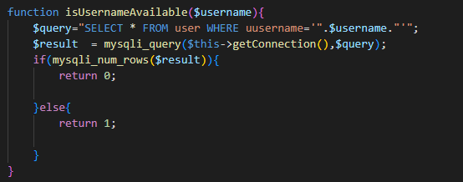

This function checks if username is already used or not and is used in login function.

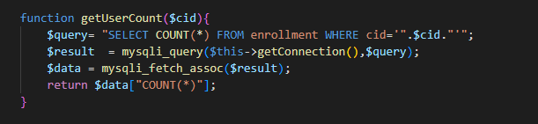

getUserCount takes course id as parameter and returns number of students enrolled in this course

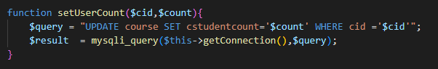

setUserCount takes course id and student count and updates it in our database.

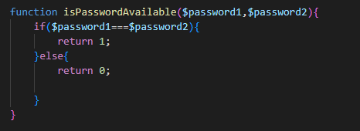

This function checks if used have not been repeated before in our database

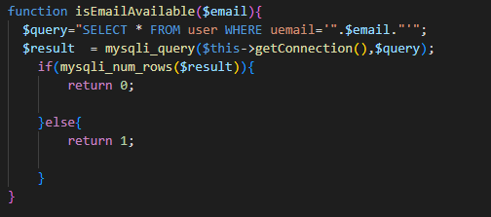

isEmailAvailable checks if given email have not been used before to create another account

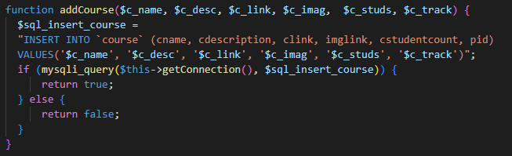

addCourse adds course with its information to database. This function is used in admin pages.

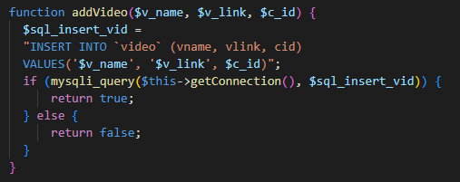

addVideo adds video with its information to database.

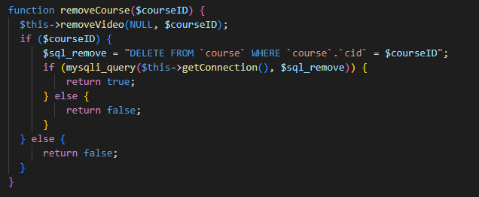

removeCourse removes course with given courseID from database

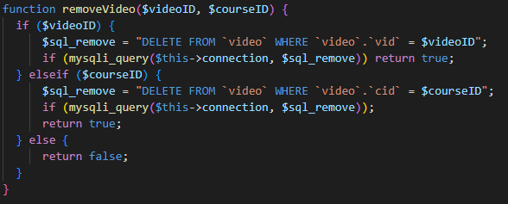

removeVideo deletes course with given videoID and courseID from database

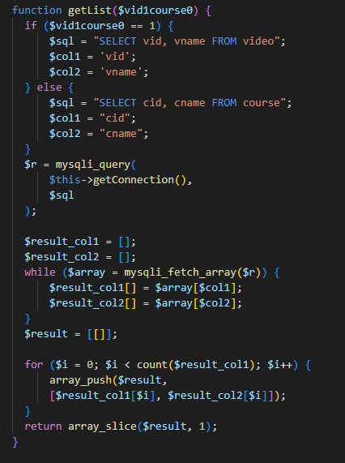

getList returns array that contains course name and id and video name and id

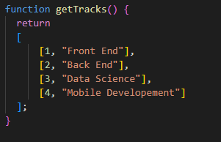

getTrack returns a list with all tracks offered

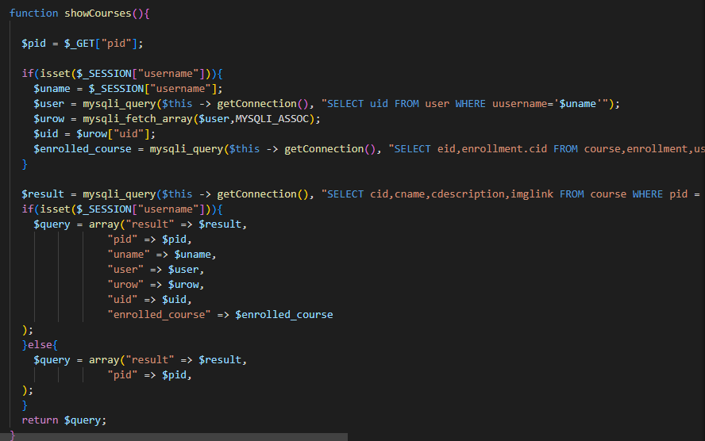

showCourses retrieves all courses offered for a specific track, then returns an array containing user info and enrolled courses for this certain user if logged in; else, returns array with courses of selected track.

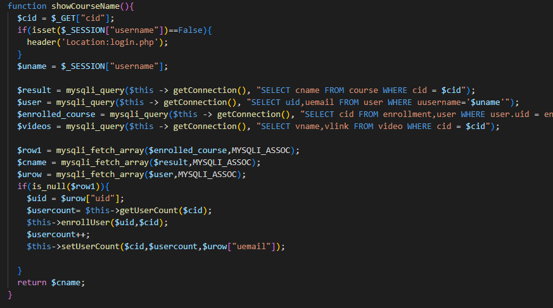

showCourseName returns coursename

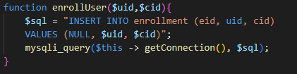

enrollUser enrolls user with uid into course with cid into enrollment table into database

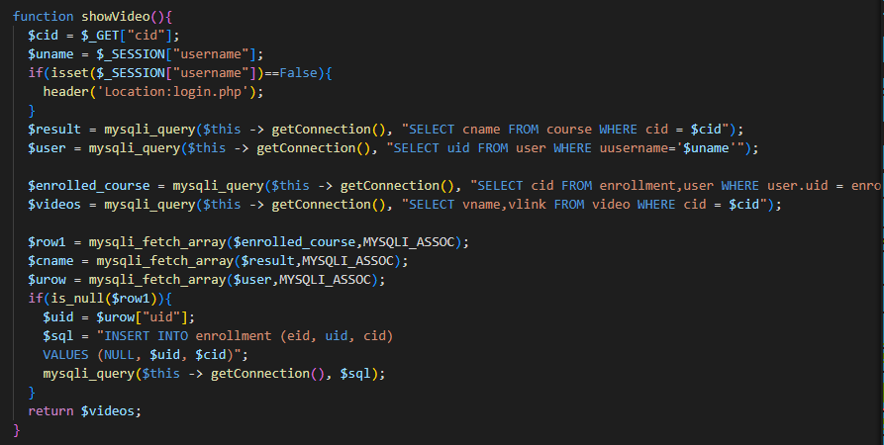

showVideo retrieves videos from video database for certain course with cid

## login.php

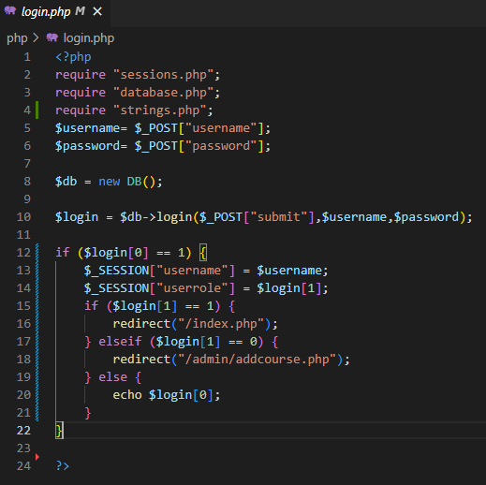

Checks return value. If 1, user is redirected to index page; if 0, user is an admin and is redirected to admin pages

## Sessions.php

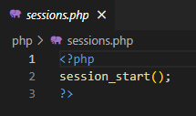

Starts session after user is logged in

## Signup.php

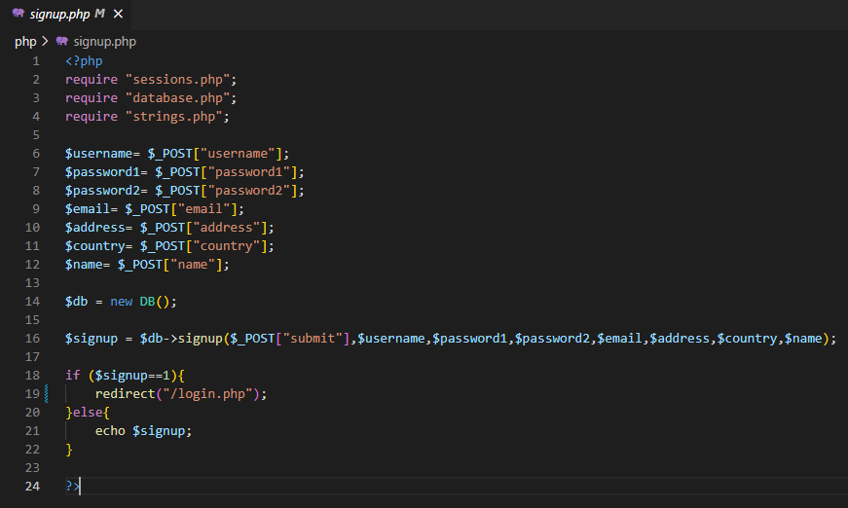

Sends user info to signup to register in the database and assigns user role 1.

## strings.php

Contains all strings used in our View.

All strings were refactored to this file

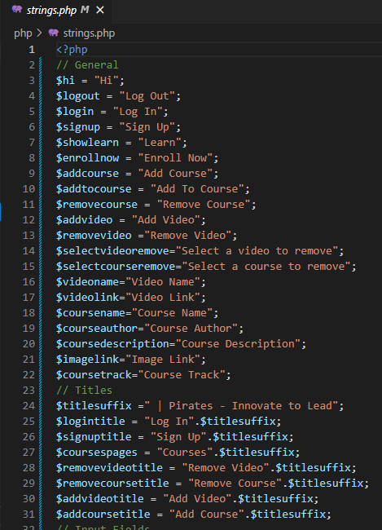

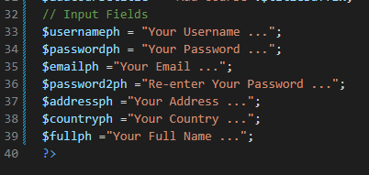

## utils.php

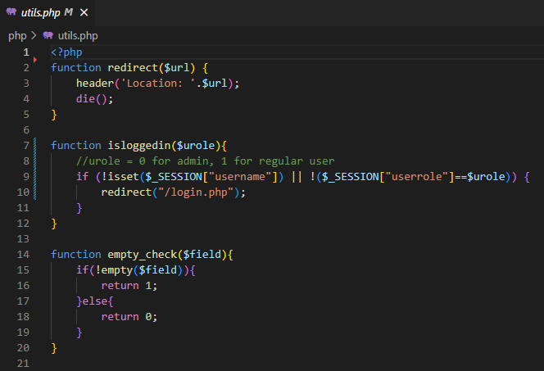

Contains utility function used in view.

isloggedin checks user role and opens a session for the appropriate user role.

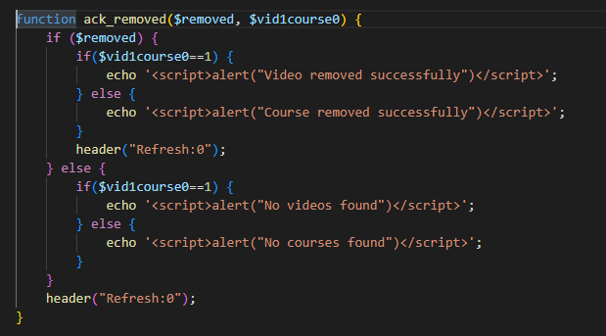

ack_removed returns acknowledgment message for item removed

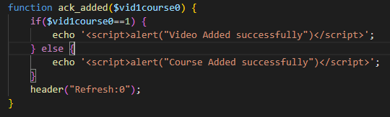

ack_added returns acknowledgment message for item added

## admin.php

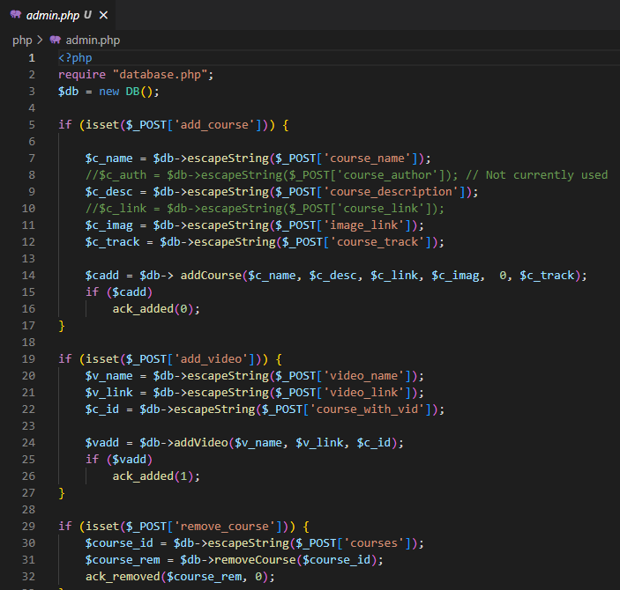

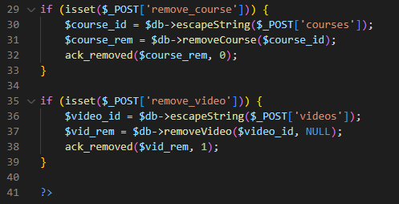

Contains all admin page functionalities (add course, remove course, add video, remove video).

## Styles Folder

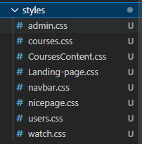

Contains all CSS style sheets for all pages

## JS Folder

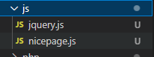

Contains all JavaScript files used

## Admin Pages

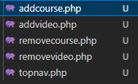

## User Pages





The courses page shows all courses offered in a specific track dynamically.

The index is our main/landing page.

Watch.php is our video page that shows all videos offered in a certain course



Navigation bar used for our pages

## Login and logout Pages





## Index Page





## Courses page





## Courses Content Page

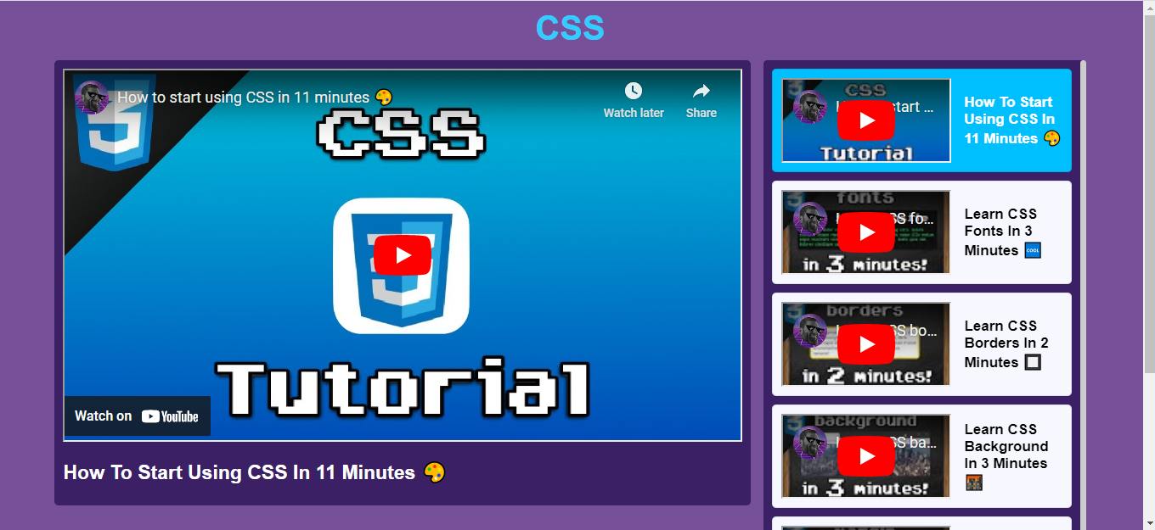

## Login Page



## Signup Page



## Admin Pages

