“Online Auction and Bidding Platform”
A Project Report Submitted in the partial fulfillment of the requirements for the award of the degree of

BACHELOR OF TECHNOLOGY
In

DEPARTMENT OF COMPUTER SCIENCE ENGINEERING
&
DEPARTMENT OF COMPUTER SCIENCE AND INFORMATION TECHNOLOGY
By

U. MOKSHA 2500031613
JAMUNA 2520030408
DHANA SRI 2520030115

Under the Esteemed Guidance of

Dr Yerragudipadu Subbarayudu Assistant Professor
Department of Computer Science and Engineering




K L (Deemed to be) University
&

DEPARTMENT OF COMPUTER SCIENCE AND INFORMATION TECHNOLOGY

Declaration

The Project Report entitled “Online Auction and Bidding Platform” is a bonafide work carried out by U. Moksha – 2500031613, Jamuna – 2520030408, and Dhana Sri – 2520030115 in partial fulfillment of the requirements for the award of the degree of BACHELOR OF TECHNOLOGY in Computer Science Engineering / Computer Science and Information Technology.
We declare that the work presented in this report is the outcome of our project development, implementation, testing, and documentation carried out as part of the academic requirements. The project, source code, database design, interface design, and testing work have been prepared for academic submission.

U. MOKSHA – 2500031613
JAMUNA – 2520030408
DHANA SRI – 2520030115

K L (Deemed to be) University

DEPARTMENT OF COMPUTER SCIENCE ENGINEERING

&

DEPARTMENT OF COMPUTER SCIENCE AND INFORMATION TECHNOLOGY

CERTIFICATE

This is to certify that the mini project based report entitled “Online Auction and Bidding Platform” is a bonafide work done and submitted by U. Moksha – 2500031613, Jamuna – 2520030408, and Dhana Sri – 2520030115 in partial fulfillment of the requirements for the award of the degree of BACHELOR OF TECHNOLOGY in Department of Computer Science Engineering, K L (Deemed to be) University, during the academic year 2026–2027.
The project work has been completed under the guidance of the project guide and has been reviewed as part of the academic evaluation process.

Signature of the Guide

Signature of the Course Coordinator Signature of the HOD

ACKNOWLEDGEMENT
The successful completion of the project “Online Auction and Bidding Platform” would not have been possible without the timely guidance, encouragement, and support received from the faculty members, project guide, course coordinator, and everyone who assisted us throughout the development process.

We express our sincere gratitude to our project guide, Dr Yerragudipadu Subbarayudu, Assistant Professor, Department of Computer Science and Engineering, for providing valuable technical guidance, constructive suggestions, and continuous encouragement during the planning, implementation, testing, and documentation of the project.

We also thank the Course Coordinator and the Head of the Department for providing the academic support and facilities required to complete this work. We are grateful to the teaching and non-teaching staff members for their cooperation and assistance whenever required.

We would also like to thank our classmates, friends, and family members for their encouragement and support. Finally, we thank everyone who directly or indirectly contributed to the successful completion of this project.

U. MOKSHA – 2500031613
JAMUNA – 2520030408
DHANA SRI – 2520030115

Abstract

The Online Auction and Bidding Platform is a web-based application designed to provide a centralized environment where sellers can publish products for auction and buyers can participate in live bidding. The system addresses common limitations of traditional auction processes by providing online accessibility, structured product and auction information, secure authentication, bid validation, and real-time bid updates.

The platform is implemented using React.js with Vite for the frontend, Node.js and Express.js for the backend, Socket.io for real-time communication, and MySQL for relational data management. JWT-based authentication and role-based authorization are used to control access for buyers, sellers, and administrators, while bcryptjs is used for secure password hashing. The backend provides REST APIs for user management, products, auctions, bids, watchlists, notifications, payments, settlements, and disputes.

The system also supports automatic auction completion, winner identification, bidding history, watchlist management, notifications, image uploads, transaction-safe bid processing, and an anti-sniping mechanism that can extend an auction when a bid is received close to its closing time. The database is organized using entities such as Users, Products, Auctions, Bids, Watchlist, Notifications, Payments, Settlements, and Disputes.
Overall, the project demonstrates the practical application of database management, web development, authentication, REST APIs, real-time communication, transaction management, software testing, and responsive user-interface design in a complete online auction system.
Index

S.  No. | Chapters | Topics | Page.no
 |  | Acknowledgement
 |  | Abstract
1 | Introduction | Background of the project  Problem statement  Scope of the project  Objectives  Importance of the application  Target users/audience | 9-10
2 | System Requirements | Hardware requirements  Software requirements  Development tools and frameworks | 11
3 | Technology Stack | Front-end  Back-end  Database  Version control  APIs and external services | 12
4 | System Architecture | High-level architecture diagram  Description of each layer  Deployment architecture | 13-14
5 | Design | System design  ER Diagram / Database schema | 15-16
6 | Implementation | Module-wise implementation  Front-end logic  API integration  Authentication & Authorization | 17-18
7 | Features | List of main features  How each feature works | 19
8 | Testing | Postman testing  Integration testing  Tools used for testing  Test cases and results | 20-21
9 | Deployment | Steps to deploy  Environment configuration  Hosting of frontend and backend | 22
10 | Challenges & Limitations | Issues faced during development  Solutions applied  Current limitations or known bugs | 23
11 | Future Enhancements | Planned features  Possible integrations or optimizations | 24
12 | Conclusion | Summary of the project  What was achieved  Skills learned during development | 25
13 | References | Books, tutorials, APIs, documentation sites used | 26

14 | Appendices | Screenshots of the app  System architecture and ER diagrams  Sample code snippets  Installation/setup instructions  User manual or guide  Geo Tag photos with guide  Review forms with guide signatures | 27-29

CHAPTER - 1 INTRODUCTION

1.1 Background of the Project
Traditional auctions require participants to be present at a specific location and time, and sellers often depend on manual records and direct communication. A web-based auction platform can remove these geographical and timing restrictions and allow users to participate through a browser. The Online Auction and Bidding Platform was developed to provide a centralized system for product listing, auction creation, bidding, and auction management.
The system uses role-based access so that sellers can create products and auctions while buyers can browse and bid. Socket.io provides real-time communication, JWT provides authentication, bcryptjs protects passwords, and MySQL maintains structured relationships between users, products, auctions, and bids.

1.2 Problem Statement
The project addresses limited accessibility, manual auction management, delayed bid updates, weak separation of buyer and seller functions, and the difficulty of maintaining accurate auction records. The system therefore requires secure authentication, role-based authorization, reliable bid validation, real-time communication, automatic auction completion, and consistent database management.

1.3 Scope of the Project
User registration and login
BUYER, SELLER, and ADMIN role management
Product creation and image upload
Auction creation and listing
Real-time bidding using Socket.io
Bid validation and bid history
Automatic auction completion and winner identification
Anti-sniping extension
Watchlist and notifications
Payment, settlement, and dispute records
MySQL database management
REST API communication
Responsive React interface
Secure authentication and authorization
Future microservices, Docker, monitoring, and external integrations

1.4 Objectives
The main objective is to design and develop a secure, user-friendly, database-driven online auction platform that enables sellers to create auctions and buyers to participate in real-time bidding. Specific objectives are to provide secure registration, role-based access, valid bid processing, real-time updates, automatic completion, winner identification, auction history, watchlists, notifications, and reliable relational data management.

1.5 Importance of the Application
The application provides a convenient digital alternative to traditional auctions. It improves accessibility, reduces manual record keeping, provides real-time bid visibility, maintains structured auction records, and demonstrates practical use of modern web development and database technologies.

1.6 Target Users/Audience
Buyers
Sellers
Administrators
Small businesses and individual sellers
Collectors and hobbyists

CHAPTER - 2 SYSTEM REQUIREMENTS

2.1 Hardware Requirements
A standard laptop or desktop is sufficient. A minimum Intel Core i3-class processor, 4 GB RAM, and approximately 10 GB free storage are suitable for basic development. An Intel Core i5-class processor, 8 GB RAM or more, SSD storage, a modern display, keyboard, mouse, and stable network connection are recommended.

2.2 Software Requirements
Windows 10/11, Linux, or macOS
Node.js and npm
React.js with Vite
Node.js and Express.js
MySQL Server and MySQL Workbench
Visual Studio Code
Modern web browser
Postman
Git and GitHub
mysql2, bcryptjs, jsonwebtoken, multer, cors, axios, Socket.io

2.3 Development Tools and Frameworks
Visual Studio Code was used for coding and debugging. React.js and Vite were used for the frontend, Node.js and Express.js for backend APIs, MySQL for relational storage, Socket.io for real-time communication, JWT and bcryptjs for authentication and password protection, Axios for HTTP requests, Multer for image uploads, Postman for API testing, and Git/GitHub for version control.

CHAPTER - 3 TECHNOLOGY STACK

3.1 Front-end
React.js with Vite is used to build the frontend. Components organize navigation, login, signup, auction listing, product details, and bidding interfaces. CSS provides the LUSSO. pink-and-white visual design and responsive presentation.

3.2 Back-end
Node.js and Express.js provide the server and REST APIs. The backend handles authentication, products, auctions, bids, watchlists, notifications, payment records, disputes, administration, validation, and Socket.io events.

3.3 Database
MySQL is the primary relational database. The online_auction_db database contains Users, Products, Auctions, Bids, Watchlist, Notifications, Payments, Settlements, and Disputes. Primary and foreign keys maintain data integrity.

3.4 Version Control
Git and GitHub are used to store project history, track changes, support collaboration, and recover previous versions.

3.5 APIs or External Services
REST APIs provide frontend-backend communication. Socket.io provides real-time communication, Axios is used by the frontend, and Multer handles image uploads. The current payment feature stores payment-related records rather than processing a live external payment gateway. Future versions may integrate payment gateways, email services, Redis, MongoDB, cloud storage, and an API gateway.

CHAPTER - 4 SYSTEM ARCHITECTURE

4.1 High-Level Architecture Diagram
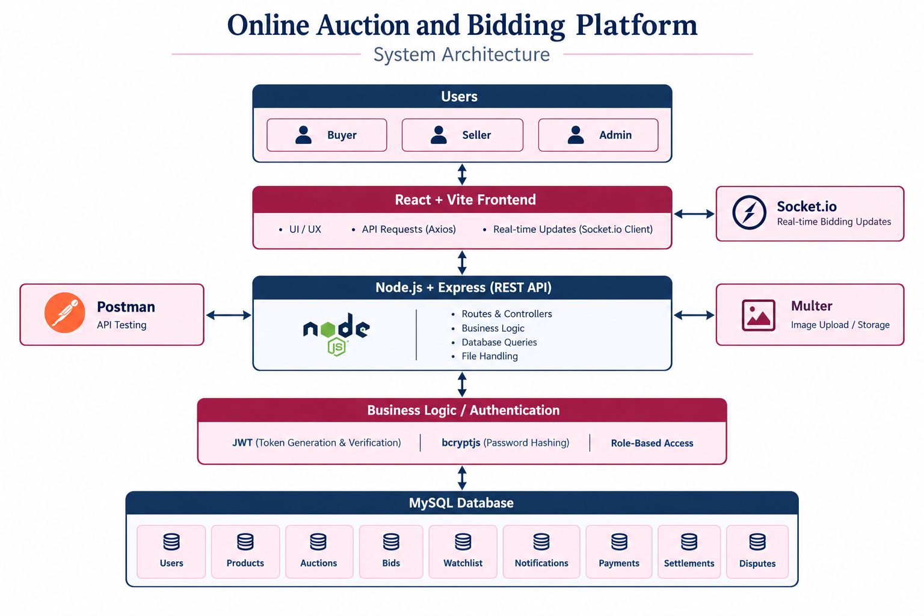
Figure 4.1: High-Level Architecture of the Online Auction and Bidding Platform
The architecture contains the user layer, React/Vite frontend, Node.js/Express backend, Socket.io real-time layer, file-upload layer, and MySQL database. Users interact with the frontend, which sends requests to the backend. The backend validates requests, performs business operations, stores data in MySQL, and broadcasts bid updates through Socket.io.

4.2 Description of Each Layer
User Layer – buyers, sellers, and administrators.
Presentation Layer – React/Vite interface and state management.
API Layer – Express REST endpoints.
Authentication Layer – JWT and role-based authorization.
Business Logic Layer – auctions, bids, watchlist, notifications, payments, disputes, and admin functions.
Real-Time Layer – Socket.io bid updates.
Database Layer – MySQL structured data.
File Layer – Multer-based product image uploads.

4.3 Deployment Architecture
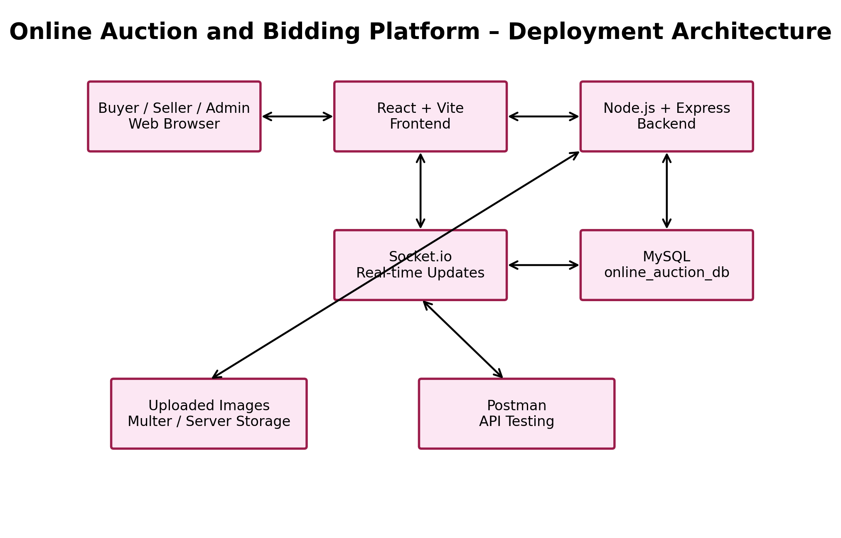
Figure 4.2: Deployment Architecture
During development, the frontend, backend, and MySQL database run locally. For production, the frontend can be hosted on a static web host, the Node.js backend on a cloud server, and MySQL on a managed database service. HTTPS, environment variables, persistent image storage, and production CORS settings should be configured.

CHAPTER - 5 DESIGN

5.1 System Design
The design is centered around users, products, auctions, and bids. Sellers create products and auctions, buyers place bids, and administrators monitor the platform. Supporting entities maintain watchlists, notifications, payment records, settlements, and disputes. The design separates presentation, business logic, real-time communication, and data storage responsibilities.

5.2 ER Diagram / Database Schema
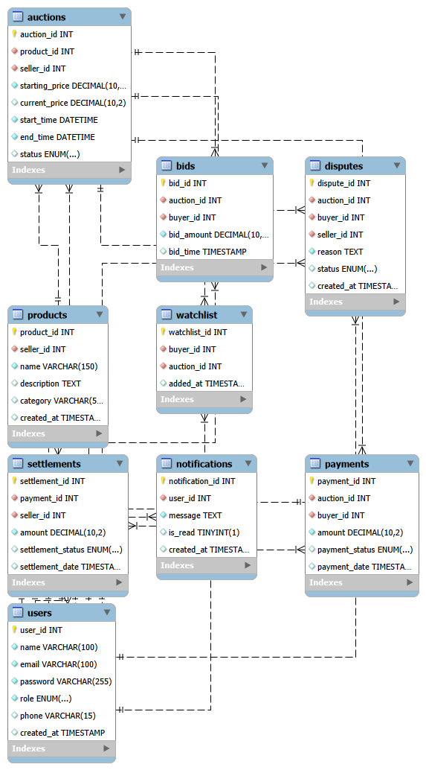
Figure 5.1: Entity Relationship Diagram of the Auction Database
Users are connected to products and auctions through ownership relationships. Auctions are connected to products and contain starting price, current price, start and end times, and status. Bids connect buyers to auctions and maintain bidding history. Watchlist, Notifications, Payments, Settlements, and Disputes store supporting information. Primary and foreign keys preserve referential integrity.

CHAPTER - 6 IMPLEMENTATION

6.1 Module-Wise Implementation
User Registration and Login
Users register and authenticate with email and password. Passwords are hashed using bcryptjs and successful authentication produces a JWT.
Role Management
BUYER, SELLER, and ADMIN roles restrict access to appropriate operations.
Product Management
Sellers add products and upload product images.
Auction Management
Sellers create auctions with product, price, and duration information.
Real-Time Bidding
Socket.io communicates bid updates to connected clients.
Bid Management
The backend checks auction status and accepts only bids above the current required amount.
Automatic Auction Completion
A periodic process checks expired auctions, closes them, stops further bidding, and identifies the highest bidder.
Watchlist
Buyers can save and remove auctions for later viewing.
Notifications
Auction-related notifications are stored and retrieved for users.
Payment and Settlement Records
Transaction-related records can be stored against auction outcomes; no live gateway transaction is currently executed.
Dispute Management
Users can create disputes and administrators can review them.
Administration
Protected admin APIs support monitoring of users and disputes.
Security
JWT, bcryptjs, role checks, input validation, and protected endpoints are used.

6.2 Front-End Logic
React state and conditional rendering control the user interface. Authentication state controls user-specific controls, Axios retrieves auction data and sends API requests, and Socket.io events update bids in real time. Forms collect and validate information before sending it to the backend.

6.3 API Integration
Axios communicates with Express REST endpoints. JSON is used for normal requests and multipart form data is used for image uploads. API responses update the React state and display appropriate success or error messages.

6.4 Authentication & Authorization
Authentication verifies the user credentials and generates a JWT after successful login. Protected endpoints validate the token, and role checks ensure that seller and administrator functions cannot be accessed by unauthorized users.

6.5 Bidding Workflow Diagram
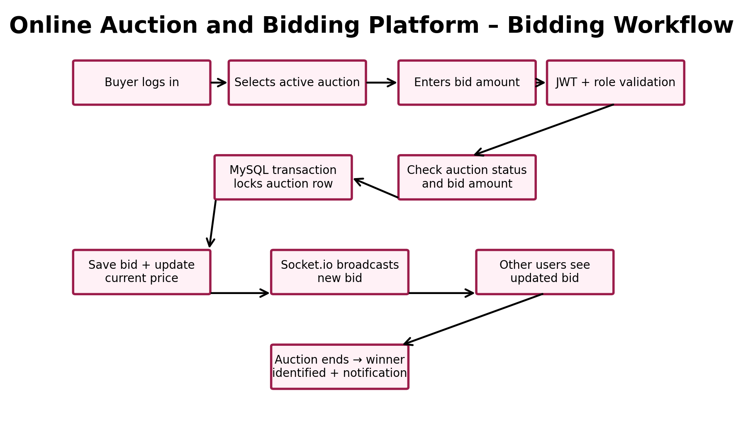
Figure 6.1: Real-Time Bidding Workflow

CHAPTER - 7 FEATURES

7.1 List of Main Features
Registration and login
Role-based access
Product management
Product image upload
Auction creation and listing
Product details
Real-time bidding
Bid validation and history
Automatic completion
Winner identification
Anti-sniping
Watchlist
Notifications
Payment and settlement records
Dispute management
Admin management
JWT authentication
Password hashing
MySQL database
REST APIs
Responsive interface
Transaction-safe bidding

7.2 How Each Feature Works
A buyer registers or logs in, browses auctions, opens an item, and places a bid higher than the current required amount. The backend validates and stores the bid and Socket.io broadcasts the update. Sellers add products and create auctions, then monitor bidding. When an auction expires, the system identifies the highest bidder and changes the auction state. Supporting modules handle watchlists, notifications, payment records, disputes, and administration.

CHAPTER - 8 TESTING

8.1 Postman Testing
Postman was used to test REST APIs independently of the React interface. Registration, login, protected routes, product, auction, bidding, watchlist, notification, payment-record, dispute, and admin APIs were tested with valid and invalid inputs. HTTP status codes and JSON responses were checked.

8.2 Integration Testing
Integration testing verified communication between React, Express, Socket.io, JWT authentication, and MySQL. A typical bid flow is React request → Express validation → MySQL bid storage → Socket.io broadcast → updated frontend display.

8.3 Tools Used for Testing
Postman – REST API testing
MySQL Workbench – database testing
Browser Developer Tools – console and network testing
Socket.io – real-time bidding testing
Visual Studio Code – debugging
Manual testing – end-to-end scenarios

8.4 Test Cases and Results
The tested scenarios produced the expected results for the implemented modules. Testing covered normal operations, invalid inputs, authorization restrictions, database operations, real-time updates, and auction completion.

Table 8.1: Test Cases and Results
ID | Module | Test Case | Expected Result | Status
TC01 | Registration | Valid registration | Account created successfully | PASS
TC02 | Registration | Duplicate email | Duplicate registration rejected | PASS
TC03 | Login | Valid credentials | JWT token generated | PASS
TC04 | Security | Protected API without JWT | Request rejected | PASS
TC05 | Role Access | Buyer opens seller-only API | Access denied | PASS
TC06 | Product | Seller adds product with image | Product stored and image path saved | PASS
TC07 | Auction | Seller creates auction | Auction created with active status | PASS
TC08 | Bidding | Valid bid above current price | Bid saved and current price updated | PASS
TC09 | Bidding | Invalid/low bid | Bid rejected with validation message | PASS
TC10 | Real-Time | New bid from another user | Updated bid visible through Socket.io | PASS
TC11 | Completion | Auction reaches end time | Auction completed and winner identified | PASS
TC12 | Watchlist | Buyer adds/removes auction | Watchlist state updated | PASS
TC13 | Notifications | Auction/bid event occurs | Notification created | PASS
TC14 | Dispute | Buyer/seller submits dispute | Dispute stored for admin review | PASS
TC15 | Database | Transaction-safe concurrent bid | Data remains consistent | PASS

CHAPTER - 9 DEPLOYMENT

9.1 Steps to Deploy
Prepare frontend, backend, SQL script, upload directory, and configuration files.
Install Node.js, npm, and MySQL.
Create online_auction_db and import the SQL schema.
Run npm install in the backend and frontend folders.
Configure database credentials, JWT secret, and port through environment variables.
Test backend APIs using Postman.
Change frontend API and Socket.io URLs to the deployed backend.
Run npm run build for the React frontend.
Deploy the frontend dist folder.
Deploy the Node.js/Express backend.
Configure persistent storage for product images.
Enable HTTPS, secure secrets, production CORS, and database access controls.
Perform end-to-end testing after deployment.

9.2 Environment Configuration
Typical environment variables include PORT, DB_HOST, DB_PORT, DB_USER, DB_PASSWORD, DB_NAME, and JWT_SECRET. Sensitive values should not be committed to GitHub. The production frontend must use the deployed backend URL rather than localhost.

9.3 Hosting of Frontend and Backend
The frontend can be deployed to a static hosting service or web server after the Vite build. The backend can be hosted on a Node-compatible cloud platform and MySQL can be hosted on a managed database service. Socket.io must remain accessible through the deployed backend for real-time bidding.

CHAPTER - 10 CHALLENGES & LIMITATIONS

10.1 Issues Faced During Development
Frontend-backend API connection and URL configuration
MySQL table relationships and data consistency
Real-time updates across multiple browser sessions
Authentication and role-based access
Image upload and storage
Auction timing and automatic expiration
Invalid bid prevention

10.2 Solutions Applied
The team used modular APIs, database validation, JWT authentication, bcryptjs hashing, Socket.io events, input validation, and periodic auction-status checks. Postman and MySQL Workbench helped isolate API and database problems, while Git provided recoverable project versions.

10.3 Current Limitations or Known Bugs
Payment is record-based and does not currently execute live gateway transactions.
The current implementation is primarily a functional monolithic Node.js backend rather than a fully separated microservices deployment.
Public cloud deployment and managed database setup require additional configuration.
Advanced monitoring, automated CI/CD, and large-scale load testing are future improvements.
Production image storage requires persistent storage configuration.

CHAPTER - 11 FUTURE ENHANCEMENTS

11.1 Planned Features
Live payment gateway integration
Email and SMS notifications
Advanced search and filtering
Buyer and seller dashboards
Auction analytics
Ratings and reviews
Improved dispute workflow
Mobile application
AI-based recommendations
Multi-language and multi-currency support

11.2 Possible Integrations or Optimizations
The platform can be extended into microservices for users, products, auctions, bidding, payments, and notifications. FastAPI can act as an API gateway, Docker/Kubernetes can support containerized deployment, Redis can support caching, MongoDB can support flexible auxiliary data, and Prometheus/Grafana or OpenTelemetry can support monitoring. GitHub Actions can automate testing and deployment. Cloud object storage can provide persistent image storage.

CHAPTER - 12 CONCLUSION

12.1 Summary of the Project
The Online Auction and Bidding Platform provides a centralized web-based environment for conducting online auctions. It connects sellers who list products with buyers who participate in bidding and combines React/Vite, Node.js/Express, MySQL, JWT, bcryptjs, Axios, Multer, and Socket.io.

12.2 What Was Achieved
The project implemented registration and login, role-based access, product management, auction creation, bid validation, real-time bidding, automatic auction completion, winner identification, watchlist management, notifications, payment and dispute records, and administrative functions. Testing covered the major implemented workflows.

12.3 Skills Learned During Development
React component and state management
REST API development with Express
MySQL and SQL
JWT authentication and authorization
Password hashing with bcryptjs
Real-time communication with Socket.io
Image upload handling
Postman API testing
Debugging and browser tools
Git/GitHub version control
Deployment and architecture concepts
Technical documentation and teamwork

CHAPTER - 13 REFERENCES
React.js Documentation
Vite Documentation
Node.js Documentation
Express.js Documentation
MySQL Documentation
Socket.io Documentation
JSON Web Token Documentation
bcryptjs Documentation
Axios Documentation
Postman Documentation
Git Documentation
GitHub Documentation

CHAPTER - 14 APPENDICES

14.1 Screenshots of the Application
Insert screenshots of the LUSSO. home page, registration, login, auction listing, product details, bidding interface, seller interface, buyer interface, notifications, and administrative screens in this section.

14.2 Sample Code Snippets
Relevant snippets may include Express API routes, React components, MySQL queries, JWT authentication, Socket.io event handling, and auction completion logic.

14.3 Installation / Setup Instructions
Install Node.js, npm, and MySQL.
Create online_auction_db in MySQL Workbench.
Import Online_Auction_Database.sql.
Open backend and run npm install.
Configure database connection and JWT secret.
Run node server.js.
Open frontend and run npm install.
Run npm run dev.
Open the Vite URL and test the application.

14.4 User Guide
A buyer registers or logs in, browses active auctions, opens an auction, and places a bid higher than the current price. A seller logs in, adds a product, creates an auction, and monitors bidding. Administrators access protected management functions. Users should keep credentials secure and follow auction rules.

14.5 Application Screenshots
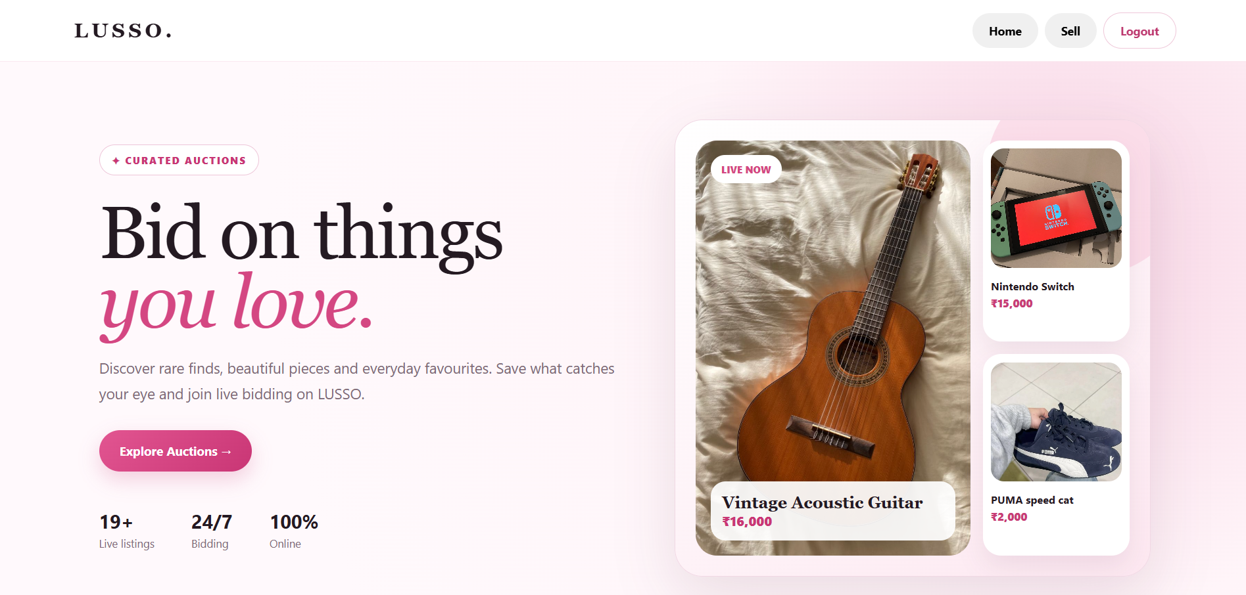
Figure 14.1: LUSSO. Home Page and Featured Auctions
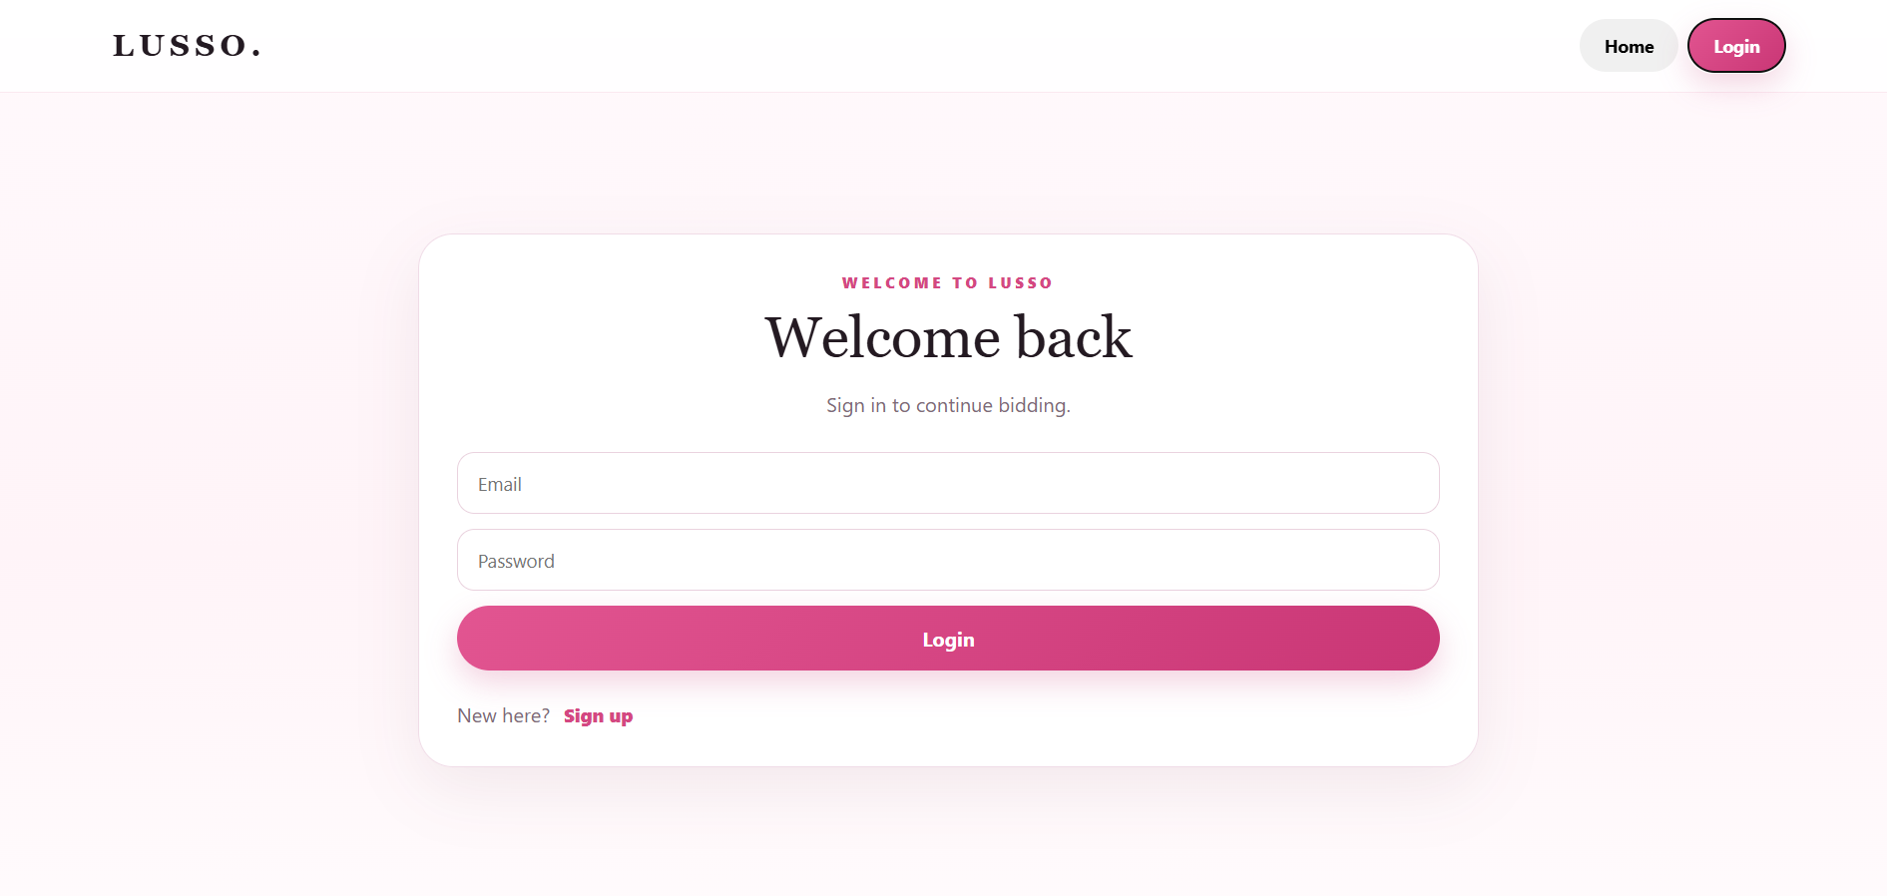
Figure 14.2: LUSSO. Login Page

Figure 14.3: Live Auctions Listing Page

14.6 Project Diagrams Included
The documentation includes the high-level system architecture diagram, deployment architecture diagram, entity relationship diagram (ERD), and real-time bidding workflow diagram. These diagrams visually represent the system components, deployment flow, database relationships, and major operations involved in the auction and bidding process.

