SUMMARY
of the License Thesis entitled:

Real-Time Light Dosimetry for Heritage Digital Twins via Texture Space Ray Tracing

Author: | Duică Sebastian
Advisor: | Assoc. Prof. Victor Ioan Bâcu

- Requirements:
This project involves modeling radiometric transport of light in a Digital Twin environment, with focus on predicting and analyzing lux-hours of light exposure experienced by heritage artifacts. This modeling process will entail exact geometrical occlusion to model light scattering directly and indirectly [1], and the dynamical integration of solar ephemeris data to predict future photometric damage to museum artifacts during the whole of the 8,760-hour long weather cycle.
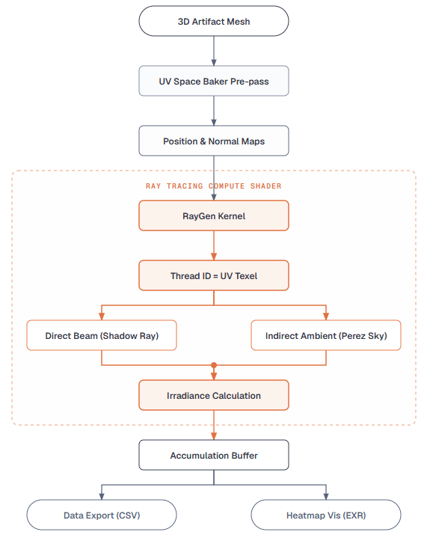
- Proposed solutions:
Solution represents an end-to-end metrology Digital Twin framework intended for high-performance architectural simulation. Key architectural elements include the following:
- Texture Space Path Tracer: Implements DirectX 12 hardware acceleration to bake accumulated irradiance onto UV Map of the target artifact indefinitely, hence bypassing the occlusion limitations associated with the traditional screen-space based techniques.
- Asynchronous CPU Orchestration: A highly optimized C# thread calculates the equations for positioning of celestial bodies and atmospheric attenuation factor [4]. Exact values of solar vectors are fed into HLSL compute kernels to provide a deterministic and precisely geographically synchronized GPU based simulation without interfering with the main thread.
- Mathematically Sound Ambient Skylight: To properly simulate indirect light scattering effects, the compute kernel uses stochastic multi-sampling by means of Cosine-Weighted Importance Sampling [2] to decrease variance. This technique is intrinsically linked with the mathematical calculation of the Perez All-Weather Sky Model [3] to produce realistic relative luminance distribution on the sky dome considering clear-sky turbidity parameters.
Figure 1: High-level system architecture pipeline.
- Results obtained:
The complete simulation pipeline provides two key analyses: visually generated heatmaps called "Inferno," which capture the spatial hotspots; and organized CSV data files which contain all the parameters for each simulated hour (i.e., Altitude, Azimuth, DeltaMax, MaxDose, and Variance).

Significantly, the analysis highlights the fact that there are considerable, mathematically proven differences between the light dose experienced by the artifact in different conservation scenarios:

- Scenario A (Baseline Exposure): In the unprotected setting, the artifact had a disastrous hotspot of 6.6 million Lux-Hours, with a high surface average of 1,682,136 Lux-Hours – well above the safety limits.
- Scenario B (Material Intervention): The implementation of UV-filtering conservation glass and matte architectural floor contributed greatly to light filtration and lowered the surface average to 356,433 Lux-Hours.
- Scenario C (Geometric Occlusion): Moving the artifact to a shaded corner, which prevented solar radiation, helped lower the average dose to 213,732 Lux-Hours, while the remaining light energy came from diffuse skylight.
- Scenario D (Synergy): The use of material intervention in combination with geometric occlusion significantly lowered the average dose to 28,596 Lux-Hours, thus making the artifact safe within 50,000 Lux-Hour conservation limits. Additionally, the absolute peak was limited to 150,000 Lux-Hours, which is a 97.7% decrease in comparison to the initial peak.
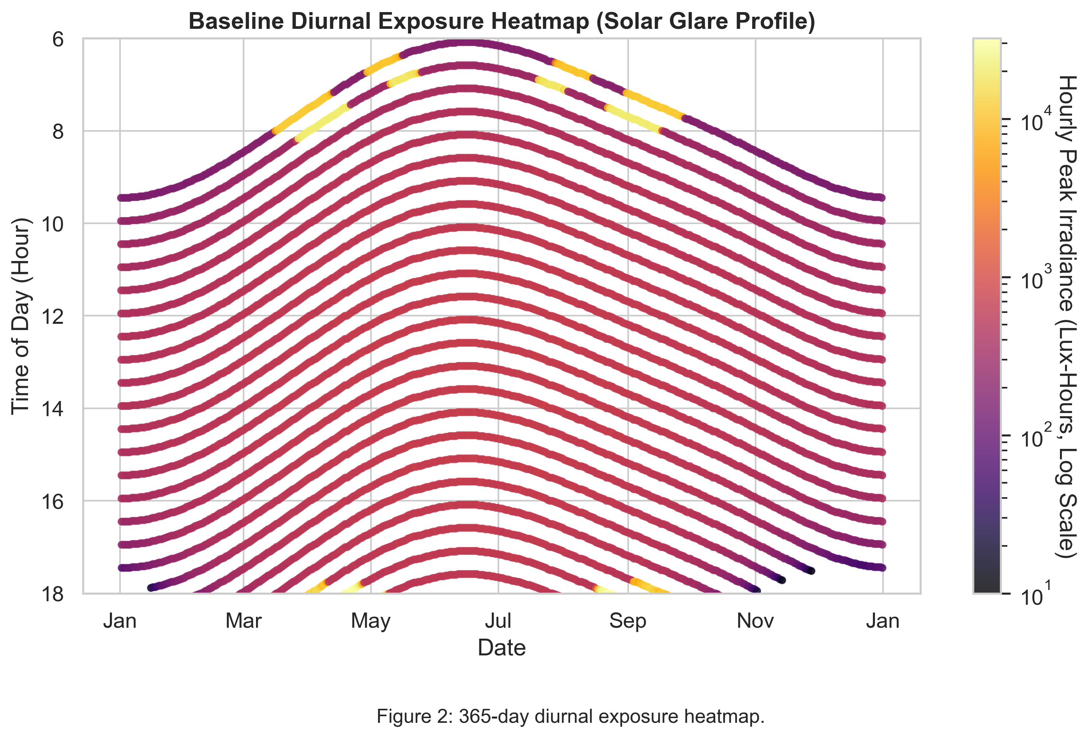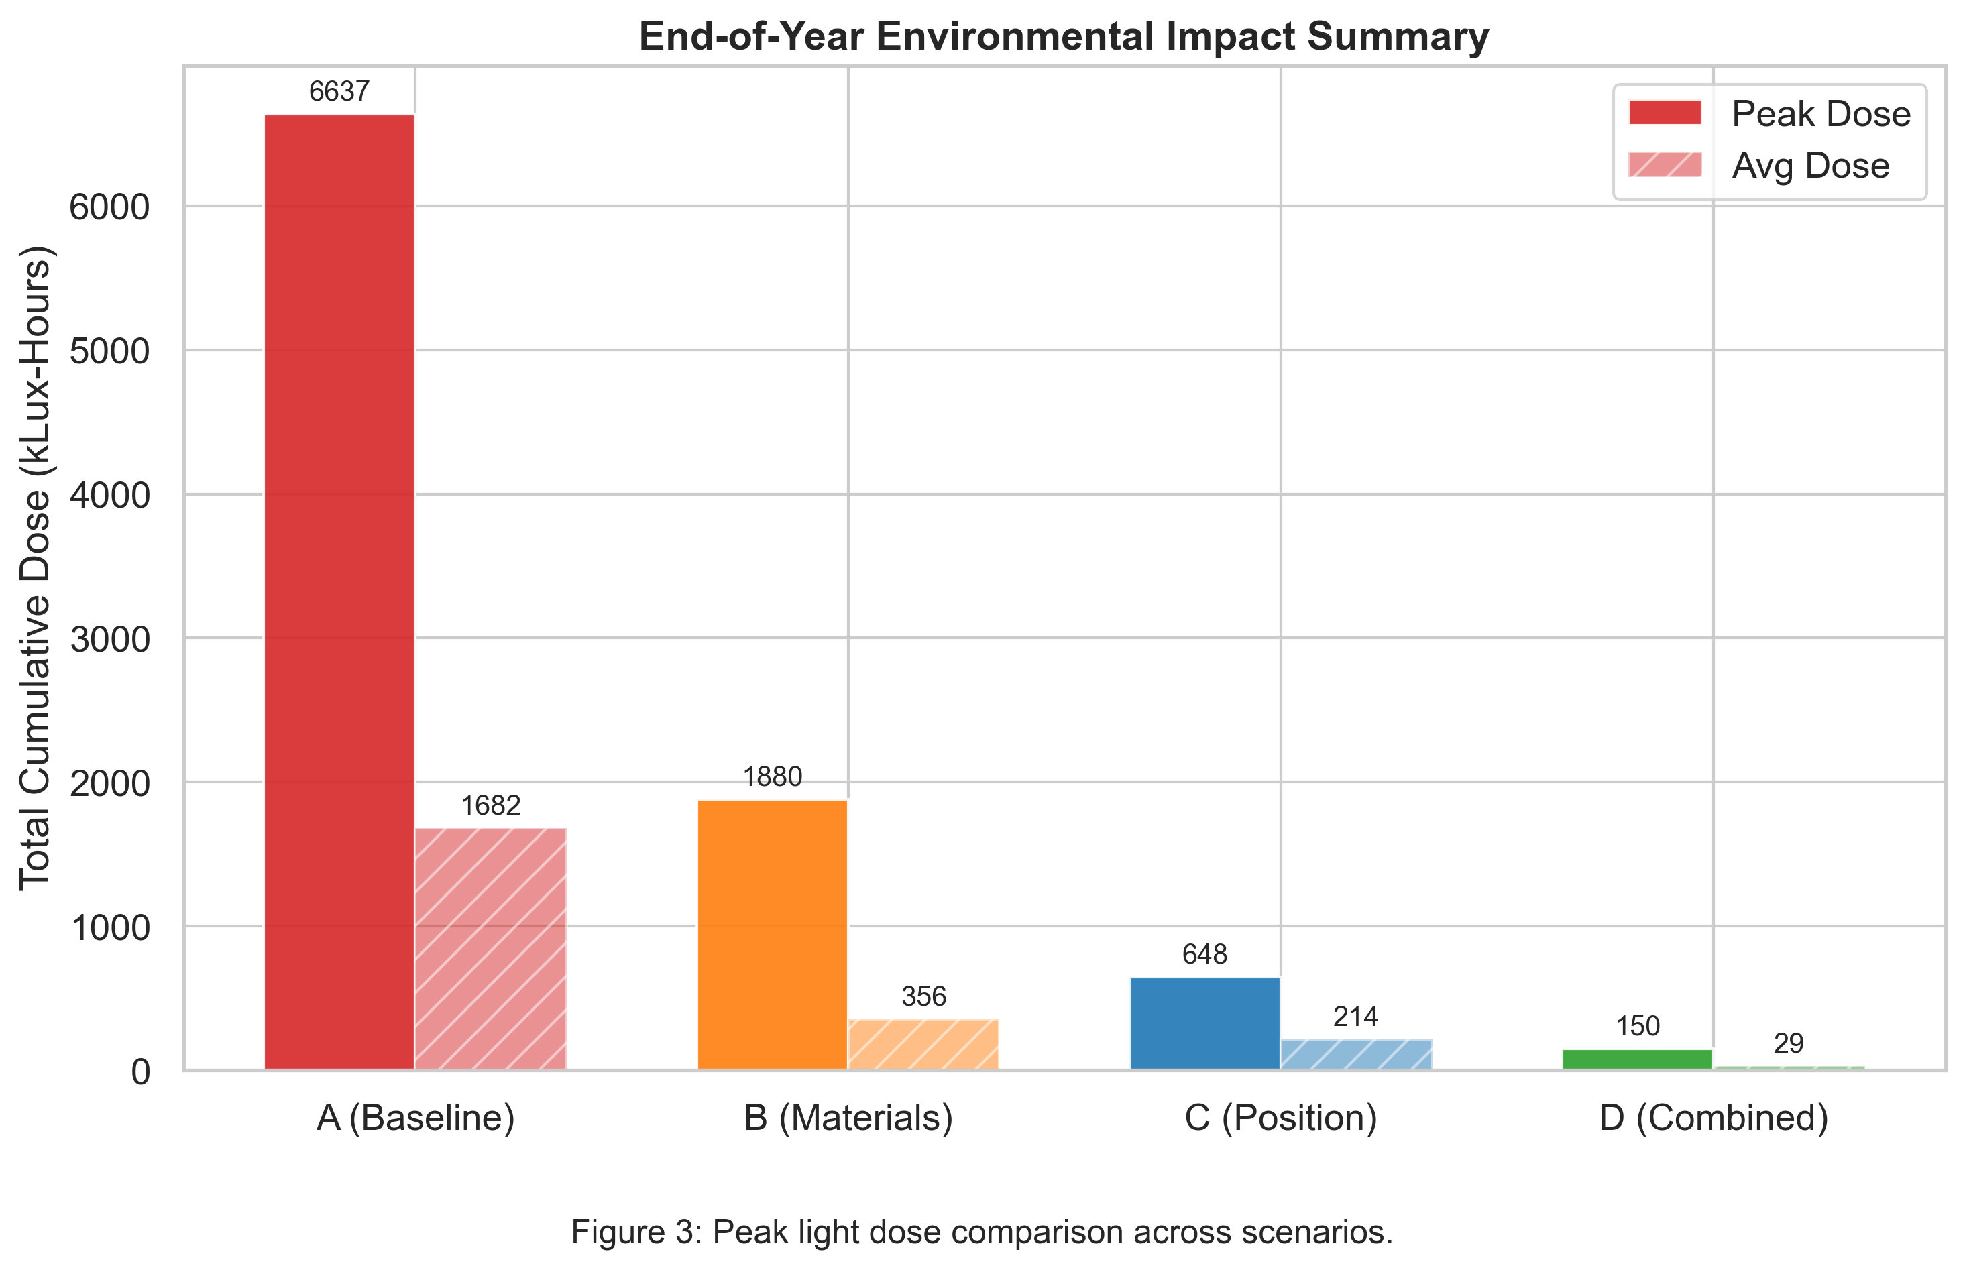
- Tests and verifications:
To guarantee thorough metrological validity in consideration of the considerable amount of dosage reduction that was mentioned above, the approach utilizes a set of hardware-accelerated Virtual Lux Sensors which asynchronously sample the raw 32-bit floating-point accumulation buffers. In this way, these sensors compute the spatial variance and the convergence error in a real-time manner.
Analysis has shown that the spatial variance conforms to the laws of physics. Since the Standard Error of the Mean (SEM) is obtained from the spatial variance directly, it can be proven that the stochastic estimator converges consistently over the surface of the artifact in a mathematically divergent-free manner. The analytical percentage error of the virtual sensors, calculated through the difference of the stochastic GPU integration and the deterministic theoretical computations, stays mathematically bounded to the range of 4.5%-7.5% throughout the entire 8,760 hour period.
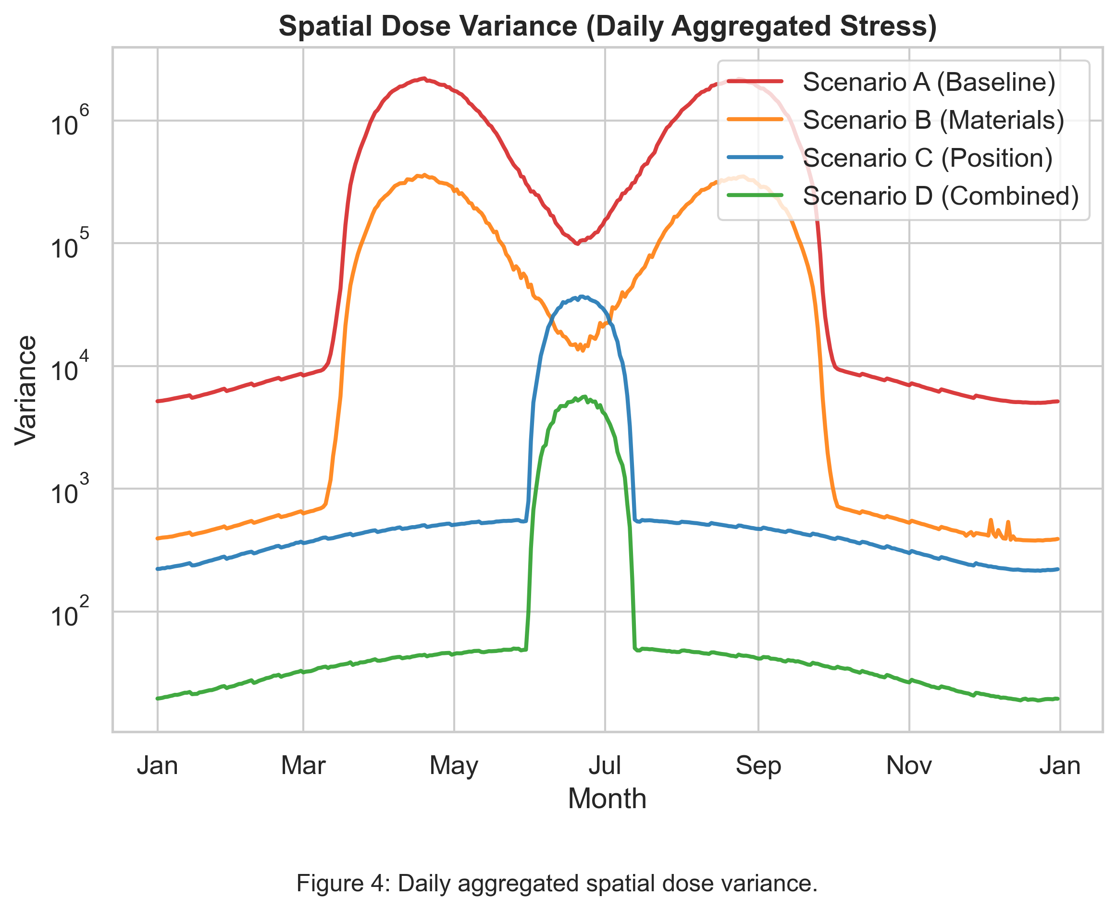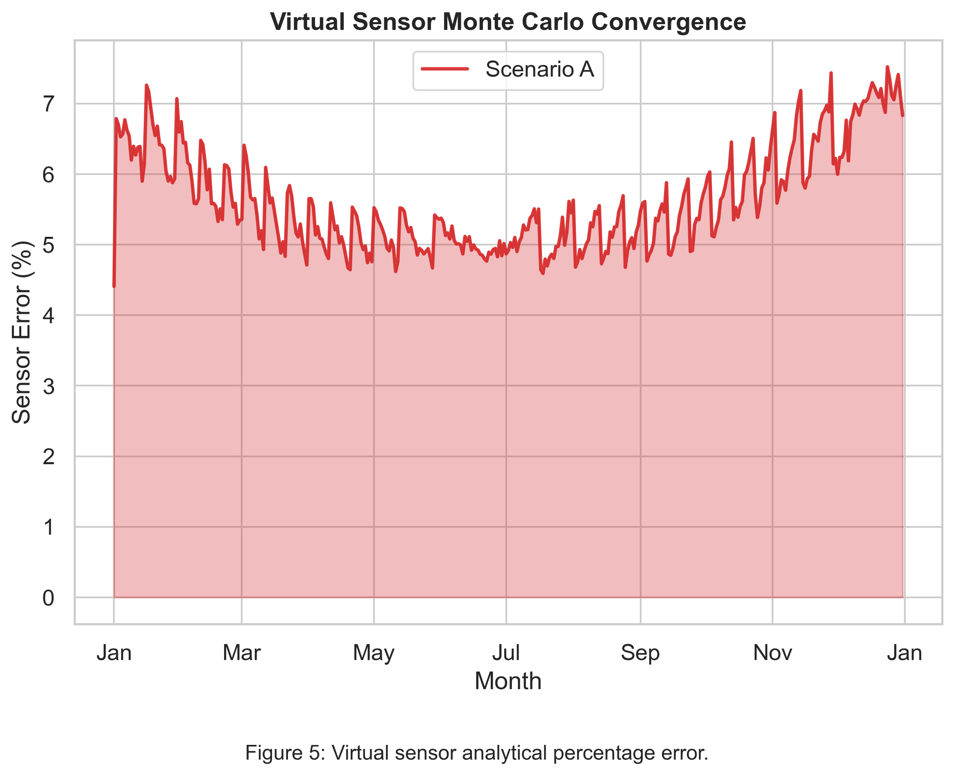
- Personal contributions:
The key innovations of this thesis include the following:
- Creation of a specialized hardware-accelerated DirectX 12 Texture Space Path Tracer created through Unity, which allows bypassing the usual screen space constraints.
- Mathematical derivation and creation of real-time calculations of the position of the sun in the sky through astronomical methods combined with the Perez Sky Model.
- Development of a robust and multi-threaded asynchronous orchestration process that can run a headless simulation for 8,760 hours without freezing the user interface.
- Creation of an energy-conserving material evaluation system ensuring R + T < 1 prediction.

- Documentation sources:
[1] M. Pharr, W. Jakob, and G. Humphreys, Physically Based Rendering: From Theory to Implementation, 3rd ed., Morgan Kaufmann, 2016.
[2] E. Veach and L. J. Guibas, “Optimally combining sampling techniques for Monte Carlo rendering,” SIGGRAPH '95, pp. 419-428, 1995.
[3] R. Perez, R. Seals, and J. Michalsky, “All-weather model for sky luminance distribution—Preliminary configuration and validation,” Solar Energy, vol. 50, pp. 235-245, 1993.
[4] F. Kasten and A. T. Young, “Revised optical air mass tables and approximation formula,” Applied Optics, vol. 28, pp. 4735-4738, 1989.

Date: ________________ | Author | _____________________________
 | Coordonator | _____________________________

