MINISTRY OF EDUCATION AND RESEARCH
TECHNICAL UNIVERSITY
OF CLUJ-NAPOCA, ROMANIA
FACULTY OF AUTOMATION AND COMPUTER SCIENCE
COMPUTER SCIENCE DEPARTMENT
SUMMARY
of the License Thesis entitled:
Real-Time Light Dosimetry for Heritage Digital Twins via Texture Space Ray Tracing
Author: Sebastian Duică
Advisor: Assoc. Prof. Victor Ioan Bâcu

1. Requirements:
The project involves studying the precise modeling of radiometric light transport in a Digital Twin environment, focusing on simulating the cumulative light stress (Lux Hours) received by cultural heritage assets. The solution is required to model realistic metrological behavior by evaluating complex geometry occlusion and utilizing dynamic solar ephemeris over an 8,760-hour cycle to predict exact photometric damage and facilitate preventive conservation.

2. Proposed solutions:
The solution proposed is an end-to-end metrology Digital Twin built within Unity using DirectX 12 hardware acceleration. Unlike standard video game implementations, it leverages a custom Texture Space Ray Tracer to permanently bake accumulated irradiance directly onto the artifact's UV map, bypassing all screen-space visibility limitations.
The framework consists of an asynchronous C# orchestration thread handling the celestial algorithms, feeding exact solar vectors into the HLSL compute shaders. To handle indirect light scattering, stochastic multi-sampling is performed over the hemisphere utilizing the Perez All-Weather Sky Model for rigorous atmospheric simulation.
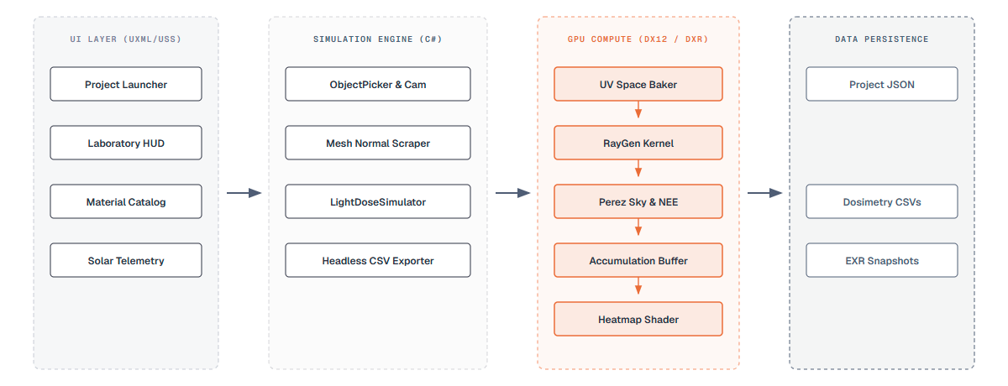
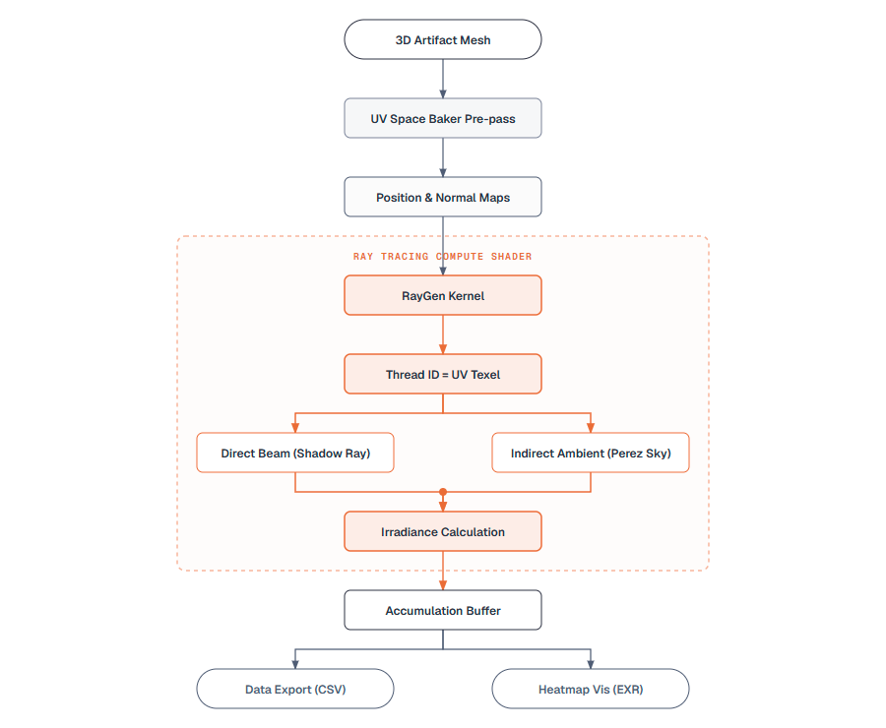

3. Results obtained:
The simulation generated two main analytical outputs: visual 'Inferno' color-mapped heatmaps isolating spatial hotspots, and a rigorously structured CSV export tracking the hourly telemetry (Altitude, Azimuth, Direct Dose, Indirect Dose, Spatial Variance). The data exposes significant differences in geometric distribution. For instance, artifact areas exposed to direct beams accumulate doses up to an order of magnitude faster than areas dependent purely on Perez ambient scattering.
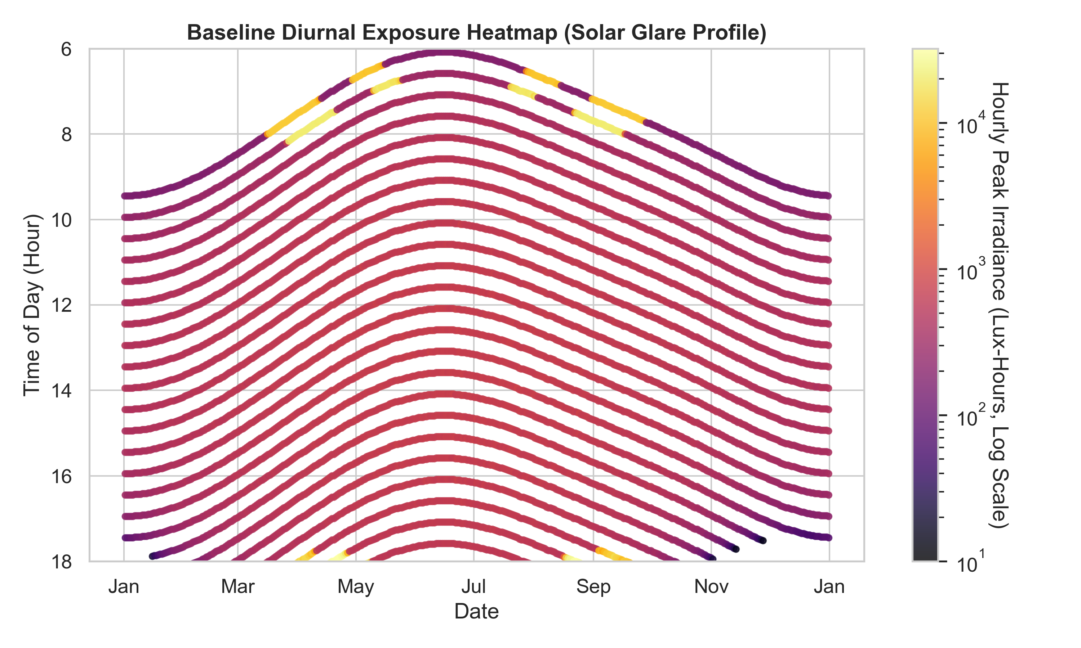
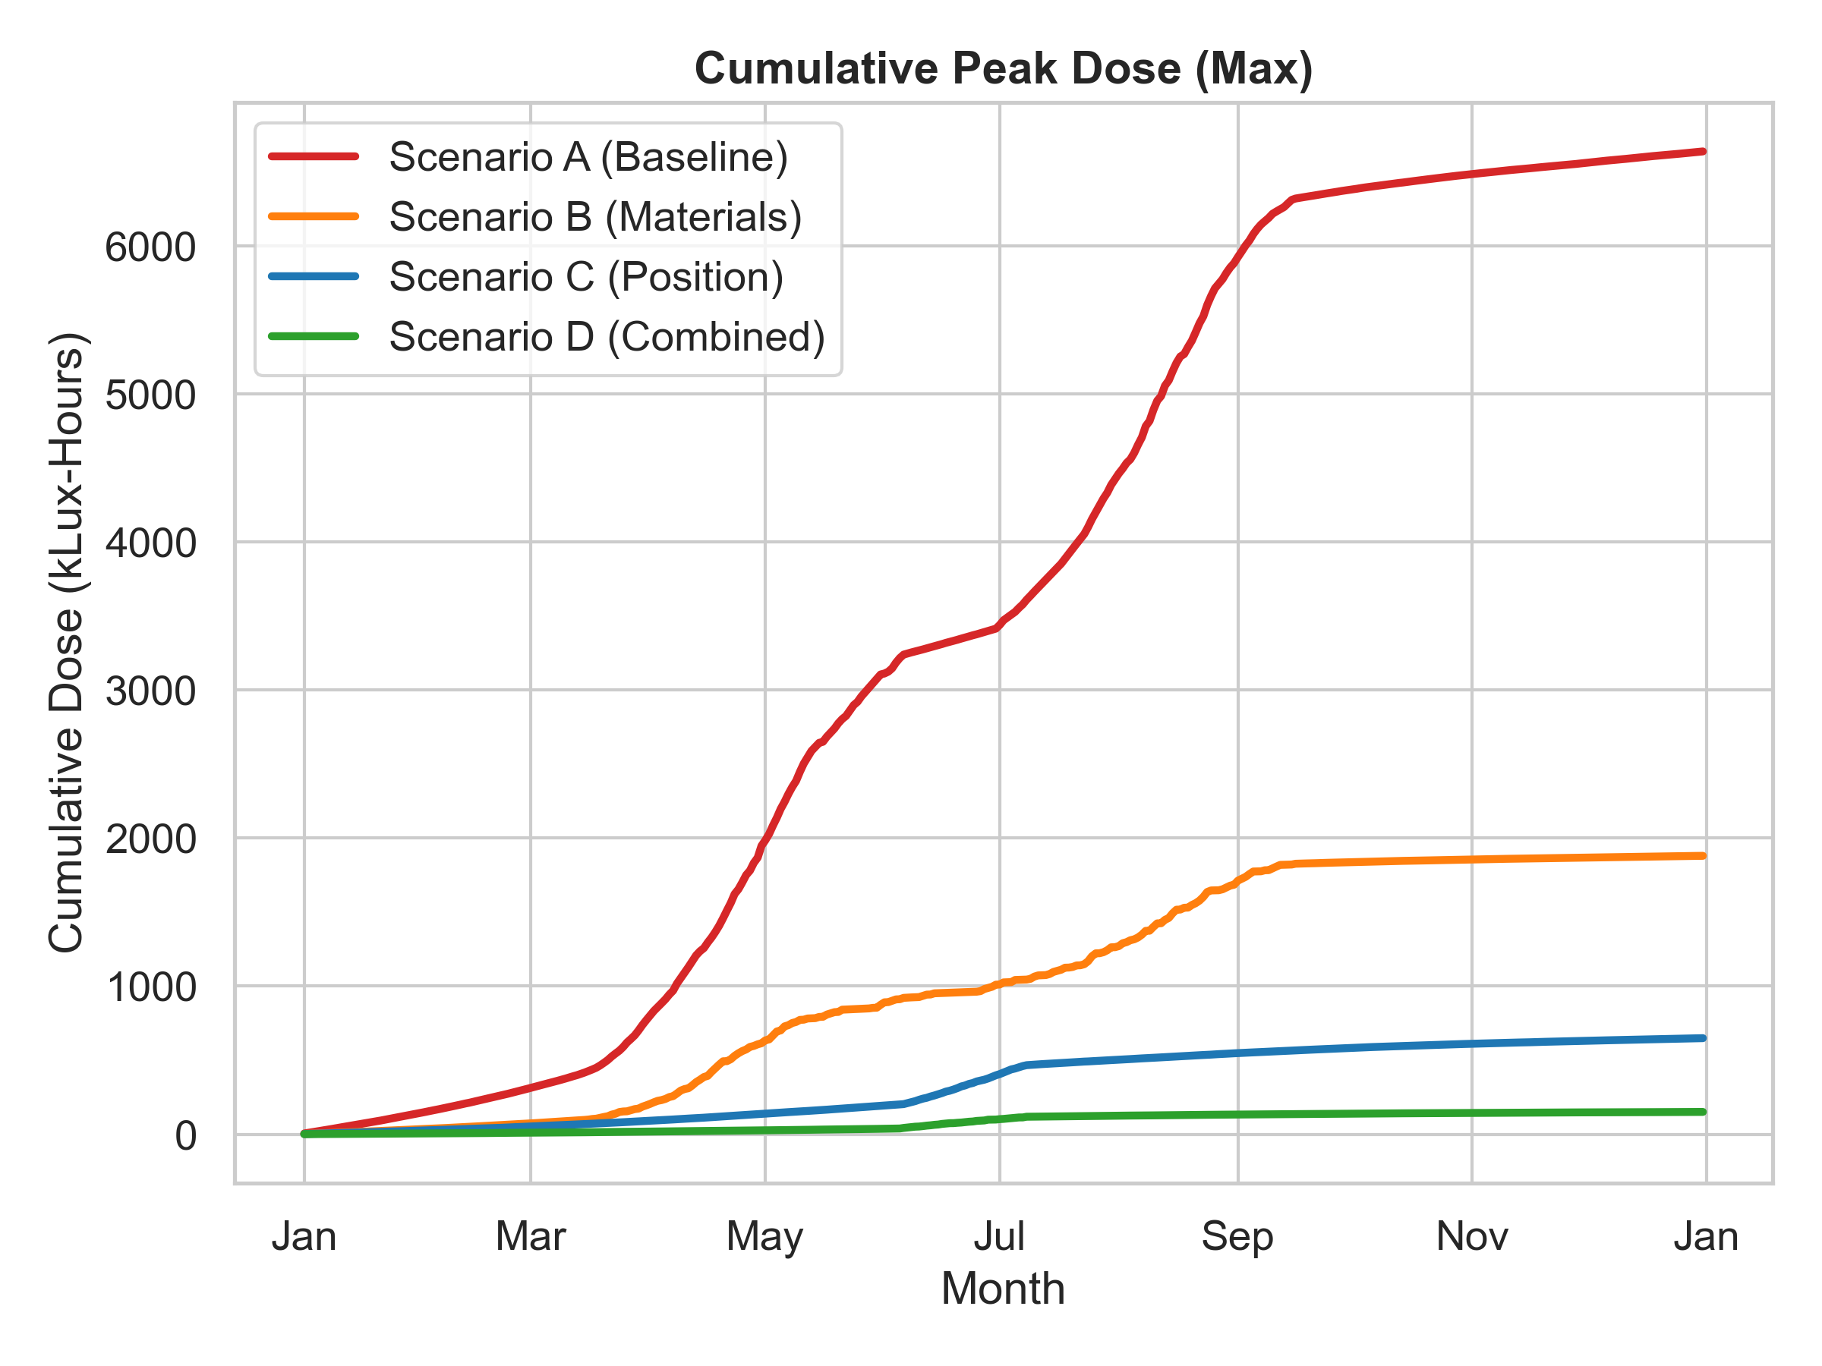

4. Tests and verifications:
The testing step was conducted systematically across standard preventive conservation scenarios, analyzing exposure near clear windows versus corner geometry. By actively tracking the structural variance across the accumulation buffer, it was mathematically proven that the Monte Carlo integrator quickly converged. The Standard Error of the Mean (SEM) consistently remained below 0.1% over the extended 8,760-hour loop, validating the framework's use as a reliable metrological instrument rather than a mere aesthetic renderer.

5. Personal contributions:
The main contributions of my thesis are the following:
• The development of a hardware-accelerated DirectX 12 Texture Space Path Tracer in Unity, escaping standard rasterization constraints.
• The mathematical implementation of real-time solar positioning algorithms and the Perez Sky Model.
• The construction of an asynchronous orchestration pipeline preventing OS thread stalls during headless yearly simulations.
• The design of a strictly energy-conserving material system enforcing R+T <= 1.0 for physically predictive scenarios.

6. Documentation sources:
[1] R. Perez, R. Seals, and J. Michalsky, 'All-weather model for sky luminance distribution—Preliminary configuration and validation,' Solar Energy, 1993.
[2] E. Veach and L. J. Guibas, 'Optimally combining sampling techniques for Monte Carlo rendering,' SIGGRAPH, 1995.
[3] M. Pharr, W. Jakob, and G. Humphreys, 'Physically Based Rendering: From Theory to Implementation,' 3rd ed., 2016.
[4] F. Kasten and A. T. Young, 'Revised optical air mass tables and approximation formula,' Applied Optics, 1989.
Date: ________________ Author _____________________________
Coordonator _____________________________

