Customer Segmentation
Executive Report
Machine Learning II | Nova IMS | Data Science Degree
Leonardo Souza | 20241411
Jaime Abreu | 20241823
Afonso Fonseca | 20241781

Metric Dimension | Value Assessment
Total Customers | 33,038
Segments Identified | 5
Algorithm | K-Means (k=5, StandardScaler, n_init=15)
Basket Rules | Apriori (min support 1%, min confidence 25%, min lift 1.1)
Largest Segment | Core Everyday Shoppers - 40.7% of base
Highest-Value Segment | High-Value Families - EUR 42,729 avg lifetime spend

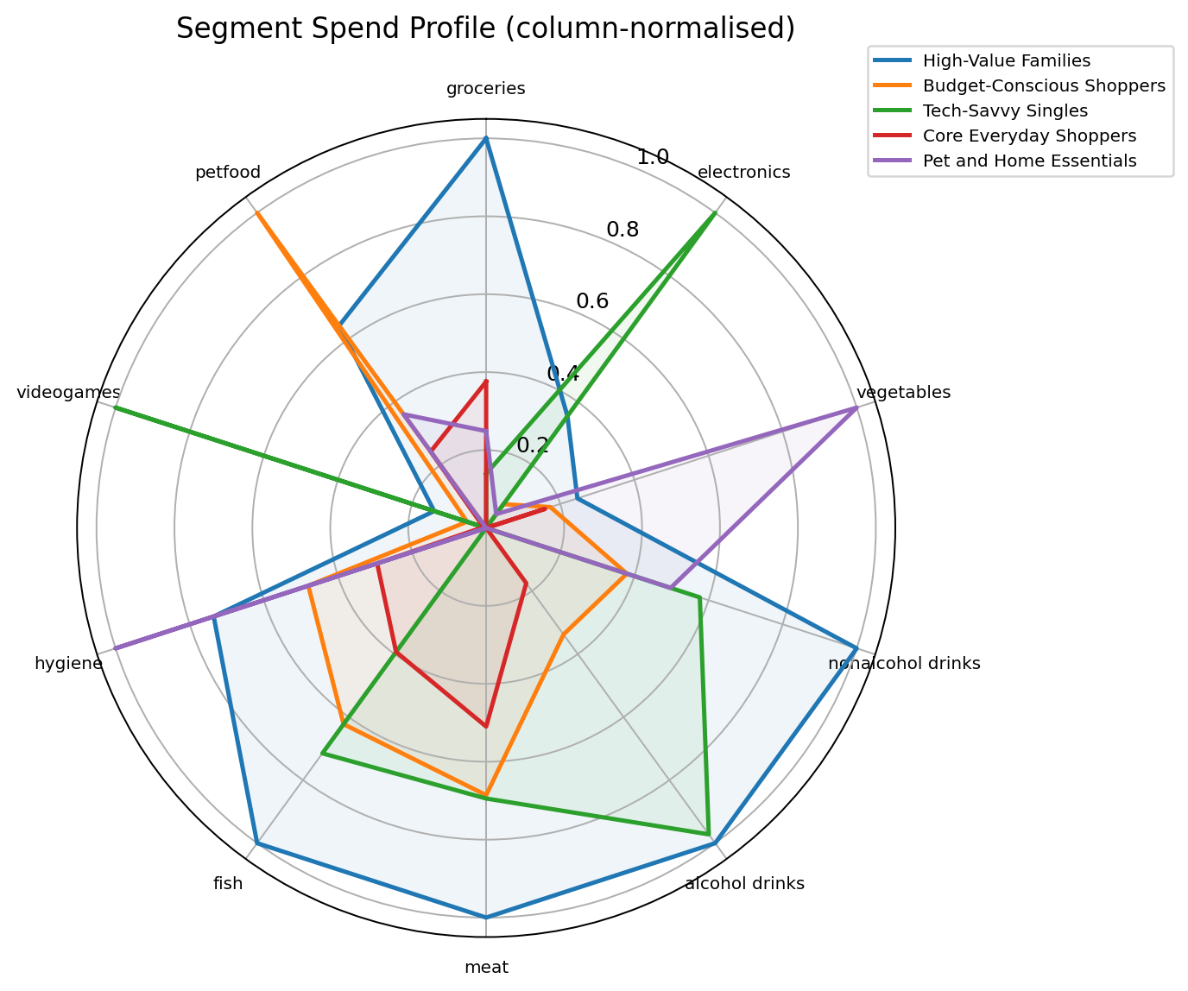

Table of Contents
1. Executive Summary
2. Exploratory Data Analysis and Pre-Processing
3. Customer Segmentation and Clustering
4. Targeted Promotion
5. Conclusion and Recommendations

1 Executive Summary
This report presents the findings of a customer segmentation study on a retail customer base of 33,038 individuals. Using K-Means clustering applied to demographic, spend-behaviour and transaction history features, five distinct segments were identified. Each segment is profiled in terms of size, spending behaviour, demographics and loyalty characteristics. Targeted marketing campaigns grounded in basket association rules are proposed for each group.

Key Findings
- High-Value Families (21% of customers) generate an estimated 38% of total lifetime revenue. Their average spend of EUR 42,729 is 2.5x the portfolio average. Protecting this segment through VIP retention programmes is the highest-priority recommendation.
- Core Everyday Shoppers are the largest segment at 41% of the base and represent the largest absolute revenue pool. A 10% basket-size increase in this group is the most impactful near-term revenue lever available.
- Budget-Conscious Shoppers visit the most distinct stores, signalling active cross-shopping. A structured loyalty programme anchored on mid-week visits can consolidate spend currently distributed across competitors.
- Tech-Savvy Singles and Pet and Home Essentials customers have clearly defined category affinities directly addressable through targeted promotions derived from basket association rules.

Revenue Contribution by Segment
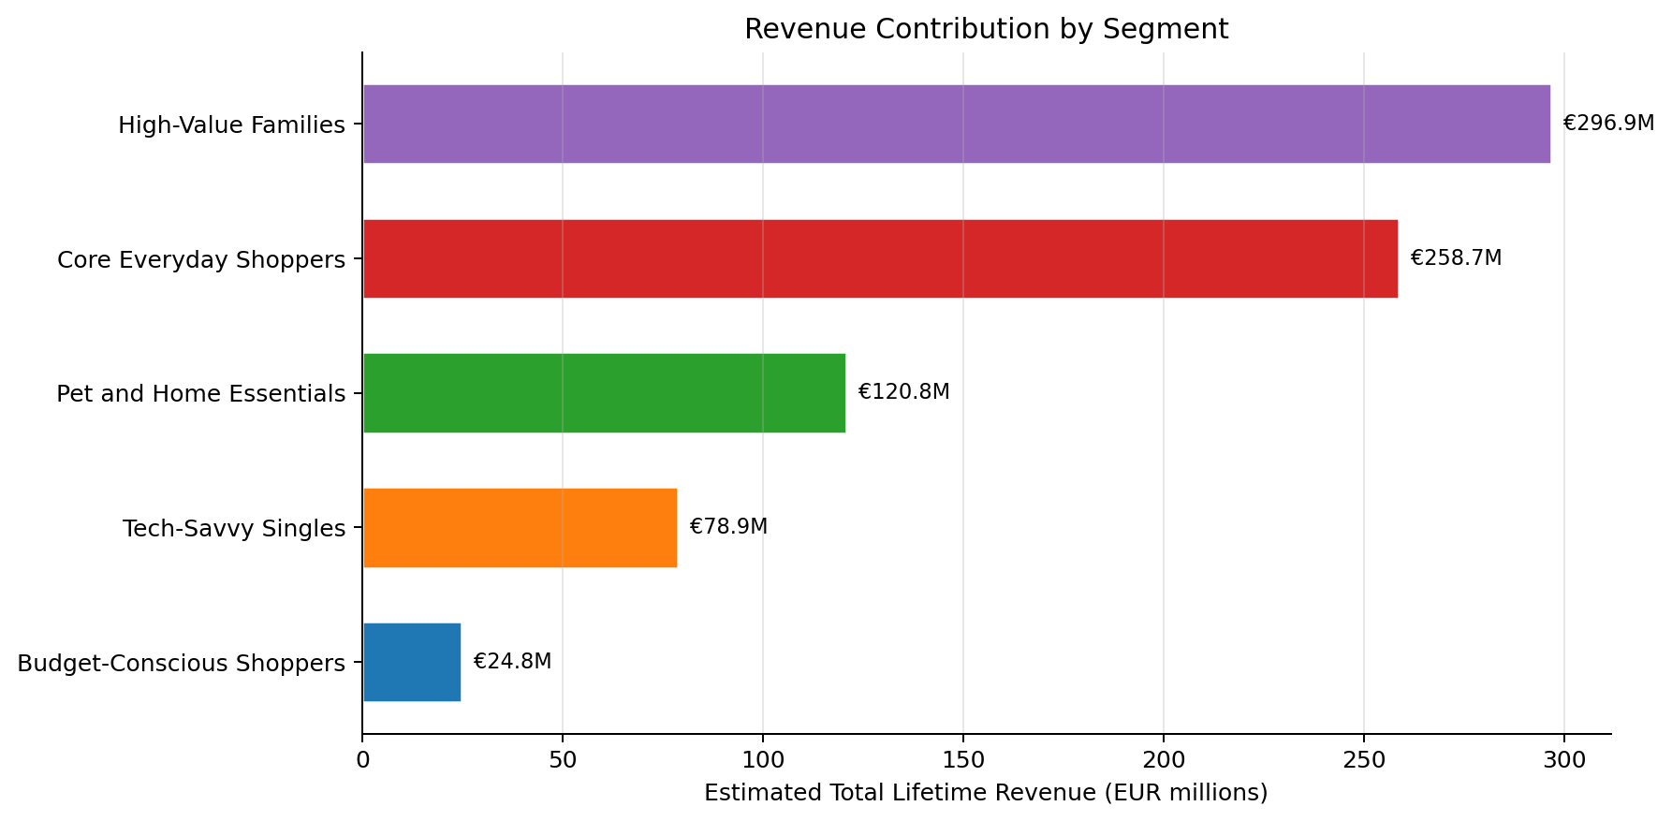
Figure 1: Estimated total lifetime revenue attributed to each segment (EUR millions).

Strategic Priorities

Protect High-Value Families
Introduce a VIP loyalty tier with exclusive cashback and family milestone rewards. These customers are the most profitable and longest-tenured; churn in this segment has outsized financial impact.

Grow the Core Everyday Base
Cross-category promotions anchored in grocery and fresh produce grow basket size in the largest customer group with minimal margin sacrifice.

Consolidate Budget-Conscious Shoppers
Mid-week double-points days and household bundle offers create habitual visits and reduce the cross-shopping that currently dilutes spend across multiple retailers.

Convert Pet Segment to Subscriptions
Predictable, high-frequency pet food purchases are a natural subscription opportunity. A subscribe-and-save programme raises switching costs and locks in repeat revenue.

2 Exploratory Data Analysis and Pre-Processing

Dataset Overview
Two datasets were provided: customer_info containing 33,038 customer records with demographic and lifetime spend information, and customer_basket containing 100,000 randomly sampled shopping baskets. The datasets are linked via customer_id.
Dataset | Rows | Key Fields
customer_info | 33,038 | Demographics, 10 lifetime spend categories, store visit history
customer_basket | 100,000 | invoice_id, customer_id, list of goods per transaction

Feature Engineering
The following transformations were applied to the raw data before clustering:
- Age was derived from customer_birthdate using a reference year of 2024.
- Education level was extracted from customer_name (PhD, Master, Bachelor, Other).
- Total children was computed as kids_home + teens_home.
- Total lifetime spend was summed across all 10 category spend columns.
- Category spend ratios (each category divided by total spend) capture relative category preference independently of overall spend level.
- Customer tenure was computed as 2024 minus year_first_transaction.
- Missing values were imputed using per-column medians to avoid sensitivity to outliers.
- All features were standardised using StandardScaler before clustering.

Feature Distributions
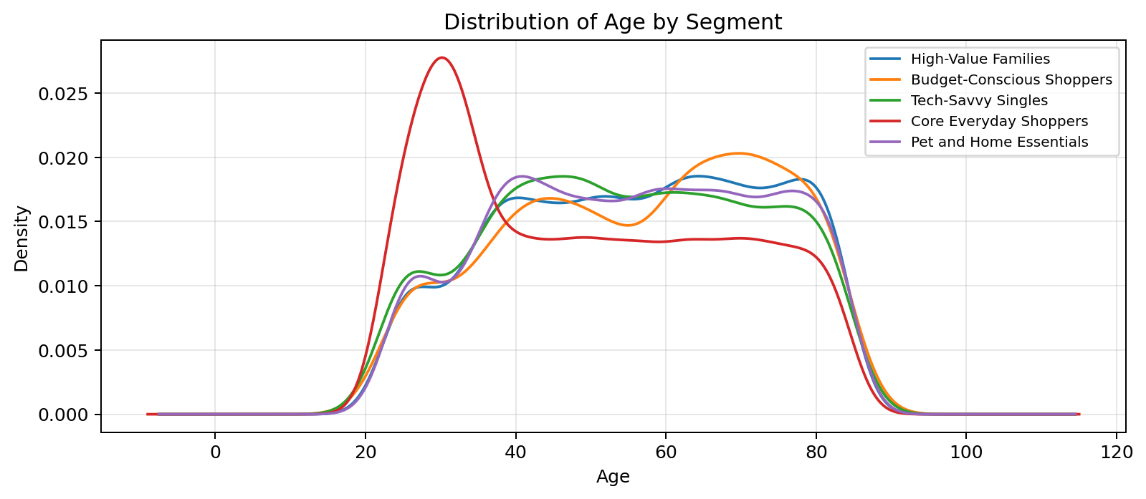
Figure 2: Customer age distribution by cluster.
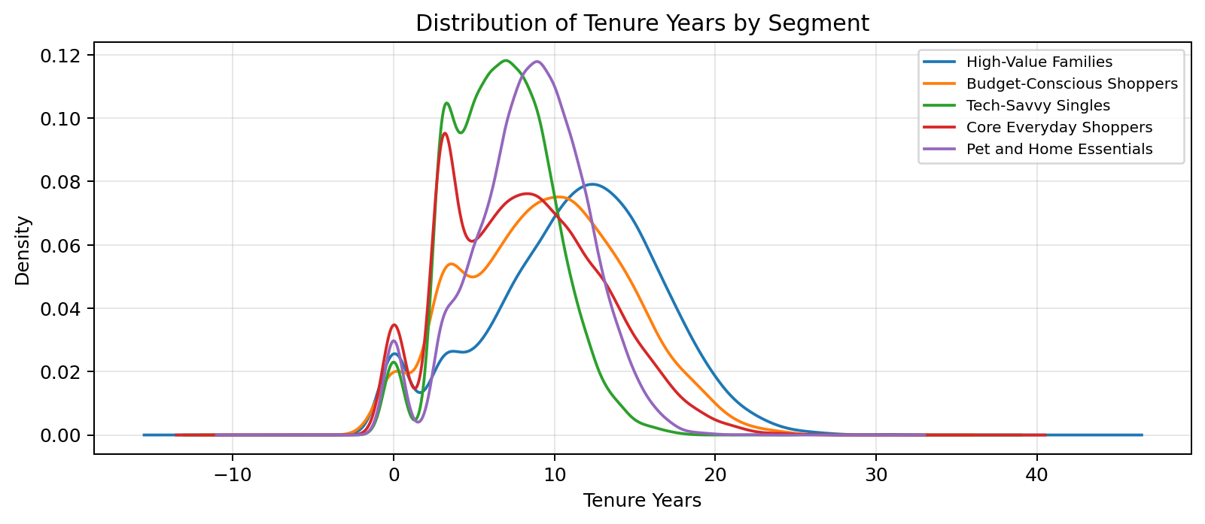
Figure 3: Customer tenure distribution by cluster (years).

Promotion Sensitivity
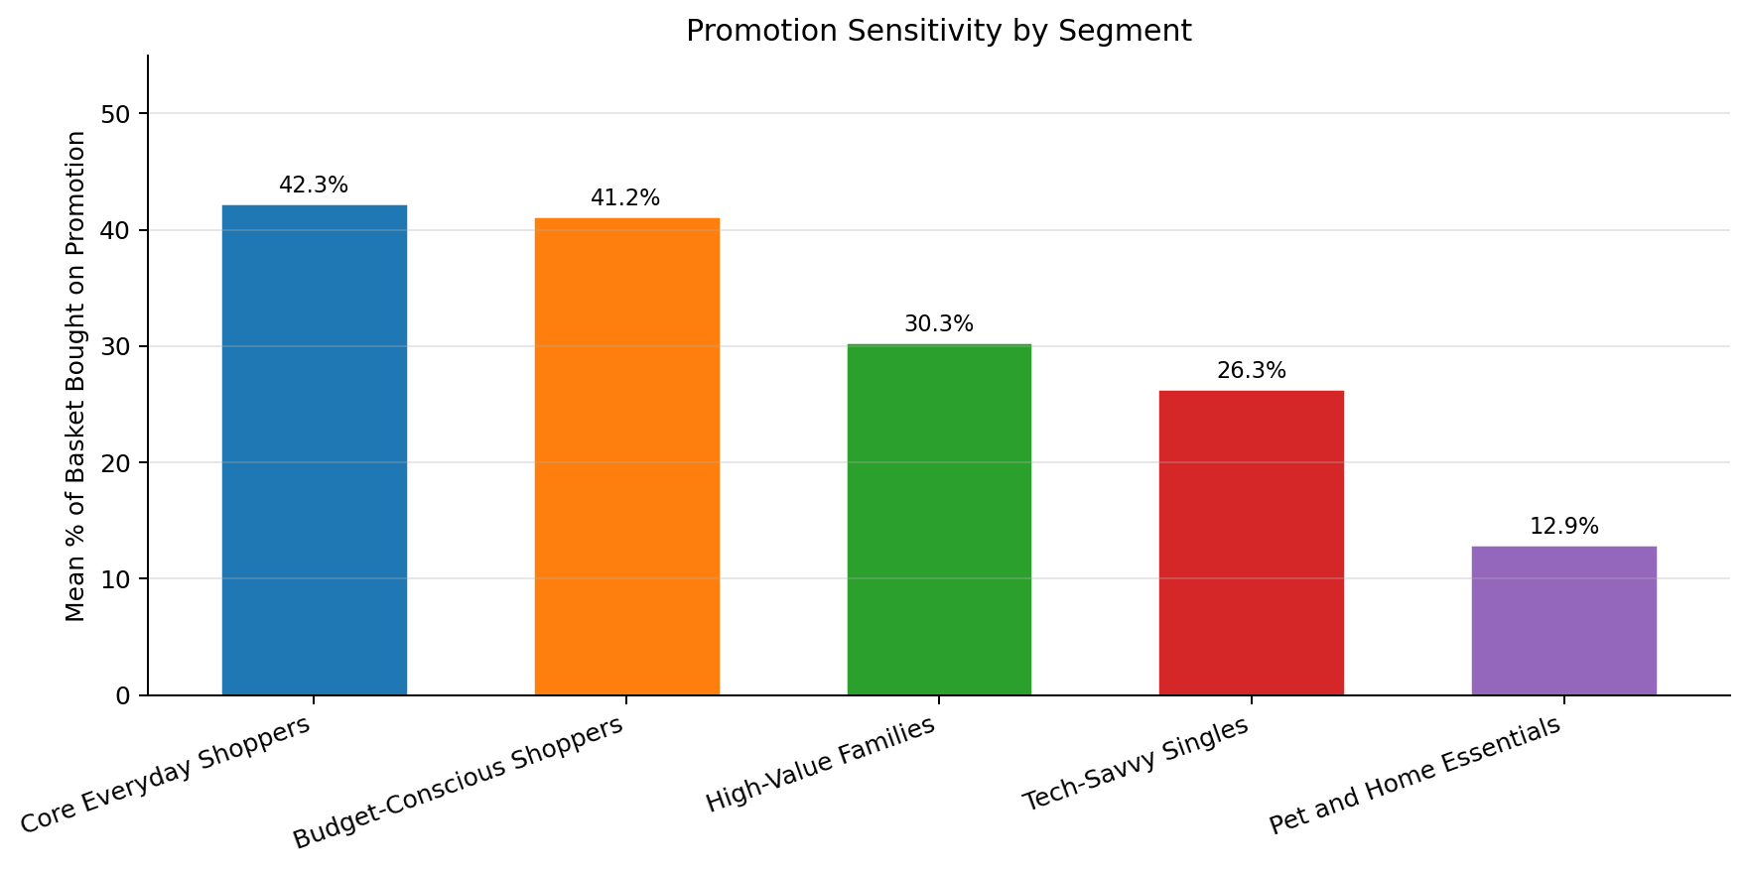
Figure 4: Fraction of basket purchased on promotion by segment. Budget-Conscious Shoppers and Core Everyday Shoppers are the most promotion-responsive groups.
Promotion sensitivity varies substantially across segments, with Budget-Conscious Shoppers and Core Everyday Shoppers exhibiting the highest rate of promotional purchasing. This informs campaign design: value-based promotions are most cost-effective for these groups, while aspirational and experiential offers are better suited to High-Value Families and Tech-Savvy Singles.

3 Customer Segmentation and Clustering

Algorithm and Configuration
K-Means clustering was applied to the standardised feature matrix. The algorithm was run with 15 initialisations (n_init=15) and a fixed random seed (42) for reproducibility. Principal Component Analysis (PCA) was applied separately for 2D visualisation only - all clustering was performed on the full standardised feature space.

Cluster Selection
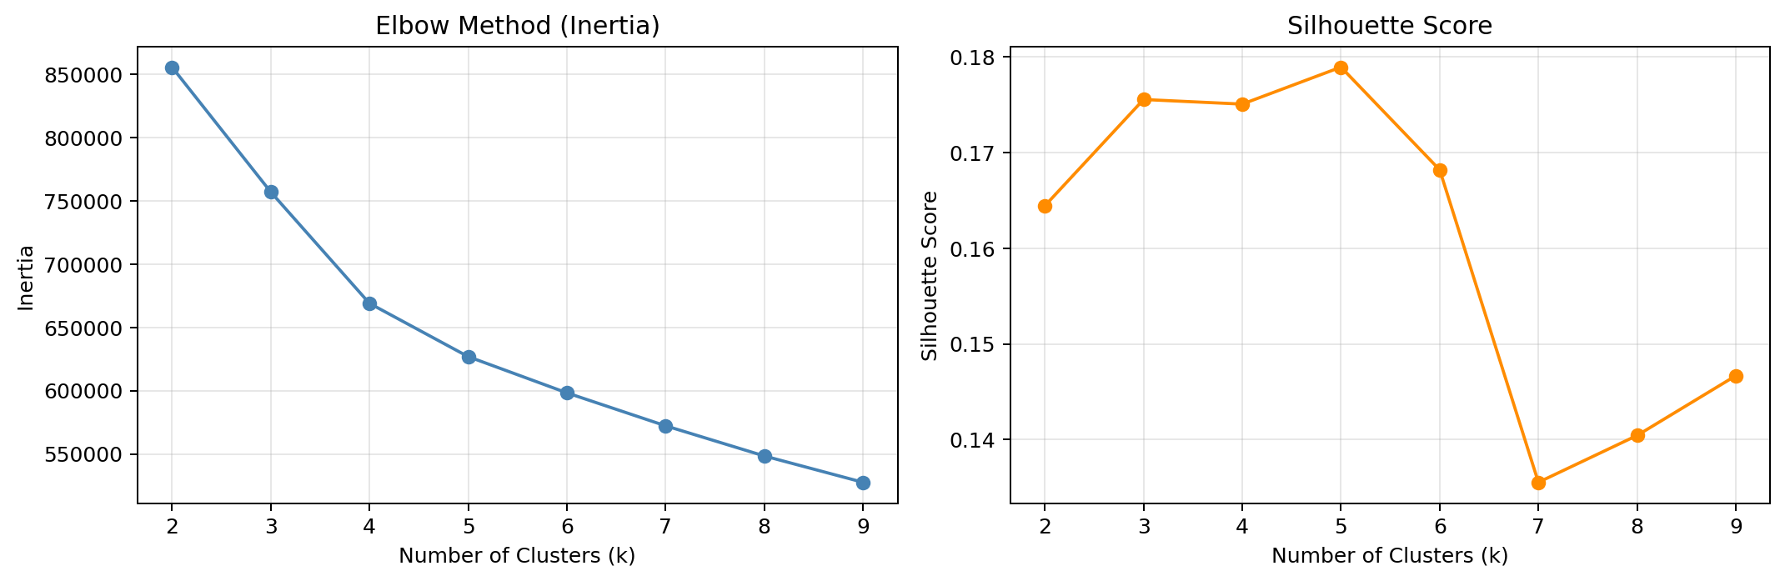
Figure 5: Elbow curve (inertia) and silhouette score across k = 2 to 9. Both metrics support k = 5.
The elbow curve shows a clear inflection at k = 5 where the rate of inertia reduction diminishes substantially. k = 5 simultaneously achieves the highest silhouette score (0.179) across all tested values of k, confirming that the clusters are both internally compact and well-separated from one another.

Cluster Visualisation
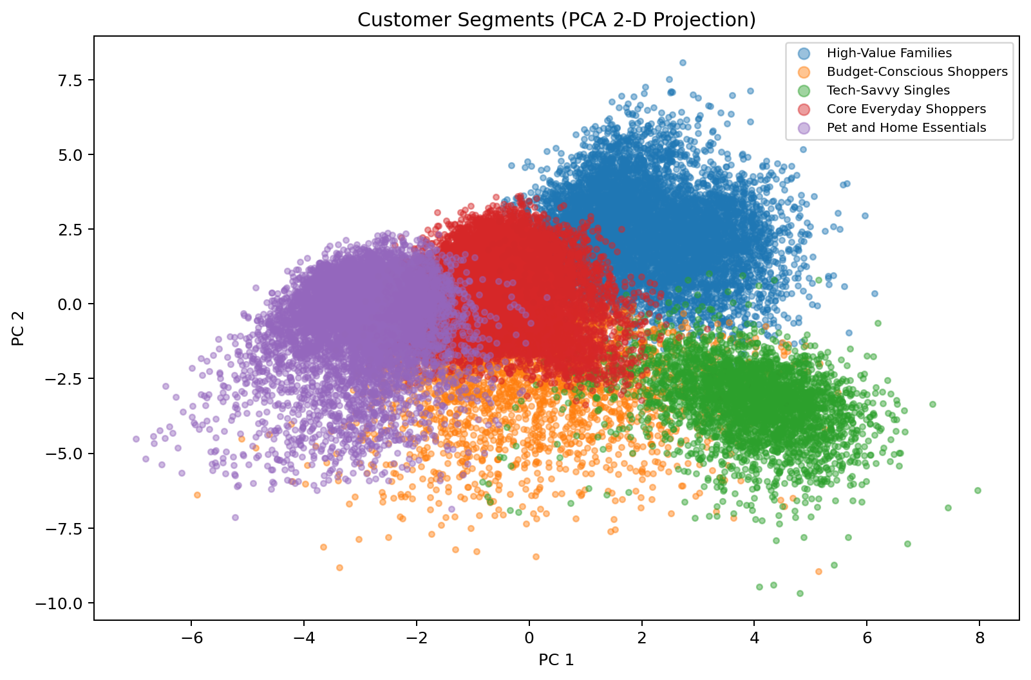
Figure 6: PCA 2D projection of all 33,038 customers coloured by assigned segment.

Segment Summary
Segment | Customers | Share | Avg Spend | Avg Age | Avg Children | Avg Tenure
Tech-Savvy Singles | 3,323 | 10.1% | EUR 23,741 | 54.6 yrs | 0.6 | 6.7 yrs
Budget-Conscious Shoppers | 2,337 | 7.1% | EUR 10,602 | 56.6 yrs | 1.8 | 9.4 yrs
Core Everyday Shoppers | 13,460 | 40.7% | EUR 19,247 | 49.3 yrs | 1.5 | 8.0 yrs
High-Value Families | 6,942 | 21.0% | EUR 42,729 | 56.1 yrs | 3.8 | 11.1 yrs
Pet and Home Essentials | 6,976 | 21.1% | EUR 17,321 | 55.5 yrs | 1.9 | 8.3 yrs

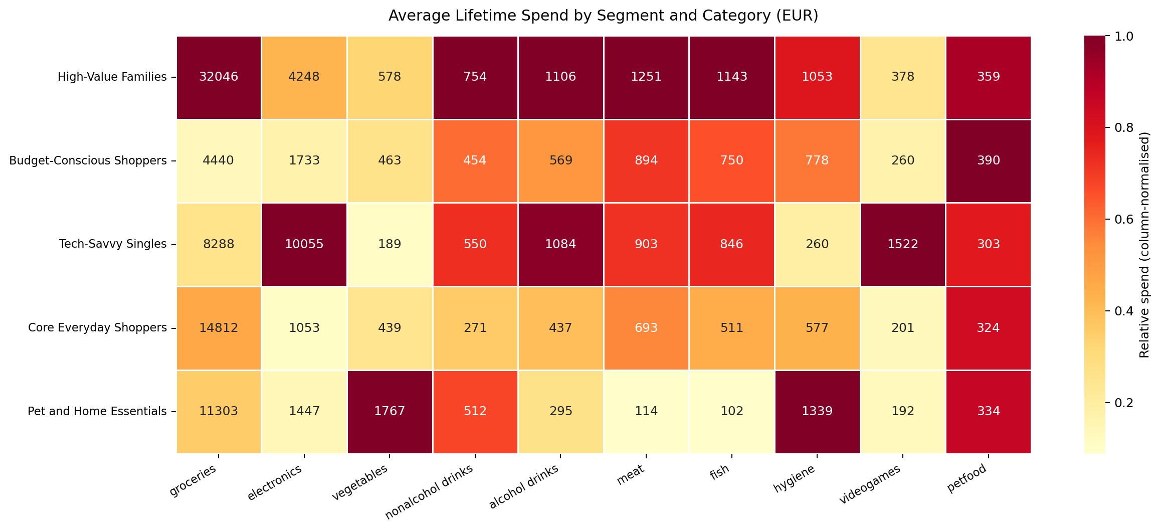
Figure 7: Average lifetime spend per category and segment (EUR).
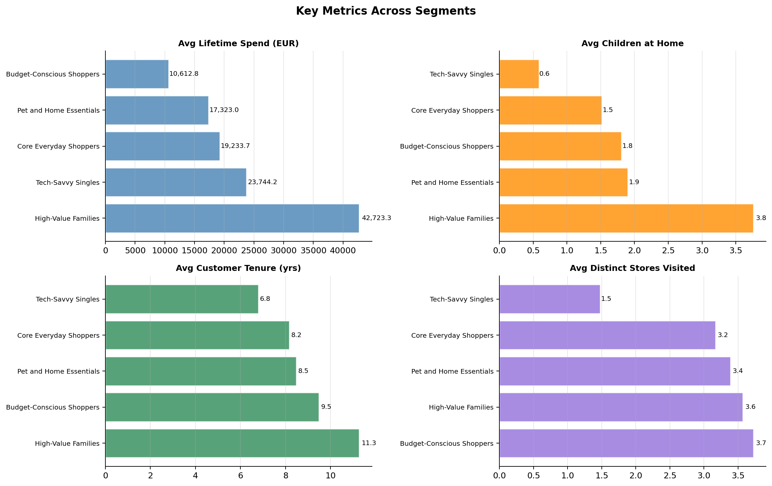
Figure 8: Key demographic and spend metrics across segments.

Segment Profiles
Tech-Savvy Singles
3,323 customers | 10.1% | Avg lifetime spend EUR 23,741

These customers spend heavily on electronics and video games, have almost no children at home, and visit fewer stores than average. Despite lower visit frequency, they are high-value per visit. Tech launch cycles, gaming bundles and device upgrade programmes are the most effective levers for this group.

Defining Characteristics
- Highest electronics and video-game lifetime spend of any segment
- Fewest children at home (average 0.6)
- Below-average store visit count - concentrated spend pattern
- Shorter customer tenure than average at 6.7 years

Budget-Conscious Shoppers
2,337 customers | 7.1% | Avg lifetime spend EUR 10,602

The most price-sensitive segment. They spread their spend across the highest number of distinct stores, indicating active cross-shopping behaviour. Above-average promotion usage signals strong price responsiveness. Loyalty mechanics that reward consolidation are the highest-impact strategy here.

Defining Characteristics
- Lowest average lifetime spend at EUR 10,602
- Highest number of distinct stores visited - strongest cross-shopping signal
- Above-average promotional purchase rate
- Moderate household size (average 1.8 children)

Core Everyday Shoppers
13,460 customers | 40.7% | Avg lifetime spend EUR 19,247

The backbone of the customer base at 41% of all customers. Grocery and fresh produce are the dominant categories, with broad product diversity. Spending and demographics are moderate across all dimensions. Incremental basket size growth through cross-category promotions represents the largest single revenue opportunity.

Defining Characteristics
- Largest segment: 40.7% of the customer base
- Grocery and vegetables are dominant spend categories
- Broadest product diversity across all segments
- Youngest age profile at 49.3 years average

High-Value Families
6,942 customers | 21.0% | Avg lifetime spend EUR 42,729

The most profitable and loyal segment. Large households, the longest customer tenure, and spend spread across every category. Even modest churn reduction in this group has outsized revenue impact. VIP recognition and family-oriented bundle offers are the highest-return investment.

Defining Characteristics
- Highest average lifetime spend: EUR 42,729 - 2.5x the portfolio average
- Largest household size (average 3.8 children)
- Longest customer tenure at 11.1 years - most loyal segment
- Spend distributed broadly across all categories

Pet and Home Essentials
6,976 customers | 21.1% | Avg lifetime spend EUR 17,321

Characterised by consistent, predictable pet-food and hygiene purchases with very low penetration in meat and fish. The regularity of their purchasing behaviour makes this segment ideal for subscription-based offers, which lock in repeat revenue and raise switching costs.

Defining Characteristics
- Highest pet-food and hygiene spend of any segment
- Very low meat and fish category penetration
- Highly predictable and routine purchasing patterns
- Strong candidate for subscription programme conversion

4 Targeted Promotion
Targeted promotions were designed for each segment using basket association rules mined via the Apriori algorithm on the customer_basket dataset (min support 1%, min confidence 25%, min lift 1.1). Rules were computed separately per cluster to ensure segment-specific relevance. Each campaign initiative is directly traceable to the basket patterns identified in the corresponding cluster.

Figure 9: Spend heatmap provides the category context for each campaign initiative.
Tech-Savvy Singles
3,323 customers | 10.1% | Avg lifetime spend EUR 23,741

Campaign Initiatives
01 | Buy 1 Video Game, get 1 free  Basket rules for this cluster show strong video game co-purchase patterns. A BOGOF offer directly targets the defining category and drives volume.
02 | Buy AirPods and Bluetooth Headphones, get 20% off your next electronics purchase  The top association rule links audio accessories. The follow-on discount reinforces this natural co-purchase and drives repeat electronics spend.
03 | Device trade-in: bring an old device, get 15% off a new one  Upgrade mechanics match this segment's propensity for tech purchases and build long-term stickiness.

Supporting Association Rules (top 3 by lift)
If customer buys | They also buy | Support | Confidence | Lift
cereals, oil | eggs | 0.012 | 43.80% | 2.13
eggs, green tea | cereals | 0.011 | 46.17% | 2.12
cereals, oatmeal | eggs | 0.021 | 43.46% | 2.12

Budget-Conscious Shoppers
2,337 customers | 7.1% | Avg lifetime spend EUR 10,602

Campaign Initiatives
01 | 50% off the second basket item in the baby food and household category  Basket analysis shows household and essentials dominance. A half-price second item drives quantity consolidation and rewards in-store spending.
02 | Buy 3 household products, earn EUR 5 off your total bill  Directly rewards basket consolidation, reducing the cross-shopping behaviour identified in this cluster.
03 | Loyalty card double-points every Wednesday  Creates a recurring anchor visit day. The price-sensitive profile of this group makes points rewards highly effective at building habitual visits.

Supporting Association Rules (top 3 by lift)
If customer buys | They also buy | Support | Confidence | Lift
airpods, bluetooth headphones | energy drink | 0.011 | 35.64% | 4.57
airpods, energy drink | bluetooth headphones | 0.011 | 40.22% | 4.55
bluetooth headphones, energy drink | airpods | 0.011 | 61.54% | 4.19

Core Everyday Shoppers
13,460 customers | 40.7% | Avg lifetime spend EUR 19,247

Campaign Initiatives
01 | Get 20% off Fish when you also buy Meat  The top association rule for this cluster is a meat-to-fish co-purchase with strong lift. The discount formalises this natural buying behaviour.
02 | Buy any 5 vegetables, receive salad dressing for free  Vegetable basket rules show strong salad associations. A free accompaniment grows fresh-category engagement and basket size.
03 | Weekly fresh deals: 30% off selected vegetables every Friday  Creates habitual visit cadence and deepens loyalty to fresh produce - the category where this segment already over-indexes.

Supporting Association Rules (top 3 by lift)
If customer buys | They also buy | Support | Confidence | Lift
airpods, energy drink | bluetooth headphones | 0.014 | 38.89% | 5.68
bluetooth headphones, energy drink | airpods | 0.014 | 63.64% | 5.18
airpods, bluetooth headphones | energy drink | 0.014 | 41.75% | 4.96

High-Value Families
6,942 customers | 21.0% | Avg lifetime spend EUR 42,729

Campaign Initiatives
01 | Family bundle: groceries, meat and fish at 15% off total basket  Multi-category basket composition is the defining trait of this cluster. A bundle reward matches their natural purchasing pattern and grows total basket value.
02 | VIP loyalty tier: double cashback on all purchases above EUR 200  The high average spend makes this segment the natural fit for a premium loyalty tier. Meaningful cashback reinforces loyalty at scale.
03 | Birthday month offer: 20% off any single category of your choice  A personalised milestone reward reinforces the emotional connection to the brand for the most profitable and longest-tenured customers.

Supporting Association Rules (top 3 by lift)
If customer buys | They also buy | Support | Confidence | Lift
asparagus, avocado | salad | 0.018 | 41.16% | 4.35
avocado, tomatoes | salad | 0.011 | 40.74% | 4.31
asparagus, zucchini | salad | 0.011 | 40.71% | 4.31

Pet and Home Essentials
6,976 customers | 21.1% | Avg lifetime spend EUR 17,321

Campaign Initiatives
01 | Buy 2 bags of pet food, get 1 free  Pet food is the defining category of this cluster. A multi-buy offer directly incentivises the behaviour already observed in basket data.
02 | Spend EUR 50 in hygiene products, earn a free cleaning kit  Hygiene is the second defining category. A threshold reward increases average transaction value and deepens category loyalty.
03 | Subscribe and Save: 10% off recurring pet food orders  The predictable, routine purchase pattern of this segment makes subscription conversion straightforward and high-value for both parties.

Supporting Association Rules (top 3 by lift)
If customer buys | They also buy | Support | Confidence | Lift
cooking oil, dog food | napkins | 0.016 | 37.10% | 2.63
dog food, napkins | cooking oil | 0.016 | 35.14% | 2.59
babies food, napkins | cooking oil | 0.015 | 35.12% | 2.58

5 Conclusion and Recommendations

Summary
Five meaningfully distinct customer segments were identified through K-Means clustering, validated by both elbow and silhouette analysis. The segments are differentiated primarily by category spend composition, household structure, customer tenure and price sensitivity. Each segment has a coherent behavioural profile that directly supports the targeted and feasible marketing initiatives proposed in Section 4.

Segment-Level Recommendations

High-Value Families
Priority retention target. Invest in a VIP loyalty tier with meaningful cashback and milestone rewards. Family-oriented bundle promotions reinforce natural multi-category purchasing. This is the highest-ROI segment for any retention spend.

Core Everyday Shoppers
Largest revenue pool due to segment size. Cross-category promotions in fresh produce and groceries grow basket size without requiring price discounting on core staples. A weekly fresh-deal anchor day creates predictable visit cadence.

Budget-Conscious Shoppers
Loyalty and consolidation are the twin goals. A mid-week loyalty event and household bundle offers reward in-store consolidation. These customers are highly promotion-responsive, making structured incentives cost-effective.

Tech-Savvy Singles
Technology product affinity is strong and basket rules confirm clear co-purchase patterns in electronics and gaming. Launch-aligned campaigns and device trade-in programmes are the highest-fit interventions.

Pet and Home Essentials
Subscription conversion is the strategic priority. High purchase regularity in pet food and hygiene makes this segment ideally suited for a subscribe-and-save programme that locks in revenue and raises switching costs.

Limitations and Future Work
- The segmentation uses lifetime aggregates. Recency-weighted features such as RFM metrics may improve separation for detecting churning customers within segments.
- The basket dataset contains 100,000 sampled transactions. Association rules for smaller segments - particularly Budget-Conscious Shoppers - have lower statistical power. A larger basket sample would improve rule quality.
- Geographic features (latitude, longitude) were excluded as they represent approximate home locations. Incorporating store proximity could further refine cross-shopping patterns in the Budget-Conscious segment.
- A temporal analysis of customer transitions between segments would enable early churn detection and dynamic re-targeting as customer behaviour evolves.

