Ex.no:2 | EDA-DATA IMPORT AND EXPORT

Aim:
To inspect dataset features, detect null values, and export data into CSV, Excel, and SQLite database formats.
Algorithm:
- Import pandas and sqlite3 libraries.
- Read ev_sales.csv using pd.read_csv().
- Inspect data structure using .head(), .tail(), .info(), .describe(), and .isnull().sum().
- Export DataFrame to .csv and .xlsx formats using .to_csv() and .to_excel().
- Connect to hotel_booking.db using sqlite3 and write data into an SQL table via .to_sql().
- Close the database connection and end execution.

Program:
# EDA - Data Import and Export
import pandas as pd
import sqlite3
df = pd.read_csv("ev_sales_by_makers_and_cat_15-24.csv")
print("===== DATASET =====")
display(df)
print("\n===== FIRST FIVE ROWS =====")
display(df.head())
print("\n===== LAST FIVE ROWS =====")
display(df.tail())
df.info()
display(df.describe(include='all'))
print("\nDataset Shape:")
print(df.shape)
print("\nColumns:")
print(df.columns)
print("\n===== MISSING VALUES =====")
print(df.isnull().sum())
df.to_csv("ev_adoption_export.csv", index=False)
print("\nCSV file exported successfully!")
df.to_excel("ev_adoption_export.xlsx", index=False)
print("Excel file exported successfully!")
conn = sqlite3.connect("ev_adoption.db")
df.to_sql(
"ev_adoption",
conn,
if_exists="replace",
index=False
)
print("Dataset exported successfully to SQLite database!")
conn.close()
print("===== DATASET INFO =====")
df.info()

print("\n===== MISSING VALUES IN EACH COLUMN =====")
print(df.isnull().sum())

print("\n===== TOTAL MISSING VALUES =====")
print(df.isnull().sum().sum())

print("\n===== ANY MISSING VALUES? =====")
print(df.isnull().values.any())

print("\n===== NON-MISSING VALUES COUNT =====")
print(df.notnull().sum())

print("===== FINAL DATASET CHECK =====")

print("\nDataset Shape:")
print(df.shape)

print("\nMissing Values:")
print(df.isnull().sum())

print("\nTotal Missing Values:")
print(df.isnull().sum().sum())

print("\nEV Adoption Data Import and Missing Value Handling Completed Successfully!")

Output:
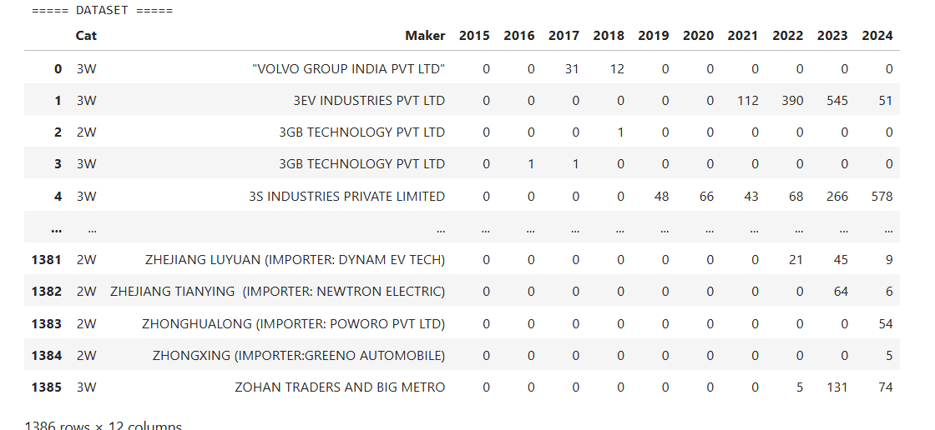
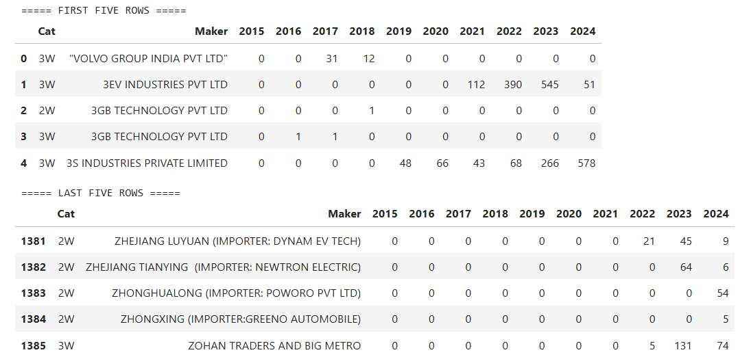
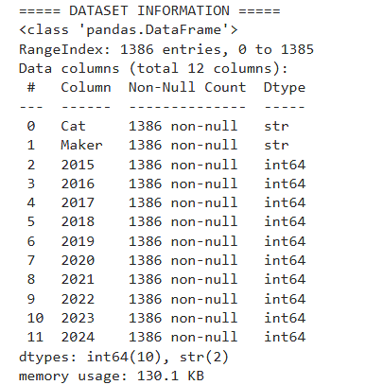
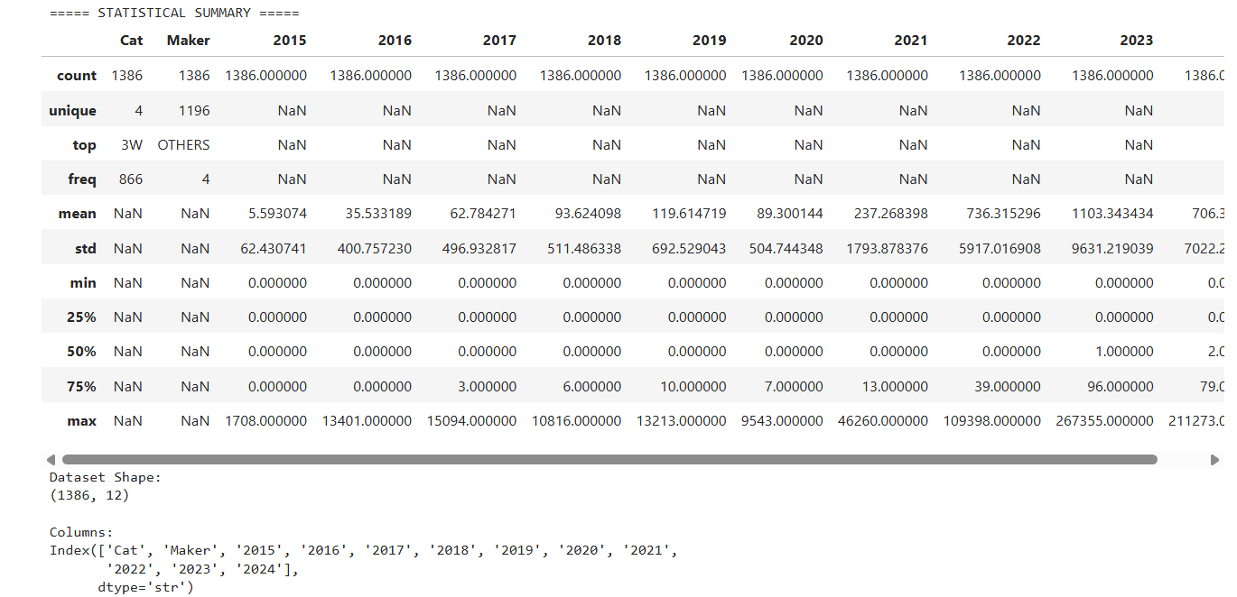
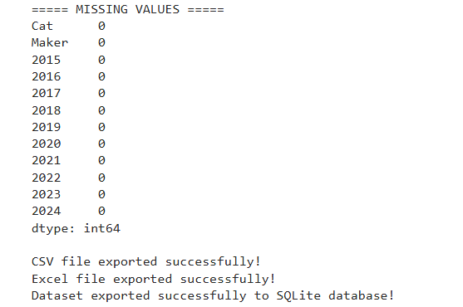
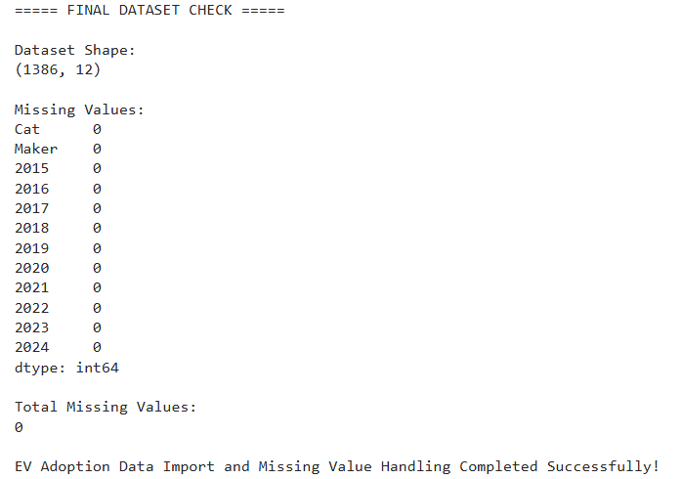v
Result:

