Ex.no:3 | DATA CLEANING

Aim:

Algorithm:
Check Missing Values:
- Start.
- Import the pandas library.
- Load the dataset into a DataFrame (df).
- Display dataset information using df.info().
- Check missing values using df.isnull().
- Count missing values using df.isnull().sum().
- Check missing values using df.isna().
- Check non-missing values using df.notnull().
- Display the results.

Drop Missing Values
- Start.
- Import the pandas library.
- Load the dataset into a DataFrame (df).
- Drop missing rows using dropna().
- Drop rows (axis=0) or columns (axis=1).
- Use how='any' to remove rows/columns containing any missing value.
- Use how='all' to remove rows/columns only if all values are missing.
- Use thresh=N to keep rows/columns with at least N non-missing values.
- Use subset=['column_name'] to drop rows based on specific columns.
- Use inplace=True to modify the original DataFrame.
- Display the cleaned DataFrame.

Program:
# EX NO: 3 - Data Cleaning

import pandas as pd

# Load dataset
df = pd.read_csv("ev_sales_by_makers_and_cat_15-24.csv")

# CHECK MISSING VALUES

print("===== DATASET INFO ====")
df.info()

print("\n===== MISSING VALUES IN EACH COLUMN ====")
print(df.isnull().sum())

print("\n===== TOTAL MISSING VALUES ====")
print(df.isnull().sum().sum())

print("\n===== ANY MISSING VALUES? ====")
print(df.isnull().values.any())

print("\n===== NON-MISSING VALUES COUNT ====")
print(df.notnull().sum())

# FILL MISSING VALUES
# Fill all missing values with 0
df_constant = df.fillna(0)

print("\n===== CONSTANT VALUE ====")
display(df_constant.head())
# Fill '2024' column with mean
df_mean = df.copy()
df_mean["2024"] = df_mean["2024"].fillna(df_mean["2024"].mean())

print("\n===== MEAN ====")
display(df_mean.head())
# Fill '2024' column with median
df_median = df.copy()
df_median["2024"] = df_median["2024"].fillna(df_median["2024"].median())

print("\n===== MEDIAN ====")
display(df_median.head())
# Fill 'Maker' column with mode
df_mode = df.copy()
df_mode["Maker"] = df_mode["Maker"].fillna(df_mode["Maker"].mode()[0])

print("\n===== MODE ====")
display(df_mode.head())
# Forward Fill
df_ffill = df.ffill()
print("\n===== FORWARD FILL ====")
display(df_ffill.head())
# Backward Fill
df_bfill = df.bfill()
print("\n===== BACKWARD FILL ====")
display(df_bfill.head())
# DROP MISSING VALUES
# Drop rows with missing values
df_drop_rows = df.dropna()
print("\n===== DROP ROWS ====")
display(df_drop_rows.head())
# Drop columns with missing values
df_drop_cols = df.dropna(axis=1)
print("\n===== DROP COLUMNS ====")
display(df_drop_cols.head())
# Drop rows having any missing value
df_any = df.dropna(how="any")
print("\n===== DROP HOW='ANY' ====")
display(df_any.head())
# Drop rows where all values are missing
df_all = df.dropna(how="all")
print("\n===== DROP HOW='ALL' ====")
display(df_all.head())
# Keep rows with at least 5 non-null values
df_thresh = df.dropna(thresh=5)
print("\n===== THRESH = 5 ====")
display(df_thresh.head())
# Drop rows where 'Maker' or 'Cat' is missing
df_subset = df.dropna(subset=["Maker", "Cat"])
print("\n===== SUBSET (Maker, Cat) ====")
display(df_subset.head())
# Drop missing values permanently
df_copy = df.copy()
df_copy.dropna(inplace=True)
print("\n===== AFTER inplace=True ====")
display(df_copy.head())

Output:
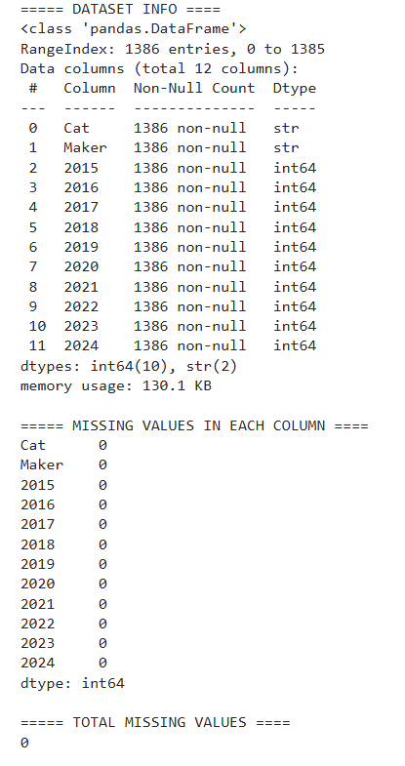
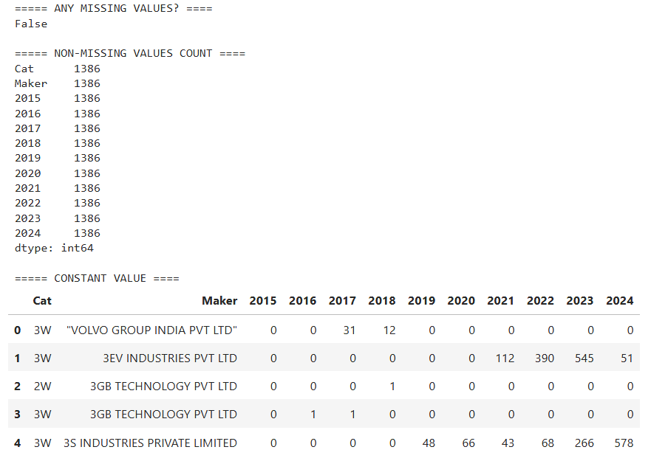

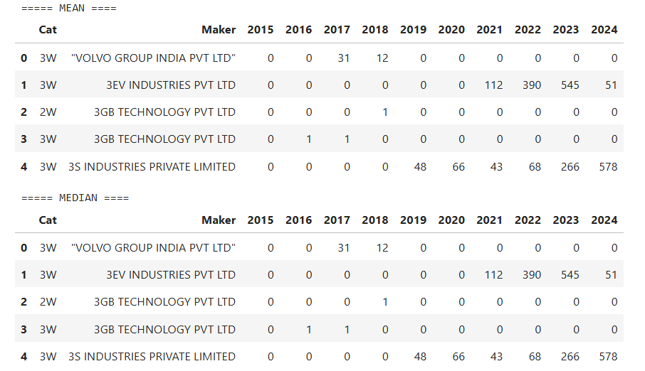
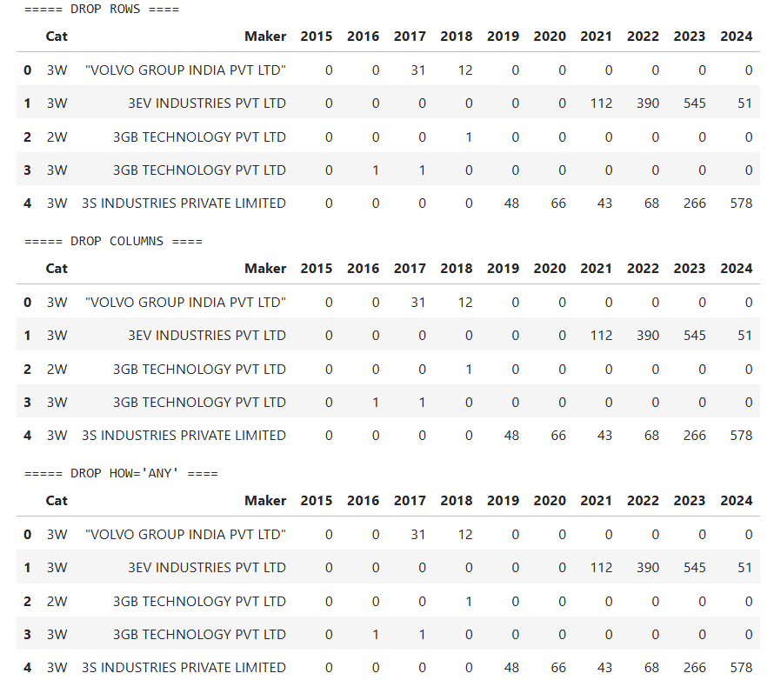

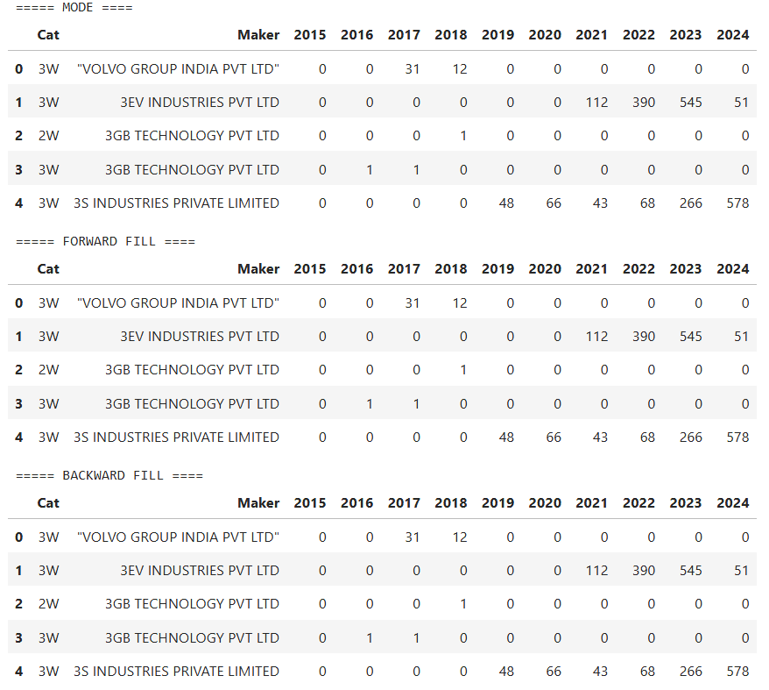

Result:

