Ex.no:5 | DATA VISUALIZATION USING MATPLOTLIB

Aim:
To visualize dataset features and distributions using line charts, bar charts, pie charts, histograms, scatter plots, and box plots using Matplotlib.

ALGORITHM 1: LINE CHART
Objective: To visualize the number of ev sales across different months.
Steps
- Load the ev sales dataset.
- Count the number of bookings for each arrival month.
- Arrange the months in chronological order.
- Plot the monthly booking counts using a line chart.
- Add title and axis labels.
- Display the graph.
Interpretation
The line chart shows how the number of ev sales varies across different months and helps identify booking trends.
years = [
"2015", "2016", "2017", "2018", "2019",
"2020", "2021", "2022", "2023", "2024"
]
yearly_sales = df[years].sum()
plt.figure(figsize=(10,5))
plt.plot(years, yearly_sales, marker='o')
plt.title("Year-wise EV Sales")
plt.xlabel("Year")
plt.ylabel("Number of EV Sales")
plt.xticks(rotation=45)
plt.grid(True)
plt.show()
ALGORITHM 2: BAR CHART
Objective: To compare the number of bookings for different ev types.
Steps
- Select the ev type column.
- Count the number of bookings for each ev type.
- Create a bar chart using the ev types and their booking counts.
- Add title and axis labels.
- Display the chart.
Interpretation
category_sales = df.groupby("Cat")["2024"].sum()
plt.figure(figsize=(7,5))
plt.bar(category_sales.index, category_sales.values)
plt.title("EV Sales by Vehicle Category")
plt.xlabel("Vehicle Category")
plt.ylabel("EV Sales in 2024")
plt.show()

ALGORITHM 3: PIE CHART
Objective: To visualize the distribution of different customer types.
Steps
- Select the customer_type column.
- Count the occurrences of each customer type.
- Calculate their proportions.
- Create a pie chart.
- Display percentage labels.
- Add a suitable title.
Interpretation
category_sales = df.groupby("Cat")["2024"].sum()
plt.figure(figsize=(8,6))
plt.pie(
category_sales.values,
labels=category_sales.index,
autopct='%1.1f%%'
)
plt.title("EV Sales Distribution by Vehicle Category")
plt.show()

ALGORITHM 4: HISTOGRAM
Objective: To visualize the distribution of booking lead time.
Steps
- Select the lead_time column.
- Divide the lead-time values into intervals or bins.
- Create a histogram using Matplotlib.
- Add title and axis labels.
- Display the histogram.
Interpretation
plt.figure(figsize=(8,5))
plt.hist(df["2024"].dropna(), bins=30)
plt.title("Distribution of EV Sales in 2024")
plt.xlabel("EV Sales")
plt.ylabel("Frequency")
plt.show()

ALGORITHM 5: SCATTER PLOT
Objective: To analyze the relationship between lead time and Average Daily Rate (ADR).
Steps
- Select lead_time as the X-axis variable.
- Select adr as the Y-axis variable.
- Plot the observations using a scatter plot.
- Add title and axis labels.
- Display the graph.
Interpretation
The scatter plot helps identify whether there is any visible relationship between how early a customer makes a booking and the Average Daily Rate.
plt.figure(figsize=(8,5))
plt.scatter(
df["2023"],
df["2024"],
alpha=0.3
)
plt.title("EV Sales: 2023 vs 2024")
plt.xlabel("EV Sales in 2023")
plt.ylabel("EV Sales in 2024")
plt.show()

ALGORITHM 6: BOX PLOT
Objective: To visualize the distribution and identify possible outliers in Average Daily Rate.
Steps
- Select the adr column.
- Remove missing values if present.
- Create a box plot using Matplotlib.
- Add a suitable title and axis label.
- Display the plot.
Interpretation
The box plot shows the central distribution of ADR and helps identify unusually high or low ADR values.
plt.figure(figsize=(7,5))
plt.boxplot(df["2024"].dropna())
plt.title("EV Sales in 2024 Box Plot")
plt.ylabel("EV Sales")
plt.show()
ALGORITHM 7: MULTIPLE LINE CHART
Objective: To compare total bookings and cancelled bookings across different months.
Steps
- Count total bookings for each arrival month.
- Count cancelled bookings for each arrival month.
- Arrange both datasets in chronological order.
- Plot total bookings using a line chart.
- Plot cancelled bookings using another line on the same graph.
- Add labels and a legend.
- Display the graph.
Interpretation
The multiple line chart allows comparison of total bookings with cancelled bookings across months and helps identify months with relatively higher cancellation activity.

Output:
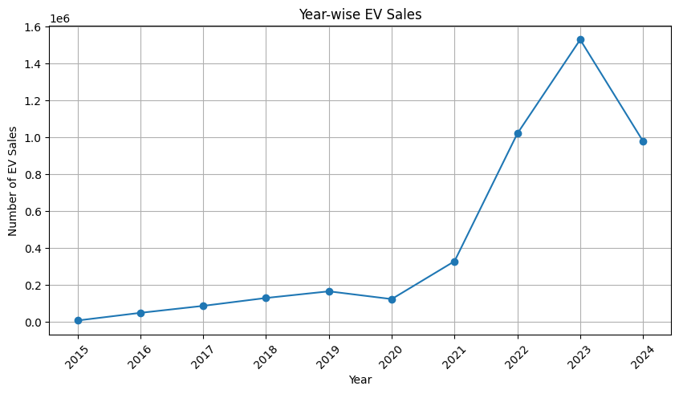
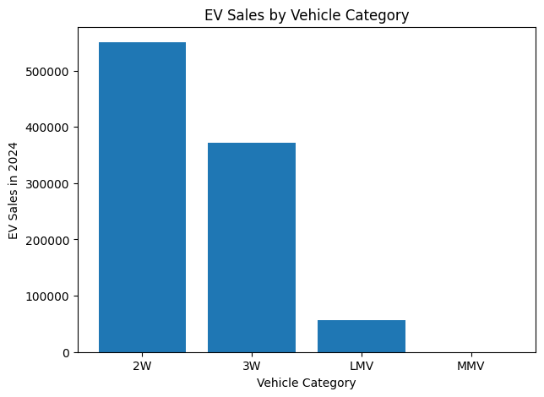
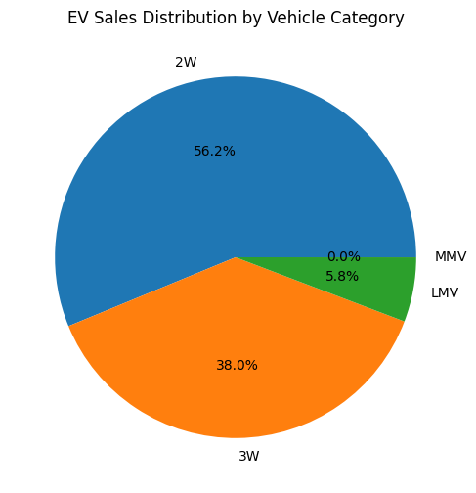
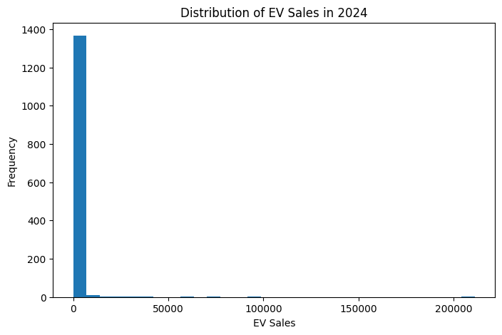
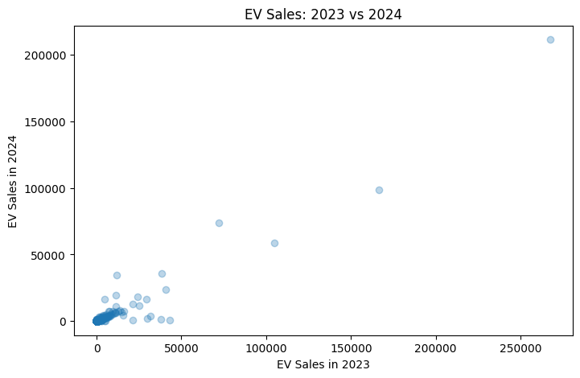
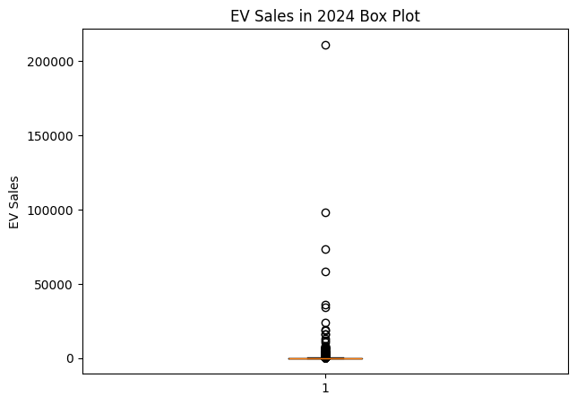
Result:

