Ex.no:4 | EXPLORATORY DATA ANALYSIS (EDA) – DATA INSPECTION, FILTERING, STATISTICAL ANALYSIS AND CORRELATION

Aim:
To perform data inspection, conditional filtering, sorting, statistical summary, group aggregation, correlation analysis, and data visualization on a hotel bookings dataset using Pandas and Matplotlib.

Algorithm:
- Start.
- Import the required Python libraries: pandas and matplotlib.pyplot.
- Load the dataset ev_sales.csv into a pandas DataFrame using pd.read_csv().
- Inspect the basic structure, initial records, shape, column data types, and numerical summaries using df.head(), df.shape, df.dtypes, and df.describe().
- Filter rows based on specific business conditions.
- Sort the dataset by adr in descending order using df.sort_values().
- Compute statistical metrics for adr including mean, median, mode, and standard deviation.
- Group data by ev type and aggregate to find the average adr using df.groupby().
- Calculate the pairwise correlation matrix for numerical features using df.corr().
- Generate a bar plot for average adr by ev type and a scatter plot of lead_time versus adr using Matplotlib.

Program:
import pandas as pd
import matplotlib.pyplot as plt
df = pd.read_csv("ev_sales_by_makers_and_cat_15-24.csv")
print("===== FIRST FIVE RECORDS =====")
display(df.head())
print("\n===== SHAPE OF DATASET =====")
print(df.shape)
print("\n===== DATA TYPES =====")
print(df.dtypes)
print("\n===== SUMMARY =====")
display(df.describe())
print("\n===== EV MAKERS WITH 2024 SALES > 1000 =====")
high_sales = df[df["2024"] > 1000]
display(high_sales.head())
print("\n===== 2-WHEELER EV SALES =====")
two_wheeler = df[df["Cat"] == "2W"]
display(two_wheeler.head())
print("\n===== SORT BY 2024 EV SALES (DESCENDING) =====")
sorted_df = df.sort_values(by="2024", ascending=False)
display(sorted_df.head())
print("\n===== 2024 EV SALES STATISTICS =====")
print("Mean :", df["2024"].mean())
print("Median :", df["2024"].median())
print("Mode :")
print(df["2024"].mode())
print("Standard Deviation :", df["2024"].std())
print("\n===== DESCRIPTIVE STATISTICS =====")
display(df.describe())
print("\n===== AVERAGE 2024 EV SALES BY VEHICLE CATEGORY =====")
category_avg = df.groupby("Cat")["2024"].mean()
display(category_avg)
print("\n===== CORRELATION =====")
corr = df[[
"2015",
"2016",
"2017",
"2018",
"2019",
"2020",
"2021",
"2022",
"2023",
"2024"
]].corr()
display(corr)
category_avg.plot(kind="bar")
plt.title("Average 2024 EV Sales by Vehicle Category")
plt.xlabel("Vehicle Category")
plt.ylabel("Average EV Sales")
plt.show()
plt.figure(figsize=(8,5))
plt.scatter(df["2023"], df["2024"])
plt.title("2023 EV Sales vs 2024 EV Sales")
plt.xlabel("EV Sales in 2023")
plt.ylabel("EV Sales in 2024")
plt.show()

Output:
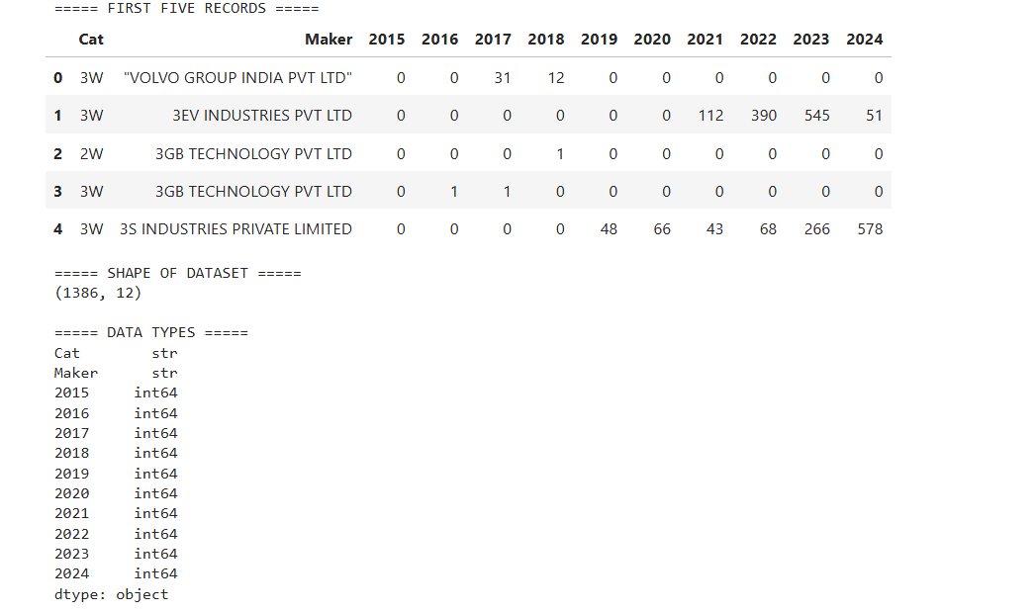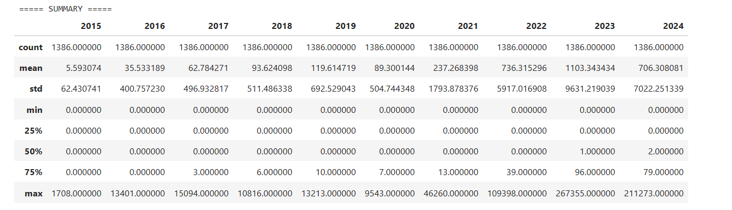

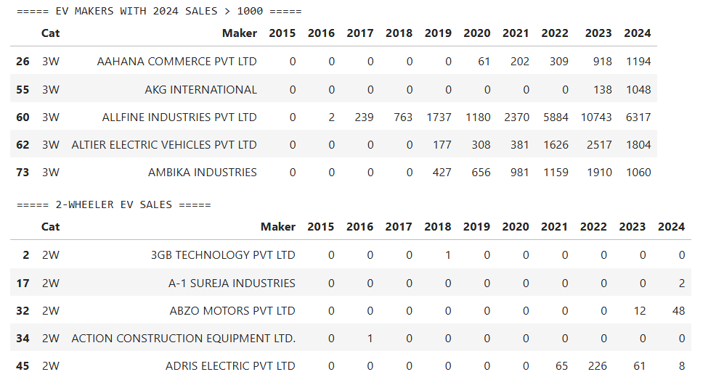
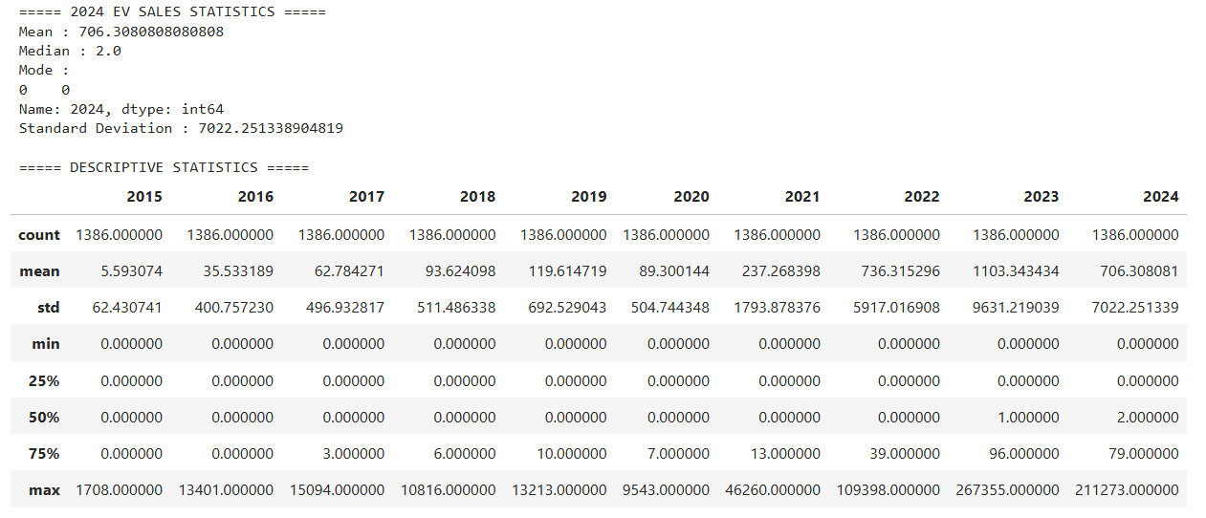
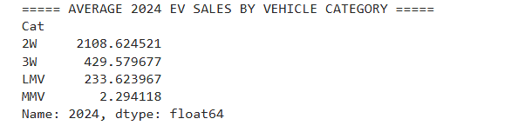
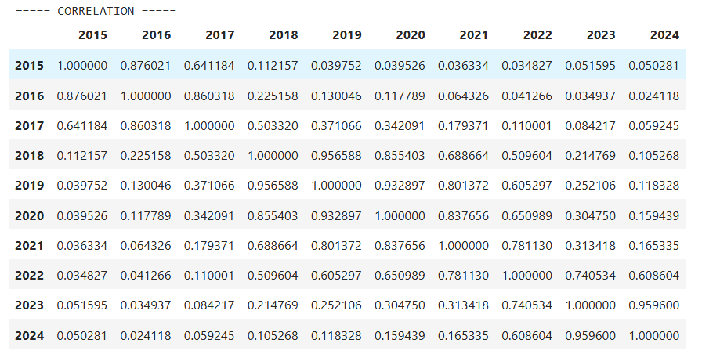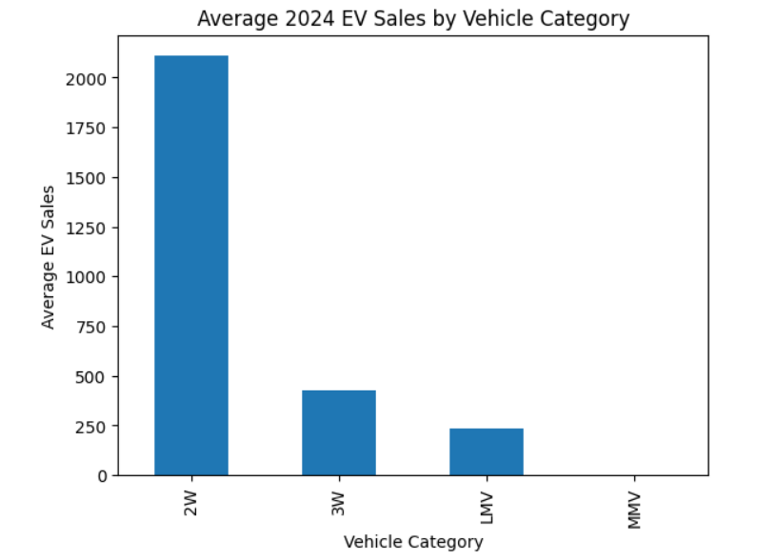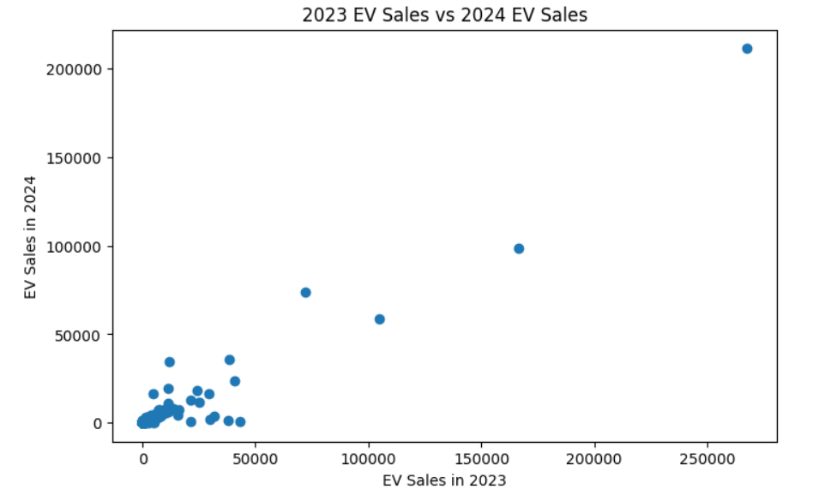
Result:

