EX No:1 | EDA-DATA CLEANING

Aim:
To perform Exploratory Data Analysis (EDA) and data cleaning on the ev sales dataset using standard data science frameworks (CRISP-DM, SEMMA, and KDD) by handling missing values, removing duplicates, creating derived features, and analyzing data patterns.

Algorithm:

- Import pandas, numpy, and matplotlib.pyplot.
- Load ev_sales.csv and inspect dataset structure, missing values, and duplicates.
- Clean data by removing duplicates, dropping the company column, and imputing missing values.
- Convert reservation_status_date to datetime format and engineer new features.
- Plot frequency distributions for key variables and display a correlation matrix heatmap.
- Summarize business insights and end execution.

Program:
import pandas
import matplotlib.pyplot as plt
df=pandas.read_csv("ev_sales_by_makers_and_cat_15-24.csv")
df.head()
df.info()
df.describe()
df.dtypes
df.isnull().sum()
df.duplicated().sum()
df.drop_duplicates(inplace=True)
df.duplicated().sum()
df.isnull().sum().sort_values(ascending=False)
# Fill missing values
df['Maker'] = df['Maker'].fillna(df['Maker'].mode()[0])
df['Cat'] = df['Cat'].fillna(df['Cat'].mode()[0])
df['2024'] = df['2024'].fillna(df['2024'].median())
df['2015'] = pandas.to_numeric(df['2015'], errors='coerce')
df['2016'] = pandas.to_numeric(df['2016'], errors='coerce')
df['2017'] = pandas.to_numeric(df['2017'], errors='coerce')
df['2018'] = pandas.to_numeric(df['2018'], errors='coerce')
df['2019'] = pandas.to_numeric(df['2019'], errors='coerce')
df['2020'] = pandas.to_numeric(df['2020'], errors='coerce')
df['2021'] = pandas.to_numeric(df['2021'], errors='coerce')
df['2022'] = pandas.to_numeric(df['2022'], errors='coerce')
df['2023'] = pandas.to_numeric(df['2023'], errors='coerce')
df['2024'] = pandas.to_numeric(df['2024'], errors='coerce')
df['total_sales'] = (
df['2015'] +
df['2016'] +
df['2017'] +
df['2018'] +
df['2019'] +
df['2020'] +
df['2021'] +
df['2022'] +
df['2023'] +
df['2024']
)
df['average_sales'] = df['total_sales'] / 10
df[['total_sales','average_sales']].head()
df['Cat'].value_counts().plot(kind='bar')
plt.title("EV Vehicle Category")
plt.show()
df.groupby('Cat')['2024'].sum().plot(kind='bar')
plt.title("EV Sales by Category in 2024")
df[['2015','2016','2017','2018','2019','2020','2021','2022','2023','2024']].sum().plot(kind='bar')
plt.title("EV Sales by Year")
plt.show()
df.groupby('Maker')['2024'].sum().sort_values(ascending=False).head(10).plot(kind='bar')
plt.title("Top 10 EV Makers in 2024")
plt.show()
df.groupby('Cat')['total_sales'].sum().plot(kind='bar')
plt.title("Total EV Sales by Category")
plt.show()
plt.hist(df['2024'], bins=30)
plt.title("EV Sales in 2024")
plt.show()
corr = df.select_dtypes(include='number').corr()
plt.imshow(corr)
plt.colorbar()
plt.xticks(range(len(corr.columns)), corr.columns, rotation=90)
plt.yticks(range(len(corr.columns)), corr.columns)
plt.show()
Output:
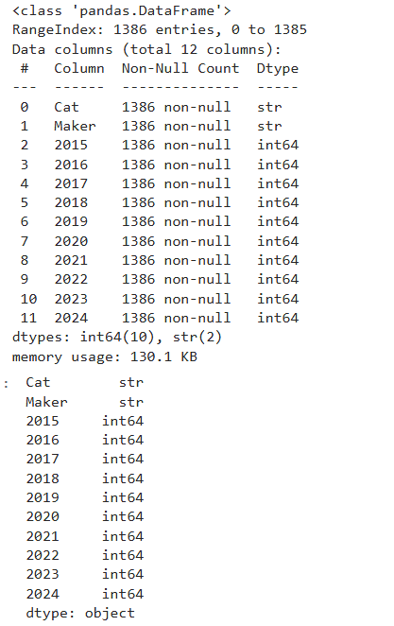
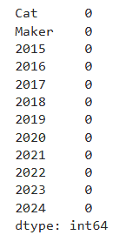
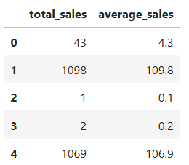
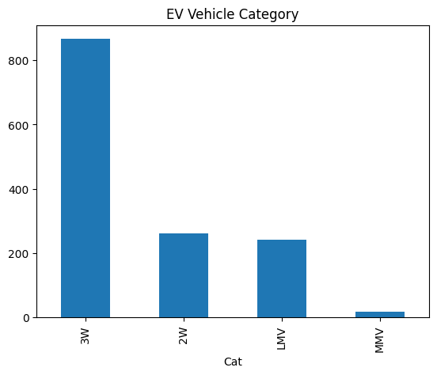
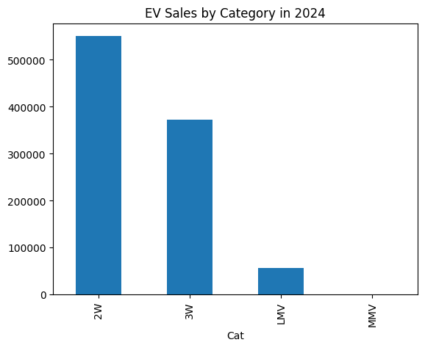
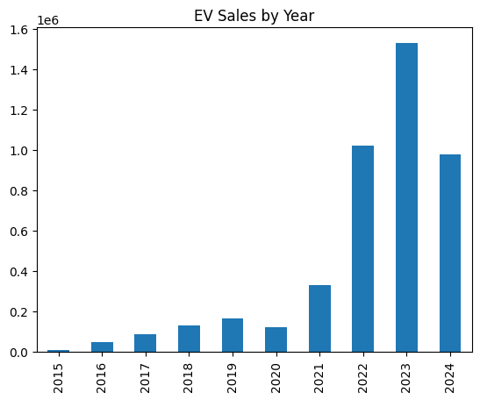
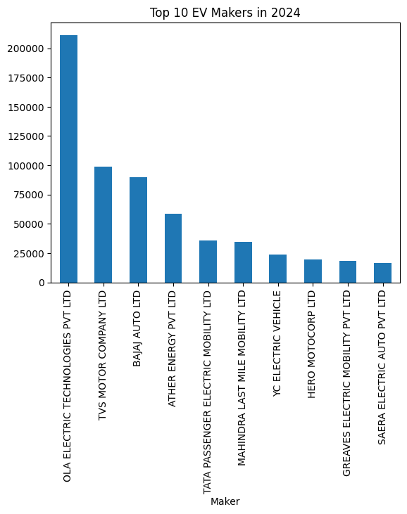
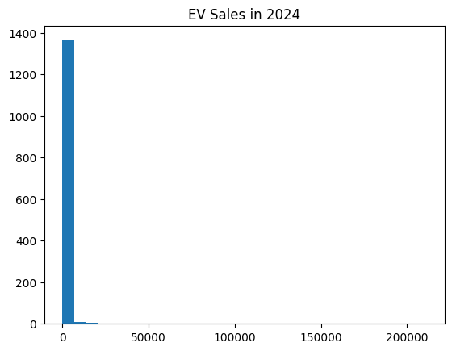
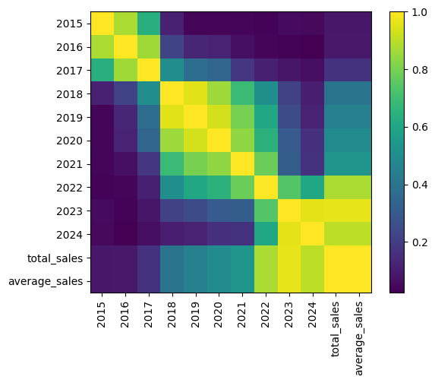
Result:

