Ex.no:6 | DATA VISUALIZATION USING POWER BI (EV Sales)

Aim:
To clean, preprocess, and transform the raw ev_sales dataset, load the clean data model into Power BI, and build an interactive visual dashboard.
Algorithm:
- Import Dataset: Load ev_sales.csv into your environment.
- Deduplication: Identify and delete duplicate rows across all fields
- Drop High-Missing Columns: Remove the company column due to excessive missing/null data.
- Impute Missing Values:
Replace missing values in agent with 0 (or median).
Replace missing values in country with "PRT" (mode).
Handle Data Type & Syntax Errors:
Replace text anomalies (like "NA" strings) in numeric columns with 0 to prevent load errors.
- Load Clean Data: Load the cleaned table into Power BI Desktop via Get Data > Text/CSV (or click Apply & Close from Power Query Editor).

- Create Core Metric:
Right-click the table name $→$ Select New Measure.
Define measure: Total Bookings = COUNTROWS(ev_sales)

Output:
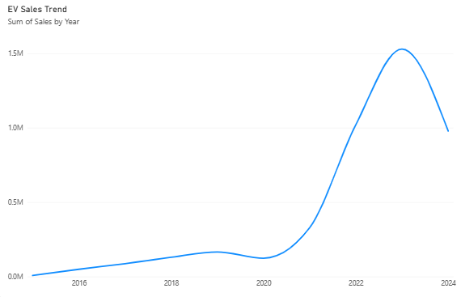

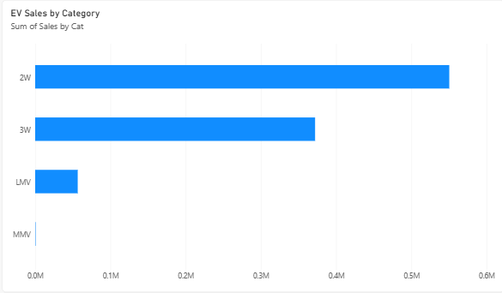

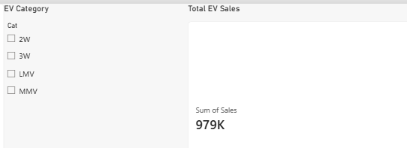

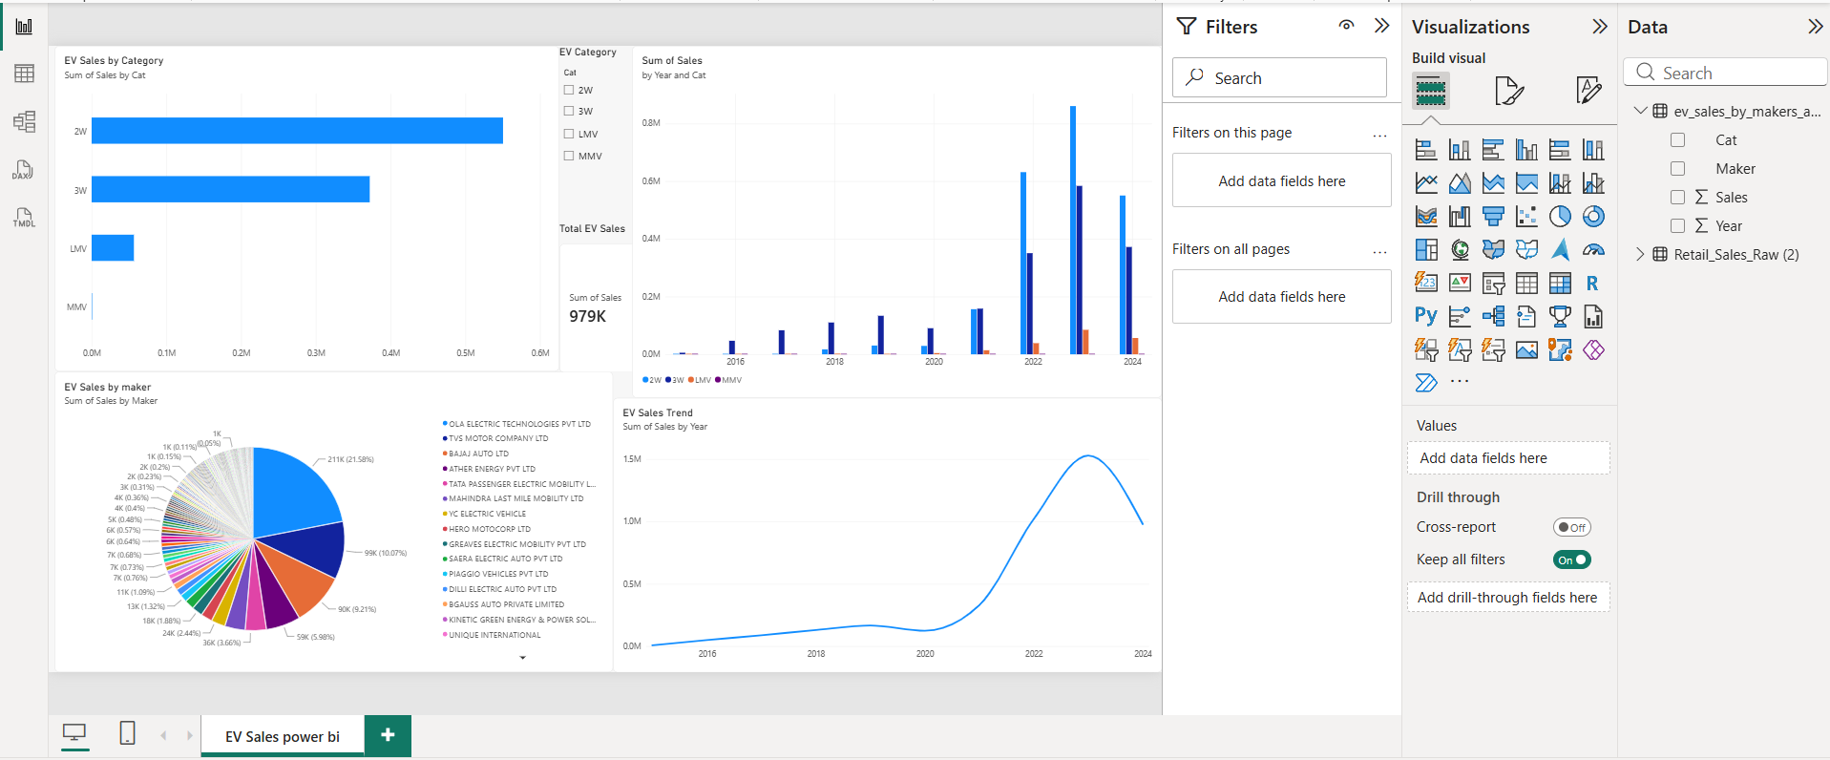

Result:

