参考サイト

<http://blogger.fastriver.net/2014/02/ad-ldaps-ad-cs.html>

openssl使用

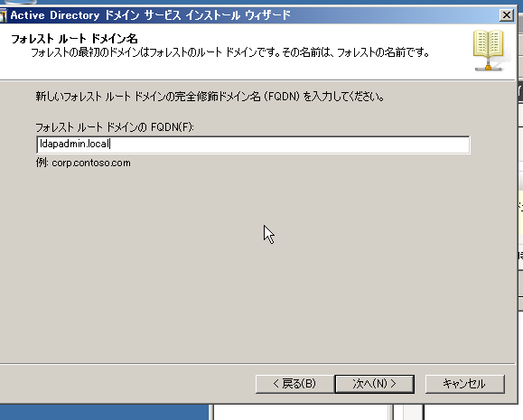

ldapadmin.local

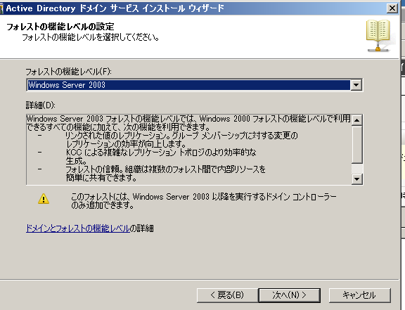

<https://rms-digicert.ne.jp/howto/csr/openssl_csr_wizard.html>

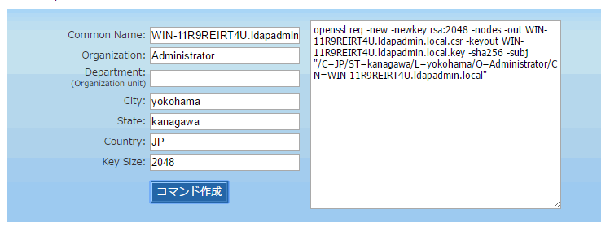

openssl req -new -newkey rsa:2048 -nodes -out WIN-11R9REIRT4U.ldapadmin.local.csr -keyout WIN-11R9REIRT4U.ldapadmin.local.key -sha256 -subj "/C=JP/ST=kanagawa/L=yokohama/O=Administrator/CN=WIN-11R9REIRT4U.ldapadmin.local"

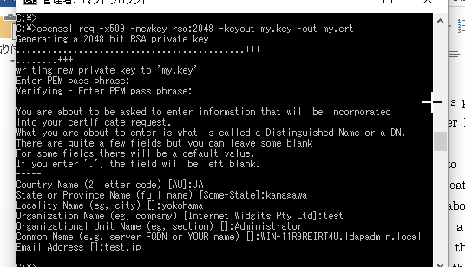

openssl req -x509 -newkey rsa:2048 -keyout my.key -out my.crt

Generating a 2048 bit RSA private key

............................................+++

........+++

writing new private key to 'my.key'

Enter PEM pass phrase:

Verifying - Enter PEM pass phrase:

-----

You are about to be asked to enter information that will be incorporated

into your certificate request.

What you are about to enter is what is called a Distinguished Name or a DN.

There are quite a few fields but you can leave some blank

For some fields there will be a default value,

If you enter '.', the field will be left blank.

-----

Country Name (2 letter code) [AU]:JA

State or Province Name (full name) [Some-State]:kanagawa

Locality Name (eg, city) []:yokohama

Organization Name (eg, company) [Internet Widgits Pty Ltd]:test

Organizational Unit Name (eg, section) []:Administrator

Common Name (e.g. server FQDN or YOUR name) []:WIN-11R9REIRT4U.ldapadmin.local

Email Address []:test.jp

C:\>

＞＞＞＞＞＞＞＞＞＞＞＞＞＞＞＞＞＞＞＞＞＞＞＞＞＞＞＞

openssl pkcs12 -export -out my.p12 -inkey my.key -in my.crt

Enter pass phrase for my.key:

Enter Export Password:

Verifying - Enter Export Password:

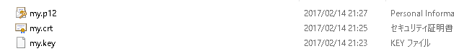

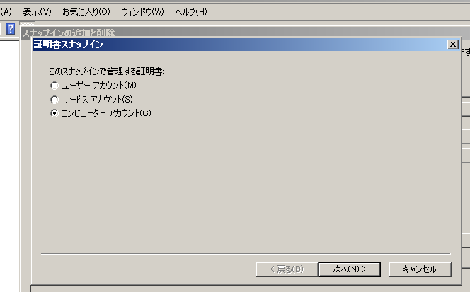

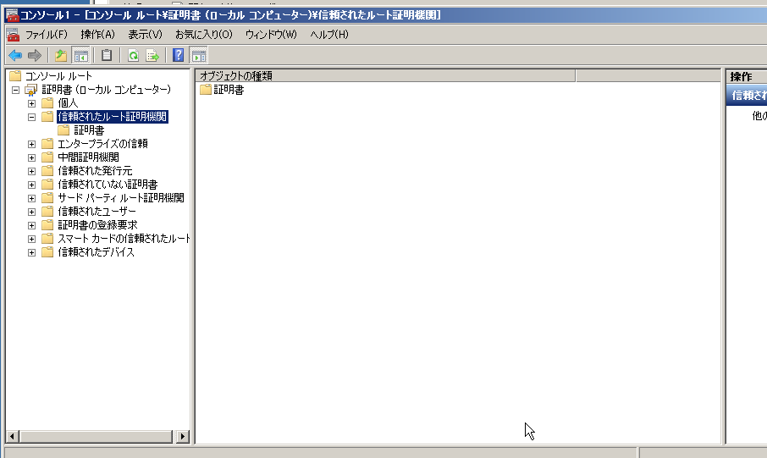

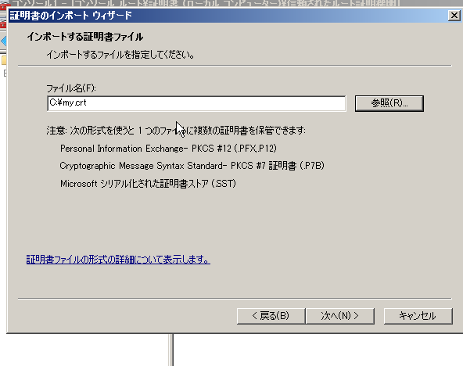

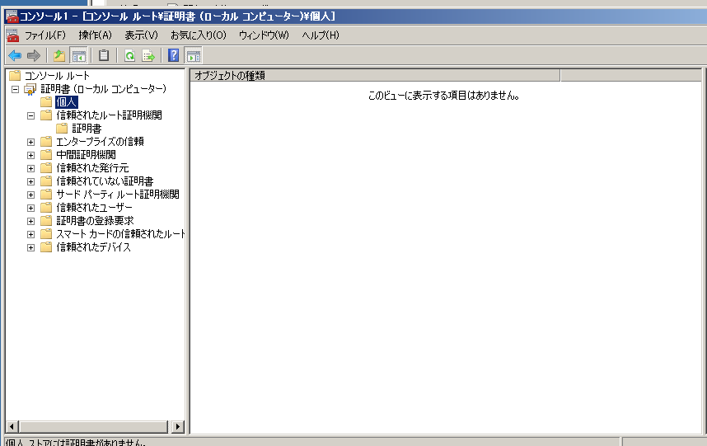

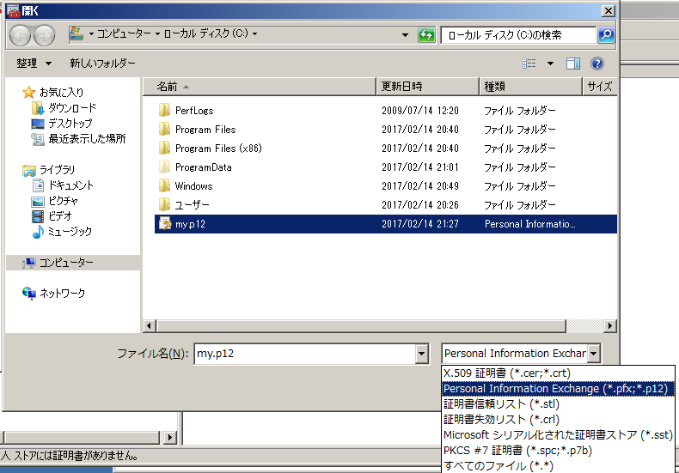

再起動

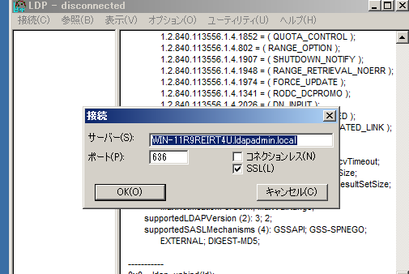

このやり方だとJAVAの認証も行く

WIN-11R9REIRT4U.ldapadmin.local

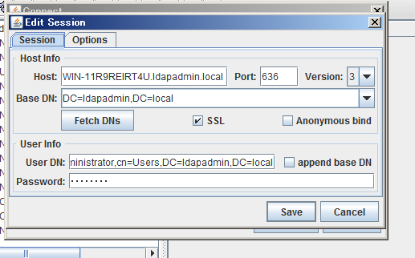

外からもHosts通してやれば見れる

C:\WINDOWS\System32\drivers\etc

