A Leakage-Free Machine-Learning QSAR Panel for Anti-Kinetoplastid Sulfonamides, with Leishmania infantum as the Primary Target
Avin
Affiliation to be added
ABSTRACT
Leishmaniasis and Chagas disease are neglected tropical diseases caused by kinetoplastid parasites for which safer chemotherapies are urgently needed. Sulfonamides are a synthetically tractable scaffold of interest, but public bioactivity data are scarce and heterogeneous, making honest model building difficult. We report a rigorously leakage-free quantitative structure-activity relationship (QSAR) panel for sulfonamide derivatives against four kinetoplastid parasites, with Leishmania infantum as the primary target. Sulfonamide compounds were extracted from ChEMBL and curated into four per-organism datasets (L. infantum, n=142; L. donovani, n=238; Trypanosoma cruzi, n=398; L. amazonensis, n=72). To avoid the optimistic bias that arises when the same molecule appears in both the training and test partitions, all models were evaluated by repeated, scaffold-grouped, activity-stratified cross-validation with feature selection refit inside every fold. A full algorithm panel (logistic regression, SVM, random forest, gradient boosting, XGBoost, LightGBM, and consensus/stacking ensembles) was compared; no ensemble or gradient-boosting method outperformed the best single interpretable model within cross-validation uncertainty. The primary L. infantum model (logistic regression on 12 interpretable Mordred descriptors) achieved a Matthews correlation coefficient of 0.42 ± 0.21 and ROC-AUC of 0.74 ± 0.14, with 98.6% applicability-domain coverage and significant Y-randomization (p=0.02). SHAP analysis revealed largely organism-specific structure-activity relationships. We present these modest but honest results as a reproducible baseline for anti-kinetoplastid sulfonamide discovery.
Keywords: QSAR; sulfonamides; Leishmania infantum; kinetoplastids; scaffold split; data leakage; SHAP; neglected tropical diseases.
1. INTRODUCTION
1.1 Kinetoplastid neglected tropical diseases
The kinetoplastid parasites Leishmania spp. and Trypanosoma cruzi cause leishmaniasis and Chagas disease, together affecting millions of people and disproportionately burdening low-income regions. Visceral leishmaniasis, caused chiefly by L. infantum and L. donovani, is fatal if untreated. Current drugs suffer from toxicity, resistance, and difficult administration, motivating the search for new chemical starting points.
1.2 Sulfonamides and computational discovery
Sulfonamides are a versatile, synthetically accessible pharmacophore with documented antiparasitic activity. Quantitative structure-activity relationship (QSAR) modeling offers a low-cost route to prioritize such compounds. However, QSAR built on aggregated public data is easily over-optimistic: when a random train/test split allows the same compound (or near-identical scaffolds) to appear on both sides, reported metrics no longer reflect prospective performance.
1.3 Objectives
We build and honestly validate a per-organism QSAR panel for sulfonamides against four kinetoplastids, treating L. infantum as the primary target. Our aims are to (i) curate sulfonamide-specific, per-organism datasets; (ii) evaluate a full algorithm panel under a strictly leakage-free scaffold-grouped protocol; (iii) select parsimonious, interpretable final models; and (iv) derive SHAP-based structure-activity relationships. We deliberately report modest, reproducible metrics rather than the inflated values obtainable from leaky splits.
2. MATERIALS AND METHODS
2.1 Data collection and sulfonamide filtering
Bioactivity records (IC50/EC50, nM, relation '=') for L. infantum (CHEMBL612848), L. donovani (CHEMBL367), L. amazonensis (CHEMBL612877), and T. cruzi (CHEMBL368) were retrieved from ChEMBL. Compounds containing a sulfonamide moiety (SMARTS S(=O)(=O)N) were retained. Because these are whole-cell phenotypic assays in which IC50 and EC50 denote the same 50%-effect quantity, the two endpoints were pooled for classification while retaining the endpoint label for auditability.
2.2 Curation
Structures were standardized (largest-fragment selection, charge neutralization, normalization, and tautomer canonicalization). Potency was expressed as pIC50, preferring the ChEMBL pchembl_value where available. Replicate measurements for a compound within an organism were merged to the median when concordant (<1 log-unit spread) and discarded when discordant. Compounds were classified Active at pIC50 >= 5.0 (IC50 <= 10 uM). The data were partitioned by organism into four independent datasets.
2.3 Descriptors and feature selection
Approximately 1,600 Mordred 2D descriptors were computed and cleaned (removing high-missingness and constant columns) to 1,271. Continuous descriptors were preferred over sparse fingerprints for interpretability and to limit overfitting at small sample size. Per organism, a label-free variance and correlation filter produced a candidate pool, from which a stability-selection procedure over cross-validation training folds (mutual information and random-forest importance) selected 12 descriptors.
2.4 Leakage-free evaluation
All models were evaluated with repeated (5x5), scaffold-grouped, activity-stratified cross-validation. Bemis-Murcko scaffolds defined the groups so that no scaffold - and, since each dataset has one row per molecule, no molecule - spanned the training and test folds. Feature scaling and supervised feature selection were refit inside each training fold, so no information from the held-out fold influenced the pipeline. For reference, the earlier random split leaked 28.9% of test molecules into training.
2.5 Model panel and final selection
The panel comprised logistic regression, SVM (RBF), random forest, gradient boosting, XGBoost, LightGBM, a soft-voting consensus, and a logistic-regression-meta stacking ensemble, all with class weighting for imbalance. Hyperparameters were tuned by nested cross-validation. Where the panel tied within one standard deviation, a parsimony rule selected the simplest interpretable model to support transparent SHAP interpretation.
2.6 Interpretation and validation
Model-agnostic SHAP values explained each final model over its 12 descriptors. Applicability domain was assessed by leverage (Williams plot; warning leverage h*=3(p+1)/n), and robustness by Y-randomization (50 label permutations). Analyses used Python 3, RDKit, Mordred, scikit-learn, XGBoost, LightGBM, and SHAP.
3. RESULTS AND DISCUSSION
3.1 Dataset characteristics
Sulfonamide filtering yielded 690 unique molecules distributed across the four organisms. The primary L. infantum dataset (n=142) was perfectly class-balanced (71 active / 71 inactive) and almost entirely IC50-based. T. cruzi (n=398) was the largest and most active-skewed (70%), while L. amazonensis (n=72) was the smallest.
3.2 Model performance
Table 1 reports the honest cross-validated performance of each organism's final model. Metrics are modest but reflect prospective, leakage-free estimates on small datasets. The primary L. infantum logistic-regression model reached MCC 0.42 ± 0.21 and ROC-AUC 0.74 ± 0.14.
Table 1. Final per-organism models and leakage-free performance (mean +/- SD over repeated scaffold-grouped CV).
Organism | n | Active % | Final model | MCC | ROC-AUC | AD % | Y-rand p
L. infantum | 142 | 50.0 | LogReg | 0.42 ± 0.21 | 0.74 ± 0.14 | 98.6 | 0.02
L. donovani | 238 | 45.4 | RandomForest | 0.28 ± 0.24 | 0.70 ± 0.14 | 97.1 | 0.02
T. cruzi | 398 | 70.1 | SVM-RBF | 0.33 ± 0.16 | 0.73 ± 0.10 | 97.5 | 0.02
L. amazonensis | 72 | 47.2 | LogReg | 0.39 ± 0.23 | 0.69 ± 0.11 | 95.8 | 0.02
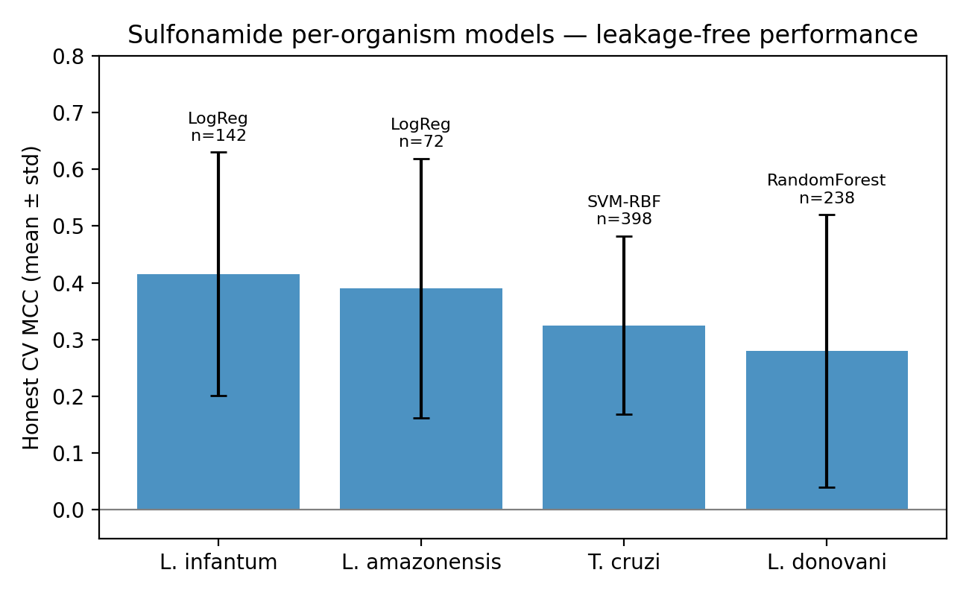
Figure 1. Leakage-free cross-validated MCC (mean +/- SD) for each per-organism sulfonamide model; the final model family and dataset size are annotated.
3.3 No advantage from ensembles or gradient boosting
Across all four organisms, XGBoost and LightGBM performed comparably to random forest and SVM, and the consensus/stacking ensembles did not exceed the best single interpretable model within cross-validation uncertainty. This supports a parsimonious modeling strategy at this data scale and yields cleaner, more defensible interpretation.
3.4 Validation
Applicability-domain coverage ranged from 95.8% to 98.6% of compounds (Figure 2). In Y-randomization, real models substantially exceeded the permuted-label distribution (p=0.02 for every organism), confirming that the models capture genuine signal rather than chance correlations.
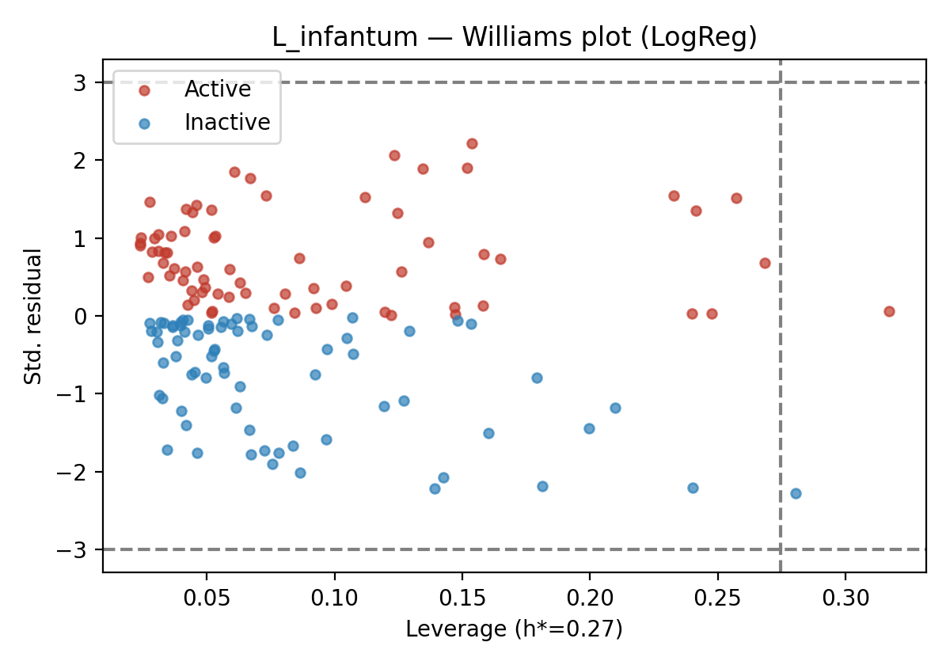
Figure 2. Williams plot for the L. infantum model: leverage vs standardized residuals; nearly all compounds fall within the applicability domain.
3.5 Structure-activity relationships (L. infantum)
SHAP analysis of the primary model highlighted atomic-number-weighted autocorrelation and partial-charge descriptors (AATS4Z, ATS5Z, ATS4Z, BCUTc-1l, PEOE_VSA2, AETA_eta) as the leading drivers (Figure 3). Grounding these against the data, active compounds tend to be larger and heavier (higher Z-weighted autocorrelation) and less dominated by specific polar surface area, whereas halogen (Cl/Br) content did not distinguish actives from inactives. The relationships are trends that can guide design rather than deterministic rules.
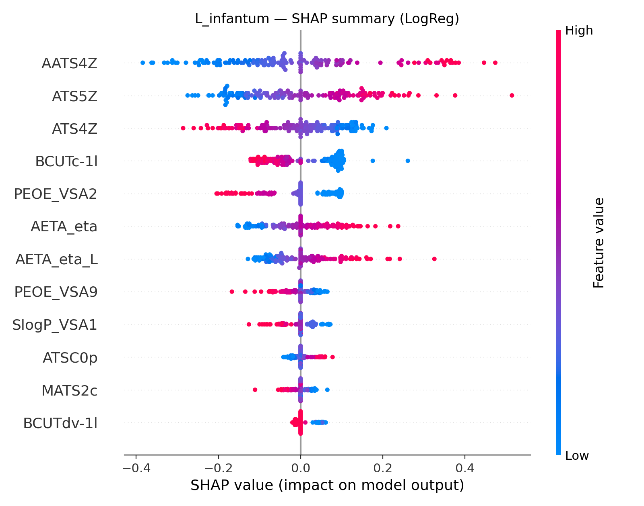
Figure 3. SHAP summary (beeswarm) for the L. infantum model over its 12 descriptors; each point is a compound, colored by descriptor value.
3.6 Cross-species structure-activity relationships
Comparing SHAP importances across organisms showed that the descriptor drivers are largely organism-specific: only one descriptor (PEOE_VSA9) ranked among the top contributors for more than one organism (L. infantum and T. cruzi). This heterogeneity is consistent with distinct parasite biology and provides direct justification for per-organism modeling over a single pooled classifier.
3.7 Limitations
The datasets are small (72-398 compounds), so confidence intervals on the metrics are wide and the abstract descriptors offer interpretive rather than mechanistic explanations. Activity is a binary threshold on pooled IC50/EC50 phenotypic data. These honest constraints should temper any prospective claims.
4. CONCLUSIONS AND FUTURE WORK
We present a reproducible, leakage-free QSAR panel for anti-kinetoplastid sulfonamides with L. infantum as the primary target. Under an honest scaffold-grouped protocol, simple interpretable models matched a full algorithm panel, achieving modest but trustworthy performance with strong applicability-domain coverage and significant Y-randomization. SHAP analysis indicates organism-specific structure-activity relationships. Future work will apply these models to prospective virtual screening of commercial libraries with applicability-domain filtering, followed by experimental validation of prioritized sulfonamides.
REFERENCES
[1] World Health Organization. Leishmaniasis fact sheet. WHO, Geneva.
[2] Gaulton, A. et al. The ChEMBL database. Nucleic Acids Res.
[3] Moriwaki, H. et al. Mordred: a molecular descriptor calculator. J. Cheminform.
[4] Bemis, G. W.; Murcko, M. A. The properties of known drugs. 1. Molecular frameworks. J. Med. Chem.
[5] Pedregosa, F. et al. Scikit-learn: Machine Learning in Python. JMLR.
[6] Lundberg, S. M.; Lee, S.-I. A unified approach to interpreting model predictions (SHAP). NeurIPS.
[7] Sheridan, R. P. Time-split cross-validation as a method for estimating the goodness of prospective prediction. J. Chem. Inf. Model.
[8] Landrum, G. A.; Riniker, S. Combining IC50 or Ki values from different sources is a source of significant noise. J. Chem. Inf. Model. 2024.

