Sql - Basics

- Creating Database: The CREATE DATABASE statement is used to create a new database to store your tables and data.
Query: CREATE DATABASE IF NOT EXISTS database_name;

- Creating Tables: The CREATE TABLE statement is used to create a new table in the database by defining column names and their data types.
Query:
CREATE TABEL table_name (
Column_name datatype constraint (id INT AUTO_INCREMENT PRIMARY KEY)
)
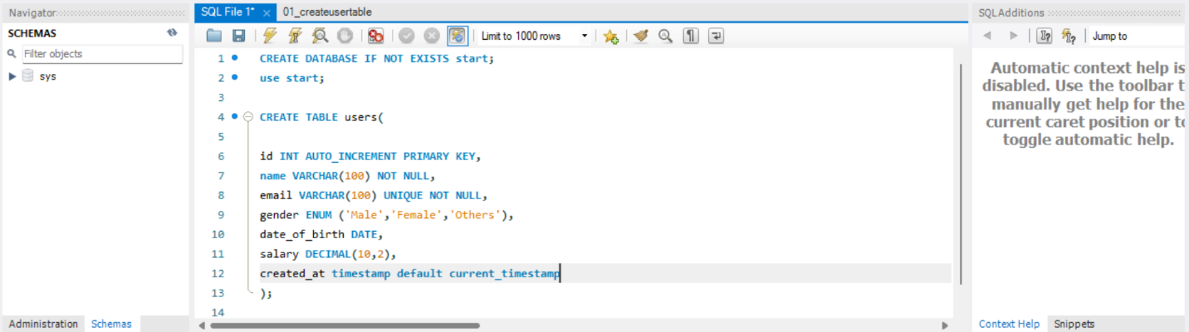

- Inserting Data into Tables
The INSERT INTO statement adds new records (rows) into a table.
We can insert data into all columns or specify particular ones.

Query: INSERT INTO users (name, email, gender, date_of_birth, salary) VALUES
(‘Pirthavi’, ‘pirthavi@gmail.com’, ‘Male’, ‘1997-08-01’, 60000);
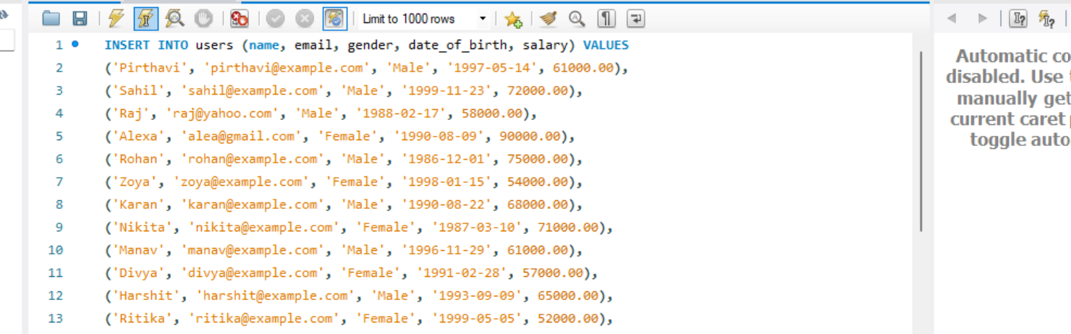

- SELECT
The SELECT statement is used to fetch data from one or more tables in a database.
It defines what columns you want to see in the result.

Query: SELECT * FROM users;
Query: SELECT email, gender FROM users;

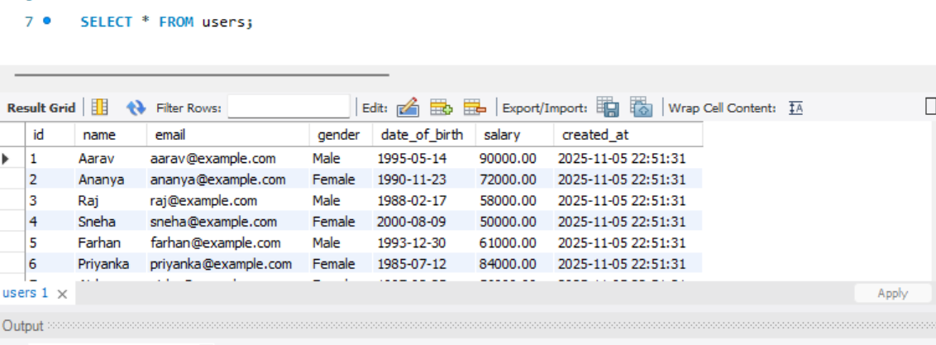

- WHERE:
The WHERE clause is used to filter records that meet specific conditions.
It helps you retrieve only the rows that satisfy a given condition.

Query: SELECT * FROM users WHERE gender = ‘Male’;
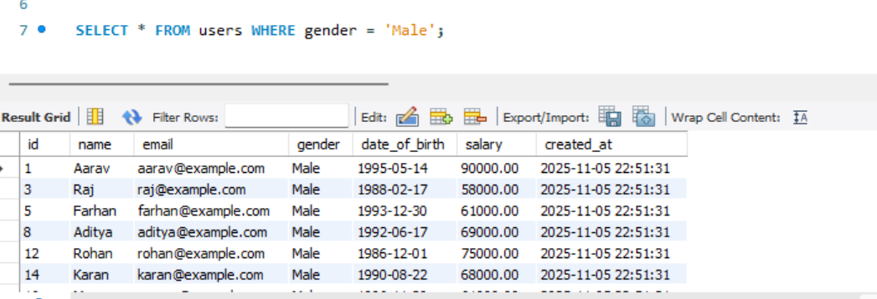

- AND / OR
- The AND and OR operators combine multiple conditions in a WHERE clause.
- AND returns records only if all conditions are true.
- OR returns records if at least one condition is true.
Query: SELECT * FROM users WHERE gender = ‘Male’ AND salary <60000;
Query: SELECT * FROM users WHERE gender = ‘Male’ OR salary <60000;
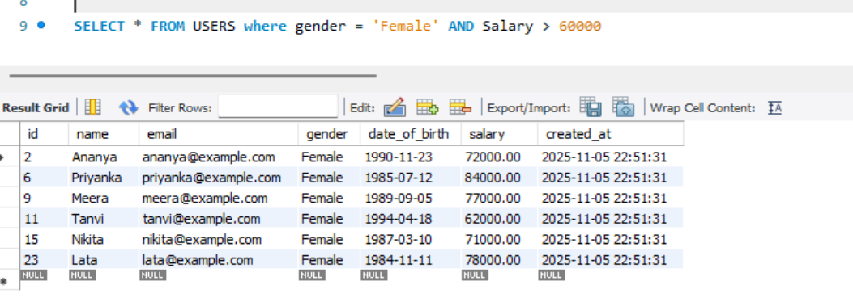
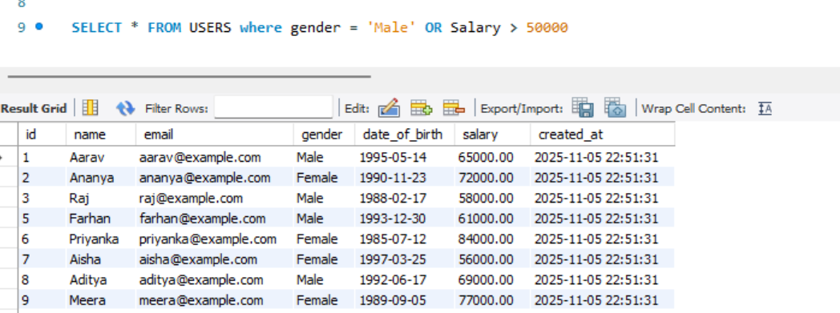
- ORDER BY
The ORDER BY clause is used to sort the result set in ascending (ASC) or descending (DESC) order based on one or more columns.
Query: SELECT * FROM users WHERE gender = ‘female’ OR salary > 50000 ORDER BY
date_of_birth DESC/ASC;
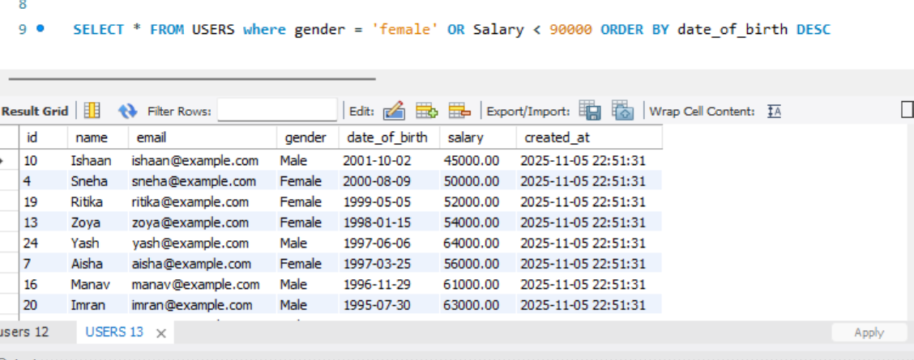
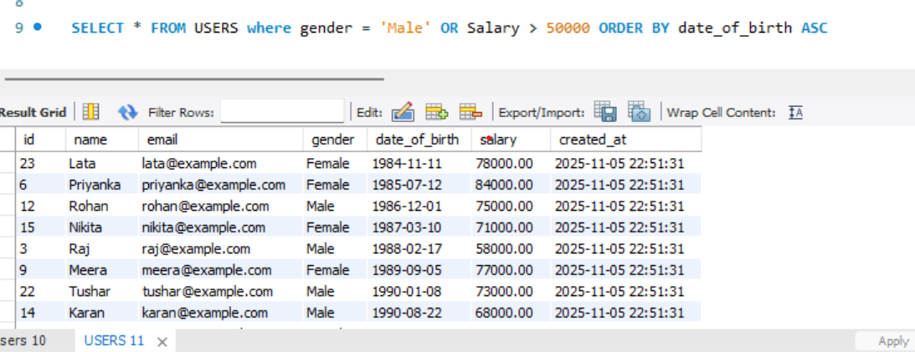

- LIMIT
The LIMIT clause restricts the number of rows returned by a query.
It’s often used to view only a small subset of results.

Query: SELECT * FROM users WHERE gender = ‘female’ OR salary > 50000 ORDER BY
date_of_birth DESC/ASC LIMIT 2;

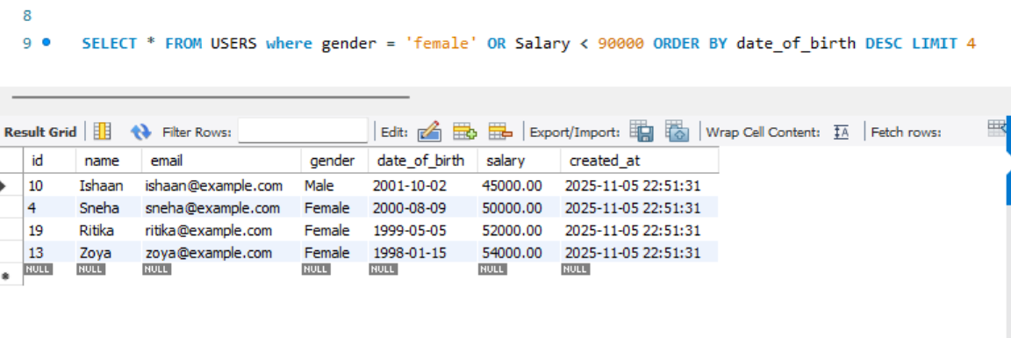
- IN
The IN operator is used to match a column against multiple possible values in a single query.
It works like multiple OR conditions.

Query: SELECT * FROM users WHERE gender IN (‘Male’, ‘Female’);
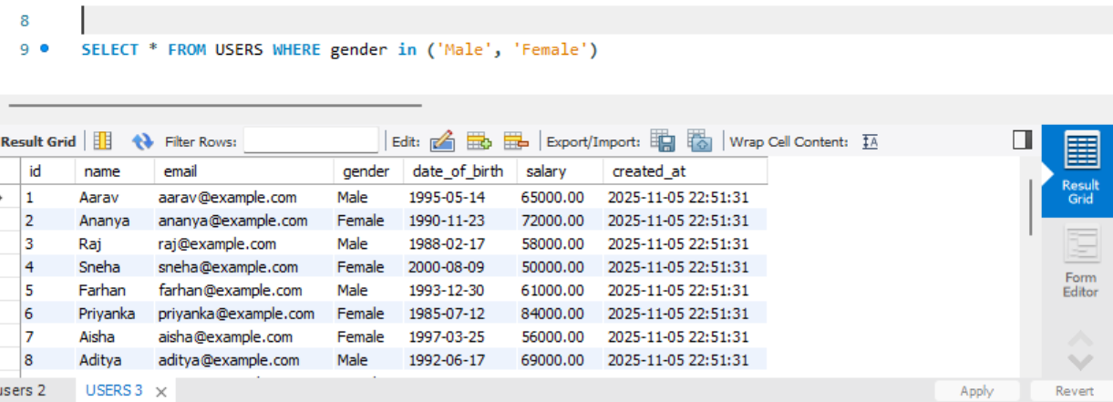

- BETWEEN
The BETWEEN operator is used to filter results within a range of values (inclusive).
It can be used with numbers, text, or dates.

Query: SELECT * FROM users WHERE date_of_birth BETWEEN ‘1995-01-01’ AND ‘2003-01-01’;

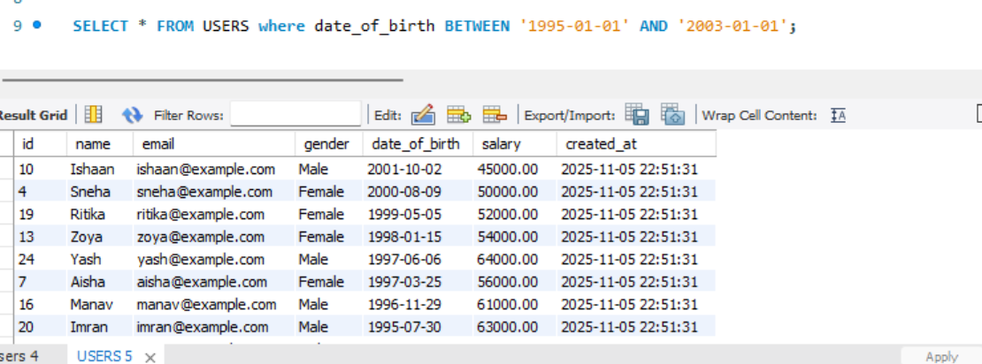

- SQL Query execution order

Here is the typical order of execution in SQL:
- FROM and/or JOIN clause. (Identify the tables to retrieve data from. Joins are processed here, Combine data from multiple tables.)
- WHERE clause. (Filter rows based on conditions.)
- GROUP BY clause. (Group rows that have the same values in specified columns.)
- HAVING clause. (Filter groups created by GROUP BY.)
- SELECT statement. (Choose which columns or expressions to display.)
- DISTINCT clause. (Remove duplicate rows (if specified).)
- ORDER BY clause. (Sort the results.)
- LIMIT and/or OFFSET clause. (Return only a subset of rows.)

Query:
SELECT department, COUNT(*) AS total_employees
FROM employees
WHERE salary > 50000
GROUP BY department
HAVING COUNT(*) > 5
ORDER BY total_employees DESC
LIMIT 10;

