Saurabh Pisal

Department of Information Technology and Management,

Illinois Institute of Technology  
+1 312 8047225, IL, 60616

spisal@hawk.iit.edu

# ABSTRACT

## When an IT organization devises N number of services, not all services are used by their clients. The client can only view the service catalogue. But whenever services are created and kept in as service portfolios a charter is always kept in order if ever the service wants to go live.

## When a service is used by the clients, what are the fallbacks or rather what are the metrics that the clients, as well as the service owner, use in order to trace its health, availability and reliability?

## The completion and the value of the service here are measured and managed through Service Level Management (SLM) process.

## The main intention of SLM process is to guarantee that the agreed Services Level Agreements implemented in all current Information Technology services and the one developing in the future are delivered to an agreed achievable target.

**Keywords**

## Service Level Agreement, Service portfolios, Service Level Management, Service Design, Business process,

# OVERVIEW

# How the SLA’s will be implemented with the management tools. How to improve Service Level Management Best practices

# Introduction

## In Service Design there are many aspects that deal with the management of the services but one of the crucial aspects is Service Level Management.

## The main objective of SLM is to design and manage meaningful and measurable metrics which cover service performance that is directly related to the business process and IT services of the Business process of customer.

## The SLM covers everything from disclaimers on what the organization will be responsible for and what it won’t be. SLM will define the stages any SLA of the services will go through in order to maintain its reliability and availability as well as keeping in mind what it will cost to the service provider if ever the services are going down. SLM will cover negotiations between businesses the agreements, contracts and implications.

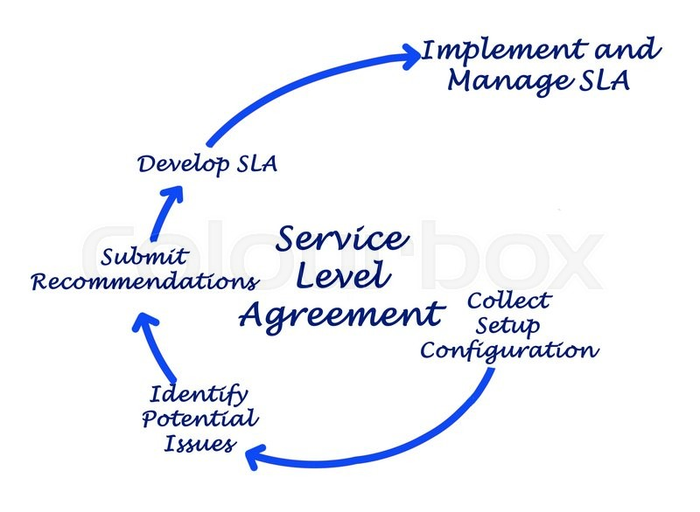

As shown in the diagram above, the SLA under goes above 5 stages as per the Service Level Management guidelines.

## Improving Service Level Management Practices

## The best practices that are followed currently in any IT service provider organization keeping in mind the infrastructure available, the support system to run that business, networking, databases. Everything is made sure is designed to meet the and support business Service Level Agreement. Secondly, SLA’s are written from the business perspective. No extra commitments than what can be provided [1].

## But all this doesn’t make the SLM robust. In order to make it robust new Practices need to be introduced. A model should be developed which should contain these new phases [1].

## Form Process Improvement infrastructure

## Development can be done by advancing the organizations' service level management practice based on ITIL. Consequently, study how the ITMS tool sustains the SLM management process. [1]

## Alerts should be configured on organizations IT service management tool keeping into mind the matrix of Service Level Agreement agreed upon between the customer and the IT service provider [1].

## An SLA module/matrix would help in visualizing the real improvement aspects, which would further help both the organization as well as the service provider to make adjust SLA negotiations in coming renewal periods. [1]

## Plot process improvement actions

## The process improvement actions can be planned according to the outcomes of the process improvement infrastructure phase. In this phase we can focus on configuring the SLA towards develop SLA rules for incidents on SLA requirements for response, resolution of incoming issues.

## Study the patter of incoming SLA breaches and make amendments required in the SLA renewal phase [1].

## Another important step towards improving the process is by making the IT service organization of the SLA’s, train the employees to be aware of how their inputs will affect the SLA’s and combined several teams in the organization how it will affect the business and the organization [1].

## Deploy & Evaluate process improvement

## This is the testing phase of any Service from the service catalogue where different instances of SLA template are applied, and the effectiveness of the SLA adherence is calculated. Depending upon the reaction and the resolution time additional changes are introduced in the Service or rather changes are made on the SLA which ever is more cost effective and negotiable [1]

## Before deploying the SLA, training sessions should be conducted in the IT service organization providing the Services. A monitoring tool should be kept observing how the SLM is taken care of and what are the metrics generated for the current service under observation. Additionally, the tool could further be used by the management of the organization to make an analysis on resources and infrastructure requirement [1]

**An Adaptive Service Level Management**

## The adaptive service level management is a method to endure client expectations. It involves certain heuristics and proactively monitors market changes to allow for optimal decision-making despite conjecture. [2]

## The Quality service requirement changes from time to time and in order to maintain such plots we cannot have one distinct contract or SLA defined in SLM. At times the SLA’s need to be changing according to the needs and the situations as required in the business requirement made by the client.

## The difficulty comes in when we need to integrate newer technology into existing services. From Service Level Management perspective for seeing changes and making amendments accordingly are highly recommended as it will help in delivering high quality, seamless and cost-effective service.

## Based on Facts and Data, changes in the SLA is possible. But this Adaptive SLM cannot be implemented on all levels of SLA. It can be implemented within the organization in OLA or in SLA with customers where the period maintaining the SLA can be altered. The diagram above depicts key elements of an Adaptive SLM system [3].

**Infrastructure improvement in Service Level Management: Dynamic infrastructure allocation**

## Sustaining the quality of service is very significant and a critical aspect of any IT service provider industry. In order to manage the quality of the service, there should be equally highly equipped technology accessible to the organization. In case the service requires 95% of SLA and due to organizational infrastructure capacity issue, the service abandons and recovery time takes more than ETA, it will have adverse effects on the service provider and the Business that will be using the services.

## This brings us to the most fundamental aspect of maintaining any SLA, i.e. Capacity Management.

## Resource obligated to maintain the Quality of Service specified in the SLA every organization needs to have Infrastructure that prioritizes services. Depending upon the priority of the service the infrastructure should be allocated automatically i.e. dynamic allocation of resources and infrastructure. [3]

## Depending upon the load, the dynamic allocation should also take place in order to maintain the request for service but there should be no SLA violations due to unavailability of resources and infrastructure. Hence, dynamically designating resource and infrastructure would help in handling all service requests of the service request and SLA’s won't be affected

**REFERENCES**

[1] M. Jäntti and A. Suhonen, "Improving Service Level Management Practices: A Case Study in an IT Service Provider Organization," *2012 IIAI International Conference on Advanced Applied Informatics*, Fukuoka, 2012, pp.139-144. doi: 10.1109/IIAI-AAI.2012.36

[2] M. C. Hsueh, "Adaptive Service Level Management," 11th IEEE International Enterprise Distributed Object Computing Conference (EDOC 2007), Annapolis, MD, 2007, pp. 451-451.  
doi: 10.1109/EDOC.2007.30

[3] S. Nakadai and K. Taniguchi, "Server Capacity Planning with Priority Allocation for Service Level Management in Heterogeneous Server Clusters," 2007 10th IFIP/IEEE International Symposium on Integrated Network Management, Munich, 2007, pp. 753-756.  
doi: 10.1109/INM.2007.374705