Saurabh Pisal

Department of Information Technology and Management,

Illinois Institute of Technology  
+1 312 8047225, IL, 60616

spisal@hawk.iit.edu

**ABSTRACT**

# The main goal of any IT organization before it becomes an organization is to gather proper capital for creating its company. The ultimate aim of any head of a company is to make a company that makes profit in the end.

# For an IT organization, the organization may be a service provider in our case. A service provider IT organization wants to make profit in every service they provide to their Clients or the Customers. What does the customer or the client use from these organizations? Well, an IT organization will provide their clients or the customers with various services.

# The ultimate aim of these service providers is to provide the best of the IT services at the lowest prices. Biggest challenge for most of the IT managers and IT service provider companies is how to implement the same; how to make profit from the services and even offer it at the best prices so that it doesn’t cost directly or indirectly too much for any IT organization.

**Keywords**

# Service Strategy, Financial Management, Capital, operational, ITIL, Artificial Intelligence, Distributed Storage.

# OVERVIEW

# Any organization which has an IT to help support its services or provides IT services to its clients need to consider their business goals or business strategy before considering what IT strategies they need to implement.

# When these IT strategies have been thought of then we can decide on the other aspects of service strategies such as Financial management in our case. There are various other Aspects that need to be considered for creating any service strategy, but Financial management is the base of any Service Strategy.

# Introduction

## In ITIL, Financial management is Financial Management for IT services in ITIL Service Strategy. What is Financial Management? Financial Management is set of Management aspects considered before taking building any strategic service considering the cost behind its creation.

## Money, human resources and time is what comes into picture before building any strategy as far as finance for its creation is concerned. There are substitutes for Human resources and time, as they are directly proportional and indirectly proportional to each other depending upon its utilization, but money cannot be replaced with anything else. Hence, financial Management is very important in creating service strategy.

## Predicting the Finance required for building services, how much would it cost for come up with new services improve them or even continuing with the same services, is what the company should be able to figure out. Figuring out how much money is required in order to use it effectively so that it will help in accordance with the aim of the service and not going into a loss.

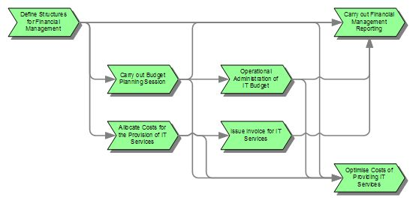

The above figure explains how a financial Management is carried out considering the Budget required, the Accounting which has Direct and Indirect cost, capital and operational cost, fixed cost and variable cost, cost types and cost elements, and Charging which deals with how to charge a customer in order for the company to stay in competition and even earn profit, having a strategic move in order to fit the role.

Financial Management provides Operational Visibility, insights into the cost of a service such as service support and service delivery, and Superior decision making on where exactly we need to spend.

**Artificial Intelligence Management in Financial Management**

## This will come into picture when we are dealing with cost type in Financial Management. A cost type comes into picture when we have hardware, software and other infrastructure related issue which need to be managed in order to save cost to company. When low skill worker is present in abundance we can avoid automation, have a budget for automation but at times we require high skilled workers which charge more. Instead we can replace it with automation and save money. As stated in the paper the role of Artificial Intelligence plays a very important role in Managing the finance of the company.

## How Artificial Intelligence is helping in Financial management is by replacing the human resource required to do a particular work in the company. Creating automations will even reduce the operational cost such a license the yearly software’s used during the service delivery.

## Financial management and its analysis with the help of Artificial Intelligence and its management has help the company in depicting the valid financial position or rather the status of the company [1].

## Below is how an Artificial Intelligence can be used in Financial management, an example of the pipeline [1].

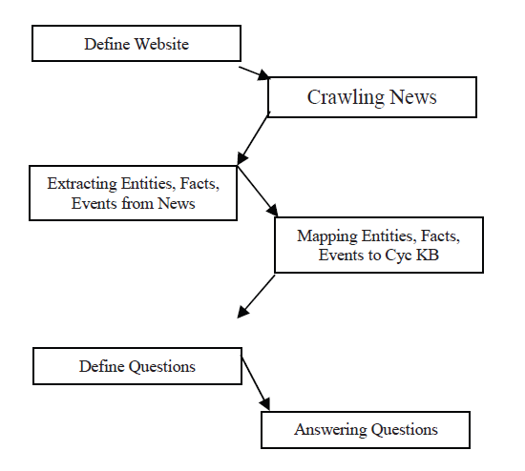

**Having Distributed Storage Technology**

In financial Management we need to take care of Accounting. What is accounting, well account is taking care of what are we spending on and the priorities on the spend. If it is required or not, whether something can be saved in it directly or indirectly or not. Saving in capital cost and operational cost.

**Operational Cost**: Software Licenses for software’s used for running processes that are required for the strategic service we have in picture of the company. The benefit from this operational cost is going to be short term but is important. This operational cost can be recovered from the customers during the charging period.

**Capital cost:** Here in Capital cost we spend on something right now for making the services better and the profit in this investment will come up later in the future. For example, office, data centers all this is required. The benefit from all of this will come over a period of time. Capital cost can be avoided by spending in small chunks and not spending in together and invest the same saved capital in modification of the service or creation of new services. This is where having a distributed storage technology comes into picture and can be used for saving money like a one-time investment from having a singe Storage technology.

Investing in Distributed Storage technologies will be more beneficial than having a capital investment in a single storage technology and having it at a single place which doesn’t consider the threats. A distributed storage technology will help in reducing the capital as well as operational cost by not having own servers to main and even now having human resource t recruit to take care of the servers. This can be completely given to the third party to take care of the services and thus producing outsourcing for storage technologies. Negotiations can be done in such cases to make contracts with distributed storage technology companies, make tie-ups and have everything in contract on its budgeting and accounting [3]. Cloud platforms for storage are the best example on how savings can be done in capital costs and thus even leading to operational cost savings. Below is the diagram of how cloud storage platform works and how it will benefit the IT company instead of having its own Server to take care of [2].

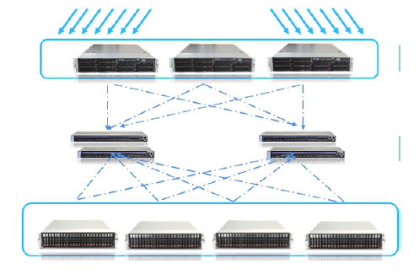

Cloud storage helping in Financial management by reducing Capital cost and further leading to reduction in Operational cost

**REFERENCES**

[1] Artificial in Vatsal Kamlesh Shah Computer Engineering Shah and Anchor Kutchhi Engineering College Mumbai, India vatsal.shah0210@gmail.comtelligence Management in Financial Crisis

[2] Hou Y, Jing W, Zhao Z, et al. A Scalable and Integrated Cloud

Monitoring Framework Based on Distributed Storage[C]. Web

Information System and Application Conference. 2013:318-323.

[3] YangYang1, YangXiaoPeng2 , GaoFeng1, LiYeTian3

(1. State Grid Henan Electric Power Information and Telecommunication Company,

ZhengZhou, China, 51805745@qq.com

2. Henan Electric Power Industry Group Co., Ltd, ZhengZhou, China

3.China International Telecommunication Construction Group Design Institute Co., Ltd, ZhengZhou, China􀋅Application of Distributed Storage Technology for Financial Management and Control System in Electric Power System